Multimodality as a Resource for Linguistic Analysis
of English-Language Stand-up Specials
Iryna Ushchapovska, Olena Nazarenko and Alina Liuta
Sumy State University, Ukraine

Abstract
This article addresses the growing demand for exploration of stand-up comedy specials through the multimodality aspect. It highlights the unique challenges that arise when analysing stand-up comedy, including the use of humour, cultural references, visual effects, and linguistic nuances. Stand-up comedy is a multimodal formation that contains different semiotic resources – verbal text, paralanguage, and non-verbal elements. Thus, this article explores multimodality as a resource for analytical methods and techniques that can be used to capture the essence of English-language stand-up comedy and explore its linguistic peculiarities. It also provides an overview of the concept and the essence of multimodality and highlights the importance of studying the original performance with its humour and audio-visual aspect. It presents various strategies to tackle linguistic challenges, such as idiomatic expressions and cultural references. Moreover, this article emphasises the need to consider cultural and contextual notions while considering stand-up comedy in cross-cultural context, such as localizing humour and adapting jokes to the cultural context of the target audience while preserving audio-visual effects.
The text pays special attention to subtitling as an effective multimodal strategy of English-language stand-up comedy, examines its types, and lists its advantages over other strategies of audio-visual content.
Overall, this article provides a valuable resource for linguists, language learners, and stand-up comedy enthusiasts interested in studying English-language stand-up comedy. It provides an overview of the complexities and challenges for considering humour and cultural references in a cross-cultural context.

Keywords: stand-up specials, multimodality, humour, cultural context, audio-visual effects, localization, subtitling, dubbing

1 Introduction

With the rise of streaming services like Netflix and Amazon Prime, stand-up comedy has become more accessible to audiences all around the world. Another point that should also be considered is that with the rise of new media, in particular the world wide web and multimedia forms of communication and entertainment, the multimodality of texts has become increasingly conspicuous (O’Sullivan 2013: 5). As a result, there has been a growing demand for scientific explorations of stand-up specials. In Ukraine, the popularity of English-language stand-up comedy has also grown, leading to the need for efficient and accurate translations that capture humour, cultural references, and the audio-visual style of the original performances. The challenge for the linguists and translators is that stand-up comedy is not homogeneous but involves different semiotic resources. Thus, multimodality should be applied to the study and translation to preserve the essence and spirit of stand-up comedy.

2 Material and methods

Several research methods were used while examining the most effective methods for capturing the essence of stand-up specials. A comparative analysis of the original text and the translated text of stand-up specials, a synthetic method, as well as a qualitative analysis of the original text were implemented to identify difficulties in the study and translation of contextual concepts and phenomena.

3 Presentation of the main research material

Focusing on the linguistic analysis of stand-up comedy specials as a form of audio-visual content, the current issue at hand is the exploration and translation of English stand-up comedy specials into Ukrainian. This issue has gained significant relevance in recent times due to the widespread popularity of stand-up comedy on a global scale, resulting in a growing demand for translations tailored to non-English speaking audiences.
In Ukraine, where English-language stand-up comedy has seen a surge in popularity in recent years, the need for efficient and accurate translations has become increasingly pronounced. However, the translation of stand-up comedy presents distinct challenges due to the incorporation of humour, cultural references, and linguistic subtleties that are challenging to capture in a different language.
Multimodal texts designed for consumption by diverse audiences can become particularly sensitive when translated for communities with varying socio-cultural and religious values compared to those of mainstream Western cultures. To maintain social and legal acceptability in the target locale, and thereby ensure that corporate profits remain robust, editorial policies advocate for both verbal and linguistic adjustments during the translation process. Hence, it becomes imperative to delve into multimodality aspects of stand-up specials that help effectively convey the essence of the performances preserving the unique humour and stylistic elements of the comedians.
A stand-up special is a form of audio-visual content; it is a clear, authorized, and cinematic recording of a stand-up comedy performance in which the stand-up comedian performs live. It is a recording of actual verbal narration that is considered successful only when the audience finds it funny (Boardman 2021). Stand-up specials are a multimodal phenomenon that incorporates sensory modalities in the production of humour and entertainment for audience consumption (Ogoanah 2019: 41). They possess a unique form of audio-visual content because they convey the essence of a live performance and allow the viewers to experience the energy and humour of stand-up comedy without being in the audience during the performance.
Multimodal texts are, according to this definition, those written to be performed live on stage (and, of course, for an audience) (O’Sullivan 2013: 6). Stand-up acts are filmed live in front of an audience, creating a sense of immediacy and intimacy that is difficult to replicate in other forms of audio-visual content. This live aspect allows the audience to feel part of the show, and the audience’s reaction can enhance the comedy experience of this audio-visual content (Chaume 2021).
Stage management, nonverbal cues (such as the comedians-audience’s gestural movements), speeches, pictures, music/sounds, and the cognitive moves-sequence contribute to the communicative value and the production of the genre (Ogoanah 2019: 40). When filming stand-up comedy, various audio-visual elements such as lighting, sound effects and choosing the right camera angles are used to enhance the impact of the jokes and create a more engaging viewing experience (Boardman 2021). For example, multiple camera angles can help the audience feel more engrossed in watching the performance (Figure 1). At the same time, sound effects and music can add more humour and emotion to the scene.
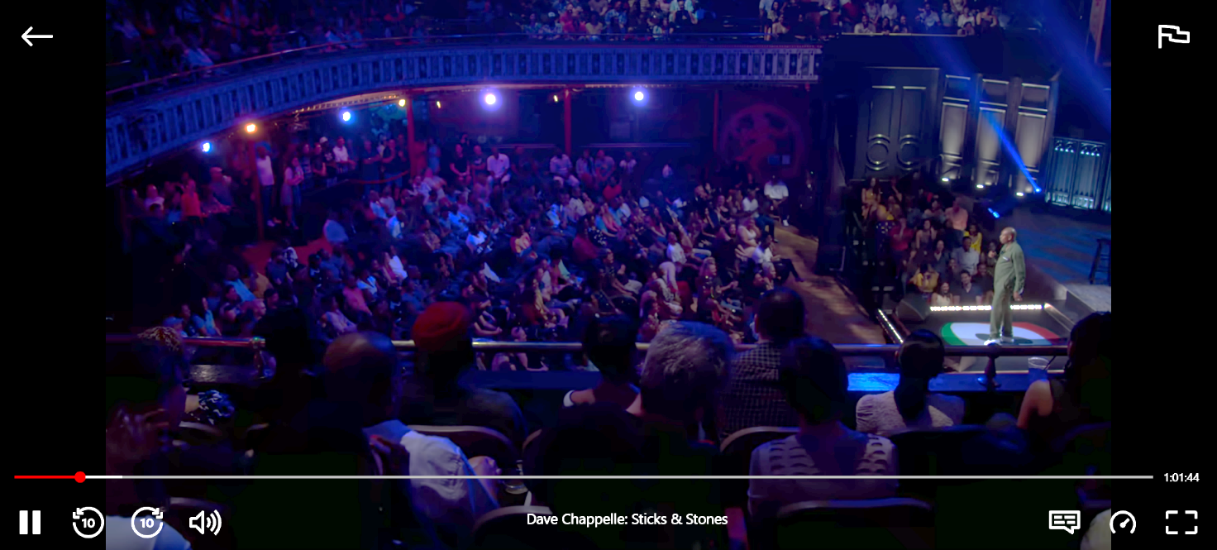
Figure 1. Dave Chapelle’s “Stick & Stones” special on Netflix introducing the importance of camera angles, lighting, interior, and seating of people.

Finally, stand-up specials provide a unique platform for comedians to showcase their talents and connect with their audience on a deeper level. The extended duration of such performance (on average, from half an hour to two hours) allows comedians to explore topics in more detail, experiment with new material, and create a narrative framework that captivates the audience from beginning to end. All in all, stand-up specials capture a live performance’s unique energy and humour and incorporate various audio-visual elements to enhance the viewing experience. They are a particular form of audio-visual content in which non-verbal components are the most difficult to interpret (Ushchapovska 2020: 209).
When stand-up specials are to be considered in a cross-cultural context, such tools as translation, dubbing, and subtitling should be used to make it easier to perceive the show. Translation is usually thought of as being about the printed word, but in today’s multimodal environment, translators must take into account other signifying elements, too. Words may interact with still and moving images, diagrams, music, typography, or page layout (O’Sullivan 2013: 2). According to the peculiarities of the reproduction form of this audio-visual content type and the challenges of translating humorous performances, there are such strategies for translating stand-up specials as subtitling, dubbing, subtitling with cultural notes and audio description. Translation and interpreting of stand-up specials may also interplay with the semiotics of the human body – the use of para-verbal signs – including but not limited to voice qualities, cadences, inflection, or rate of speech – and non-verbal signifiers – such as gestures or movements (Pérez-González 2014: 4). Let us consider the definition and features of the most often used translation strategy in more detail.
Subtitling is the process of displaying text on screen, usually at the bottom of the screen, to translate dialogue from one language to another or to provide a written transcription of spoken content for viewers who are hard of hearing. Subtitling can be defined as “the process of converting an audio-visual environment into a textual one by creating, synchronizing and placing a written translation of the spoken words, which is displayed on the screen simultaneously with audio and image” (Gottlieb 1994: 119). Subtitling is commonly used in the television and film industry to reach a wider audience and facilitate communication across language barriers (Figure 2). It is also a critical accessibility tool, allowing people with hearing impairments to access audio-visual content. Adding subtitles in the target language can be an effective strategy for making content accessible to non-native speakers. Subtitles can help viewers who struggle to understand a comedian’s accent or slang and can provide an extra layer of humour for viewers who are fluent in both languages.
In subtitling, the multimodality of the audiovisual text is both a challenge and a resource for subtitlers. The image may impose severe challenges on the translator, e.g., through instances of verbal/visual puns, but through verbal/visual redundancy the other modes of the audiovisual text can also provide sufficient context to make certain verbal elements redundant, and thus make it easier to condense the text (O’Sullivan 2013: 11)
Figure 2. Dave Chapelle’s stand-up special “The Closer” on “Netflix” with the Ukrainian subtitling

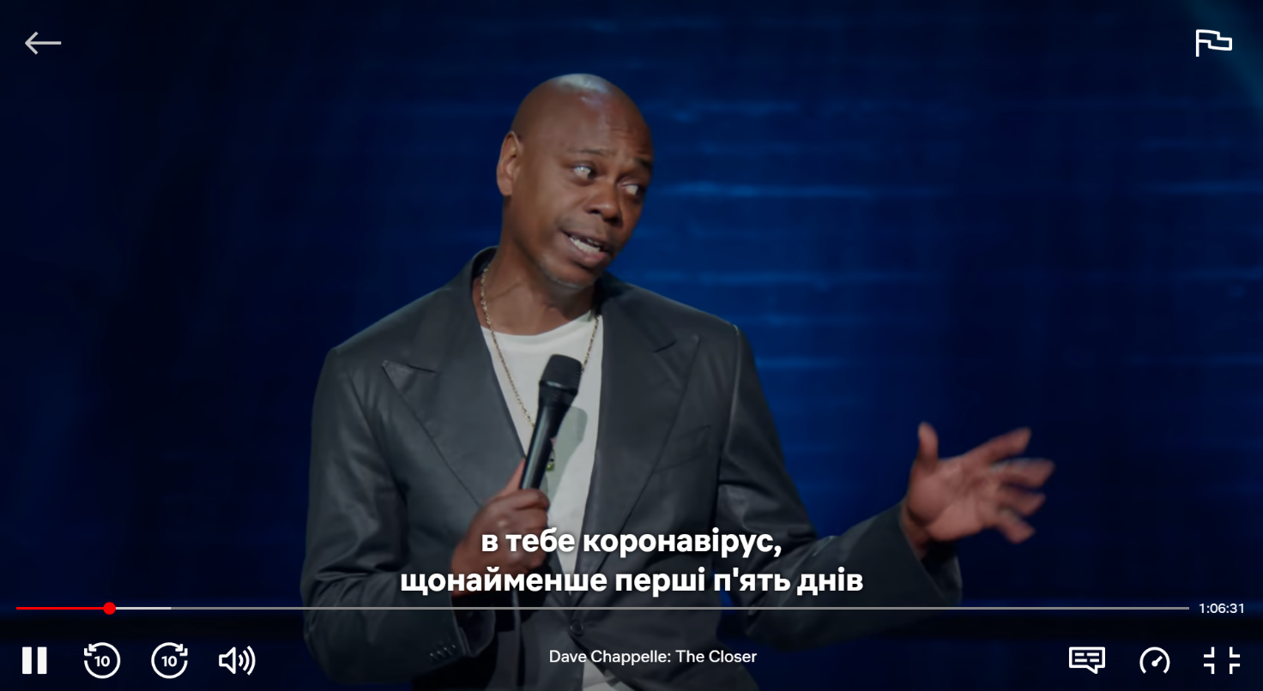
In general, the choice of audio-visual translation strategy for stand-up comedy depends on the specific needs and preferences of the target audience, as well as on the style and content of the comedian’s performance. However, subtitling is the most common strategy for translating English-language stand-up specials, usually divided into intralingual, interlingual, and bilingual (Pedersen 2011). The world of stand-up comedy is a treasure trove of linguistic analysis, and when it comes to English-language stand-up specials, the concept of multimodality plays a pivotal role in unravelling their complexity. In this context, a great example to dissect the multifaceted nature of multimodality in linguistic analysis is Dave Chapelle’s stand-up specials.
Multimodal texts are those meticulously crafted to be performed live on stage, with a primary focus on engaging an audience (O’Sullivan 2013: 6). Chappelle’s stand-up specials epitomize this definition, as they are recorded in front of a live audience, creating an immediate and intimate connection that sets the stage for linguistic analysis. One essential element of this multimodal linguistic analysis is the careful management of the stage. Lighting, in particular, emerges as a potent resource. It serves not only to set the mood but also to guide the audience’s attention [Figure 3]. Subtle changes in lighting can accentuate punchlines, create dramatic pauses, or shift the overall atmosphere. Chappelle expertly exploits these lighting nuances to reinforce the linguistic impact of his words.
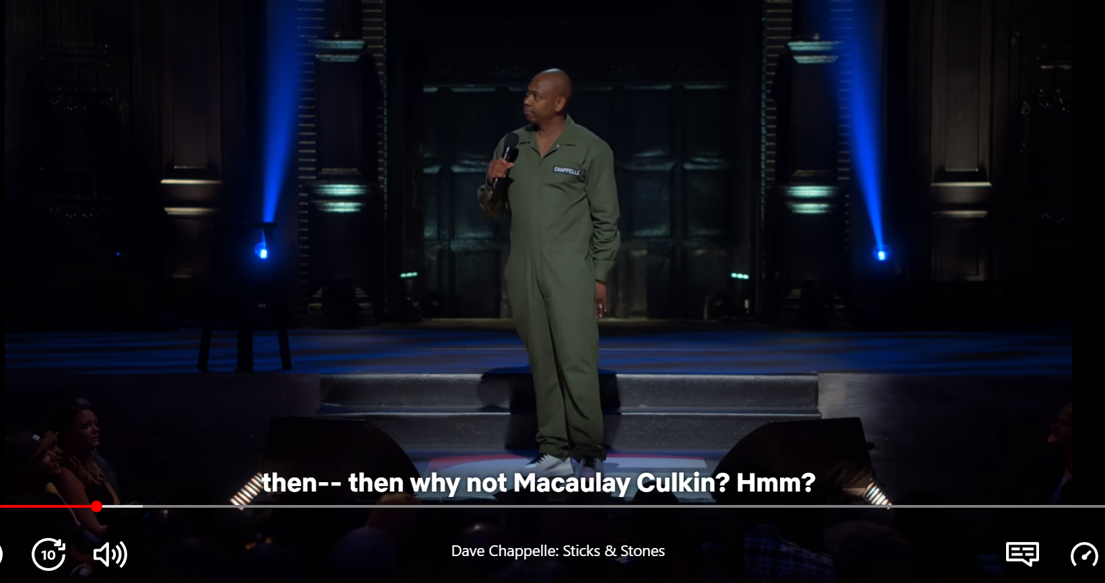
Figure 3. Dave Chapelle’s stand-up special “Sticks & Stones”
Nonverbal cues, including Chappelle’s own gestures and movements, as well as those of the audience, contribute significantly to the multimodal tapestry of his performances. The comedian’s physical presence on stage is captivating, and his body language serves as an additional layer of communication that enriches the linguistic analysis. Furthermore, the audience’s reactions, ranging from uproarious laughter to subtle nods of agreement become invaluable linguistic data points that underscore the communal and interactive nature of stand-up comedy.
Speech, the primary mode of communication, is where linguistic analysis naturally finds its focus. Chappelle’s mastery of language, his precisely chosen words, and the rhythm of his delivery are all ripe for linguistic exploration. Yet, within the context of multimodality, these linguistic elements coalesce with other resources. Visuals and images, when incorporated into his act, function as linguistic aids that add depth and humour to his narratives.
Chappelle’s tone of voice is a crucial element of his comedy. He can switch from a calm and measured delivery to an explosive, energetic tone in an instant for comedic effect. His impeccable timing and vocal inflections enhance the humour of his punchlines. For example, in his “Stick & Stones” special, he uses a calm and deliberate tone when talking about everyday observations but shifts to a high-energy and animated tone when delivering a punchline, creating a stark contrast that heightens the humour. Sound effects and music, while often overlooked in traditional linguistic analysis, emerge as vital components in the multimodal analysis of Chappelle’s specials. These elements are strategically placed to punctuate jokes, create comedic timing, and emphasize linguistic nuances. The choice of music complements the linguistic mood, further enriching the analysis by highlighting emotional resonances within Chappelle’s narratives. Camera angles, too, hold linguistic significance within this multimodal framework. For example, in the specials “The Closer”, multiple camera perspectives offer viewers a dynamic vantage point, allowing them to explore linguistic nuances that might be obscured in a single viewpoint. Close-up shots, in particular, enable the audience to discern the intricacies of Chappelle’s facial expressions, which often serve as linguistic cues, emphasizing comedic beats and strengthening the connection between the comedian and the audience.
In sum, Dave Chappelle’s stand-up specials serve as rich resources for linguistic analysis within the context of multimodality. Through meticulous stage management, the utilization of nonverbal cues, the artful employment of speech and visuals, and the strategic use of lighting, sound effects, and camera angles, Chappelle crafts a multidimensional linguistic experience that transcends the boundaries of language alone. This exploration underscores how multimodality in stand-up specials can be a powerful tool for linguistic analysis, shedding light on the intricate interplay of linguistic elements in the realm of comedy. Dave Chappelle’s unparalleled mastery of these multimodal resources solidifies his position as a legend in the world of linguistic humour analysis.

4 Conclusions and perspectives

In conclusion, the world of stand-up comedy presents a unique and captivating multimodal challenge when it comes to audio-visual translation strategies. The choice of strategy hinges upon the distinct demands and preferences of the target audience, as well as the stylistic nuances and content of the comedian’s performance. When it comes to translating English stand-up specials into Ukrainian, subtitling has emerged as the most effective method for faithfully conveying the original essence to Ukrainian viewers. Dubbing, while seemingly logical, can occasionally misalign with the comedian’s precise timing and delivery, leading to unintended humour loss. In stark contrast, subtitling emerges as the optimal choice. It preserves the comedian’s original timing and delivery, ensuring that the humour remains intact. It stands as the most cost-effective and efficient translation option. Furthermore, subtitling has the capacity to maintain the original cultural context and humour, making it the ideal companion for stand-up specials.
Finally, the study of stand-up comedy, as exemplified by Dave Chappelle’s specials, reveals the profound significance of multimodality in linguistic analysis. Chappelle’s masterful use of various elements, such as stage management, nonverbal cues, speech, visuals, lighting, sound effects, and camera angles, creates a multi-layered linguistic experience that transcends the confines of language alone. This examination underscores the potency of multimodality in stand-up specials as a formidable tool for linguistic analysis, unveiling the intricate interplay of linguistic components within the realm of humour.

References

Boardman, Frank. 2021. What Is a Stand-Up Special? “Aesthetic investigations”. Vol. 5 No. 1: Special Issue: Isn't All Art Performed? URL: https://doi.org/10.58519/aesthinv.v5i1.11774 (Accessed 10.10.2023)
Chaume Frederic. 2019. Audiovisual translation in the age of digital transformation: Industrial and social implications. URL: http://dx.doi.org/10.1075/btl.148.05cha (Accessed 10.10.2023)
Chenxu Hu. 2021. Neural Dubber: Dubbing for Videos According to Scripts. 35th Conference on Neural Information Processing Systems. URL: https://openreview.net/pdf?id=_H7TNRQQeH8 (Accessed 13.10.2023)
Díaz Cintas, Jorge, Remael, Aline. 2007. Audio-visual Translation: Subtitling (1st ed.). Routledge.
Fryer, Louise, & Walczak, Agnieszka. 2017. Audio Description. The Routledge Handbook of Audio-visual Translation. P. 1–16.
Gottlieb, Henrik. 1992. Subtitling – a new university discipline. Teaching translation and interpreting. Amsterdam: John Benjamins, P. 161 –170
Gottlieb, Henrik. 1994. Subtitling: Diagonal translation. Perspectives – Studies in Translation Theory and Practice. No. Vol 2, No 1. P. 101–121.
Ogoanah, Felix N., Oj, Fredrick O. 2019. A multimodal generic perspective on Nigerian stand-up comedy. European Journal of Humour Research. 6 (4) 39–59
O'Sullivan, Carol. 2013. Multimodality as a challenge and resource for translation. The Journal of Specialised Translation. Issue 20. P. 2–14
Pedersen, Jan. 2011. Subtitling norms for television: an exploration focussing on extralinguistic cultural references. vol. Benjamins translation library. URL: https://jvinfo.nu/LMEDIA/Advanced_Translation_on_Subtitling.pdf (Accessed 13.10.2023)
Pérez-González, Luis. 2014. Multimodality in Translation and Interpreting Studies. URL: http://eu.wiley.com/WileyCDA/WileyTitle/productCd-0470671890.html (Accessed 13.10.2023)
Radetska, Svitlana, Kalishchak, Tetiana. 2016. Subtytruvannya yak vyd audiovizualnoho perekladu: perevahy ta nedoliky [Subtitling as a type of audiovisual translation: advantages and disadvantages]. Naukovi zapysky Nizhynskoho derzhavnoho universytetu im. Mykoly Hoholya. Filolohichni nauky. Issue 2. P. 81–84. (In Ukrainian)
Ushchapovska, Iryna, Movchan, Diana, and Chulanova, Halyna. 2020. Idioethnic Features of Multimodal Advertising Texts: a Case Study of Coffee Commercials. SKASE Journal of theoretical linguistics. Vol. 17, № 5. 208–222

Sources

- Dave Chappelle: Sticks & Stones (2019) – Transcript. Scraps from the Loft. URL: https://scrapsfromtheloft.com/comedy/dave-chappelle-sticks-stones-transcript/ (Accessed 03.10.2023)
- Dave Chappelle: The Bird Revelation (2017) – Transcript. Scraps from the Loft. URL: https://scrapsfromtheloft.com/comedy/dave-chappelle-the-bird-revelation-2017-full-transcript/ (Accessed 05.10.2023)
- Watch Dave Chapelle: Stick & Stones | Netflix – Official Website URL: https://www.netflix.com/title/81140577 (Accessed 22.10.2023)
- Watch Dave Chapelle: The Closer | Netflix – Official Website URL: https://www.netflix.com/title/81228510 (Accessed 22.10.2023)

Iryna Ushchapovska
PhD in Philology, Associate Professor
Senior Lecturer
Department of Germanic Philology
Sumy State University, Ukraine
e-mail: i.ushchapovska@gf.sumdu.edu.ua

Olena Nazarenko
Senior Lecturer
Department of Germanic Philology
Sumy State University, Ukraine

Alina Liuta
Master’s Student
Department of Germanic Philology
Sumy State University, Ukraine

In SKASE Journal of Literary and Cultural Studies [online]. 2023, vol. 5, no. 2 [cit. 2023-12-
29]. Available on web page http://www.skase.sk/Volumes/SJLCS11/01.pdf. ISSN 2644-5506

