Emotiveness of Multimodal Website Book Reviews: an Influential Aspect
Iryna Ushchapovska, Halyna Chulanova, and Diana Movchan, Sumy State University, Ukraine

Abstract
The article presents the results of the study of the influential potential of website book reviews in terms of multimodality. The research is based on modern approaches to understanding the issue of linguistic influence as a multimodal suggestive discursive phenomenon. Being a secondary text, a book review optionally accompanies the literary work as a primary construction with its pragmatic orientation. Targeted at the main text, the book review makes it the object of evaluation, while the reader, being the author of the review, acts as the subject of the evaluation. It has been revealed that emotional saturation is an immanent characteristic of website book reviews. Persuasive influence is simultaneously a psychological phenomenon and communicative process. The appeal of book reviews to the psychic and emotional sphere of human life determines the specificity of the selection and organization of verbal and non-verbal resources. It is proved that the emotiveness of book reviews has a categorical status and is implemented at different verbal (phonetic, morphological, lexical, and syntactic) and non-verbal (graphic and visual) levels.

Keywords: book review, website, reader, multimodality, emotionality, emotiveness

1 Introduction

Considering the rapid pace of the development of computer communication, the Internet is an integral component of interpersonal interaction and a mobilizer of language resources to influence people’s consciousness, feelings, and thoughts. The use of verbal and non-verbal means in the field of electronic communication has a conscious, purposeful, and social-evaluative character, which determines the need for research aimed at identifying and explaining the potential of multilevel means of speech influence of certain genres in Internet discourse, implemented both in the general strategies of this Internet genre and in its separate segments.
The issue of the effectiveness of speech influence involves addressing such concepts as “persuasiveness” and “suggestiveness”. At the same time, persuasive influence is considered a special type of communicative action, namely a certain influence of the author of an oral or written message on his addressee to convince of something, to call for the implementation or non-implementation of certain actions (Hesse 2015). Persuasive communication is often equated with rational argumentation. If persuasive influence is an appeal to logic, reason, and facts, then suggestive influence bypasses reason through direct or indirect suggestions. This is usually an appeal to emotions, the unconscious, and vivid impressions (Miller & Johnson-Laird 2014).
It is worth noting that, despite the differences, persuasive and suggestive means of influence are often used in a complex manner; the use of suggestive methods at the initial stage of influence is particularly productive, as it allows bringing the addressee into a certain psychological state, which is necessary for the further perception of arguments and the achievement of a perlocutionary effect. This work deals mainly with the form of hidden, disguised influence, i.e., suggestion. A suggestion can be described as an effect on the mental sphere of the addressee, which is associated with a decrease in the level of criticality in the perception of content, with a lack of purposeful and active understanding, analysis, and correlation with experience (Bandler 2019). The effectiveness of suggestion is determined, according to researchers, by the characteristics of the suggestor (status, intellectual, etc.), the characteristics of the suggerend (emotional state, degree of perception of external influence), relations between the participants of the act of suggestion (trust, authority, and dependence), ways of constructing forms and means of influence. Suggestiveness as a type of hidden influence in the process of communication is widely used in many types of discourse, including Internet discourse, but the specifics of suggestive influence within the framework of text reviews have not yet become the subject of a special linguistic analysis, which determines the relevance of this scientific investigation.
The theoretical base of the study was made up of the concepts of domestic and foreign authors, dedicated to various aspects of the study of the problem of linguistic influence in the field of communication theory, pragmalinguistics, discourse analysis, multimodal linguistics, and psycholinguistics (Batsevich 2004, Zasekina, Zasekin 2008, Pocheptsov 2012, Susov 2009, Kaminska 2019, Kalmykova 2015, Kutuza 2018, Osgood 1988, Pinker 1998, Turnbull 2003, Seuren 2009, Turk 2003, Kress G. & van Leeuwen 2001, etc.). The purpose of the study is to identify and comprehensively describe the communicative, pragmatic, and suggestive characteristics of website book reviews as a relevant component of multimodal Internet discourse and modern communicative space.

2 Material and methods

The material of the research is book reviews, selected by the method of continuous sampling from the book review website (Goodreads). The research involves such research methods as the discursive method, the contextual and interpretive method, the descriptive method, the analysis of linguistic means of suggestion, and the analysis of communication in the light of the theory of language activity.

3 Presentation of the main material

Given the unstoppable pace of informatization of society, the study of the peculiarities of communicative behavior in the virtual space gives rise to several issues related to the explanation of the characteristic features of communication within the framework of various genres of Internet discourse: Internet forums, chats, electronic magazines, web pages, banner advertising, correspondence via e-mail, etc. Analyzing virtual communication on Internet forums, some peculiarities can be highlighted. Thus, virtual communication is multimodal as it is both verbal and non-verbal (visual), it has signs of both oral and written communication, it is unofficial, which is determined by the status equality of the participants, it is asynchronous, it is open and proactive as users can choose the interlocutor themselves and interrupt communication at any time. An important feature of Internet communication is anonymity, which allows an individual to feel free and reveal those qualities that he does not allow himself to show in real life (Kaminska 2019: 151).
Book reviews or “blurbs” as an example of Internet communication have all the above-mentioned features. Blurbs are a key part of book marketing: they are supposed to entice readers to buy the book. They are a sales pitch that should sound interesting and should represent what is in the book without giving too much away. The blurb is designed to entice the reader. If a blurb makes a reader want to read more, it’s successful, if a blurb bores or overwhelms the reader, it needs to be rewritten. Blurbs are sure to be called a marketing tool to sell a book. Thus, book review websites can be considered a marketing platform. There are several such sites a reader may refer to before making his/her purchase decision. The greater the diversity of opinions gathered on the website, the more confidence the reader may have about his further interaction with the book.
New technologies have enabled free access to any source of information, to its literary form as well, providing the possibility of prompt direct contact, the dialogue between the author and the reader, as well as between the readers. The freedom, efficiency, immediacy, and interactivity of this kind of communication led to the emergence of a fundamentally new actor in traditional literature – an active reader. He seeks to influence potential readers and for this purpose, he organizes a kind of “advertising campaign” of the literary piece he has read, creating his book review based on his reading experience. The communicative situation carried out with the help of such a book review text can be described by the following scheme:
AUTHOR 1 → BOOK → READER = AUTHOR 2 → BOOK REVIEW → POTENTIAL READER
The reader, who is also the producer of the review text, having familiarized himself with the new book, expresses his opinion about what he has read and shares it with other readers. Being an auxiliary text, a book review text optionally accompanies the literary text as a primary construction with its inherent pragmatic orientation. Book reviews are informative, self-sufficient for interpretation, have their addresser and addressee, set clear goals, and are one of the means of influencing the recipient’s choice. The purpose of such texts is to form a certain reader’s assessment and create a psychological and emotional atmosphere, prompting the reader to take a certain action (Movchan, Chulanova, Kobyakova 2017: 110). The significance of book reviews is indicated by the fact that when choosing a new book, a potential reader, before buying it, tries, as if to “peek” inside the book, to understand whether this work will meet his expectations. Thus, the reader is assisted by the book review texts posted on the websites, to which the reader draws his attention. Further readers’ revelations posted on the Internet prove this fact:
Scanning the reviews, one particular unhappy customer called the book “puerile”. They intended it as an insult but actually, it’s the truest thing they said about the book they never finished (1).
First look at that title. It’s weird, isn’t it? I would never have read this if not for the amazing cover next to it and the good reviews and let’s admit, the fact that there is a movie on this (2).
The suggestiveness of book review texts is the infusion that is consciously carried out by the author of such a book review text (suggestor) concerning a potential reader (suggerend). Deliberate infusion in book review texts consists in the use of special “verbal formulas” by the suggestor, which are introduced into the mental sphere of the suggerend and become active elements of his consciousness and behavior. The content of deliberate infusion is a component of the information contained in the text and is often characterized by unawareness, imperceptibility, and involuntary assimilation.
Given the fact that indirect infusion appeals not to the consciousness of the suggerend, but to mental structures that lie beyond it, it can be argued that linguistic suggestion is characterized by the “logic of trance”, that is, tolerance of logical contradictions under the influence of emotional and irrational elements of the listener’s psyche (Denisevych 2016: 33). Emotional infusion within the framework of book review texts as a product of processing primary literary texts is aimed at creating or correcting the general emotional mood of a potential reader. The suggestor tries to evoke certain positive or negative emotions of the suggerend, among which we highlight the following:
- pleasant surprise:
I’m at a loss for how to tell you about this book without telling you too much of what makes it so juicy and enjoyable. I’ll just sum it up as READ. THIS. BOOK! (3)
- pleasure:
LOVED this book. It’s like watching a train wreck in slow motion. It reminds me of BIG LITTLE LIES- parents behaving badly in believable, horrifying, yet shockingly relatable ways! So so so good (3).
- delight:
This book is solidly on my 'best of 2019' book list. GET THIS BOOK NOW, Y'ALL…. order it, pick it up at your local indie book shop, put it on your library holds list...just get your hands on it (3).
Exceptional? Oh yes! This, my friends, was just about the best inside look at privileged parenting I've ever read. What a great idea for a book! (3).
- respect for the author and his work:
I am madly in love with Jane Fallon’s latest novel!!! I can’t believe I have had Sweet Revenge forever and haven’t read it yet. You can be sure to see it reviewed very soon! (4).
I highly enjoy Stephen King’s descriptive writing style! I was on the edge of my seat for the majority of the novel, and I definitely did not sleep well the following night! (5).
- disappointment:
I’ve been reading Uncle Stevie for about 35 years now, and there’s been plenty of peaks and valleys in my fandom. This time out he found a whole new way to disappoint me (6).
- dislike of the author:
Juvenile. Immature. Boring. I couldn’t care less what happened to Holly. I didn’t finish the book. I’ve always enjoyed Jane Fallon’s books (the first 7 were brilliant) but I feel she’s just churning them out now. I didn’t enjoy her previous book to this and was hoping she’d get back on track but not with this one. A 10-year-old could read this book (4).
- irritation:
There's nothing positive about this book, so let's just go straight into why it was so bad (7).
I fully respect what Stein was trying to do...well, I guess what she actually did and why, but I never want to read the story of Melanctha again in my life. No never no more do I want to read Melanctha. Never no more in my life do I want to read Melanctha. No never no more again (8).
The emotional saturation of book review texts is their immanent quality, the purpose of which is the ability to excite the reader and influence his emotional and mental state. Emotions are expressed as a kind of experience that performs a key function in managing behavior (Apresyan 2018; Argaman 2010). Osgood sees emotions as “one of the subsystems of consciousness that is part of human intelligence” (Osgood 1988). From this statement, it follows that emotionality has a close connection with consciousness and thinking, and therefore with language. Emotiveness, acting as a means of linguistic influence, can stimulate emotionality, which at the same time functions together with language and compensates for linguistic means.
Emotive adjectives (emotives), such as juicy and enjoyable, achingly funny, laugh-out-loud brilliant, all-around wholesome, nutritious, genuinely fascinated, etc. have special pragmatic potential. A specific feature of emotions is their special reference: they do not correlate directly, like indicative words, with objects and phenomena of reality. They correspond to the typed emotions evoked by these objects, in our case, books. In the closest context, the presence of several emotives creates an emotive “chain”, in which the nature of semantic relations is determined by the specifics of the situation being transmitted, the systemic relations of emotive lexical units, the features of the thesaurus of the linguistic personality. In emotional chains, both the convergence of the meanings of emotional lexical units and their opposition can occur:
Funny, enjoyable, somewhat predictable but once I start I can’t put it down.
I hate Joel Golby cause he made me write my first Goodreads review. I hate Joel Golby because his writing is so good I get disappointed in my own. I hate Joel Golby because he made me have a Big Think about drinking. I hope he writes a load more books (1).
Emotives as a special layer of vocabulary are characterized by contextuality, i.e., the maximum conditioning of their meaning by the speech situation. Let's consider a few examples:
Enthralling, admirable, refreshing book from an extraordinary lady (9).
Garish! Outrageous! The master of snappy dialogue (10).
Thus, in example, the adjective “refreshing” attracts attention precisely in the context mentioned above. The direct meaning of the word garish is “bright”, but the brightness denoted by the word is unpleasant for the eye, which is reflected in the dictionary definition as “unpleasantly bright” and is proved by the examples of garish light – “something that cuts the eyes, blinding light”, garish clothes – “motley clothes”. In the book review text, this word acquires a positive meaning and emphasizes the extraordinary, scandalous nature of the book. Based on the propositions of suggestive linguistics, it can be argued that adjectives used to denote sensory and visual perception are quite productive, as they quite accurately visualize the characteristics of the subject of the message, “visualizing” the content of what is communicated, thereby intensifying the impact on the recipient. From the perspective of multimodal linguistics, book review texts are a multimodal formation – a synthesis of modes – semiotic resources of different natures (Ushchapovska, Movchan, Chulanova 2020: 211). A verbal text is complemented by visual resources (pictures, symbols, typefaces, and use of colors) to intensify the perception of the book review and make it more attractive and persuasive.


Figure 1: “Tell Me a Secret” book review (4)

As we can see from the below-listed examples, to emphasize the intensity of impressions from the literary work, capture the reader’s attention, and evoke certain emotions in him, various types of intensifiers are used, such as “creative” spelling, capitalization, intentional violation of punctuation rules, exclamation marks, interrogative sentences, unfinished statements, etc. The combination of text and visual signs dramatically lowers the threshold of effort required to perceive the message. A “cooperative effect” is created, associated with the interaction of two types of perception – semantic and aesthetic since graphic design is an integral part of the discourse of aesthetics (Kress G. & van Leeuwen 2001). The use of a capital letter in cases not determined by the rules of grammar is a common method of suggestion: a capital letter gives weight, and visually distinguishes a word from others:

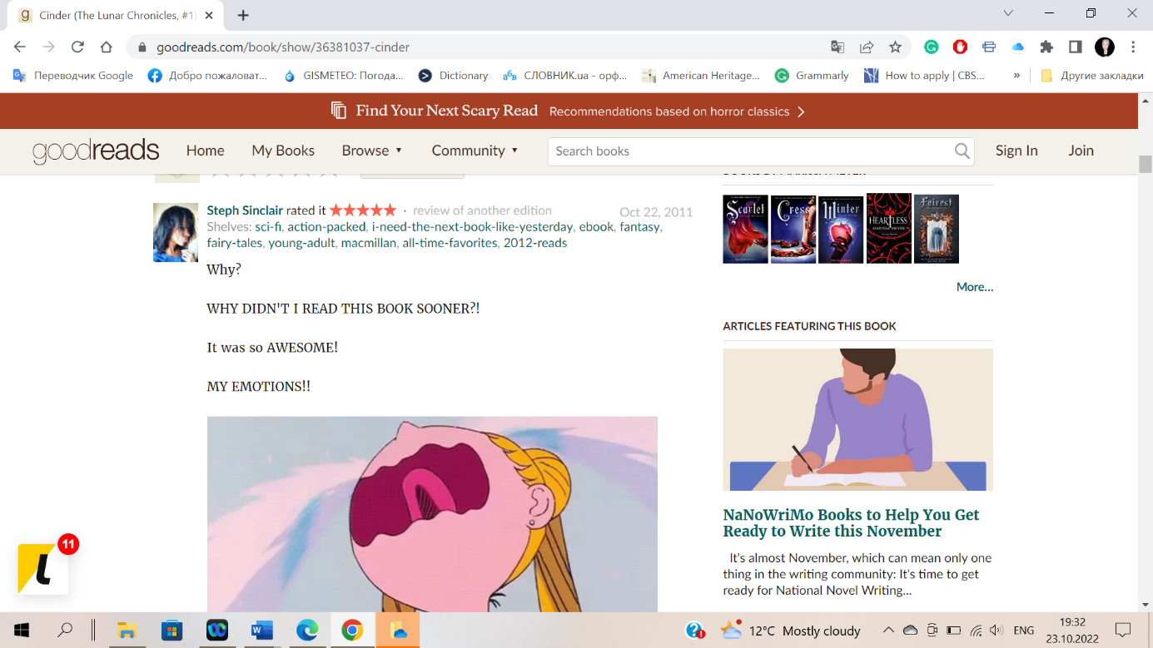
Figure 2: “Cinder (The Lunar Chronicles)” book review (16)

To attract the reader’s attention, the author selects individual segments of the statement
in bold, and resorts to multiple repetitions of a letter within one word, thereby optically increasing its volume.

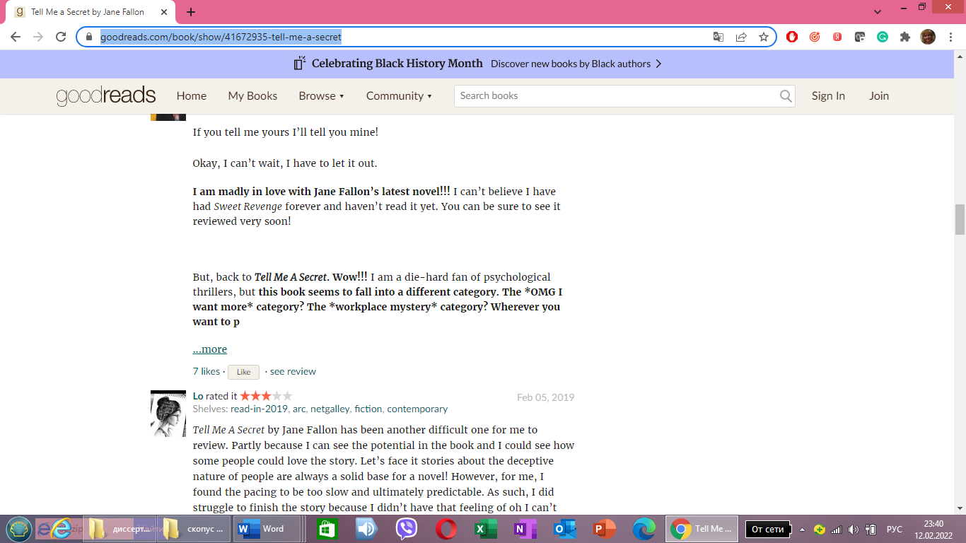
Figure 3: “Tell Me a Secret” book review (4)

Violation of punctuation and spelling rules can also be considered as a means of explaining the author’s heightened emotional tone. The number of used exclamation marks, question marks, and ellipsis corresponds to the strength of the addresser’s emotions. All these means emphasize the addressability and dynamics of the message, implicitly appealing to the consciousness of the potential reader, and increasing the influential effect. An example of using exclamation and question marks:

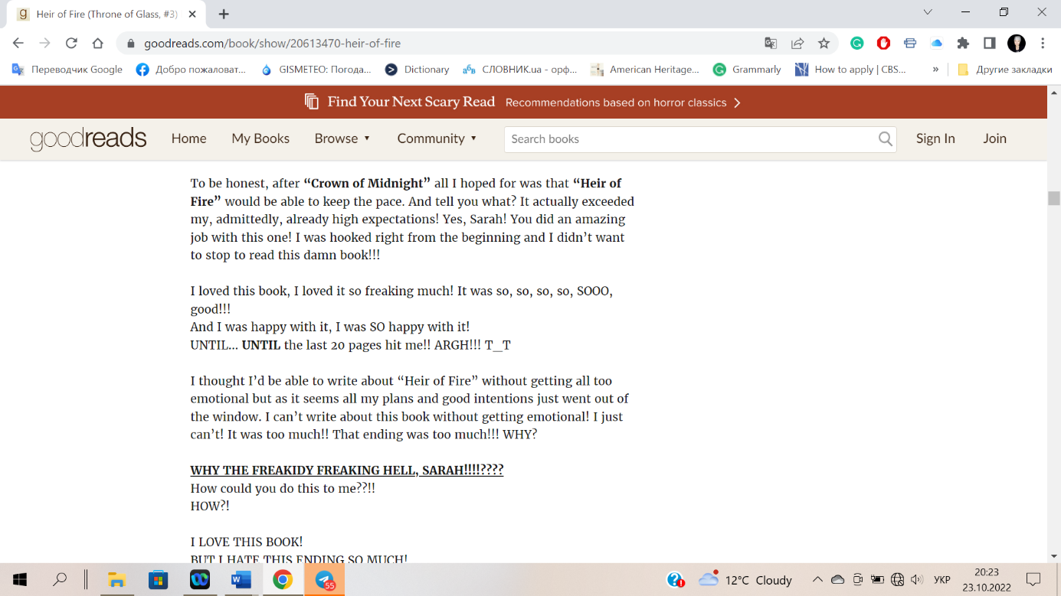
Figure 4: “Heir of Fire” book review (17)

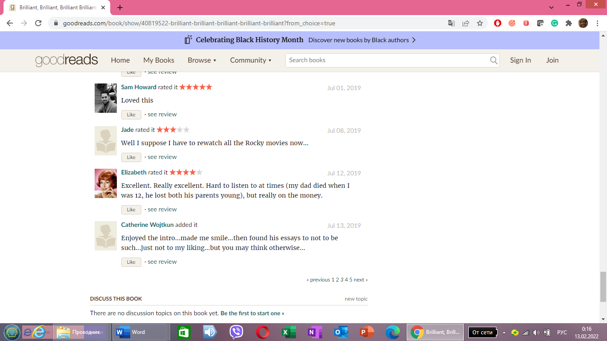
Use of ellipses:
Figure 5: “Brilliant, Brilliant, Brilliant Brilliant Brilliant“ book review (1)

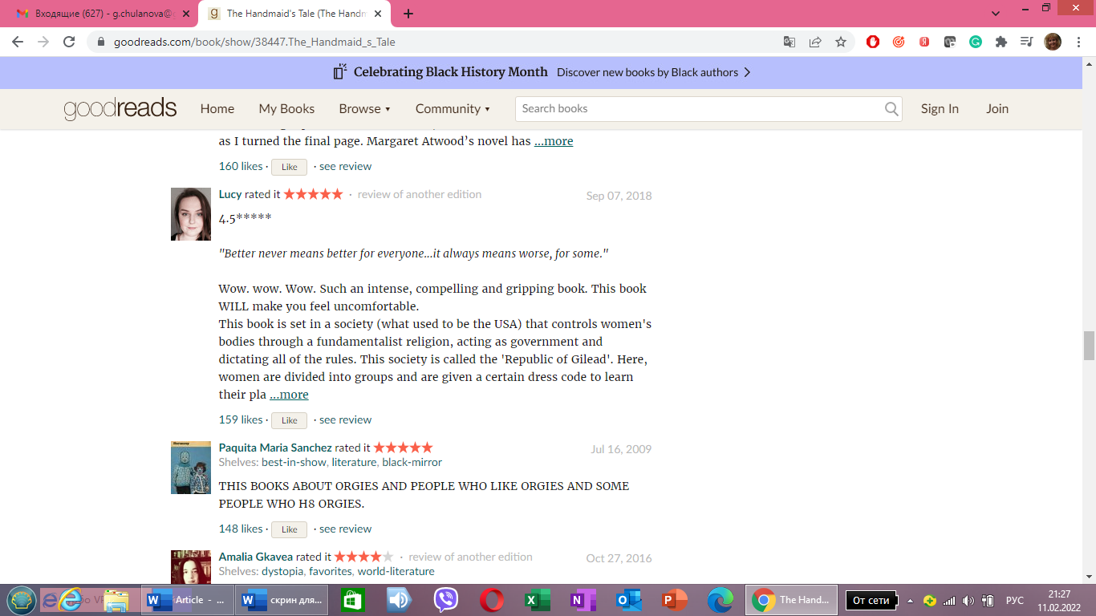
Use of blended spelling: “people who H8 orgies”:
Figure 6: “The Handmaid’s Tale” book review (18)

Modern internet communication brought about new multimodal tools – emoticons – to express the emotions:
Dear,
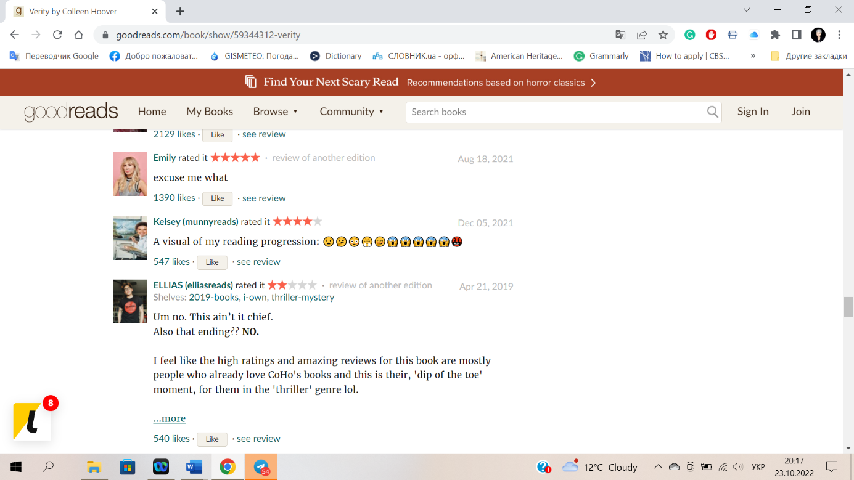
What’s your opinion, if instead of using something like ... “he said with a smile”, I’ll put “-:)” in a fictional book? Or about the use of emoticons in books in general?
I know it's probably not customary, ‘shallow, cheap and infantile’ even, but their use becomes more and more frequent. If I wrote something Leo Tolstoy style, it wouldn’t fit, but in my stuff, it should be Ok. My editor and beta-readers seem to be against.
You? (11).
Figure 7: “Verity” book review (19)
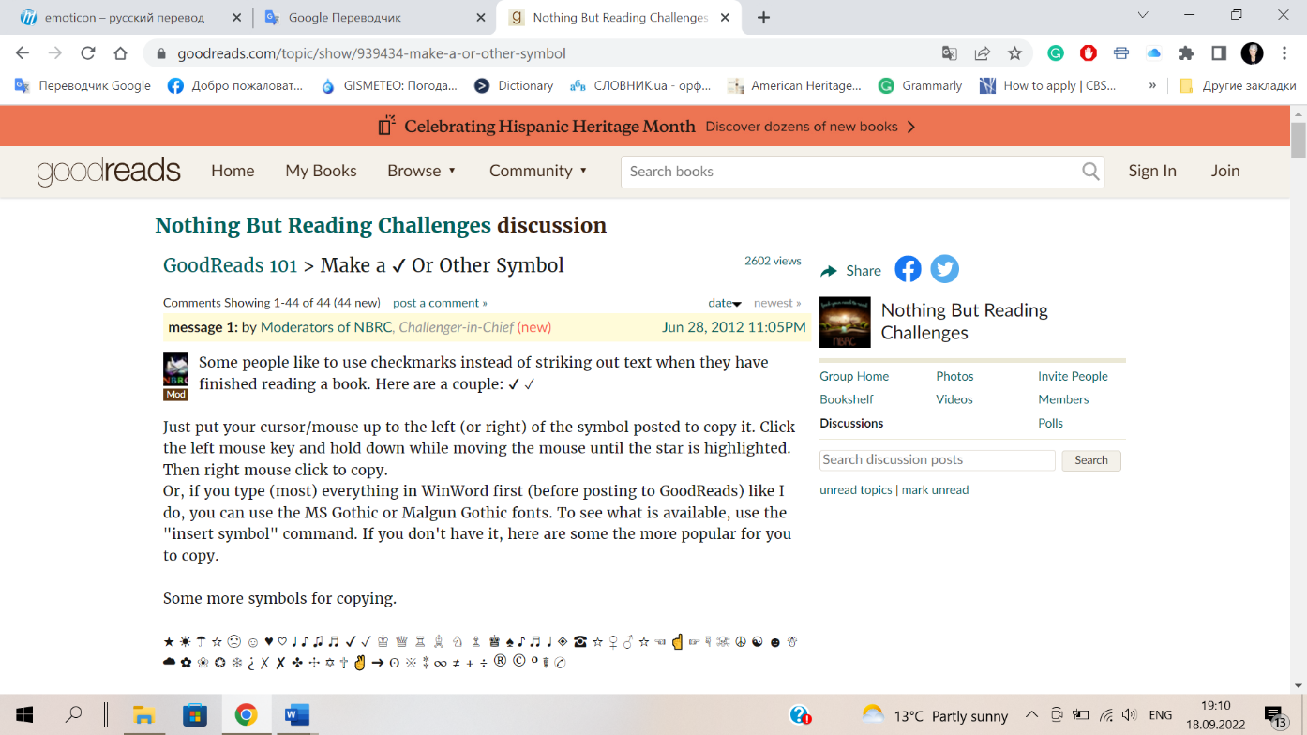
The Goodreads website gives it advice how to use emoticons to emphasize the book review text:

Fugire 8: “Make a or other symbols” (20)

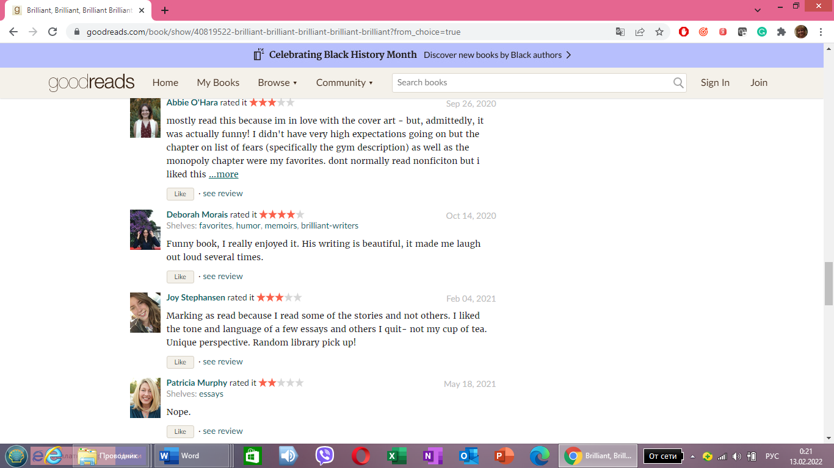
To influence the choice of a potential reader, book review authors such a visual tool as star-rating emphasizing their preferences:
Figure 9: “Brilliant, Brilliant, Brilliant Brilliant Brilliant” book review (1)

Some book review writers resort to the use of memes – another modern multimodal tool, which literally shows the emotions:


Figure 10: “Beautiful Disaster” book review (21)


Using illustrations from the screen adaptation of the book is also a powerful emotional tool to persuade a book review reader to choose it, even because of curiosity:
Figure 11: “Memoirs of Geisha” book review (22)

Language forms, with the help of which communication is carried out on the Internet, have their specific features. These include the reflection of oral speech in writing. Thus, one can often find spoken exclamations in the book review texts. They, as in conversation, denote the primary emotion felt after reading the book. All typical features of emotional vocabulary are concentrated in exclamations: syntactic optionality, that is, the possibility of omission without breaking the phrase, lack of syntactic connections with other parts of the sentence; semantic irradiation, which consists in the fact that the presence of at least one emotive word gives emotionality to the entire statement, provoking empathy – a self-organizing conceptual structure that arises in consciousness as a reflection of the probabilistic nature of the world (Tatsenko, 2020: 414). Exclamations fully reflect the breakthrough of the subjective, personal in speech, as well as the psychological adjustment of communicators. By the nature of the expressed meaning, there can be exclamations of an emotional state, as well as emotional and evaluative exclamations with significant evaluation roles in their semantics. The examples are as follows:
Well, I must say this book was aptly named! “Mmm” was basically my main reaction while looking through it (12).
Then they can say, “Oh, that’s why the chorus gets stuck in our heads (13).
Wow. Wow. Wow. Such an intense, compelling, and gripping book. This book WILL make you feel uncomfortable (14).
The role of exclamations is significant, as they give the expression an idioethnicity, naturalness, and emotionality.
A change in the sound form of an exclamation opens great opportunities for semantic differentiation:
ewwww… I hated this book. it was really uninteresting 2 me. I only finished it cuz it was a skool assignment (15).
The intonation variation of consonants reflects the degree of disappointment of the authors of the reviews. The book review texts, in which the addresser’s emotional attitude towards the book is expressed with the help of exclamations, are characterized by high expressiveness and emotionality. In live communication, exclamations are words that spontaneously express a person’s emotional state, so here their expressiveness is primary. In book review texts, expressiveness is secondary and stylistically determined.

4. Conclusions and perspectives

Thus, an immanent property of website book review texts is their emotional load, i.e., the ability to excite the reader, influence his emotional and mental state, setting a behavior algorithm that determines the specificity of the selection and organization of verbal and nonverbal resources. In the book review texts we analyzed, there are no clear directives, and the words and visual means used with a suggestive purpose are perceived casually and imperceptibly, influencing the recipient’s subconscious. Such a selection of verbal and non-verbal means contributes to unconscious, imperceptible, and involuntary assimilation of information. The emotionality of book review texts has a categorical status and is realized at different verbal levels (phonetic, morphological, lexical, and syntactic), as well as non-verbal (graphical and visual). Emotionality, acting as a means of linguistic influence, can stimulate emotionality, thereby causing emotional resonance between the addresser and the addressee. Pragmatic influence in book review texts is carried out by activating cognitive, psychological, social, and linguistic mechanisms that make it possible to influence consciousness, the process of making certain decisions by a potential reader. We associate the prospects of further scientific enquiries with the expansion of the source base for the study of book review texts, which will make it possible to obtain knowledge about the general patterns and influential nature of the book review text and the specifics of its constructions. We also see another possible direction of further work in the study of book review texts aimed at different target audiences.

References

Apresyan, Margarita. 2018. On the Concept of “Expressiveness” In Modern Linguistics. Annals of Language and Literature. Volume 2. Issue 4. 8-12.
Argaman, Osnat. 2010. Linguistic Markers and Emotional Intensity. Journal of psycholinguistic research. Vol. 39 Issue 2. 89-99.
Bandler, David. 2019. Neuro-linguistic programming: The complete guide to behavioral psychology and social influence using NLP, covert persuasion, mind control and ethical manipulation. London: Independently Published.
Batsevych, Florii. 2009. Osnovy komunikatyvnoyi linhvistyky (Basics of communicative linguistics). In Ukrainian. Kyiv: Akademiya.
Denisevych, Olena. 2016. Specifics of the structure of associative fields of advertising vocabulary. Psycholinguistics. 20 (2), 30-39
Freeth, Peter. 2008. NLP in Business. London: Communications In Action.
Hesse, Nina. 2015. Persuasive Kommunikation. Die Kunst der Überredung. München: GRIN Verlag.
Kalmykova, Larysa. 2015. Movlennyeva diyalnistyak skladova chastyna predmeta psykholinhvistyky (Speech activity as a constituent part of the subject of psycholinguistics). In Ukrainian. East European Journal of Psycholinguistics. Vol. 2. No. 1, 59-67.
Kaminska, Olha, Stezhko, Yuri & Hliebova, Lyudmyla. 2019. Psykholynhvistyka virtualnoi komunikatsii v konteksti zalezhnosti vid sotsialnykh merezh (Psycholinguistics of virtual communication in the context of addiction to social networks). In Ukrainian. Psychoguistics. 25 (1), 147-164.
Kress, Gunter. & Van Leeuwen, Theo. 2010. Multimodal Discourse: The Modes and Media of Contemporary Communication. London: Arnold Publishers.
Kutuza, Natalya. 2018. Communicative suggestion in advertising discourse: Psycholinguistic aspect. Kyiv: Dmytro Burago Publishing House.
Miller, George & Johnson-Laird, Philip. 2014. Language and perception. Cambridge: Cambridge University Press.
Movchan, Diana, Chulanova, Galyna & Kobyakova, Iryna. 2017. Communicative-mediatory function of secondary text-reviews. Advanced Education. 7. 108–113.
Osgood, Charles. 1988. Psycholinguistics, Cross-Cultural Universals, and Prospects for Mankind. Praeger Publishers.
Рetrenko, Victor & Kucherenko, Vladimir. 2009. Iskusstvo suggestivnogo vozdejstviya, ili nekotorye mysli vprok. (The art of suggestive influence, or some experimental thoughts). In Russian. Zhurnal praktikuyushhego psikhologa. Issue 6. 73–84.
Pinker, Steven. 1998. The Language Instinct. How the Mind Works. London: Penguin Books.
Pocheptsov, Gerogii. 2012. Zabezpechennya komunikatyvnykh operatsiy derzhavy. (Ensuring communicative operations of the state). Psycholinguistics. In Ukrainian. Issue 10. 300-305.
Seuren, Pieter A. M. 2009. Language in Cognition. Oxford: Oxford University Press.
Susov, Ivan. 2009. Lingvisticheskaya pragmatika (Linguistic pragmatics). In Russian. Vinnytsia: Nova Knyha.
Tatsenko, Nataliia. 2020. Empathy as a self-organized cognitive model: a linguistic synergetic perspective. Lege artis. Language yesterday, today, tomorrow. The journal of University of SS Cyril and Methodius in Trnava. Trnava: University of SS Cyril and Methodius in Trnava, 2020, V (1), 390-423. (Web of Science)

Turk, Christopher. 2003. Effective Speaking. Communicating in Speech. Cardiff: Taylor & Francis Group.
Turnbull, William. 2003. Language in Action. Psychological Models of Conversation. Hove; New York: Taylor & Francis Group.
Ushchapovska, Iryna, Movchan, Diana, and Chulanova, Halyna. 2020. Idioethnic Features of Multimodal Advertising Texts: a Case Study of Coffee Commercials. SKASE Journal of theoretical linguistics. Vol. 17, № 5. 208-222.
Zasekina, Larysa & Zasekin, Serhii. 2008. Psykholinhvistychna diahnostyka (Psycholinguistic diagnosis). In Ukrainian. Lutsk: RVV Vezha.

Sources

- https://www.goodreads.com/book/show/40819522-brilliant-brilliant-brilliant-brilliant-brilliant
- https://www.goodreads.com/book/show/35900387-eleanor-oliphant-is-completely-fine
- https://www.goodreads.com/book/show/42207168-the-gifted-school
- https://www.goodreads.com/en/book/show/41672935-tell-me-a-secret
- https://www.goodreads.com/book/show/55944544-later
- https://www.goodreads.com/review/show/2401538293
- https://www.goodreads.com/questions/1532946-thoughts-on-the-ending
- https://www.goodreads.com/review/show/120595050
- https://www.goodreads.com/en/book/show/49202118-a-rogue-of-one-s-own
- https://www.goodreads.com/book/show/24224064-there-must-be-some-mistake
- https://www.goodreads.com/topic/show/18009449-use-of-emoticons-in-a-book
- https://www.goodreads.com/en/book/show/20913852-foods-that-make-you-say-mmm-mmm
- https://www.goodreads.com/book/show/25985241-before-the-devil-breaks-you?ac=1&from_search=true&qid=ufBDExmkhL&rank=1
- https://www.goodreads.com/en/book/show/43080854-the-home
- https://www.goodreads.com/book/show/55817097-twisted-love
- https://www.goodreads.com/book/show/36381037-cinder?ac=1&from_search=true&qid=ZbOKsxB4II&rank=1
- https://www.goodreads.com/book/show/20613470-heir-of-fire?ac=1&from_search=true&qid=Pn768DKUsZ&rank=1
- https://www.goodreads.com/book/show/38447.The_Handmaid_s_Tale?ac=1&from_search=true&qid=LkqyLgKWqq&rank=1
- https://www.goodreads.com/book/show/59344312-verity?ac=1&from_search=true&qid=Zx1AKriWLT&rank=1
- https://www.goodreads.com/topic/939434-make-or-other-symbols
- https://www.goodreads.com/book/show/11505797-beautiful-disaster?ac=1&from_search=true&qid=KoZRpIDf1e&rank=1
- https://www.goodreads.com/book/show/929.Memoirs_of_a_Geisha?ac=1&from_search=true&qid=U1UivWjCs1&rank=1

Iryna Ushchapovska
PhD in Philology, Associate Professor
Department of Germanic Philology
Sumy State University Ukraine
i.ushchapovska@gf.sumdu.edu.ua

Halyna Chulanova
PhD in Philology, Associate Professor
Department of Germanic Philology
Sumy State University Ukraine
g.chulanova@gf.sumdu.edu.ua

Diana Movchan
PhD in Philology, Associate Professor
Department of Germanic Philology
Sumy State University Ukraine
d.movchan@gf.sumdu.edu.ua

In SKASE Journal of Literary and Cultural Studies [online]. 2022, vol. 4, no. 3 [cit. 2022-12-30]. Available on web page http://www.skase.sk/Volumes/SJLCS09/03.pdf. ISSN 2644-5506

