Intervocalic Gemination in Mappila Malayalam: Evidence
from Perso-Arabic Loanwords
Thamanna Raza PP and Somdev Kar
Indian Institute of Technology Ropar, India

Gemination, being a common feature of Dravidian languages, has been found to be an effective adaptation strategy in Malayalam (spoken in India). Gemination plays a crucial role in the nativization of loanwords of Perso-Arabic origin (PAO) in the language variety ‘Mappila Malayalam,’ which contains a large number of PAO words. This study attempts to analyze different patterns of gemination in the loanword phonology of the Mappila Malayalam for a range of sounds and their occurrences in various combinations and positions. The field data collected from the northern Malabar region of Kerala (India) indicates a variation in speech with respect to the profound variables, age, geographical region, and education. In progression, the segmental distribution and gemination patterns are phonologically characterized and accounted for within the framework of the stratal optimality theoretic model (Kiparsky 2000). The OT analysis of the PAO words shows certain generalized strategies that can be used to draw implications for syllable structure theories in Malayalam.

Keywords: Loanword phonology, Nativization, Gemination, Optimality Theory, Mappila Malayalam

1 Introduction

Mappila Malayalam is a variety of the Malayalam language, which belongs to the South Dravidian language group. It is predominantly used by the Mappila Muslims residing in the Malabar region situated in the northern part of the state of Kerala (Sreedhar 1964; Shamsudheen 2014; R 2009; Grierson 1906). The term Mappila and Malabar entails vernacular currents of Perso-Arabian cultural mobilities along the Malabar Coast in the backdrop of maritime trade (Ilias & Hussain 2017; Prange 2018). As a consequence of this language contact scenario, unlike other varieties of Malayalam, Mappila Malayalam (hereafter, abbreviated as MM) vocabulary is rich in Perso-Arabic origin words (Chaitanya 1971; Shamsudheen 2014; Ilias & Hussain 2017; Cheerangote 2018). It has been noted that the impact of Sanskrit-origin words on the phonological system of Malayalam has resulted in a differentiation in vocabulary between native Dravidian words and those of Sanskrit origin. (Godavarma 1946; Mohanan 1982). Similarly, the stratification of Perso-Arabic origin words (hereafter abbreviated as PAO) with respect to nativization is also significant.
It is a Dravidian rule that voiceless plosives occur non-intervocalically, i.e., word initially and in clusters. Malayalam speakers follow this firmly in the spoken language. In written language, Dravidian words follow this rule. Loanwords from Sanskrit, English, and Arabic can be seen as written violating this rule (Aboobakar 2018). However, they are spoken by satisfying both the source language (hereafter abbreviated as SL) form and the TL (subsequently abbreviated as TL) rule. This preserves the voiceless plosive of SL in an intervocalic position in TL, which is achieved by geminating the voiceless plosive. Aside from a few studies by Cheerangote (2017) and Namboodiripad (2021), the geminate patterns of Perso-Arabic origin words (hereafter, PAO) in MM have not been sufficiently explored. This paper focuses on the segmental distribution, syllabification, and weight typology of geminates in the nativization of PAO words in MM.
Phonetically, geminates are identified as minimal or near-minimal pairs, having longer contact duration of articulators. This contrast is manifested either at the underlying level of a language’s representation before any phonological processes occur, which are known as ‘underlying geminates or lexical geminates’ or in the surface pronunciation due to the implementation of phonological rules, called ‘derived geminates’ (Blevins 2004; Swadesh 1937). Derived geminates emerge either as a result of morphological processes across the morpheme boundary, known as ‘morphological geminates,’ or due to assimilation, known as ‘assimilatory geminates.’ Malayalam (Asher & Kumari 1997), Bengali (Lahiri & Hankamer 1988), Sardinian (Ladd et al. 2003), Italian (M Payne 2005), Berber (Ridouane 2010), Japanese (Kawagoe 2015; Kubozono, Takeyasu & Giriko 2013; Kawagoe 2015) and Turkish (Lahiri & Hankamer 1988) has both underlying and derived geminates, whereas Russian (Dmitrieva 2012) has only derived geminates. Aside from these categories, different types of gemination patterns have been attested across languages based on various aspects. With respect to geminate positioning, Trukese exhibits geminate words medially and words initially (Kubozono 2017). While Ngada, Malay, Nyaheun, Pattani, Leti, and Yapese have geminates only in the word-initial position (Kraehenmann 2011), and Japanese and Italian has geminates only in the word medial position (Tanaka 2007; Kawagoe 2015; Kubozono, Takeyasu & Giriko 2013). However, in Bengali and Tashlhiyt Berber, geminates occur word-initially and word finally (Dmitrieva 2012; Ridouane, Hermes & Hallé 2014; Kotzor et al. 2016). However, cross-linguistically, geminates occur primarily in the intervocalic position (Thurgood 1993; Muller 2001). Apart from these, geminates have been categorized into three groups based on syllable weight (Davis 2011). Accordingly, in Latin, Lake Miwok, Selkup, and Tubatulabal geminates have the same weight as coda consonants (Tranel 1991). Meanwhile, in San’ani Arabic or Cahuilla, Koya and Seth’s geminates always bear weight (Davis 2003; Davis 2011). However, in Ngalakgan (Baker 1998), geminates are always non-moraic. Concerning the type of consonants, voiceless stops, and nasals occur as geminates in most languages (Ladefoged & Maddieson 1996; Kubozono 2017).

2 Distribution of geminates concerning the vocalic environment

Previous studies based on vowel length show that co-occurrence constraints on intervocalic geminates interact with the duration of the surrounding vowels (Hassan 1981; al-Tamimi, Abu-Abbas & Tarawnah 2010). Following the two-phase theory, the closure gesture during the initial articulation of a geminate is predicted by the preceding vowel, and the opening movement of the second phase is predicted by the following vowel (Tatham & Morton 1973; Delattre 1971).
Local & Simpson (1999) and Arya (2021) demonstrate that long vowels before geminates are shortened in Malayalam, as is the case in Tashlhiyt Berber (Ridouane 2007), Italian (Esposito & Di Benedetto 1999; Faluschi & Benedetto 2001), Hindi (Ohala 2007), Lebanese Arabic (Issa 2017) and Bengali (Lahiri & Hankamer 1988). Short and long vowels alike have shorter durations when occurring before long consonants (Velayudhan & Howie 1974). Hence, pre-geminate lax vowels in English-origin words are adapted as reduced vowels (Namboodiripad 2015).
In the case of PAO words, it has been noticed that the environment in which gemination occurs can be explained based on surrounding vowel length and quality. In the intervocalic position, geminates occur with a variety of vowel combinations. The majority of the geminates occur between the vowels /a/_/a/, /u/_/a/, /a/_/u/ and/a/_/i/, among which /a/_/a/ (geminates preceded and followed by /a/) is the most commonly seen pattern. The obstruents /k,t,b/ and sonorants /n,l,v,r,j/ are seen to have maximum occurrences in this environment.

(1) Gemination of obstruents (from appendix A)
a. <മക്ക> /makka/ [makka] ‘name of a place’ (Joseph 2015: 366)
b. <വത്തക്ക> /vat̪t̪akka/ [vat̪t̪akka] ‘a fruit’
(Perwad, Theruvath & Amanullah 2016: 22)

Both long and short vowels precede and follow geminates in the intervocalic position, as described below. In the case of sonorant geminates, only the succeeding vowel is long. Whereas in the case of obstruent geminates, four patterns are observed – (1) both the pre-geminate and post-geminate vowel is short (V_V), (2) only the preceding vowel is long (Vː _V), (3) only the following vowel is long (V_Vː) and (4) both the preceding and succeeding vowel is long (Vː _Vː). The obstruent geminates that appear in V_V are mostly /p/, /t/, /dʒ/, /f/, /s/ etc. The sonorant geminates that occur in this environment are mostly /v/, /l/, /m/, /n/ etc. The obstruent geminates that appear in /V/_/Vː/ are mostly /k/, /t/, /dʒ/, /d/, /f/ etc. The sonorant geminates that occur in this environment are mostly dental approximant, /l, j, m, n/, etc. The obstruent geminates that appear in Vː _V are mostly t and k. Voiced (obstruent and sonorant) geminates are commonly not seen in this pattern. The geminates in Vː _Vː are very rare in occurrence. The only few cases identified belong to /t/ and /k/. Voiced (obstruent and sonorant) geminates are commonly not seen in this environment.
Many words in PAO vocabulary have more than one gemination occurring in the same word. The addition of [t̪t̪] in the final syllable is ubiquitous in PAO words. However, as /ni:jat/ is the Arabic origin of (2b), [t̪t̪] gemination in this case might be a result of the constraint on word-final consonants (for details, refer to section 3). In Srikumar's (2023) analysis, word-final consonants are identified as those preceding the schwa, exemplified by clusters such as “mp,” “nj,” “rp,” or geminated consonants like “pp,” “kk,” “tt,” “cc,” etc. In contrast, plausible word-initial clusters encompass combinations like “pɭ,” “kɭ,” “gl,” “pr,” “kr,” “mr,” “sm,” “ʃm,” “sw,” etc. This pattern of sound sequences adheres to the Sonority Sequencing Generalization (SSG), which stipulates that consonants tend to rise in sonority in the onset position and decline in sonority in the coda.
This leads to double gemination in most of the words. Both the geminates that occur within a word are preceded by short vowels. An important point to note here is the gemination of /j/ in (2b) (similar to the case in 12b) when contained by a shortened vowel. /j/, being an approximant (and not a voiceless plosive), has no restriction in the intervocalic position to be pronounced as a singleton in Malayalam. Even then, its gemination strongly favors the phonological constraint on closed syllables with short vowels (refer to section 3). The phonetic study (Arya 2021) of Malayalam geminates that argues for the shortening of vowels preceding geminates supports this constraint. It predicts gemination and preceding vowel shortening as coarticulation effects. The phonetic realization that needs some clarity is whether the geminates are of the same quantity/quality. Both obstruents (/k/, /t/, /f/, /b/) and sonorants (/l/, /j/, /n/) occur as geminates in such words as is shown in (2).

(2) Double gemination within a single word (from appendix B)
a. /b/ - <മുഹബ്ബത്ത്> /muhabbat̪t̪ə/ [mohabbat̪t̪ə] ‘love’ (Azeez 2003: 275)
b. /j/ - <നിയ്യത്ത്> /n̪iːjat̪t̪ə/ [n̪ijjat̪t̪ə] ‘intention’ (Azeez 2003: 237)

2.1 Vowel length and geminates

The environment of occurrence listed shows that geminates in PAO words also precede long vowels (V:_V, V:_V:). The majority of the geminates occurring in the intervocalic position were voiceless plosives. A minimal pair was necessary to study the phonetic nature of these geminates. However, a minimal pair consisting of a geminate and a singleton voiceless plosive in the intervocalic position was difficult to find due to the Dravidian restriction: ‘voiceless plosives cannot occur intervocalically’ (Krishnamurti 2003). However, the typical nature of the geminates in Malayalam shows a shortening in the pre-geminate vowel (Velayudhan & Howie 1974; Local & Simpson 1999; Arya 2021). In view of the above assumption, an experiment was conducted to study the following objective: To identify if there is any quantitative difference in the geminates preceded by phonologically long vowels and short vowels, both in the speech of Mappila speakers and non-Mappila speakers (to probe into if there is any dialectal variation).
The data was collected from 9 G2 and 6 G1. The G1 and G2 were asked to read the PAO words written in Malayalam script in which the geminates occur preceded by a short vowel ([uppa]) and a long vowel ([baːppa]). In addition, G2 were asked to name the term used to address their father. The recorded audio was analyzed in PRAAT to determine the durational differences in geminates.

(3) Spectrogram 1: [uppa] spoken by G2

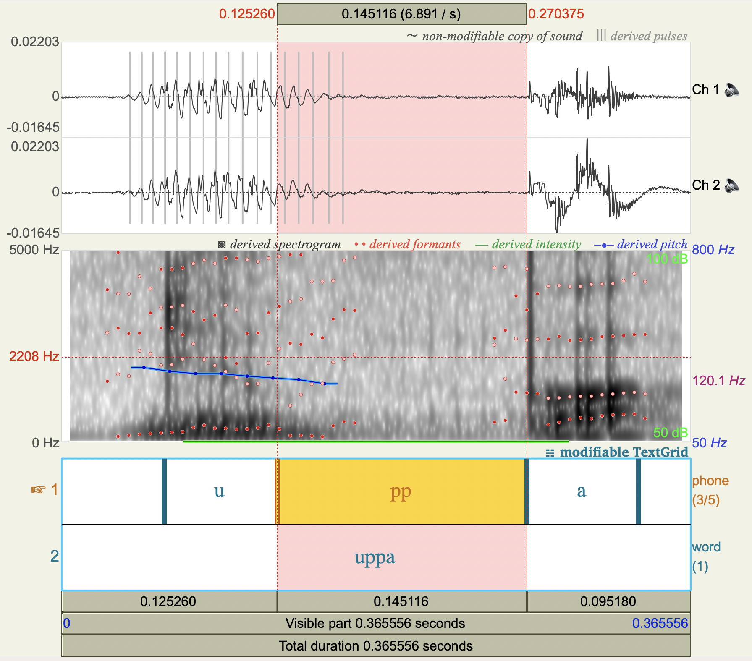

(4) Spectrogram 2: [baːppa] spoken by G2

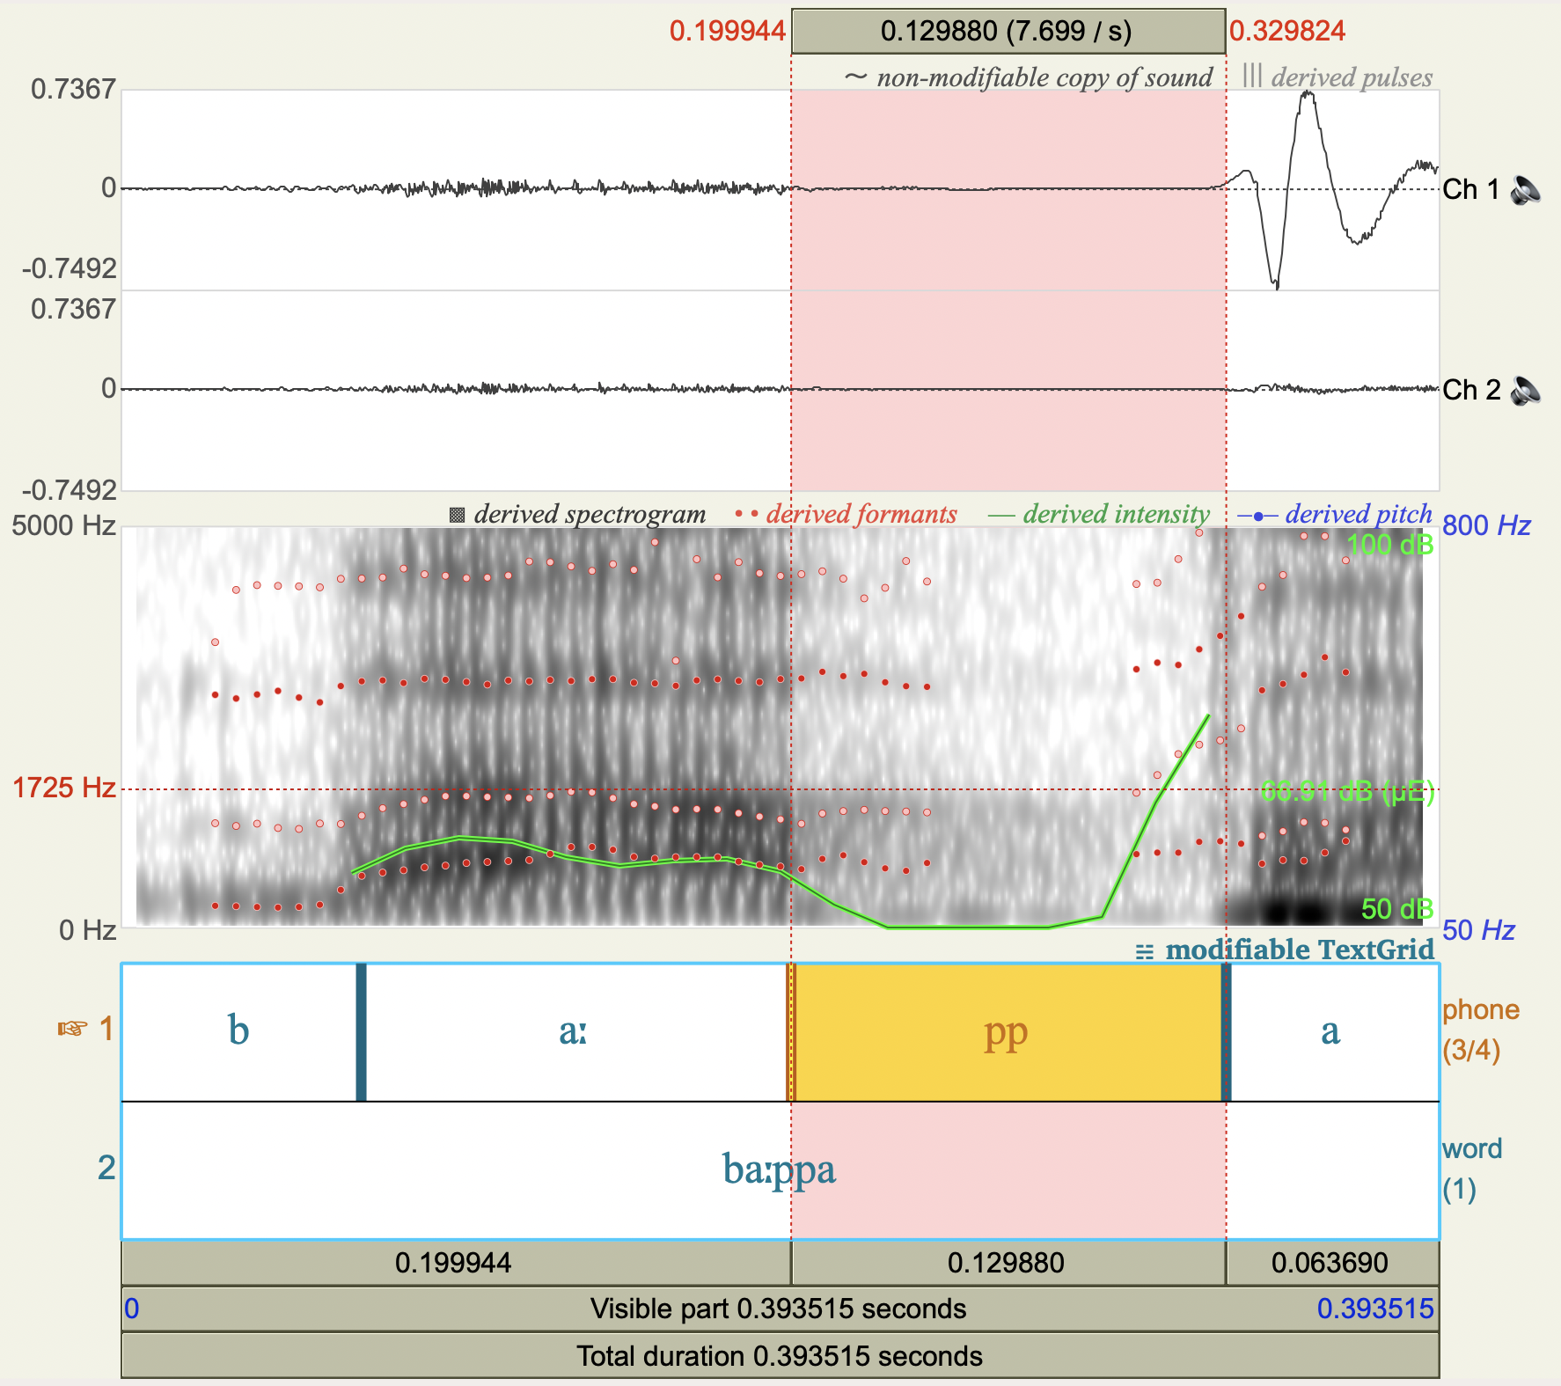

(5) Spectrogram 3: [uppa] spoken by G1

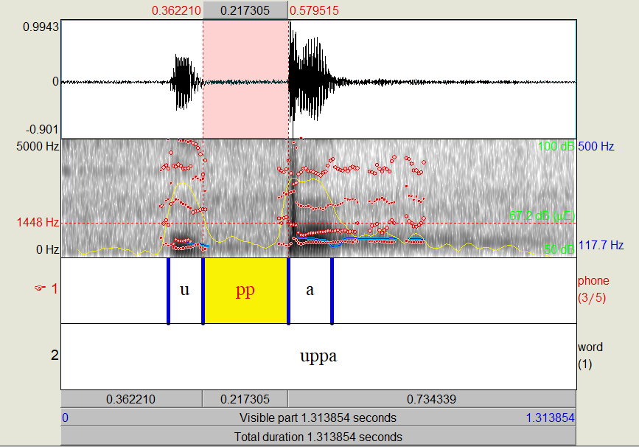
(6) Spectrogram 4: [baːppa] spoken by G1
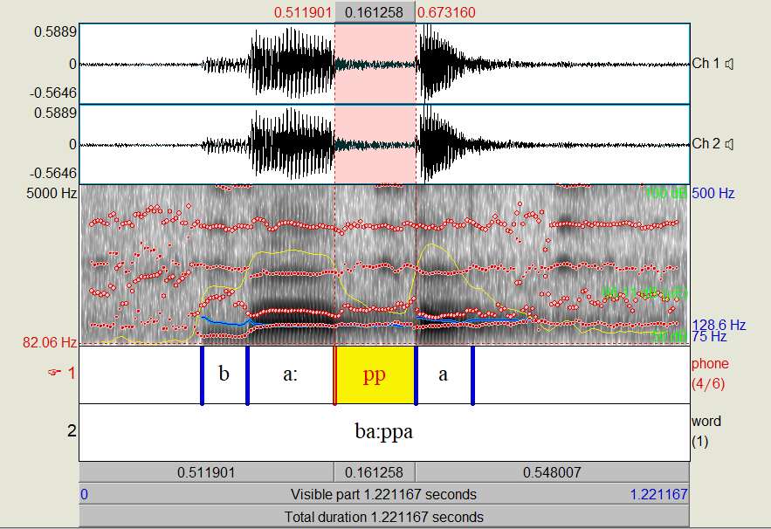

The experiment yielded findings concerning the connection between the duration of the preceding vowel and subsequent gemination in the speech of G1 and G2. Both geminates, the one preceded by a short vowel [uppa] and the other one preceded by a long vowel [ba:ppa], were of similar duration (0.145116 secs and 0.129880 secs, respectively) in the speech of G2. Also, the geminate preceded by a short vowel (0.217305 secs) is approximately double in duration compared to the geminate preceded by a long vowel (0.161258 secs) in the speech of G1. This has been further attested by a word that has both geminates, one preceded by a short vowel and the other by a long vowel (/sakkaːt̪t̪ə/). There has also been evidence that the pregeminate vowels in Malayalam are commonly shortened (Local & Simpson 1999). Further, this shows the difference in the phonetic nature of geminates across dialects (G1 and G2) in Malayalam. The duration of a geminate preceded by a short vowel in the speech of G2 (0.1 secs) is half of G1 (0.2 secs).

3 Structural representation

Crosslinguistically, geminates are treated as weight-bearing units (Hayes 1989; Ham 1997). Also, there is a typological generalization that codas can contribute moraic weight (Curtis 2003). Shreds of evidence show that Malayalam has light, heavy, and super heavy syllables (hence, monomoraic, bimoraic, and trimoraic, respectively), where the syllable weight depends on the length of the vowel and the coda. We can see a similar distribution of syllable weight in some other languages, such as Bedouin Jordanian Arabic (Huneety & Mashaqba 2016). This contradicts the argument that “A coda, or even a complex coda, does not have any mora of its own as it invariably shares a mora with the preceding vowel” (Mohanan 1986; Broselow, Chen & Huffman 1997).

(7) Heavy syllable - VC structure (8) Super heavy syllable - V:C structure

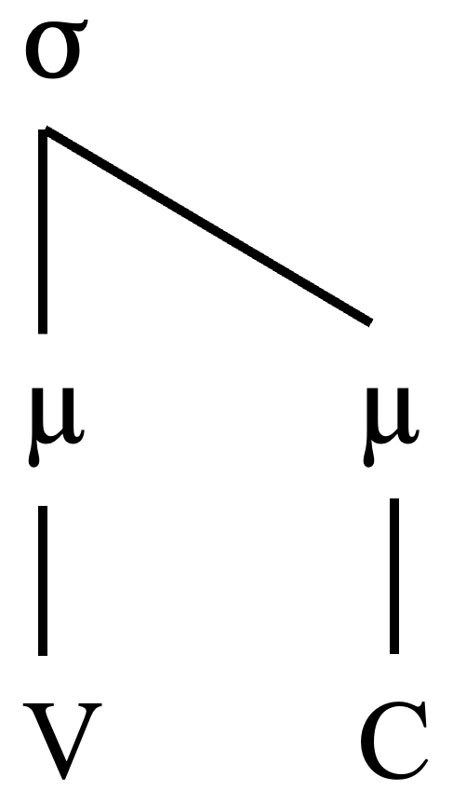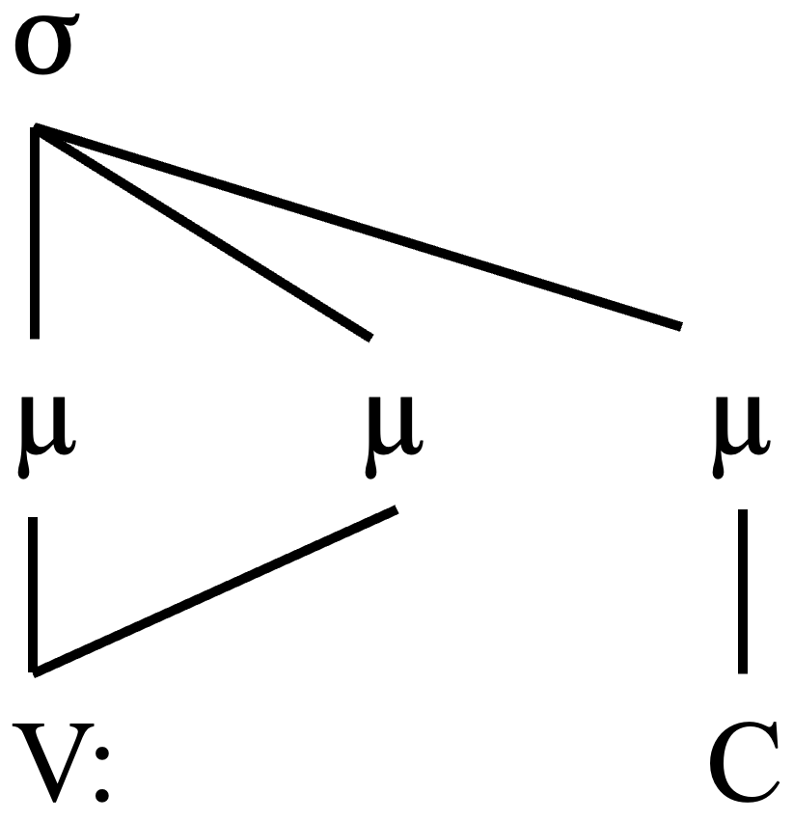

Traditional grammarians consider long consonants as geminates or clusters (double occurrence of the same phoneme). This difference in the criteria for evaluating long consonants and long vowels is designed to serve various higher levels of phonological analysis. As can be predicted from evidence in (Paul 2014; Namboodiripad 2021; Srikumar 2023), gemination appears to be a phonological outcome in favor of the presence of coda in Malayalam. In Srikumar's (2023) analysis, it is proposed that Malayalam often limits its use of consonants, favoring only nasal (/n/), /m/, and laterals at the word’s end, as demonstrated by examples like “paal-ə” for ‘milk.’ This observation challenges the No Coda Hypothesis by suggesting the plausibility of closed monosyllabic roots in Malayalam. Similarly, monosyllabic English words ending in consonants tend to undergo a vowel insertion, especially if they contain short vowels, resulting in the gemination of their final consonants. Additionally, there exists compelling evidence supporting consonant doubling when vowels are introduced after closed syllables. Consequently, the gemination of closing consonants in syllables with short vowels (schwa epenthesis) appears to be an inevitable consequence.
Phonologically speaking, intervocalic gemination in the majority of languages is structurally represented as ambisyllabic (Kubozono 2017). The two-phase theory and the implosive explosive theory define ambisyllabicity as the double occurrence of the same consonant in two phases, i.e., as a coda in the initial phase and onset in the second phase (Tatham & Morton 1973). The acoustic analysis of the intervocalic sonorant geminates in Malayalam identified the geminates to be ambisyllabic in nature (Local & Simpson 1999). Therefore, its structure follows that of the majority of the Indian languages (Kar 2010; cf. WGG) as illustrated in (9).
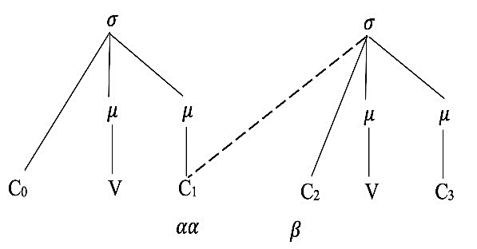
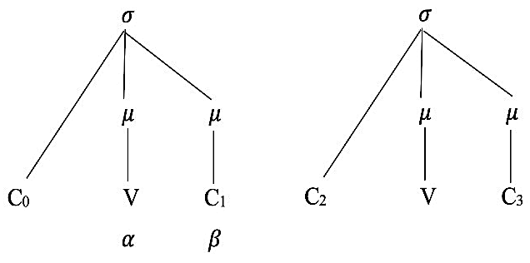
(9) Ambisyllabic representation of geminates

The ambisyllabic nature of the geminates in Malayalam is accounted for by the two-directional sharing forces on the coda consonant. Two principles are employed to examine the well-formedness of the syllable boundary clusters. The preceding vowel (stressed syllable) needs more mora from the coda, as in diagram (6), and the force of the obligatory contour principle and the maximal onset principle from the succeeding onset, as in diagram (7). To elicit more evidence, consider the SL to TL changes in the examples given in (10).

(10) Heterosyllabicity (from appendix C) (Azeez 2003: 255; Joseph 2015: 348)

a. labaaba <എലപ്പ> /elappa/ [elappa] ‘intelligent’ (Azeez 2003: 174)
b. makkar <മക്കാർ> /makkaːr/ [makkaːr] ‘mock, sly’

During nativization, identical consonants, which are part of two different syllables in SL, cluster together and form geminates in TL. The phenomenon is commonly observed in the gemination of obstruents. From (10a) and (10b), it can also be noted that only the vowel that precedes geminates is reduced. This might be a possible doorway to the ambisyllabic nature of geminates. Also, in (10a), it can be a case of elision of the first obstruent /b/ as well. However, this needs to be studied further.

4 Optimality Theoretic analysis

Optimality Theory is a well-established and widely accepted framework that analyses the structural well-formedness of a language. In this study, only the dictionary headwords from selected literature were analyzed as the focus is on morpheme-internal gemination (in other words, intervocalic gemination). The primary spoken data comes from the CIIL corpus, which was further rechecked with the field data collected from native speakers. Field data was recorded from twenty-four MM speakers from four northern districts of Malabar where PAO words, namely Kasargod, Kannur, Kozhikode, and Malappuram, were used frequently. The variables age, gender, and education, which affect the dialect variation cross-linguistically, were carefully incorporated in the selection of informants.
The current research expands on the output-oriented analysis within the framework of stratal optimality theory (Prince & Smolensky 1993; Itô & Mester 1995; Kiparsky 2000). It aims to capture generalizations based on data from the non-native strata of Malayalam (Prince & Smolensky 1993; Itô & Mester 1995; Kiparsky 2000). The theory structured the components constituting the lexicons of natural languages based on an overarching core-periphery arrangement. In congruence with this model and the earlier studies on Malayalam phonology, we propose a core-periphery structure for the Malayalam lexicon. It contains a core lexical stratum with native Malayalam vocabulary and various peripheral strata comprising Sanskrit borrowings, Perso-Arabic borrowings, and other borrowings. Thus, by incorporating OT, we present an interaction of the constraints that govern the nativization processes gemination’ in PAO words.
The consonantal length shows contrast in the intervocalic position, with irregularities with respect to articulatory features of consonants like the place, manner (Asher & Kumari 1997), and voicing (Arya 2021). Observations show that the consonant type, positional preferences, clustering, declustering, and the non-native inventory of sounds trigger gemination in the PAO words. Based on the surrounding vowel length, consonants can be classified into two main groups – (1) voiceless plosives and (2) fricatives, voiced plosives and sonorants (except some nasals).

4.1 Voiceless plosives (and some nasals)

Intervocalically, all voiceless plosives (if not occurring as a singleton) and some nasals always occur as geminates. The absence of singleton voiceless plosives in the intervocalic position has been noted in previous studies (Krishnamurti 2003). Thus, the voiceless plosives that occur intervocalically in SL undergo various repair strategies like nasalization, voicing, and gemination in TL. The cases with a voicing strategy might be less as the native Malayalam inventory lacks voiced obstruents. Yet, a comprehensive response to the inquiry about selecting the different strategies mentioned earlier, specifically ‘Which strategy applies where?’, remains a puzzle.

(11) Voicing (from appendix D)
a.<റാത്തീബ്> /raːt̪t̪iːbə/ [raːt̪t̪iːbə] ‘an exercise of devotion’ (Azeez 2003: 320)
b.<ശാപ്പാട്> /ɕaːppaːʈə/ [ɕaːppaːɖə] ‘food’ (Azeez 2003: 291)

From the example set (11), it has been observed that ‘the consonant (or intervocalic voiceless plosive) that comes after a voiceless geminate that occurs between two long vowels’ is voiced (or undergoes voicing) in the actual pronunciation (either maintains from UR to SR as voiced or else undergoes voicing). This is a case where voicing repairs the Dravidian rule voiceless plosives cannot occur intervocalically. The phoneme is voiced in SL as well. Comparing the example sets 1 and 2, it is evident that long vowels trigger the voicing repair.
Among these strategies, gemination is the primary focus of the present study. Also, from the available data, it is observed that gemination seems to have more attestations than voicing and nasalization in the order of gemination > voicing > nasalization. An extensive survey on the geminates in 28 languages demonstrated the preference for obstruent geminates compared to sonorant geminates (Taylor 1985; Kawahara 2005). In PAO words, among the obstruents, voiceless plosives are more preferred, in the order: Vless plosive > Vd plosive/affricate > Vless fricative > Vd fricative. The voiceless plosives that are geminated in the intervocalic position, listed in the decreasing order of their number of occurrences in the commonly used vocabulary, are /t̪/, /k/, /p/, /t/, /c/, /ʈ/.
Most of the voiceless obstruents that occur in the intervocalic position in the SL adopt the strategy of changing to the geminated counterpart of the equivalent obstruent in the TL. Voiceless plosive geminates occur in four intervocalic environments – (1) preceded and followed by a short vowel (V_V); (2) preceded by a short vowel and followed by a long vowel (V_Vː); (3) preceded by a long vowel and followed by a short vowel (Vː _V); (4) preceded and followed by a long vowel (Vː_Vː). Unlike the other geminates, voiceless plosives can also occur preceded by a long vowel.

(12) Vocalic environment of geminates
- V_V <വത്തക്ക> /vat̪t̪akka/ [vat̪t̪akka] ‘a fruit’ (Perwad, Theruvath & Amanullah 2016: 22)
- V_Vː <നിക്കാഹ്> /nikaːhə/ [nikkaːhə] ‘marriage’ (Joseph 2015: 352)
- Vː _V <ഹലാക്ക്> /halaːkkə/ [halaːkkə] ‘total loss’
(Nediyanad 2009:199; Sreenathan 2015:192; Joseph 2015:338)
- Vː_Vː <റാത്തീബ്> /raːt̪t̪iːbə/ [raːt̪t̪iːbə] ‘an exercise of devotion’ (Azeez 2003: 320)

The syllabic constraints relevant in this context in the target language are stated from (13) to (16).

(13) Max-C-IO (Kager 1999)
Output must preserve the consonants of its input.

(14) Ident-IO [C] (Kager 1999)
Correspondent segments have identical consonants.
This constraint is an extension of Ident-IO [a]

(15) *Gem (Rose 2000)
Long consonants are disallowed.

(16) Son-Seq (Kager 1999)
Complex onsets rise in sonority, and complex codas fall in sonority.

It operates according to the sonority sequencing principle (Clements 1990). This principle posits that syllables typically adhere to a structure where less sonorous sounds are positioned at the syllable edges while more sonorous sounds are situated toward the center. Consequently, this principle aids in elucidating the prevalence of specific sound combinations in diverse languages, shaping both syllable structure and permissible sound combinations within a given language. The sonority scale illustrates the favored sequence in which phonemes are organized within a syllable, determined by their level of sonority. The subsequent diagram depicts a slightly altered rendition of the sonority scale (Burquest & Payne 1996; Kar 2010; Alqahtani 2019).

(17) Sonority scale (from Kar 2010)

Tables 1 and 2 show the OT account of the gemination strategy that satisfies the listed constraints. Table 1 in (18) analyses voiceless plosive gemination preceded by a short vowel based on the example /ikka/ ‘addressing term for an elderly male.’

(18) Table 1: Voiceless plosive gemination in V_V

 | /ikka/ | Max-C-IO | Ident-IO [C] | Son-Seq | *Gem
a. ☞ | ik.ka |  |  |  | *
b. | ikk.a |  |  | *! | *
c. | i.kka |  |  | *! | *
d. | ik.a | *!
e. | i.ka | *!
f. | ig.ga |  | *!* |  | *

The choice of consonant correspondence over *Gem shows that faithfulness dominates markedness. This interaction is manifested by evaluating six candidates for the input /ikka/. The location of the geminated consonant within the syllable is determined by constraints that hold a high-rank Max-C-IO, Ident-IO [C], and Son-Seq, which rule out the other five candidates. Eventually, the four constraints select the optimal output [ikka] when ranked in the order shown in (19).

(19) Max-C-IO, Ident-IO [C], Son-Seq » *Gem

Differently, in Table 2 in (20), we see the gemination preceded by a long vowel. It is analyzed based on the example /halaːkkə/ ‘trouble.’ More such cases have been mentioned in Appendix D.

(20) Tableau 2: Voiceless plosive gemination in Vː_V

 | /halaːkkə/ | Max-C-IO | Ident-IO [C] | Son-Seq | *Gem
a. ☞ | ha.laːk.kə |  |  |  | *
b. | ha.laːkk.ə |  |  | *! | *
c. | ha.laː.kkə |  |  | *! | *
d. | ha.laːk.ə | *!
e. | ha.laː.kə | *!
f. | ha.laːg.gə |  | *!* |  | *

As seen in Table 1, the choice of consonant correspondence over *Gem shows that faithfulness dominates markedness. This interaction is manifested by evaluating six candidates for the input /halaːkkə/. The location of the geminated consonant within the syllable is determined by constraints that hold a high-rank Max-C-IO, Ident-IO [C], and Son-Seq, which rule out the other five candidates. Eventually, the four constraints select the optimal output [ha.laːk.kə], when ranked in the order shown in (19).

(21) Max-C-IO, Ident-IO [C], Son-Seq » *Gem

There are other indirect processes by which voiceless plosive geminates are formed in the intervocalic position. The native Malayalam inventory is devoid of the feature voicing for obstruent consonants (Asher & Kumari 1997). The repair strategy employed by TL to militate against the occurrence of this laryngeal feature is devoicing. In PAO words, phonemic reduction is a prominent nativization process. Phonemic reduction refers to a segment getting nativized to its phonetically closest equivalent. The non-native laryngeal phonemes in the SL get reduced to their voiceless counterpart in TL. Thus, in many cases, devoicing or delaryngealization gives rise to voiceless plosives. Though this seems to be happening, the more common phonological constraint applicable throughout the lexicon, regardless of the voicing feature of the closing consonant, on syllables containing short vowels could be the trigger, as explained in section 3 (Srikumar 2023). For instance, consider the example in (22).

(22) Delaryngealisation (from appendix E)
b > /p/ aban /oppana/ [oppana] ‘mappila dance form’ (Azeez 2003: 171)

Additionally, the cross-linguistic evidence shows that voiced geminates are found very rarely. Articulatory difficulty might be a possible reason for this absence. It is equally important to note here that native Malayalam inventory does not possess voiced obstruents but was later introduced through loanwords. It has been observed that all stops were voiceless in the initial position as well as in gemination in Malayalam (Krishnamurti 2003). In coherence with this argument, the phonetic study of the phonemic inventory of the Namboodiri dialect of Malayalam reports that “…as with phonemic singleton voiced aspirated plosives, the geminate counterparts are devoiced in our speaker’s recordings” (Namboodiripad & Garellek 2017).
From the provided examples in set (22), it is clear that the voiced plosives that occur in the intervocalic position in SL become voiceless in TL and further get geminated. This happens even after the Dravidian rule allows voiced plosives to occur intervocalically, so it's a possibility that these set of words might have been borrowed before the introduction of voiced plosives to the Malayalam inventory (as native Malayalam inventory do not have voiced plosives).
The phonemes of SL that are not present in the TL are borrowed via the process of phonemic reduction. The non-native voiced phonemes in PAO words become its equivalent voiceless phoneme present in the TL along with gemination. For an instance, consider the example (23).

(23) Phonemic reduction (from Appendix N)
z > /ss/ /naazir/ <നസ്സർ> /nassar/ [nassar] ‘observer’ (Azeez 2003: 165)
Similarly, the laryngeal phonemes that are not present in the TL get reduced to an equivalent voiceless phoneme of the TL along with gemination.

(24) Deaspiration (from appendix F)
a. <കാഫർ> /kaːpʰar/ [kaːfar] ‘non-believer’ (Azeez 2003: 186)
b. < മുനാഫിക്ക്> /munaːpʰikʰə/ [munaːfikkə] ‘hypocrite’ (Azeez 2003: 271)

Among the nasal geminates, intervocalically, /ņ/, /ŋ/, and /ɲ/ are always geminated (Krishnamurti 2003; Namboodiripad & Garellek 2017). The tableau 3 in (25) analyses nasal gemination based on the example /piɲɲaːɳam/ ‘ceramic utensil’ (Joseph 2015). More such cases have been mentioned in Appendix J.

(25) Table 3: Nasal gemination

 | /piɲɲaːɳam/ | Max-C-IO | Ident-IO [C] | Son-Seq | *Gem
a. ☞ | piɲ.ɲaː.ɳam |  |  |  | *
b. | piɲɲ.aː.ɳam |  |  | *! | *
c. | pi.ɲɲaː.ɳam |  |  | *! | *
d. | piɲ.aː.ɳam | *!
e. | pi.ɲaː.ɳam | *!
f. | pin.naː.ɳam |  | *!* |  | *

As seen before in Tableau 1 and 2, the choice of consonant correspondence over *Gem shows that faithfulness dominates markedness. This interplay is demonstrated through the assessment of six candidates representing the input /piɲɲaːɳam/. The placement of the geminated consonant within the syllable is a result of constraints that hold a high-rank Max-C-IO, Ident-IO [C], and Son-Seq, which rule out the other five candidates. Eventually, the three constraints select the optimal output [piɲ.ɲaː.ɳam], when ranked in the order

(26) Max-C-IO, Ident-IO [C], Son-Seq » *Gem

4.2 Sonorants, fricatives, and voiced plosives

Sonorants (except some nasals), fricatives, and voiced plosives behave similarly. Intervocalically, voiced obstruents (mainly /b/) and fricatives (mainly /s/) occur as singletons and geminates.

(27) Singletons versus geminates
a. Voiced plosive singleton: <സാഹിബ്> /saːhibə/ [saːhibə] ‘companion’
(Azeez 2003: 302)
b. Voiced plosive geminate: <റബ്ബ്> /rabbə/ [rabbə] ‘the lord’ (Azeez 2003: 319)
c. Voiceless fricative singleton: <ഒസീർ> /osiːr/ [osiːrə] ‘close friend’
(Azeez 2003: 176)
d. Voiceless fricative geminate: <ഖിസ്സ, കിസ്സ> /kissa/ [kissa] ‘story’
(Azeez 2003: 189)

Voiced obstruent geminates are comparatively less than voiceless obstruent geminates and fricatives due to articulatory difficulty (Kawahara 2005; Jaeger 1978; Taylor 1985; Ohala 1983; Hayes & Steriade 2004). This has been accounted for within the framework of evolutionary phonology eliciting phonetically natural constraints (Kawahara 2006). The voiced plosives that are geminated in the intervocalic position, listed in the decreasing order of their number of occurrences in the commonly used vocabulary, are /b/, /d̪/, /dʒ/, /z/. Even though voiceless geminate plosives are mostly preferred, many voiced plosive geminates from SL are maintained in TL. One among them that has been reported is the occurrence of voiced unaspirated geminate plosives in loanwords (Namboodiripad & Garellek 2017). Similar examples from PAO words are listed in (28).

(28) Gemination of voiced plosives in different intervocalic environments (from Appendix G)
a. V_V <റബ്ബ്>/rabbə/ [rabbə] ‘god’ (Azeez 2003: 319)
b. V_Vː <ദജ്ജാൽ> /daʤʤaːl/ [daʤʤaːlə] ‘a bad person’ (Azeez 2003: 225)

Table 4 in (29) analyses the gemination of voiced plosives based on the example /rabbə/' god.' More such cases have been mentioned in Appendix G.

(29) Table 4: Voiced plosive gemination

 | /rabbə/ | Max-C-IO | Ident-IO [C] | Son-Seq | *Gem
a. ☞ | rab.bə |  |  |  | *
b. | rabb.ə |  |  | *! | *
c. | ra.bbə |  |  | *! | *
d. | rab.ə | *!
e. | ra.bə | *!
f. | rap.pə |  | *!* |  | *

As observed in Tableau 1, 2, and 3, the choice of consonant correspondence over *Gem shows that faithfulness dominates markedness. This dynamic is evidenced through the assessment of six candidates for the input /rabbə/. The positioning of the geminated consonant within the syllable is a consequence of constraints that hold a high rank, Max-C-IO, Ident-IO [C], and Son-Seq, which rule out the other five candidates. Eventually, the four constraints select the optimal output [rab.bə], when ranked in the order

(30) Max-C-IO, Ident-IO [C], Son-Seq » *Gem

The cross-linguistic attestation of fricative geminates is rarely found to be evidenced in the nativization of PAO words. Fricatives that are geminated in the intervocalic position, listed in the decreasing order of their number of occurrences in the commonly used vocabulary, are /s/, /f/, /h/, /z/, /ɕ/. The fricatives that are present as singletons but not as geminates in Malayalam, like /f/, /h/, and /ɕ/ (Namboodiripad & Garellek 2017), can be articulated as geminates in PAO words. They don't exist even in Sanskrit origin words. Therefore, the presence of /f/ and /h/ geminates in PAO words contributes to the existence of the Perso-Arabic strata in the Malayalam lexicon.

(31) Gemination of fricatives (from appendix G)
a. v_v <ഖിസ്സ, കിസ്സ> /kʰissa/, /kissa/ [kissa] ‘story’ (Azeez 2003: 189)
b. v_vː <ഒസ്സാൻ> /ossaːn/ [ossaːn] ‘Muslim barber’ (Azeez 2003: 176)

Table 5 in (32) analyses the gemination of fricatives based on the example (28b). More such cases have been mentioned in Appendix G.

(32) Table 5: Fricative gemination

 | /ossaːn/ | Max-C-IO | Ident-IO [C] | Son-Seq | *Gem
a. ☞ | os.saːn |  |  |  | *
b. | oss.aːn |  |  | *! | *
c. | o.ssaːn |  |  | *! | *
d. | os.aːn | *!
e. | o.saːn | *!
f. | oz.zaːn |  | *!* |  | *

As found in the tableaux so far, the choice of consonant correspondence over *Gem shows that faithfulness dominates markedness. This interplay becomes evident through the examination of six candidates for the input /ossaːn/. The placement of the geminated consonant in the syllable is influenced by constraints of high rank, Max-C-IO, Ident-IO [C], and Son-Seq, which rule out the other five candidates. Eventually, the four constraints select the optimal output [os.saːn] when ranked in the order

(33) Max-C-IO, Ident-IO [C], Son-Seq » *Gem

It is also to be noted that, when we consider the changes from SL to TL, /z/ that occurs in the intervocalic position in SL are nativized in TL as geminated /s/.
34) /s/ gemination (from appendix N)
PAO /naazir/ <നസ്സർ> /nassar/ [nassar] ‘observer’ (Azeez 2003: 234)

This does not happen in non-intervocalic positions, as illustrated in (35). Here, zakaat ‘almsgiving’ in SL becomes /sakkaːt̪t̪ə/ in TL and never becomes /ssakkaːt̪t̪ə/ in TL.

(35) PAO /zaka:t/ MM <സക്കാത്ത്> /sakkaːt̪t̪ə/ [sakkaːt̪t̪ə] ‘almsgiving’
(Nediyanad 2009: 109)

Within sonorants, specific manners of articulation are favored more as geminates than others. This might be due to articulatory reasons. Sonorants that are geminated in the intervocalic position, listed in the decreasing order of their number of occurrences in the commonly used vocabulary are /m/, /j/, lateral approximant /l/, /n/, /r/, /v/, dental approximant /l/, /ɲ/, /ŋ/, /ɳ/, /ɭ/.
Sonorant (except some nasals), fricative, and voiced geminate occur commonly in two intervocalic environments - (1) when it is preceded and followed by a short vowel (V_V), and (2) when preceded by a short vowel and followed by a long vowel (V_Vː). Short vowels precede geminates in both scenarios.
Glides also follow the same ranking of constraints as shown in (33). Among the glide consonants in the intervocalic position, /j/occurs as a geminate more often than /v/.

(36) intervocalic environments of glide geminates (from appendix H)
a. V_V <മയ്യത്ത്> /majjat̪t̪ə/ [majjat̪t̪ə] ‘deceased, dead body’ (Azeez 2003: 258)
b. V_Vː <തയ്യാർ> /t̪ajjaːr/ [t̪ajjaːrə] ‘readiness’ (Azeez 2003: 218)

Table 6 analyses the gemination of glides based on the example (32a). More such cases have been mentioned in Appendix H.

(37) Table 6: Gemination of a glide in /majjat̪t̪ə/ ‘dead body’

 | /majjat̪t̪ə/ | Max-C-IO | Ident-IO [C] | Son-Seq | *Gem
a. ☞ | maj.jat̪.t̪ə |  |  |  | **
b. | majj.at̪.t̪ə |  |  | *! | **
c. | ma.jjat̪.t̪ə |  |  | *! | **
d. | maj.at̪.t̪ə | *! |  |  | *
e. | ma.jat̪.t̪ə | *! |  |  | *
f. | maʤ.ʤat̪.t̪ə |  | *!

As found in the tableaux so far, the choice of consonant correspondence over *Gem shows that faithfulness dominates markedness. This dynamic is evident in the examination of six candidates for the input /majjat̪t̪ə/. The placement of the geminated consonant in the syllable is determined by constraints that hold a high rank, Max-C-IO, Ident-IO [C], and Son-Seq, which rule out the other five candidates. Eventually, the four constraints select the optimal output [maj.jat̪.t̪ə], when ranked in the order

(38) Max-C-IO, Ident-IO [C], Son-Seq » *Gem

Among the liquid consonants that occur in the intervocalic position, /l/occurs as a geminate more often.

(39) intervocalic environment of /l/ geminate (from appendix I)
a. V_V <മഹല്ല്> /mahallə/ [mahallə] ‘prescribed jurisdiction of a mosque’ (Perwad, Theruvath & Amanullah 2016: 77)
b. V_Vː <ദല്ലാൾ> /d̪allaːl/ [d̪allaːlə] ‘broker’ (Azeez 2003: 226)

The rhotic /r/ geminate in Arabic is quite peculiar in nature (Mubarak 2018). It is articulated more than two times. /r/ geminates neither exist in Malayalam nor in the English-origin words of Malayalam (Namboodiripad & Garellek 2017). Therefore, the /r/ geminate in PAO words contributes towards the Perso-Arabic strata in the Malayalam lexicon. Among sonorants, the nasal geminate /m/ is more common in PAO words, whereas among the nasals, /n/ and /m/ occur as short and long in the intervocalic position (Asher & Kumari).

(40) Intervocalic environment of nasal geminates (from appendix J)
a. V_V <ജിന്ന്> /ʤinnə/ [ʤinnə] ‘spirit’ (Joseph 2015: 358)
b. V_Vː <ഖമീസ്>, <കമീസ്> /kʰami:sə/ /kamiːsə/ [kammiːsə] ‘gown type shirt’
(Joseph 2015: 343)

Interestingly, the Malayalam nasals ɲ and ŋ occur only as geminates and are being followed even in the case of PAO words as well.

4.3 Non-intervocalic geminates: /r/ as a trigger

In Malayalam, the liquid /r/, being rhotic, stands apart from other consonants in its inability not to form a geminate (Asher & Kumari 1997; Sadanandan 1999; Punnoose 2013). It is also quite peculiar that the voiced apico-dentialveolar tap or trill /r/contrasts with the long voiceless alveolar stop /rr/ (Asher & Kumari 1997). According to the phonological rule of non-intervocalic gemination in Malayalam, “If the first melody is a non-nasal sonorant and the second melody is a non-glide, the second one must be a geminate” (Mohanan 1986). The phenomenon occurs inside a cluster, which is the word medial. Sanskrit-origin words in Malayalam exemplified it. Later, its applicability in the native Malayalam strata was also reported (Arya 2021).
Further, more specifically, evidence from PAO words shows that when /r/ occurs as the first melody in a word medial cluster, the second melody (voiceless plosives) is a geminate. This represents a situation of a derived or assimilatory geminate, wherein the gemination occurs exclusively in the surface form and not in the underlying representation. This further directs to an association of /r/ with both gemination and cluster formation. Furthermore, it is validated when we look at the segmental distribution and phonotactic pattern of the understudied clusters, where the rhotic /r/ occurs as the second melody. The PAO examples discussed (41) and (42) hypothesize that gemination and cluster formation were the adaptation strategies triggered by the presence of /r/. It can be noticed that similar patterns can be seen both in Sanskrit strata (/t͡ʃakkram/) as well as in native strata (tira > /attra/) (Burrow & Emeneau 1984).
Words in (41) exemplify the geminate formation in the /Cr/ cluster. These clusters have always been preceded by short vowels, as is the case in native Malayalam geminated words.

(41) Geminate formation in /Cr/ cluster (from Appendix K)
a. <മദ്രസ> /mad̪rasa/ [mad̪d̪rasa] ‘Islamic teaching institute’ (Azeez 2003: 257)
b. <മുക്രി> /mukri/ [mukkri] ‘One who takes care of the mosque and related
things’ (Azeez 2003: 269; Joseph 2015:358)

When a geminated obstruent occurs in a syllable preceding /r/, the vowel in-between the geminate and /r/ is deleted and thus forms a geminated obstruent+/r/ cluster. As mentioned, this applies to native Malayalam strata (/ittiri/ [ittri]). PAO words listed in (42) exemplify cluster formation with /r/ in PAO words. This commonly occurs word medially.

(42) Cluster formation with /r/ (from appendix L)
a. <ദിക്‌ർ> /d̪ikər/ [d̪ikkrə] ‘prayer’ (Azeez 2003: 228)
b. <പത്തിരി> /pat̪t̪iɾi/ [pat̪t̪ɾi] a type of pancake’ (Joseph 2015: 342)

Following the Sonority Sequencing Principle (SSP), final clusters of rising sonority are generally disfavored (Clements 1990; Kager 1999). Sequences involving a consonant followed by /r/ constitute an example of rising sonority. As a result, many languages utilize vowel epenthesis to disrupt such clusters (Anderson 1974; Anderson 1975). An alternative method of repair involves deleting the final consonant within the cluster. In contrast, /Cr/ clusters are formed in PAO words, as shown in (42). Given that/Cr/ clusters manifest word-medially in PAO words, they are distributed across different syllables to maintain sonority balance.
Hence, the syllabification pattern of /Cr/ clusters could be aligned with that seen in the other Indian languages, as is shown in (43) (Kar 2010) (cf. WGG).

(43) Structural representation of /Cr/ clusters
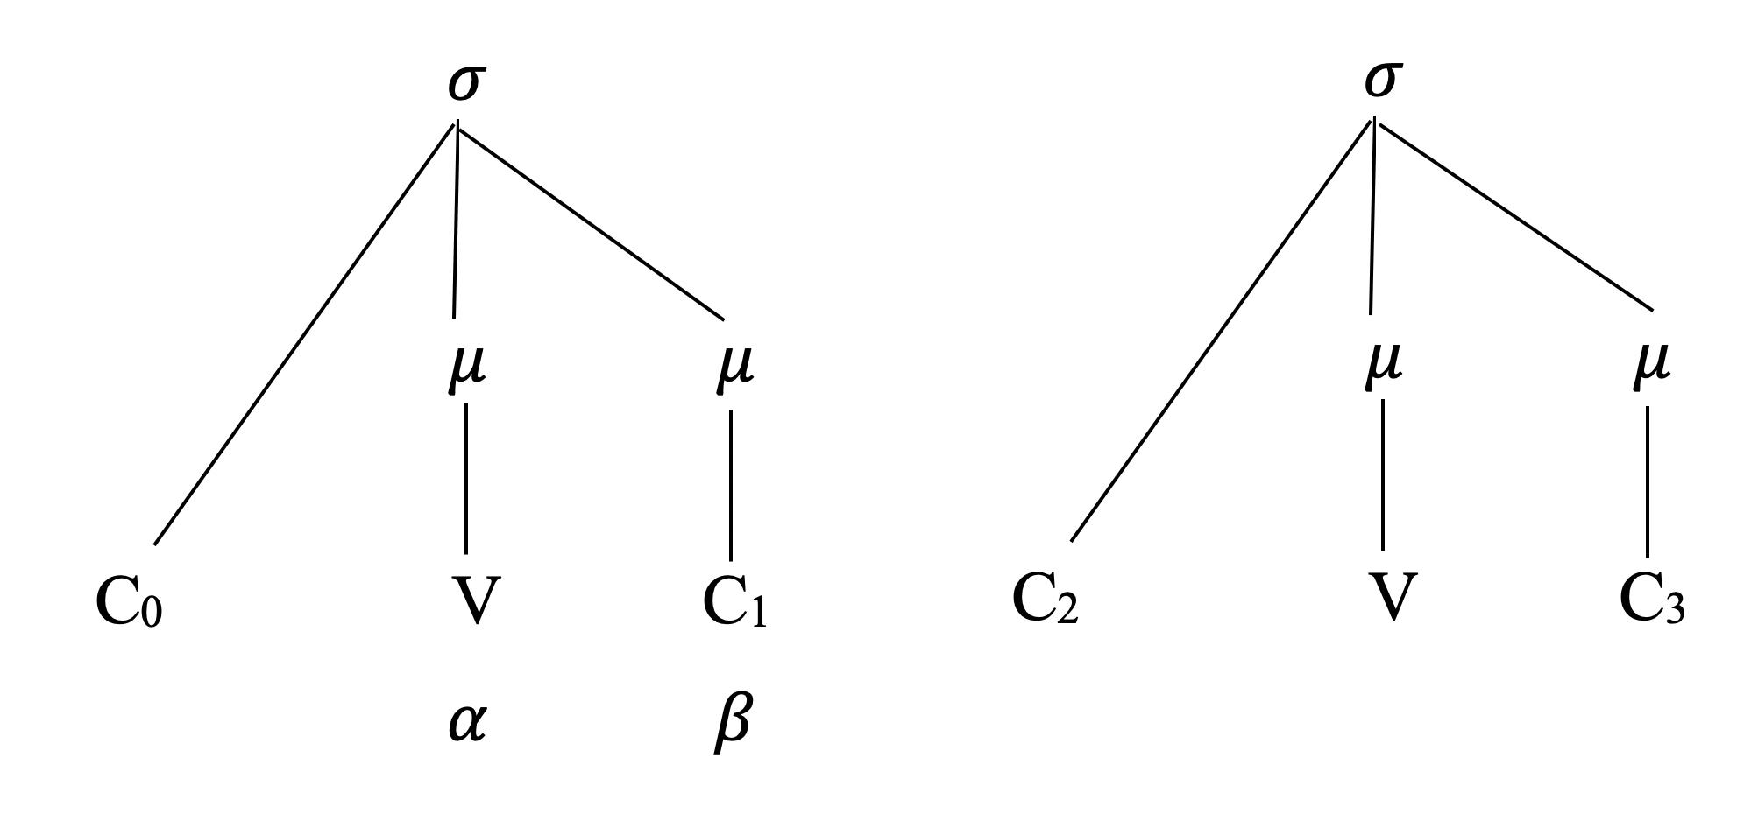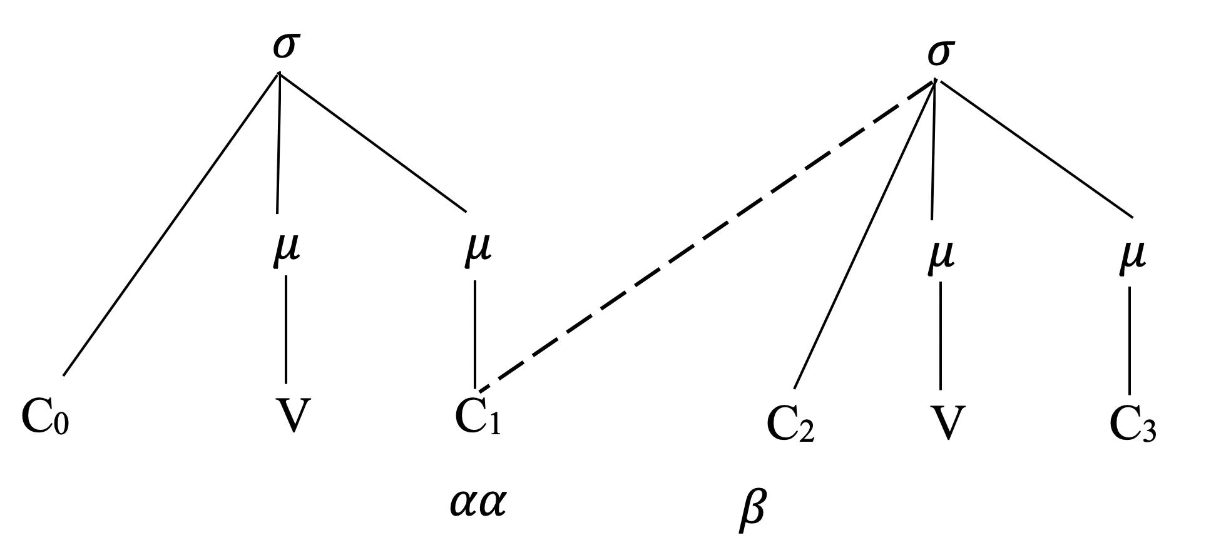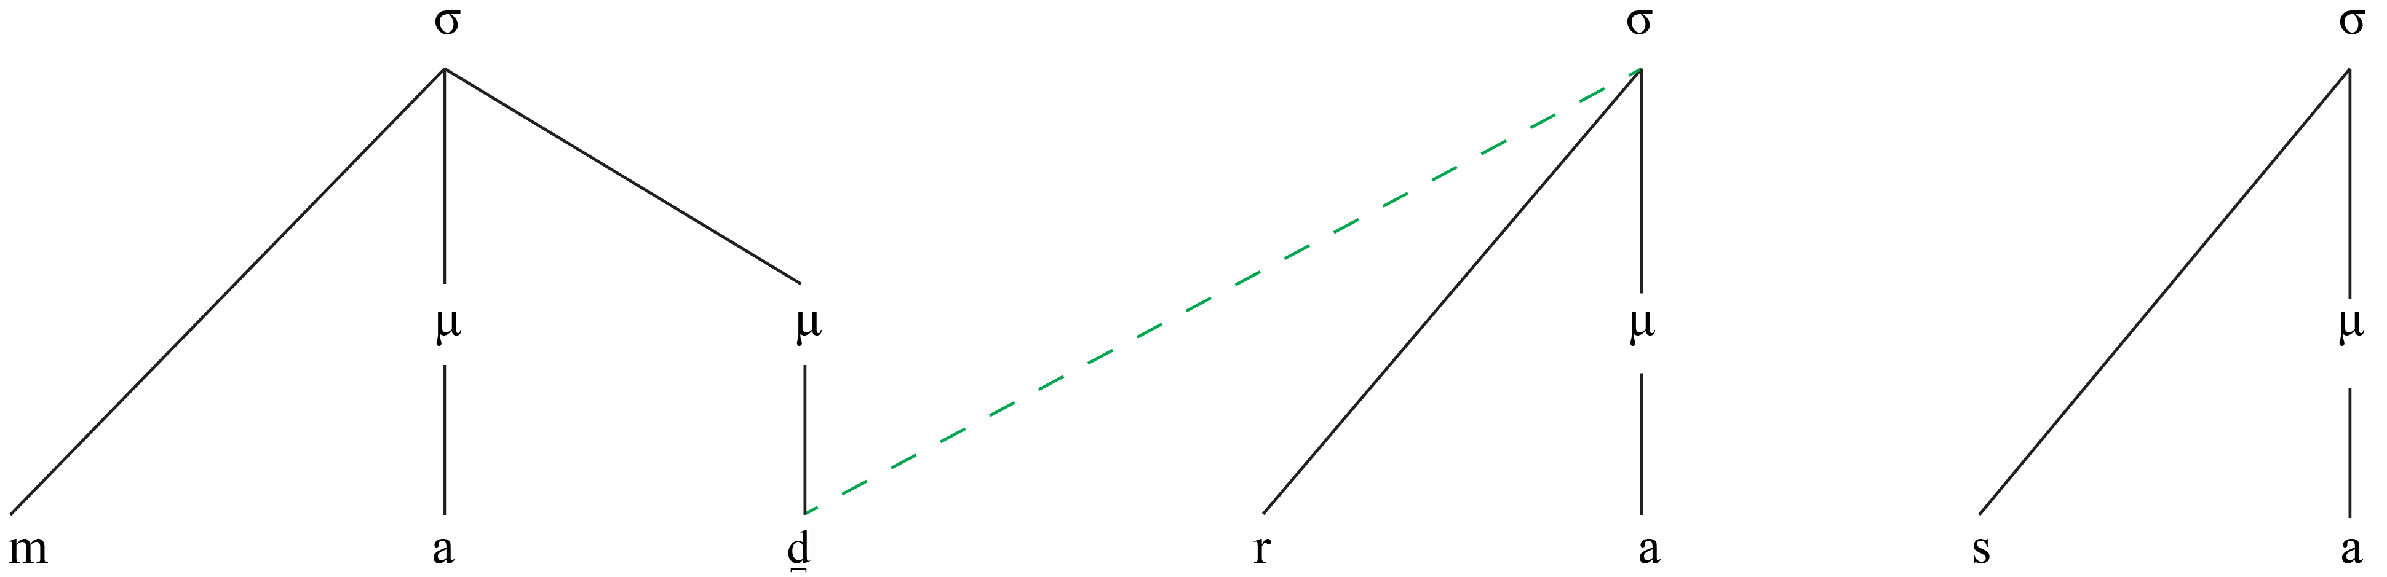

This pattern of syllabification could be phonologically accounted for using the OT framework. The relevant constraints in this scenario (that have not been mentioned before) are listed from (44) to (48).

(44) SyllCont (Davis 1998; Gouskova 2002)
Sonority must not rise across a syllable boundary.

The foundation of the SyllCont constraint lies in the underlying principle proposed by (Kaye, Lowenstamm & Vergnaud 1985; Vennemann 1987).

(45) Linearity-IO (Pater 2004)
The output reflects the precedence structure of the input and vice versa.

(46) Ident – IO [V] (Kager 1999)
Correspondent segments have identical vowels.

This constraint is an extension of Ident-IO [a] from Kager (1999)

(47) *CCV/r/
A vowel cannot occur between a geminate and /r/

(48) SWP (McCarthy 2003: 115; Dutta 2018: 106)
Stressed light syllables are prohibited

This constraint has been formulated based on the stress-to-weight principle (Fitzgerald 1997; Prince 1990), Prokosch's Law (Prokosch 1939,) and the rule of Obligatory Branching (Hayes 1980; Hammond 1986). The imposition of the constraint *3μ ‘No trimoraic syllables’ results in all stressed syllables becoming bimoraic, as in Tableau 2 (Kager 1999: 268).
Tables 7 and 8 show the OT account of /Cr/ clusters that satisfy the listed constraints. The analysis is based on the example /mad̪rasa/ ‘religious institution.’ More such cases have been mentioned in the appendix.

(49) Table 7: OT analysis of gemination in /Cr/ cluster

 | /mad̪rasa/ | SyllCont | Max-C-IO | Ident-IO[v] | Linearity-io | *CCV/r/ | Son-Seq | SWP | *Gem
a. | mad̪.d̪a.ra.sa |  |  |  |  | *! |  |  | *
b. ☞ | mad̪.d̪ra.sa |  |  |  |  |  |  |  | *
c. | mad̪.d̪ə.ra.sa |  |  | *! |  | * |  |  | *
d. | ma.d̪ra.sa |  |  |  |  |  |  | *!
e. | mad̪d̪.ra.sa | *! |  |  |  |  | * |  | *
f. | ma.d̪d̪ra.sa |  |  |  |  |  | *! | * | *
g. | ma.da.ra.sa |  | *! |  |  |  |  | *
h. | ma.d̪ar.sa |  |  |  | *! |  |  | *
i. | ma.d̪d̪ar.sa |  |  |  | *! | * | * | * | *
j. | mad̪.d̪ra.ssa |  |  |  |  |  | *! |  | **

Even though five extra constraints were added, the hierarchy of the previous constraints was intact, as seen in the rankings of Tableau 1 to 6. The ranking in Tableau 7 shows the choice of faithfulness constraints over *Gem. This interplay is demonstrated through the assessment of ten candidates for the input /mad̪rasa/. The position of /ccr/ in the syllable is due to the high-ranked constraints, which rules out the other nine candidates.
According to Mohanan (1986: 112), in Malayalam, “…if the first syllable of a word has a short vowel and the second syllable has a long one, the primary stress falls on the second syllable; otherwise, the primary stress falls on the first syllable. Secondary stress falls on all the remaining long vowels.” Therefore, in the instance illustrated in Tableau 7, the optimal candidate (48b) adheres to this constraint. This is because both the initial and second syllables are short in (48b). Consequently, the primary stress is placed on the first syllable, characterized by a CVC structure. CVC structures (cf. (7)) are heavy in Malayalam as codas bear weight. Therefore, candidate b does not violate SWP, whereas the light syllables bearing stress in candidates d, f, g, h, and i violate SWP and thus got eliminated. Eventually, the constraints select the optimal output [mad̪.d̪ra.sa], when ranked in the order as in (50).

(50) SyllCont, Max-C-IO, Ident-IO [V], Linearity-IO, *CCV/r/, Son-Seq, SWP » *GEM

Table 8 analyses cluster formation based on the example /pat̪t̪iri/ 'pancake’. Word-medially, when /r/ follows /CCV/, the vowel between the geminate and /r/ is deleted, forming a geminated cluster /CCr/. More such cases have been mentioned in the appendix.

(51) Table 8: OT analysis of cluster formation with /r/

 | /pat̪t̪iri/ | Syll Cont | Max-C-IO | Ident-IO[v] | Linearity-io | *CCV/r/ | Son-Seq | SWP | *Gem
a. | pa.tt̪i.ri |  |  |  |  | *! | * | * | *
b. | pat̪.t̪i.ri |  |  |  |  | *! |  |  | *
c. | pat̪.t̪ə.ri |  |  | *! |  |  |  |  | *
d. | pa.t̪t̪ri |  |  |  |  |  | *! | * | *
e. | pat̪t̪.ri | *! |  |  |  |  | * |  | *
f. ☞ | pat̪.t̪ri |  |  |  |  |  |  |  | *
g. | pat̪.t̪ir |  |  |  | *! | * |  |  | *
h. | pat̪.t̪ir.ri |  |  |  |  | *! |  |  | **

As seen in Table 7, the ranking here shows the choice of faithfulness constraints over *Gem. This dynamic is demonstrated through the assessment of eight candidates for the input /pat̪t̪iri/. The position of /ccr/ in the syllables is due to the high-ranked constraints, which rules out the other seven candidates. Eventually, the constraints block vowels between a geminate and /r/, favoring cluster formation with /r/ in PAO words when ranked in the order shown in (52).

(52) SyllCont, Max-C-IO, Ident-IO[V], Linearity-IO, *CCV/r/, Son-Seq, SWP » *Gem

These clusters, which have not been analyzed in the previous literature, are directly related to a variety of findings. The moraic analysis of the heterorganic cluster argues contrary to the No-Coda hypothesis claimed to hold in Malayalam (Mohanan 1982). It is also a counterargument to the proposition that 'A consonantal segment cannot bear weight' (Mohanan 1989). Nevertheless, this phenomenon is limited to the medial position within a word. This study also responds to the proposal of perceiving geminate consonants as a single unit (Mohanan 1989).

5 Conclusion

The OT account for lexical and assimilatory geminates detailed in this study looked into various coarticulation factors that occur in PAO words. Thus examined, distinct vowel environments found both preceding and following geminates in PAO words in terms of their phonological length, quality, and also the different categories of consonants occurring as geminates in these environments. Even though the voiceless plosives and some nasals behave in a different way with various other distribution patterns when compared to sonorants, fricatives, and voiced plosives, the single ranking for gemination takes care of those restrictions economically.

(53) SyllCont, Max-C-IO, Ident-IO[V], Linearity-IO, *CCV/r/, Son-Seq, SWP » *Gem

This harmonic ranking of constraints in both intervocalic and non-intervocalic gemination also establishes the ambisyllabicity of geminates and the weight-bearing coda, as illustrated in (9) and (43). These pieces of evidence call for a revisit of the tautosyllabic and weightless geminate structure proposed by (Mohanan 1986; Broselow, Chen & Huffman 1997). The survey conducted to determine the phonetic nature of gemination resulted in three significant findings.

(A) Both geminates, the one preceded by a short vowel and the other one preceded by a long vowel, were of similar duration in the speech of G2.
(B) The geminate preceded by a short vowel is approximately double in duration compared to the geminate preceded by a long vowel in the speech of G1.
(C) The duration of a geminate preceded by a short vowel in the speech of G2 is half of G1.
Among other features contributing to a Perso-Arabic lexical stratum of Malayalam, the geminates exclusive to PAO words like /f/, /h/, /ɕ/, and /r/ play a significant role. However, the gemination and cluster formation triggered by the presence of /r/ can be seen in Sanskrit origin words, native Malayalam words, and PAO words.

Sources

Malayalam Corpus from Central Institute of Indian Languages, Mysore, India

Acknowledgments

The work was supported by the Indian Institute of Technology Ropar, India, through a doctoral fellowship and funding for the field data collection. The authors are appreciative of the anonymous reviewers for their insightful remarks and constructive suggestions that improved the paper significantly.

Abbreviations

MM – Mappila Malayalam
PAO – Perso-Arabic Origin
V – Vowel
V: - Long vowel
G1 – The group of speakers who speak a variety of Malayalam that is not Mappila Malayalam
G2 – The group of speakers who speak Mappila Malayalam
a – Kasargod; b – Kannur; c – Kozhikode; d – Malappuram (used in the experiment in § 2.1)
WGG – West Germanic Gemination
SL – Source Language
TL – Target Language
CIIL - Central Institute of Indian Languages
UR – Underlying Representation
SR – Surface Representation
OT – Optimality Theory

Appendices

Appendix A
Obstruent gemination
- /makka/ [makka] 'name of a place.'
- /sad̪akʰa/ /swad̪akʰa/ [sad̪akka] ‘charity’ (derived)
- /vat̪t̪akka/ [vat̪t̪akka] ‘watermelon’
- /muhabbat̪t̪ə/ /mohabbat̪t̪ə/ [mohabbat̪t̪ə] ‘love’

Appendix B
Double gemination within a single word
- pateka, batte:ka /vat̪t̪akka/ [vat̪t̪akka] ‘a fruit’
- muHabbat /muhabbat̪t̪ə/ [mohabbat̪t̪ə] ‘love’
- niiyaat /n̪i:jat̪t̪ə/ [n̪ijjat̪t̪ə] ‘intention’ (derived)
- sunnat /sunnat̪t̪ə/ [sunnat̪t̪ə] ‘prophetic tradition’
- vaka:lat /vakka:lat̪t̪ə/ [vakka:lat̪t̪ə] ‘representation’
- zaka:(h)t /sakka:at̪t̪ə/ [sakka:t̪t̪ə] ‘almsgiving’
- halaqat /alikkat̪t̪ə/ [alikkat̪t̪ə] ‘ear ring’

Appendix C
Evidence of heterosyllabicity
- labaaba /elappa/ [elappa] ‘intelligent’
- madda /mad̪d̪ə/ [mad̪d̪ə] ‘lengthening’
- irtidaad /irt̪t̪ad̪d̪a/ [irt̪t̪ad̪d̪a] ‘apostasy’
- mak kar /makka:r/ [makka:r] ‘mock, sly’

Appendix D
Voicing in the intervocalic position
via nasalization: a. qitt /kunnan/ [kunnan] ‘male cat.’
via voicing feature: b. firyat /para:t̪i/ [para:d̪i] ‘complaint’ (derived)
c. taukiid, taqiid /t̪a:kki:t̪ə [t̪aːkkiːd̪ə] ‘warning’ (derived)
d. raatib /raːt̪t̪iːbə/ [raːt̪t̪iːbə] ‘an exercise of devotion’
e. sabiaa /ɕaːppaːʈə/ [ɕaːppaːɖə] ‘food’ (derived)

Appendix E
Delaryngealisation
ʤ > /c/ a. auʤ /uʧʧʰam/ [uʧʧam] ‘peak, climax’ (derived)
b > /p/ b. aban/oppana/ [oppana] ‘mappila dance form’
c. sabiaa /ɕaːppaːʈə/ [ɕaːppaːɖə] ‘food’ (vː_vː)
d > /t/ d. bad /vit̪t̪ə/ [vit̪t̪ə] ‘seed’
ʤ > /k/ e. siʤaːr /ɕikkaːr/ [ɕikkaːr] ‘hunting’
j > /k/ f. amliːya /amlaːkkə/ [amlaːkkə] ‘products’

Appendix F
Deaspiration
a. k > /hh/ aakir /aːharam/ [aːhharam] ‘the hereafter’ (derived)
b. g > /kk/ tagayyur /t̪akʰajjur/ [t̪akkajjur] ‘right to divorce husband’ (derived)
c. q > /kk/ munafiq /munaːpʰikkə/ [munaːfikkə] ‘hypocrite’

Appendix G
Voiced plosives as geminates
v_v a. laʤʤa /laʤʤa/ [laʤʤa] ‘modesty’
b. rabb /rabbə/ [rabbə] ‘god’
c. haʤʤ /haʤʤə/ [haʤʤə] ‘pilgrimage’
v_vː d. daʤʤaal /daʤʤaːl/ [daʤʤaːlə] ‘a bad person’

Appendix H
intervocalic environments of glide gemination
V_V a. majjit /majjat̪t̪ə/ [majjat̪t̪ə] ‘deceased, dead body’
b. nubuvat /nubuvvat̪t̪ə/ [nubuvvat̪t̪ə] ‘prophet hood’
V_Vː c. tajjaar /t̪ajjaːr/ [t̪ajjaːrə] ‘readiness’

Appendix I
intervocalic environment of /l/ gemination
V_V a. mahalla /mahallə/ [mahallə] ‘ward’
V_Vː b. dallaal /d̪allaːl/ [d̪allaːlə] ‘broker’
c. allaah /allaːhu/ [aLLaːhu] ‘god, the almighty.’

Appendix J
intervocalic environment of nasal gemination
V_V a. umm /umma/ [umma] ‘mother’
b. ʤin /ʤinnə/ [ʤinnə] ‘spirit’
c. sunnat /sunnattə/ [sunnattə] ‘prophetic habits’
V_Vː d. qamiisw /kamiːsə/ [kammiːsə] ‘gown type shirt’ (derived)

Appendix K
Geminate formation in /Cr/ cluster (derived)
- /supra/ [suppra] ‘A cloth used to sit on and dine’
- /ibraːhiːm/ [ibbraːhim] ‘Personal name’
- /pat̪raːsə/ [pat̪t̪raːsə] ‘Show off, luxurious.’
- /mad̪rasa/ [mad̪d̪rasa] ‘Islamic teaching institute’
- /mukri/ [mukkri] ‘One who takes care of the mosque and related things.’
- /mukri/ [mukkri] ‘One who takes care of the mosque and related things.’
- /sihərə/ [sihhrə] ‘Witchcraft’

Appendix L
Cluster formation with /r/ (derived)
- /d̪ikər/ [d̪ikkrə] ‘prayer’
- /kaːfar/ [kaːffrə] ‘non-believer’
- /pat̪t̪iɾi/ [pat̪t̪ɾi] a type of pancake.’
- /d̪arasə/ [d̪arsə] ‘religious institute’

Appendix M
The IPA symbols used in this paper to transcribe the Malayalam words have been with respect to that used by Dr. Binny Abraham in his thesis titled ‘Centralized vowels in Dravidian languages of Attappady acoustic historical and orthographic perspectives’ submitted to the University of Kerala in the year 2020.

Appendix N
/s/ gemination
- PAO /aizzat/ MM <ഇസ്സത്ത്> /issat̪t̪ə/ [issat̪t̪ə] ‘respect’
- PAO /naazir/ MM <നസ്സർ> /nassar/ [nassar] ‘observer’
- PAO /raza/ MM <റസ്സ> /rassa/ [rassa] ‘loss’

References

Aboobakar, P A. 2018. Arabi Malayalam (അറബി മലയാളം) [Arabi-Malayalam]. Kondotty: Mahakavi Moinkutty Vaidyar Mappila Kala Academy.
Alqahtani, Mufleh Salem M. 2019. Sonority Sequencing Principle in Sabzevari Persian: A Constraint-Based Approach. Open Linguistics 5(1). 434–465.
Anderson, Stephen R. 1974. The Organization of Phonology. New York: Academic Press.
Anderson, Stephen R. 1975. On the interaction of phonological rules of various types. Journal of Linguistics 11(1).
Arya, K S. 2021. Non-intervocalic geminates in Malayalam. The English and Foreign Languages University.
Asher, R. E. & T. C. Kumari. 1997. Malayalam. London: Routledge.
Azeez, K Abdul. 2003. Arabic loanwords in Malayalam: A study. Thiruvananthapuram: University of Kerala.
Baker, Brett. 1998. Edge-crispness: segment to mora isomorphism. In Proceedings of the 16th West Coast Conference on Formal Linguistics, 33–47. Somerville, Mass.: Cascadilla Press.
Blevins, Juliette. 2004. Evolutionary Phonology: The Emergence of Sound Patterns. 1st edn. Cambridge University Press.
Broselow, Ellen, Su-I Chen & Marie Huffman. 1997. Syllable weight: convergence of phonology and phonetics. Phonology 14(1).
Burquest, Donald A. & David L Payne. 1996. Phonological analysis: a functional approach. In Phonology 13. 269–274.
Burrow, T & M.B. Emeneau. 1984. Dravidian Etymological Dictionary. Clarendon Press.
Chaitanya, Krishna. 1971. A History of Malayalam Literature. Orient Longman.
Cheerangote, Saidalavi. 2017. Phonological Features of Arabi-Malayalam. Language in India 17.
Cheerangote, Saidalavi. 2018. Contact-Induced Elements in Arabi-Malayalam. Language in India 18(5). 333–341.
Clements, G. N. 1990. The role of the sonority cycle in core syllabification. In John Kingston & Mary E. Beckman (eds.), Papers in Laboratory Phonology, 283–333. Cambridge: Cambridge University Press.
Curtis, E. 2003. Geminate Weight: case studies and formal models. University of Washington (Doctoral Dissertation.)
Davis, Stuart. 1998. Syllable contact in optimality theory. Journal of Korean Linguistics 23. 181–211.
Davis, Stuart. 2003. The Controversy over Geminates and Syllable Weight. In Caroline Féry & Ruben Van De Vijver (eds.), The Syllable in Optimality Theory, 77–98. Cambridge: Cambridge University Press.
Davis, Stuart. 2011. Geminates. In Marc Van Oostendorp, Colin J. Ewen, Elizabeth Hume & Keren Rice (eds.), The Blackwell Companion to Phonology, 1–25. Oxford: John Wiley & Sons, Ltd.
Delattre, Pierre. 1971. Consonant gemination in four languages: an acoustic, perceptual, and radiographic study Part I. IRAL - International Review of Applied Linguistics in Language Teaching 9(1). 31–52.
Dmitrieva, Olga. 2012. Geminate typology and the perception of consonant duration. Stanford University.
Dutta, Hemanga. 2018. Gemination and segmental patterns with reference to Sanskrit and Assamese: An OT account. Lingua 203. 102–110.
Esposito, Anna & Maria Gabriella Di Benedetto. 1999. Acoustical and perceptual study of gemination in Italian stops. The Journal of the Acoustical Society of America 106(4). 2051–2062.
Faluschi, Simone & Maria-Gabriella Di Benedetto. 2001. Acoustic analysis of singleton and geminate affricates in Italian. The European Student Journal of Language and Speech (1). 1–13.
Fitzgerald, Colleen M. 1997. O’odham rhythms. University of Arizona (Doctoral Dissertation.)
Godavarma, K. 1946. Indo-Aryan Loan words in Malayalam. Mavelikara: Ramavarma & Bros.
Gouskova, Maria. 2002. Falling sonority onsets, loanwords, and Syllable Contact. In Mary Andronis, Christopher Ball, Heidi Elston & Sylvain Neuvel (eds.), CLS 37: Papers from the 37th meeting of the Chicago Linguistic Society, 175–185. Chicago: The Chicago Linguistics Society.
Grierson, George Abraham. 1906. Linguistic Survey of India. Vol. 4. Calcutta.
Ham, William H. 1997. A new approach to an old problem: Gemination and constraint reranking in West Germanic. Journal of Comparative Germanic Linguistics 1(3). 225–262.
Hassan, Zeki Majeed. 1981. An Experimental Study of Vowel Duration in Iraqi Spoken Arabic. University of Leeds (Doctoral Dissertation.)
Hayes, Bruce. 1989. Compensatory Lengthening in Moraic Phonology. In Linguistic Inquiry, vol. 20, 253–306. Massachusetts, MA: The MIT Press.
Hayes, Bruce & Donca Steriade. 2004. Introduction: the phonetic bases of phonological Markedness. In Bruce Hayes, Robert Kirchner & Donca Steriade (eds.), Phonetically Based Phonology, 1–33. Cambridge: Cambridge University Press.
Huneety, Anas & Bassil Mashaqba. 2016. Stress rules in loan words in Bedouin Jordanian Arabic in the north of Jordan: a metrical account. SKASE Journal of Theoretical Linguistics 13(3). 1–13.
Ilias, M H & K. T. Shamshad Hussain. 2017. Arabi-Malayalam: Linguistic Cultural Traditions of Mappila Muslims of Kerala. New Delhi: Indira Gandhi National Centre for the Arts.
Issa, Amel. 2017. Acoustic Cues to the Singleton-Geminate Contrast: The Case of Libyan Arabic Sonorants. In Interspeech 2017, 2988–2992. ISCA.
Itô, Junko & Armin Mester. 1995. The core-periphery structure of the lexicon and constraints on reranking. University of Massachusetts occasional papers 18. 181–209.
Jaeger, Jeri J. 1978. Speech Aerodynamics and Phonological Universals. Proceedings of the 4th Annual Meeting of the Berkeley Linguistics Society 4. 312–329.
Joseph, P M. 2015. Malayalathile parakeeya padangal (മലയാളത്തിലെ പരകീയ പദങ്ങൾ) [Loanwords in Malayalam]. Thiruvananthapuram: Kerala Bhasha Institute.
Kager, Rene. 1999. Optimality Theory. Cambridge: Cambridge University Press.
Kar, Somdev. 2008. Gemination in Bangla: An optimality Theoretic Analysis. Dhaka University Journal of Linguistics 1(2). 87–114.
Kar, Somdev. 2010. Syllable structure of Bangla: an Optimality-theoretic approach. Newcastle: Cambridge Scholars Publishing.
Kawagoe, Itsue. 2015. The phonology of sokuon, or geminate obstruents. In Haruo Kubozono (ed.), The Handbook of Japanese Phonetics and Phonology, 79–120. Berlin: De Gruyter Mouton.
Kawahara, Shigeto. 2005. Sonorancy and geminacy. In L. Bateman, A. Werle, M. O’Keefe and E. Reilly (eds.) University of Massachusetts Occasional Papers in Linguistics 32: Papers in Optimality Theory III, 145–186. Amherst, MA: GLSA.
Kawahara, Shigeto. 2006. Mimetic gemination in Japanese: A challenge for Evolutionary Phonology. Theoretical Linguistics 32, 411–424.
Kaye, Jonathan, Jean Lowenstamm & Jean-Roger Vergnaud. 1985. The internal structure of phonological elements: a theory of charm and government. Phonology Yearbook 2(1). 305–328.
Kiparsky, Paul. 2000. Opacity and cyclicity. The Linguistic Review 17(2-4). 351–366.
Kotzor, Sandra, Allison Wetterlin, Adam C. Roberts & Aditi Lahiri. 2016. Processing of Phonemic Consonant Length: Semantic and Fragment Priming Evidence from Bengali. Language and Speech 59(1). 83–112.
Kraehenmann, Astrid. 2011. Initial Geminates. In Marc Van Oostendorp, Colin J. Ewen, Elizabeth Hume & Keren Rice (eds.), The Blackwell Companion to Phonology, 1–23. Oxford: John Wiley & Sons, Ltd.
Krishnamurti, Bhadriraju. 2003. The Dravidian languages. Cambridge: Cambridge University Press.
Kubozono, Haruo. 2017. The phonetics and phonology of geminate consonants. Vol. 2. Oxford University Press.
Kubozono, Haruo, Hajime Takeyasu & Mikio Giriko. 2013. On the positional asymmetry of consonant gemination in Japanese loanwords. Journal of East Asian Linguistics 22(4). 339–371.
Ladd, D Robert, James M Scobbie, John Local, Richard Ogden & Rosalind Temple. 2003. External sandhi as gestural overlap? Counterevidence from Sardinian. In Phonetic interpretation: Papers in laboratory phonology VI, 164–182. Cambridge: Cambridge University Press.
Ladefoged, Peter & Ian Maddieson. 1996. The sounds of the world’s languages. Oxford: Blackwell Publishers.
Lahiri, Aditi & Jorge Hankamer. 1988. The timing of geminate consonants. Journal of Phonetics 16, 327–338.
Local, John & Adrian P. Simpson. 1999. Phonetic implementation of geminates in Malayalam nouns. In Proceedings of the 14th International congress of Phonetic sciences 4, 595–598. San Francisco: University of California.
M Payne, Elinor. 2005. Phonetic Variation in Italian Consonant Gemination. Journal of the International Phonetic Association 35. 153–181.
McCarthy, John J. 2003. OT constraints are categorical. Phonology 20(1). 75–138.
Mohanan, Karuvannur Puthanveettil. 1982. Lexical phonology. Massachusetts Institute of Technology. (Doctoral Dissertation.)
Mohanan, Karuvannur Puthanveettil. 1986. The Theory of Lexical Phonology. Dordrecht: D. Reidel.
Mohanan, Tara. 1989. Syllable structure in Malayalam. Linguistic Inquiry 20(4). 589–625.
Mubarak, Ahmed Sahib. 2018. The Phenomenon of Gemination in English and Arabic. British Journal of English Linguistics 6(5). 28–37.
Muller, Jennifer S. 2001. The phonology and phonetics of word-initial geminates. Ohio State University. (Doctoral Dissertation.)
Namboodiripad, Savithry. 2015. Moraic geminates in Malayalam: evidence from minimal word effects and loanword adaptation. Conference presentation presented at the The 15th Annual Meeting of the Linguistic Society of America, Portland.
Namboodiripad, Savithry. 2021. Non-Dravidian elements and (non) diasystematic change in Malayalam. In Hans C. Boas and Steffen Höder (ed.), Constructions in Contact 2: Language change, multilingual practices, and additional language acquisition, 192–232. Amsterdam: John Benjamins Publishing Company.
Namboodiripad, Savithry & Marc Garellek. 2017. Malayalam (namboodiri dialect). Journal of the International Phonetic Association 47(1). 109–118.
Nediyanad, Hassan. 2009. Arabi Malayala Padakosam (അറബി മലയാള പദകോശം) [Arabi-Malayalam Dictionary]. Thrissur: Kerala Sahitya Akademi.
Ohala, John J. 1983. The Origin of Sound Patterns in Vocal Tract Constraints. In Peter F. MacNeilage (ed.), The Production of Speech, 189–216. New York, NY: Springer New York.
Ohala, Manjari. 2007. Experimental methods in the study of Hindi geminate consonants. In Experimental Approaches to Phonology, 351–368. Oxford: Oxford University Press.
Pater, Joe. 2004. Austronesian Nasal Substitution and Other NC Effects. In John J. McCarthy (ed.), Optimality Theory in Phonology, 269–289. Malden, MA: Blackwell.
Paul, Pooja. 2014. Malayalam stress and weight reconsidered. In. Massachusetts.
Perwad, Abdul, AQM Theruvath & Adoor Amanullah. 2016. Kaasrote Baase [Kasargod language].
Prange, Sebastian R. 2018. Monsoon Islam: Trade and Faith on the Medieval Malabar Coast. Cambridge: Cambridge University Press.
Prince, A. 1990. Quantitative Consequences of Rhythmic Organization. In K. Deaton, M. Noske, M. Ziolkowski (ed.), CLS 26-II: Papers from the Parasession on the Syllable in Phonetics and Phonology, 355–398. Chicago: Chicago Linguistic Society.
Prince, Alan & Paul Smolensky. 1993. Optimality Theory: Constraint Interaction in Generative Grammar. New Brunswick, NJ: Rutgers University Center for Cognitive Science.
Prokosch, Eduard. 1939. A comparative Germanic grammar. Baltimore: Linguistic Society of America.
Punnoose, Reenu. 2013. The Contested Fifth Liquid in Malayalam: A Window into the Lateral-Rhotic Relationship in Dravidian Languages. Phonetica 70. 274–297.
R, Preeta Kumari. 2009. Dialect diversity and linguistic change in a Kerala village. University of Kerala. (Doctoral Dissertation.)
Ridouane, Rachid. 2007. Gemination in Tashlhiyt Berber: an acoustic and articulatory study. Journal of the International Phonetic Association 37(2). 119–142.
Ridouane, Rachid. 2010. Geminates at the junction of phonetics and phonology. In C. Fougeron, B. Kühnert, M. D'Imperio & N. Vallée (Ed.), Laboratory Phonology 10, 61–90. Berlin: De Gruyter Mouton.
Ridouane, Rachid, Anne Hermes & Pierre Hallé. 2014. Tashlhiyt’s ban of complex syllable onsets: phonetic and perceptual evidence. STUF - Language Typology and Universals 67(1). 7–20.
Rose, Sharon. 2000. Rethinking geminates, long-distance geminates, and the OCP. Linguistic inquiry 31(1). 85–122.
Sadanandan, S. 1999. Malayalam Phonology: An Optimality Theoretic Approach. University of Southern California. (Doctoral Dissertation.)
Shamsudheen, K O. 2014. Mappila Malayalam (മാപ്പിള മലയാളം) [Mappila Malayalam]. Kozhikode: Lipi Publications.
Sreedhar, M V. 1964. A descriptive analysis of the Malabari dialect of Malayalam. Savitribai Phule Pune University. (Doctoral Dissertation.)
Sreenathan, M. 2015. Dialect Study: Malappuram. Malappuram: Thunchath Ezhuthachan Malayalam University. (Doctoral Dissertation.)
Srikumar, K. 2023. Syllable Coda in Malayalam: A reappraisal. International Journal of Dravidian Linguistics 52(2). 16–53.
Swadesh, Morris. 1937. The Phonemic Interpretation of Long Consonants. Language 13. 1–10.
Tamimi, al-Feda, Khaled Abu-Abbas & Rama Tarawnah. 2010. Jordanian Arabic Final Geminates: An Experimental Clinical Phonetic Study. Poznań Studies in Contemporary Linguistics 46. 111–125.
Tanaka, Shin’ichi. 2007. Itariago no jūshiin to sokuonkeisei: shurui to seikiichi ni chakumoku shite [Geminates in Italian and gemination in Japanese: analysis of class and position of consonants]. In Proceedings of the 134th Meeting of the Linguistic Society of Japan, 252–257.
Tatham, M.A.A. & Katherine Morton. 1973. Electromyographic and Intraoral Air-Pressure Studies of Bi-Labial Stops. Language and Speech 16(4). 336–350.
Taylor, Martha. 1985. Some patterns of geminate consonants. The University of Chicago Working Papers in Linguistics 1. 120–129.
Thurgood, Graham. 1993. Geminates: a cross-linguistic examination. Papers in Honor of Frederick H. Brengelman, 129–139. Fresno: Dept of Linguistics, California State University.
Tranel, Bernard. 1991. CVC light syllables, geminates, and Moraic Theory. Phonology 8(2). 291–302.
Velayudhan, S. & John M. Howie. 1974. Acoustical measurements of distinctive vowel quantity in Malayalam. Language and Speech 17(1). 95–102.
Vennemann, Theo. 1987. Preference Laws for Syllable Structure: And the Explanation of Sound Change with Special Reference to German, Germanic, Italian, and Latin. Berlin: De Gruyter Mouton.

Thamanna Raza PP
Department of Humanities and Social Sciences
Indian Institute of Technology Ropar
Rupnagar, Punjab 140001
India
E-mail: 2017hsz0005@iitrpr.ac.in
ORCID: 0000-0002-7129-2317

Somdev Kar
Department of Humanities and Social Sciences
Indian Institute of Technology Ropar
Rupnagar, Punjab 140001
India
E-mail: somdev.kar@iitrpr.ac.in
ORCID: 0000-0002-2133-7900

In SKASE Journal of Theoretical Linguistics [online]. 2024, vol. 21, no. 1 [cit. 2024-06-26].
Available on web page http://www.skase.sk/Volumes/JTL56/01.pdf. ISSN 1336-782X

The phonetic alterations observed in the principal literary languages during the creation of tadbhavas, regardless of chronological sequence, include the following: the truncation of non-initial long vowels, including those preceding -CC, regardless of their placement within the word (Krishnamurti 2003).
Listed below are the abbreviations used in the experiment and hereafter. - G1 – The group of speakers who speak a variety of Malayalam that is not Mappila Malayalam; - G2 – Mappila Malayalam speakers; a – Kasargod; b – Kannur; c – Kozhikode; d – Malappuram

