Exploring Curricular Aspects of Dialogue Interpreter Training:
A Report on Two Surveys
Rachel E. Herring, Century College
Anne Catherine Gieshoff, Zurich University of Applied Sciences
Abstract
The last few decades have seen considerable growth in the availability of formal training opportunities for dialogue interpreters. These training opportunities range from post-graduate university courses to undergraduate certificates to short courses and workshops offered by non-governmental or community organizations. Although many publications have reported on training opportunities and courses, they generally provide high-level overviews of programs. There is little available information provided by individual instructors on the theoretical frameworks informing their work as trainers and the didactic materials that students are exposed to. This paper reports on two exploratory surveys of teachers of dialogue interpreting, encompassing both academic and non-academic training contexts, aimed at increasing our knowledge of these aspects of interpreter training. The results illustrate commonalities and differences in teachers’ backgrounds, the didactic materials they employ, and the theoretical frameworks that inform teaching and are encountered by learners. The authors argue for strengthening of collaboration among those involved in teaching dialogue interpreters and for continued research efforts focused on teaching and learning of dialogue interpreting.
Keywords: public service interpreting, interpreter training, survey, theory in interpreter training, materials in interpreter training
- Introduction
Training opportunities for dialogue interpreters have become more prevalent during the last several decades. Such opportunities are often offered outside tertiary-level institutions (Bao 2015; Kim 2017; Mikkelson 2017; Angelelli 2020), although the number of tertiary-level programs available has increased during the first decades of the twenty-first century. There is also a growing body of pedagogically focused research related to dialogue interpreting and overviews of training programs in a range of contexts (see, for example, Delgado Luchner 2019; Šveda 2021; Wakabayashi & O’Hagan 2022; and Napier et al. 2024). The majority of such reports describe the general outlines of curricula, offering relatively few specifics about aspects such as the materials used with learners and the theoretical frameworks informing teaching and learning.
Much discourse around dialogue interpreting has focused on the question of professionalization (Gentile 2016; Tiselius 2021). Among the hallmarks of professional status that appear in discussions of professionalization is the existence of a shared body of knowledge that is specific to the profession and the existence of professional education regulated by members of the profession (Weiss-Gal & Welbourne 2008). Perusal of the interpreting studies literature related to teaching and learning of dialogue interpreting suggests that there is some level of consensus around key aspects that should be addressed in training (e.g. Hale 2007; Corsellis 2008; Angelelli 2017; Ozolins 2017; Orlando 2019), as further discussed in Section 2. To date, however, there is relatively little information available about the extent to which dialogue interpreter training programs rest on and disseminate a shared body of knowledge and theory. There is also a lack of information about the professional and educational profiles of the people carrying out such training. Moreover, there has been little systematic comparison between formal academic settings and non-academic settings (e.g. courses offered through NGOs, interpreting agencies, government programs) with regard to such aspects.
As a first step toward addressing the paucity of available information regarding a range of aspects of teaching of dialogue interpreting and potential differences between academic and non-academic training contexts, two surveys were developed, one aimed at teachers of dialogue interpreting working in institutions of higher education (formal academic settings, or FAS) and the other aimed at teachers of dialogue interpreting working in non-academic settings (NAS). The study was exploratory in nature, with a broad aim of gathering information directly from teachers of dialogue interpreting about their backgrounds, the programs they teach in, the didactic materials they use, strengths and weaknesses of such materials, and the theoretical frameworks informing teaching and learning, and subsequently making the results available to researchers as an impetus for further research and a baseline for comparison. The two groups (FAS and NAS) were surveyed separately due to the need to tailor the survey content to specific aspects of the experience of each group. This paper focuses on the data related to respondents’ backgrounds (Section 5.1), the didactic materials they employ (Section 5.2), and theoretical frameworks informing teaching and learning (Section 5.3), and discusses the implications of the findings for training of public service interpreters.
- Existing publications on dialogue interpreter training
Among the main sources of information about dialogue interpreter training worldwide are overviews of the situation in a specific geographical area or overviews of specific programs or projects. Three recent examples are the volumes edited by Šveda (2021) and Wakabayashi & O’Hagan (2022), which focus on Central Europe (the former) and Australia and New Zealand (the latter), and the volume edited by Napier et al. (2024), which discusses training of interpreters of signed language in a number of countries. In addition to edited volumes such as these, there are a number of papers that report on training efforts in places such as Sweden (Gustafsson et al. 2012), the United Kingdom (de Pedro Ricoy 2010; D’Hayer 2012), Spain (Foulquié-Rubio 2018), Kenya (Delgado Luchner 2019), and Argentina (Manfredi & Lázaro Gutiérrez 2021), among others.
Another source of information about the landscape of dialogue interpreter training consists of publications that discuss the subject more generally, rather than with a focus on a specific program or region. These works highlight issues such as the importance of empirically-grounded teaching that embraces pedagogical knowledge, principles, and theory (Angelelli 2017) and the need to strike a balance in training programs between translation competence, setting-related content, and social and interactional aspects (Ozolins 2017). Other papers focus on specific challenges confronting dialogue interpreting trainers, such as the diversity of student profiles and the need to transcend traditional notions of interpreting and translation (Valero Garcés 2019). Pedagogical and didactic aspects of dialogue interpreting have also been addressed in edited volumes dedicated to the subject (e.g. Cirillo & Niemants 2017), monographs (e.g. Mazzei & Jay-Rayon Ibrahim Aibo 2022; Tipton 2024), and chapters within more broadly focused handbooks (e.g. several chapters in Gavioli & Wadensjö 2023).
Information about dialogue interpreter training can also be found in monographs and manuals that are intended as introductions to the field and in textbooks (e.g. Hale 2007; Rudvin & Tomassini 2011; Tipton & Furmanek 2016). These and other authors address skills and knowledge needed by dialogue interpreters, including the following:
- Knowledge of context and subject matter (Corsellis 2008; Hale 2007; Tipton & Furmanek 2016; Gentile et al. 1996)
- Language competence (Corsellis 2008; Hale 2007; Gentile et al. 1996; Tipton & Furmanek 2016)
- Cross-cultural awareness (Hale 2007; Tipton & Furmanek 2016; Rudvin & Tomassini 2011)
- Knowledge of ethics, role behavior, and professional issues (Corsellis 2008; Hale 2007; Tipton & Furmanek 2016)
- Interpreting theory (Tipton & Furmanek 2016; Hale 2007; Ozolins 2017)
- Practical and business-related aspects (Tipton & Furmanek 2016; Gentile et al. 1996)
The publications mentioned in the preceding paragraphs tend to address dialogue interpreter training from a macro perspective, providing overviews of specific programs, regional situations, or high-level recommendations for teaching and learning. The micro-level perspective is also represented in the literature, often in the form of classroom-based studies reported on by teachers who have carried out action research with their students (see Nicodemus & Swabey 2015; Crezee & Burns 2019). Such reports give glimpses of the interpreting classroom, but in a necessarily limited fashion, given their scope and aims. One source of a comprehensive micro-level view of a training program is Maximous’ (2017) dissertation-length case study. Drawing on observations, interviews, and questionnaires, reflecting both faculty and student perspectives, she paints an exhaustive picture of an academic year in a university-level program in Australia. She reports on evidence of variability and lack of uniformity in teaching approaches and methods and a lack of awareness and uptake of research and theory, with many respondents (both faculty and students) viewing them as of low value or relevance. Her findings point to possible gaps and inconsistencies between the macro-level perspectives contained in overviews and manuals and on-the-ground realities. This raises the question of whether similar patterns would be detected in other training contexts, or whether they are unique to the context that Maximous reports on. The survey data reported on in this paper may serve as a point of reference for development of more in-depth studies similar to that carried out by Maximous, leading to a fuller picture of concepts and frameworks taught of dialogue interpreting
- Theory in interpreter training
The relationship between theory and practice in interpreter training has been addressed by a number of scholars, who are generally united in emphasizing the fundamental importance of theory and research for both teachers and learners. In relation to this discussion, it is important to distinguish between two aspects of theory (following Setton 2010): on the one hand, theory related to teaching and learning, both in general and in connection with interpreting, which is primarily related to the instructor and how they conceptualize and approach instructional activities; and, on the other, student-facing theory, which is the domain-related theory to which students are exposed through instructional materials (e.g. textbooks, articles) and classroom activities (e.g. lectures, presentations).
In connection with the need for instructors to have a balanced knowledge of both the vocational–practical and the academic aspects of interpreting, Orlando (2019: 221) notes that “knowing the profession but nothing of the academic discipline and the findings from the research carried out in T&I Studies will be an impediment to the sound theoretical education of future professionals.” The benefit of theory to student interpreters is clearly explicated by Arumí Ribas (2020: 73), who states that “trainee interpreters need a number of concepts that enable them to put names to the description of the process they go through while interpreting and to analyse the challenges they encounter in their training.” Similar arguments have been made with respect to the need for interpreter training itself, from curricula down to individual class activities, to be rooted in a clear theoretical model or conceptualization of interpreting (e.g. Setton 2010, Angelelli 2017, 2020). In her chapter on training of community interpreters, Hale (2007: 176) describes the connection between theory-informed teaching and learning outcomes:
[K]nowledge and skills are crucial elements in any Community Interpreting course. However, teaching these areas will not be effective if it is not underpinned by a theory of interpreting or informed by the results of research […] Applying theoretical principles in the teaching of the practical skills is essential if students are to understand the reasons why their choices are being assessed as appropriate or inappropriate.
The theoretical frameworks informing trainers’ approaches to teaching and the frameworks and constructs encountered by students in the course of their studies are thus highly relevant objects of research, inasmuch as they provide insight into the conceptualizations and representations of interpreting that learners are being exposed to during this process of learning and socialization (see Angelelli 2020; see also Washbourne & Liu 2023, on an ontological turn in translator and interpreter training).
The macro-level information about dialogue interpreter training that is contained in publications providing high-level descriptions of programs and in manuals and textbooks does not provide detailed insight into the theoretical frameworks and conceptualizations of interpreting and of pedagogy that inform trainers’ work with learners nor into the aspects of theory and research that interpreter trainees are exposed to (that is, student-facing theory). Maximous’ (2017: 242) case study of teaching and learning of community interpreting reports “considerable” variation in teaching practices and approaches within a single program, as well as a lack of awareness and appreciation for research and theory and their relevance to teaching and learning of interpreting. To date, a clear picture of how research and theory inform interpreting training worldwide is lacking.
- Method
This paper reports on two surveys of trainers of dialogue interpreters. The first survey (late July to mid-September 2021) was aimed at trainers working in formal academic settings (FAS). The second survey (mid-March to late June 2022) was aimed at trainers working in non-academic settings (NAS). Ethics approval for both surveys was sought and obtained through the institutional review process at Century College (Minnesota, USA). Both surveys were built in a secure institutional Microsoft Forms account and were set up to gather responses anonymously.
The FAS survey was developed in light of the scope and aims for the project (see Section 1) and on the basis of a review of relevant literature, discussed in part in Sections 2 and 3. It was piloted and revised in response to feedback from colleague interpreter trainers and scholars. The survey was a mix of closed-ended and open-ended questions and consisted of the following sections:
- Acknowledgement and consent—1 question, closed-ended
- Eligibility to participate in the study—2 questions, closed-ended (see below)
- Questions related to the program you teach in—8 questions, mix of open-ended, closed-ended, and Likert scale
- Questions about the courses you teach—9 questions, mix of open-ended, closed-ended, and Likert scale
- Demographic information—7 questions, mix of open-ended and closed-ended questions
The NAS survey was largely the same as the FAS survey. Introductory segments at the beginning of each set of questions were modified to reflect the intended audience. The wording of closed-ended response choices was slightly modified in some cases to better fit the NAS setting; these changes were made in consultation with colleagues training in NAS (for example, the question in the FAS survey about the type of program in which the respondent taught was converted into two questions about the teaching situations in which NAS respondents work). The full text of both surveys is available upon request to the corresponding author.
Invitations to participate in the surveys were disseminated via professional associations, emails to professional contacts, and social media. Prospective participants were identified through the first author’s professional networks as well as through internet searches of publicly available listings of faculty (for the FAS survey) and of interpreter training organizations (for the NAS survey).
Upon entering the survey tool, participants were asked to confirm that they had read the study description and information (including information about anonymity of responses) and that they consented to participating in the study. The second and third questions of each survey served as screen-in/screen-out questions for respondents, confirming their status as (recently) active trainers of dialogue interpreters in the indicated setting for each survey. Respondents were required to answer all questions, with the exception of two open-ended questions. The FAS survey received 41 complete responses; 13 potential respondents were screened out. The NAS survey received 21 complete responses; 5 potential respondents were screened out.
- Results
  - Demographic information
Responses to the FAS survey come from teachers working in 15 countries: Australia (N=3), Austria (N=4), Belgium (N=2), Canada (N=2), Finland (N=1), Germany (N=2), Haiti (N=1), Ireland (N=1), New Zealand (N=1), Norway (N=5), Spain (N=2), Sweden (N=4), Turkey (N=1), the United Kingdom (N=3), and the United States (N=11). More than half of FAS respondents teach in Europe (56%, N=23), and 32% (N=13) teach in North America.
Respondents to the NAS survey teach in Australia (N=1), Austria (N=1), Canada (N=2), Japan (N=1), Mexico (N=1), Turkey (N=1), and the United States (N=16). The NAS respondents teaching in the United States make up 76% of the respondents to this survey.
As detailed in Table 1, respondents teaching in formal academic settings tend to have higher levels of formal education, are more likely to have received more formal training in interpreting, and are more likely to have completed some type of formal training as teachers in comparison with the respondents from non-academic settings, whereas respondents from non-academic settings are more likely to be working as interpreters in addition to working as trainers.
Respondents were asked to describe what, if any, formal training in teaching they had taken part in. FAS respondents mention experiences ranging from attendance at conferences to undergraduate coursework to graduate degrees in teaching. The majority describe training related to teaching in higher education, in general, although some also mention training in teaching for compulsory primary and secondary schooling, including completion of teacher certification courses. Of thirty-one respondents to this question, nine (29%) mention completing workshops, courses, or degrees specifically related to interpreting pedagogy.
The NAS respondents describe formal training in teaching ranging from continuing education offerings, workshops, summer schools, training aimed at employees in the private sector, training-of-trainers programs aimed at licensees of private short courses, teacher training for compulsory primary and secondary schooling, and postgraduate degrees or certificates in education, including higher education. With the exception of train-the-trainers sessions for private short courses offered by the organizations that license the courses, the respondents do not mention trainings specifically related to interpreting pedagogy.
Table 1: Respondents’ demographic information
 |  | NAS | FAS
Highest level of formal education (not necessarily interpreting-specific): | Bachelor’s degree  Some graduate coursework  Graduate certificate  Master’s degree  PhD | 3 (14.3%)  2 (9.5%)  0 (0.0%)  12 (57.1%)  4 (19.0%) | 2 (4.9%)  0 (0.0%)  1 (2.4%)  14 (34.1%)  24 (58.5%)
Formal training in interpreting  (NB: respondents were asked to select all that applied to them) | None…………………………….  Private short course……………..  Continuing education/  professional development………  College/university-based short course, undergraduate level…  College/university-based degree (BA or equivalent)……………  College/university-based short course, postgraduate level…….  Postgraduate degree (MA or equivalent)…………………….  Other…………………………… | 1 (4.8%)  11 (52.4%)  11 (52.4%)  2 (9.5%)  1 (4.8%)  2 (9.5%)  5 (23.8%)  0 (0.0%) | 1 (4.8%)  5 (12.2%)  9 (22.0%)  11 (26.8%)  6 (14.6%)  4 (9.8%)  18 (43.9%)  4 (9.8%)
Experience training interpreters (in years) | < 5  5–10  11–15  16–20  21–25  26–30  > 30 | 5 (23.8%)  6 (28.6%)  0 (0.0%)  2 (9.5%)  5 (23.8%)  0 (0.0%)  3 (14.3%) | 5 (12.2%)  10 (24.4%)  6 (14.6%)  9 (22.0%)  6 (14.6%)  2 (4.9%)  3 (7.3%)
Formal training in teaching | Yes  No | 11 (52.4%)  10 (47.6%) | 31 (75.6%)  10 (24.4%)
  - Didactic and instructional materials
Respondents were asked a question aimed at better understanding the extent to which the curriculum they use is institutionally mandated or otherwise fixed (that is, consisting of structure and content provided to the trainer, with little room for individual modification), draws on materials made available to them by an institution on a voluntary basis, or is self-created. Within the FAS group, 35% (N=14) of respondents report having access to program-provided syllabi, materials, and activities, but having the freedom to adapt them as they see fit, while 39% (N=16) report that course goals and learning objectives are set by the institutions and they create their own syllabi, materials, activities, and so forth. Only 17% (N=7) of FAS respondents report that they must create everything, including learning objectives and curricula, on their own. In contrast, 43% (N=9) of the NAS respondents report creating their own curricula and finding or creating all of their own materials, 29% (N=6) have some curriculum and materials provided for them but also create some materials on their own, and 24% (N=5) use curricula and materials that are created and provided by someone else (e.g. private training programs). In both groups, most trainers are responsible for creating at least some of the didactic materials they use with learners, with the proportion being higher in the FAS group.
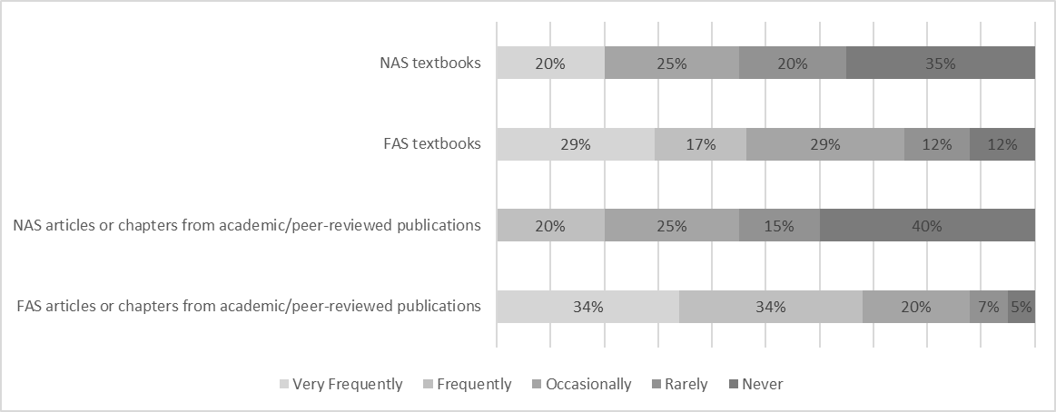
As noted above, the existing literature provides little information about the types of didactic materials (that is, excluding those used as stimuli for interpreting exercises and practice) that are used in dialogue interpreting classrooms. In order to take a first step toward gathering such information, respondents were provided with a list of types of didactic materials and asked to state how frequently they use each type of material with learners. Details of these results appear in Figures 1–3.
Figure 1: Types of instructional materials used with learners, #1
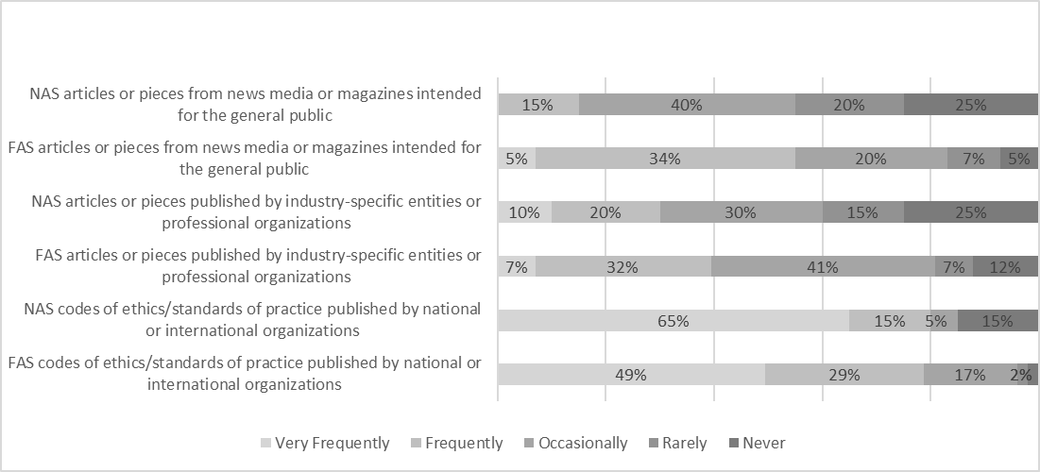
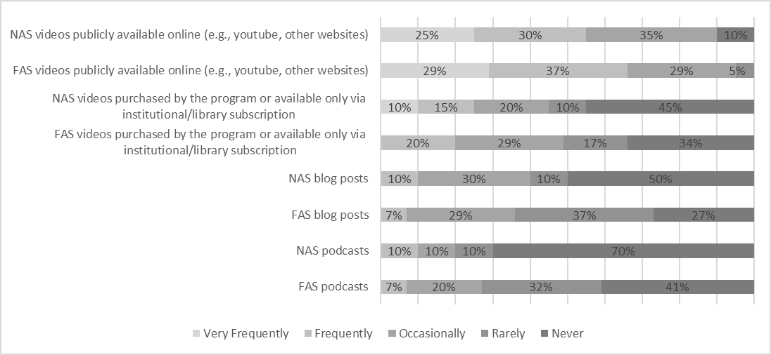
Figure 2: Types of instructional materials used with learners, #2
Figure 3: Types of instructional materials used with learners, #3
We conducted chi-square tests to compare the FAS and NAS responses for each of the types of material listed. A statistically significant relationship between type of material and FAS/NAS responses was only found for articles published in academic journals (X²=18.853, p=0.001). Binomial testing revealed that FAS respondents significantly more often reported that they use academic articles frequently or very frequently (FAS: 34%, NAS: 0%, p <0.000), while the proportion was significantly lower for the answer option “never” (FAS: 5%, NAS: 38%, p < 0.000). No statistically significant difference was found for the answer options “rarely” (FAS: 7%, NAS: 14%, p=0.267) and “occasionally” (FAS: 20%, NAS: 24%, p=0.59) (see Appendix for detailed statistics).
Respondents also had the opportunity to list types of didactic materials that they use that had not been included in the Likert scale survey item. Among the types of materials listed by the FAS respondents are self-created lectures, slideshow presentations, and videos; program-created course compendia or packets; textbooks and research articles from other disciplines; and resources created and disseminated by governmental and non-governmental entities (e.g. the European Commission, foundations or professional organizations related to specific diseases or conditions). NAS respondents mention materials such as patient-directed educational materials, medical books or curricula, self-prepared slideshow presentations, case studies and scenarios drawing on real-life situations, and government documents and policies.
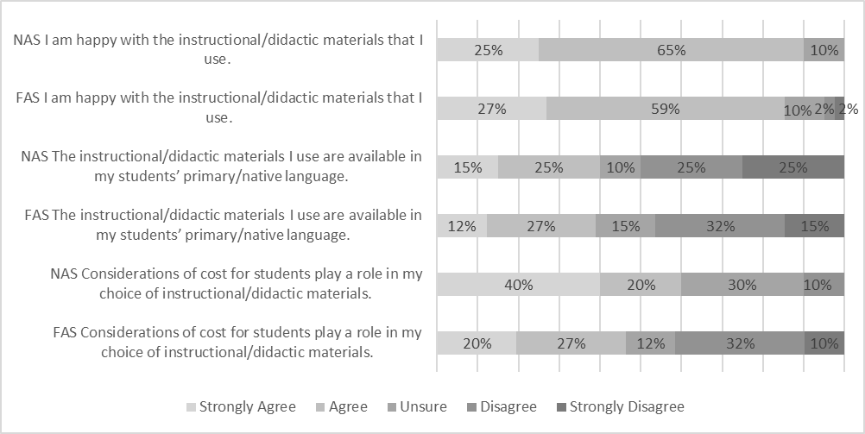
In addition to gathering information on the different types of materials being employed in dialogue interpreter training, the survey contained items aimed at gaining information about various aspects of trainers’ perspectives on the materials they use, including their satisfaction with the materials, the extent to which the materials are appropriate for students or need to be adapted for students’ use, and the extent to which cost is a factor in choosing materials. Respondents were then asked to read a number of statements related to the didactic materials they use and to indicate their level of (dis)agreement with each statement (Figures 4–6).
Figure 4: Aspects of instructional and didactic material, #1
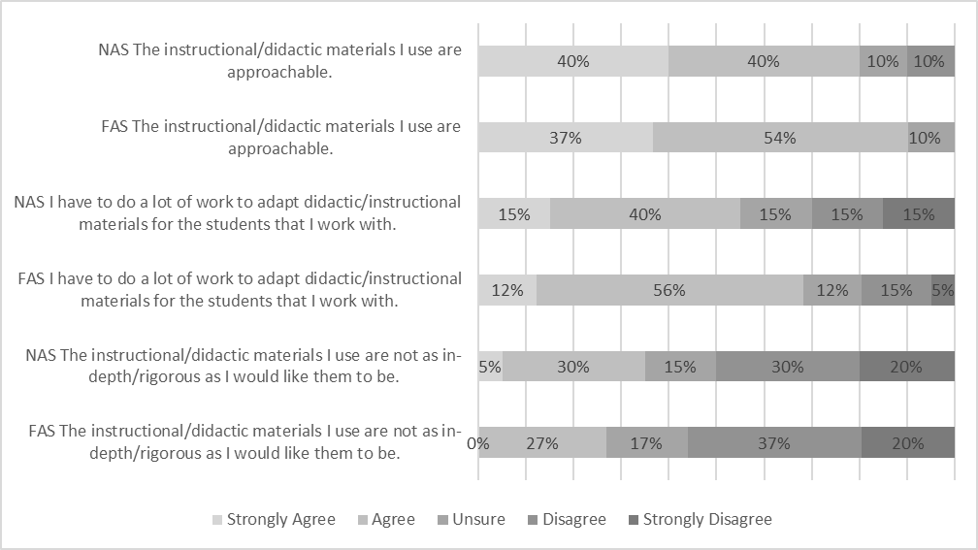
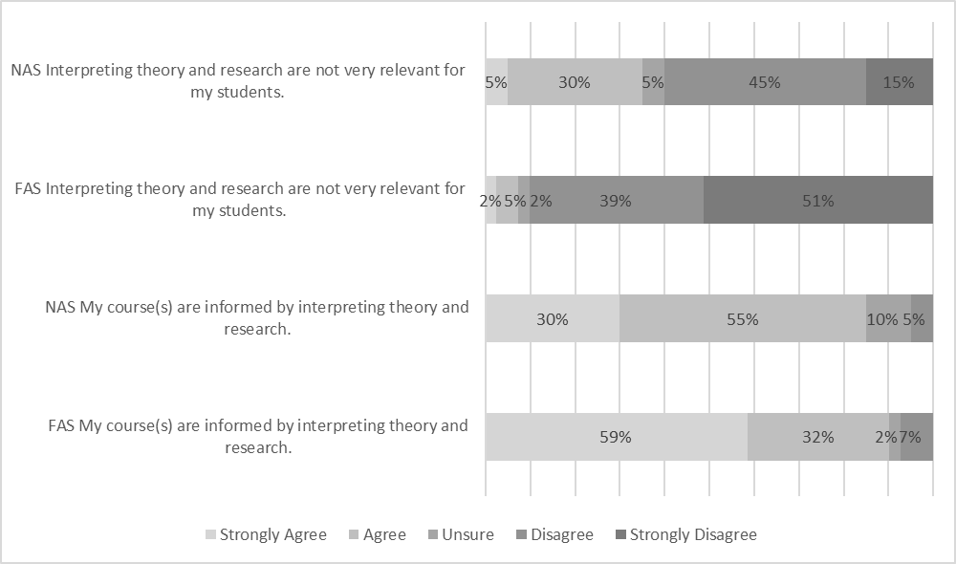
Figure 5: Aspects of instructional and didactic material, #2
Figure 6: Aspects of instructional and didactic material, #3
For each of the statements regarding instructional materials (see Figures 4–6), the association between respondents’ agreement and their teaching setting was investigated with a chi-square test. For most statements, no relationship was found between the responses of FAS and NAS respondents. A statistically significant relationship was found for the statement “interpreting theory is not relevant for my students” (X²=11.606, p=0.021) and a marginally significant association for the statement “considerations of cost for students play a role in my choice of instructional/didactic material” (X²=9.297, p=0.054). In order to investigate the differences more closely, a binomial test was performed on each of the answer options. This test revealed in the first case that trainers from formal academic settings tended to disagree more strongly with the statement that interpreting theory is irrelevant than trainers from non-academic settings (FAS: 32%, NAS: 1%, p <0.001). Trainers from non-academic settings, in contrast, agreed more strongly with the statement on cost considerations (FAS: 5%, NAS: 29%, p <0.001) (see Appendix for detailed statistics).
In order to gain insight into barriers, gaps, and areas of need related to available instructional materials, respondents were asked an open-ended question about what they see as the greatest weaknesses of the materials they use. In the FAS survey, four respondents did not answer this question and two respondents indicated that they do not perceive any particular weaknesses in the materials they use. In the NAS survey, one respondent did not answer the question, and two respondents indicated no weaknesses. Thus, 35 FAS respondents and 19 NAS respondents described weaknesses in materials. The two sets of responses were analyzed separately to identify recurring themes. Similar themes were identified in both sets of responses: the focus or content of available materials, the approachability of materials for learners, the language(s) in which materials are written, and the need to create or adapt materials for use in the classroom. In the representative examples below, we have employed bold typeface to highlight particularly salient elements of the responses.
- Focus or content of available materials
- Not flexible in use for deaf interpreters. Most materials are focused on the auditory features of speech.—NAS
- Limited reference to different country contexts. We teach from the perspective of institutional interactions in [Country], but students come from all over the world and are unlikely to stay to work in [Country]. Having access to materials of use across the board is challenging.—FAS
- Approachability of materials for learners
- Some are complex and difficult to quickly understand, so I have to do a lot of the thinking for students, which puts them at a disadvantage as they are learning my interpretation of the materials and not analyzing them for themselves.—NAS
- The available materials are often outdated or fall to one extreme or the other (too simplistic or too unapproachable; below college level or above undergraduate reading level). Many materials do not come with an applied component to easily tie theory into practice.—FAS
- Language(s) in which materials are written
- The weakness of instructional materials (e.g. books and journal articles) is that they may be in a language not accessible to the students whose working languages/bilingual competency does not include e.g. English. ….. Central curricular texts must adapted to the students’ common language (in our case, [Language]) by the course organizer.—FAS
- Not a lot of information for signed languages. We borrow a lot from spoken languages. We have to generate the [Language] content we use, which is time consuming.—FAS
- Need to create or adapt materials for use in the classroom
- Re: interpreting theory, I use it a lot but it has to be adapted to plain speech to be relevant - and very often I have to adapt materials that take a broad swipe at the fields I work in but aren’t really targeted well.—NAS
- I mostly create my own instructional materials, so as to be able to tailor the materials to the students and their particular needs. In that sense, I guess the greatest weakness is the time it takes to prepare classes.—NAS
  - Theoretical frameworks and constructs informing teaching & learning
The survey contained several open-ended questions aimed at gathering information related to the theoretical frameworks and constructs informing respondents’ work as trainers and to which learners are exposed in classroom and homework activities.
Respondents were invited to identify the five scholars or theoretical frameworks that have most influenced their work as interpreter educators, first with reference to interpreting and translation and then with reference to teaching and learning. With regard to theoretical frameworks and constructs related to translation and interpreting, FAS respondents mention forty-nine separate scholars or scholarly teams. Of these, thirty-four are mentioned once, ten are mentioned between two and four times, and five are mentioned five or more times, as detailed in Table 2. In addition, FAS respondents mention a number of constructs and frameworks that are not strongly associated with a specific scholar or scholarly team (e.g. discourse and conversation analysis; relevance theory; theories of politeness, face, and agency). NAS respondents mention twenty scholars or scholarly teams in response to this survey item. Of these, thirteen are mentioned once, three are mentioned twice, one is mentioned four times, and three are mentioned five times, as detailed in Table 3. NAS respondents mention fewer theoretical constructs not associated with specific authors, but do mention a few, including deliberate practice models and functional effect and communicative intent (i.e. skopos theory).
Table 1: Most frequently referenced T&I scholars influencing FAS respondents’ work as interpreter educators
Name(s) | Number of Mentions
Cecilia Wadensjö | 14
Daniel Gile | 12
Robyn Dean & Robert Pollard | 7
Peter Llewellyn-Jones & Robert G. Lee | 6
Sandra Hale | 5
Table 2: Most frequently referenced T&I scholars influencing NAS respondents’ work as interpreter educators
Name(s) | Number of Mentions
Cross-Cultural Healthcare Program / Cynthia Roat | 5
Robyn Dean & Robert Pollard | 5
Holly Mikkelson | 5
With respect to the question about scholars and theoretical constructs and frameworks related to teaching and learning, 27 FAS respondents (66%) responded to this question, with responses falling into two broad categories: scholars and frameworks that can be categorized as being within translation and interpreting studies (TIS), and those from outside TIS. In the first group, twenty-one scholars are mentioned, some of whose work is pedagogically oriented and some of whose work is not. The second category of responses to this question includes scholars and frameworks related to teaching and learning from outside TIS. Among the theoretical frameworks mentioned are constructivism, situated learning, experiential learning, critical pedagogy, and reflective practice. All of the NAS respondents answered this item in the survey, although 29% (N=6) of them answered “not applicable,” “none,” or “as above.” As with the FAS respondents, NAS respondents mention some TIS scholars in response to this question. Respondents also mention packaged curricula licensed by private interpreter training companies. Several responses mention specific frameworks from the field of teaching and learning, including principles of adult education (andragogy), deliberate practice, reflective practice, experiential learning, and competency-based learning. Responses from both groups provide evidence of current trends in interpreting pedagogy and didactics as discussed by authors such as Orlando (2016), Li (2018), Orlando (2019), and Tiselius & Herring (2023).
In order to get a sense of the range of theoretical perspectives that learners are exposed to and the extent to which learners may or may not be exposed to a shared body of theory and knowledge, respondents were asked to list the names of up to five scholars whose work their students are exposed to in some way as part of their studies. FAS respondents listed 90 scholars or scholarly teams in response to this prompt, with five names being mentioned more than five times and nineteen names mentioned three or more times (Table 4). Thus, 71 out of 90 names (79%) mentioned by FAS respondents appeared only one or two times. NAS respondents mentioned 35 scholars or scholarly teams in response to this question. Of these, 7 are mentioned two or more times, with the most-frequently appearing name mentioned four times (Table 5). In the NAS survey, 28 out of 35 names (80%) appear only once.
Table 3: Names mentioned more than five times in response to query about scholars whose work students are exposed to in FAS
Name | Number of Times Mentioned
Franz Pöchhacker | 14
Cecilia Wadensjö | 13
Daniel Gile | 12
Sandra Hale | 10
Jemina Napier | 9
Table 4: Names mentioned two or more times in response to query about scholars whose work students are exposed to in NAS
Name | Number of Times Mentioned
Holly Mikkelson | 4
Cross Cultural Health Care Program / Cynthia Roat (Bridging the Gap training course) | 3
Robyn Dean & Robert Pollard | 3
Marjory Bancroft | 2
Daniel Gile | 2
Sandra Hale | 2
Jean-François Rozan | 2
The number of separate names mentioned and the tendency for names to be mentioned only once illustrate the heterogeneity of the discipline and the range of scholars whose work is encountered by learners. The names mentioned by the two groups (FAS and NAS) do overlap; for example, four of the five names most frequently mentioned by the FAS group are also mentioned by the NAS group. NAS responses to this question include curricula produced especially for short training courses, such as Bridging the Gap and The Community Interpreter, while the FAS responses do not mention such materials.
Respondents were also asked to share information (i.e. author, title) for up to five didactic materials (e.g. journal articles, book chapters, textbooks, recorded webinars or presentations) that are assigned to students. The majority of the publications listed by FAS respondents are in English (or are identified or listed in English); however, publications in a number of other languages are also mentioned, including Danish, Galician, German, Norwegian, Spanish, and Swedish. No NAS respondents specifically mentioned items written in languages other than English. The prevalence of English-language texts mentioned in the responses is perhaps not surprising in light of the fact that the survey was administered in English; at the same time, it also may reflect the tendency noted by the respondents quoted in Section 5.2 who mention lack of texts in languages other than English as a weakness of the didactic materials they use.
The responses that included sufficient information to allow for further analysis were categorized by type of (re)source. FAS responses included videos, documents produced by governmental or non-governmental organizations and institutions (e.g. Departments of Education of individual US states, professional organizations, United Nations High Commissioner for Refugees), textbooks or other didactically oriented volumes, academically oriented volumes (e.g. monographs, edited volumes), and papers from scholarly journals. Many of the textbooks mentioned by FAS respondents are aimed at students training to go into a specific setting, such as courts or healthcare. However, textbooks are mentioned less frequently than academically oriented books (whether monographs or edited volumes) and peer-reviewed journal articles, which is in line with the responses to the question about frequency of use of various types of materials (see Figures 1–3 above). Publications listed by the NAS respondents include textbooks and didactically oriented books, peer-reviewed articles, academically oriented monographs, curricula for specific private training programs, codes of ethics and standards of practice, news articles, videos and podcasts, and government policies. Fewer materials were mentioned by NAS respondents than by FAS respondents; indeed, some NAS respondents stated that they do not generally assign homework to trainees, but, if they do, it is likely to be practice-oriented, rather than involve consumption of didactic material.
- Discussion
  - Geographic coverage and respondent profiles
The majority of the responses to both surveys are from trainers working in Europe and North America. The limited geographical coverage may be in part due to the existence of fewer training programs for dialogue interpreters outside these regions; it may also, however, reflect insufficient dissemination of the survey, despite efforts to reach a wide audience. The survey was also only available in English, which may have influenced the geographical range reached.
Within this sample, respondents from FAS tend to have higher levels of formal education, are more likely to have completed some type of formal training as teachers and are more likely to have received more formal training in interpreting, in comparison with the respondents from NAS. The fact that 95% (N=39) of FAS respondents have completed at least some graduate study and that more than half (59%, N=24) have completed a PhD may be a reflection of the fact that tertiary-level institutions generally require such qualifications in order to teach; it may also reflect the possibility that FAS trainers with PhDs were more likely to respond to a request to participate in a research study. That said, the percentage of NAS respondents reporting having completed some type of graduate-level studies is also quite high, at 76% (N=16).
With regard to formal training in interpreting, 24% (N=5) of the NAS respondents report having completed a post-graduate level program (MA degree or equivalent), in comparison with 44% (N=18) of the FAS respondents. Given the paucity of graduate-level training specifically focused on dialogue interpreting before the last couple of decades, it might be seen as noteworthy that so many of the participants in both groups have graduate-level training in interpreting. However, it is possible that the graduate-level study of interpreting undertaken by many of these respondents was focused on conference interpreting or on interpreting and translation in general, rather than on dialogue interpreting in particular.
FAS respondents are also more likely to have received formal training in teaching (FAS respondents: 76%, N=31; NAS respondents, 52%, N=11) and to have participated in training specifically related to interpreting pedagogy. Only 29% (N=9) of the 31 FAS respondents who report having received formal training related to teaching specifically mention training related to teaching interpreting, while the only type of interpreting-pedagogy-specific training mentioned by the NAS group is training-of-trainers (TOT) sessions intended to prepare trainers to teach specific private curricula. The need for teaching staff to have training in pedagogy, both in general and specific to interpreting, has been addressed by scholars such as Angelelli (2017), Orlando (2019), and Kadrić & Pöllabauer (2023). Availability of TOT courses and materials is a highly relevant topic for trainers in both FAS and NAS. Although the data gathered in these surveys provides only limited information about trainers’ access to and participation in TOT activities, these findings resonate strongly with the discussions found in the just-cited literature of the need for teacher training for trainers of dialogue interpreters. In our view, efforts to respond to this need should take trainers in NAS into account, rather than focusing solely on trainers in FAS, inasmuch as NAS trainers may have received less formal training in interpreting (and thus may have less grounding in theory) and, by virtue of their training context, may not have institutional affiliations that would allow them the same access to academic publications enjoyed by their FAS colleagues.
  - Didactic materials
The section of the survey focused on curriculum began with a question aimed at understanding the extent to which respondents create their own curricula and teaching materials versus teach from a fixed curriculum and set of materials. The great majority of respondents in both groups report that they create and/or adapt materials for use with their students (NAS: 71%, N=15; FAS: 98%, N=40). This suggests a landscape that allows for significant individual variation among trainers. This can be a strength of training programs, inasmuch as it allows for flexibility and tailoring of instruction to learner needs and profiles. At the same time, it can potentially be a weakness, since developing one’s own curricula and teaching materials requires a significant amount of time and effort, the need for which may or may not be reflected in remuneration rates. Additionally, lack of shared understandings and frameworks (both of interpreting and of teaching and learning) within a program or across programs in a geographical area can lead to inconsistencies and confusion for both service users and interpreters in relation to issues such as standard practices, understanding of role boundaries and decision-making latitude, and conceptualizations of what constitutes (un)ethical behavior.
The range of types of didactic materials encountered by students in both FAS and NAS settings reinforces the impression of a heterogeneous landscape. While some materials and authors are mentioned by multiple respondents, learners are likely to encounter a wide range of materials by a wide range of authors. Many of the materials that respondents mention assigning to learners are focused broadly on dialogue interpreting, often addressing multiple settings rather than one single setting (e.g. medical, legal). This may be evidence of a curricular tendency toward what Taibi et al. (2022: 97) describe as a “generic skills education,” with a primary focus on developing interpreting skills in general, rather than on preparation for a specific work setting. The fact that FAS respondents are significantly more likely than NAS respondents to assign academic, peer-reviewed publications as reading material for their students is indicative of some differences in the type of materials that learners in the two settings encounter. It is perhaps not surprising that credit-granting institutions of higher learning would require more engagement with academically oriented texts. Additionally, as noted above, FAS respondents are also more likely to have higher levels of education, in general, and may therefore be more likely to be acquainted with research- and theory-focused texts. The frequent use of academic, peer-reviewed publications as texts in the interpreting classroom merits further investigation, given that such texts are by nature not intended for an audience of learners and may present a number of challenges for use in the dialogue interpreting classroom (Tiselius & Herring 2023).
Most respondents in both groups report being happy with the didactic materials they use (NAS: 90%, N=18 strongly agree or agree; FAS: 85%, N=35 strongly agree or agree) and feeling that the materials they use are approachable for learners (NAS: 80%, N=16 strongly agree or agree; FAS: 90%, N=37 strongly agree or agree). At the same time, a majority of both groups reports having to do a lot of work to adapt materials to meet learners’ needs (NAS: 55%, N=11 strongly agree or agree; FAS: 68%, N=28 strongly agree or agree), and half (NAS) or close to half (FAS) report not having materials available in their students’ primary language (NAS: 50%, N=10 strongly disagree or disagree; FAS: 46%, N=19 strongly disagree or disagree). The need to create and adapt materials, the approachability of materials, and the languages in which materials are available are common themes in the responses to the open-ended question about weaknesses of available instructional and didactic materials, as discussed in Section 5.2. These responses resonate with Orlando’s (2016: 65) call for “more and more accessible, journal articles and […] books or textbooks on the didactics of T&I.” Similar themes are also highlighted by Hale (2007: 17), who reports on focus groups in which community interpreter trainers identified “lack of teaching materials and textbooks to guide them, time limitations and the students’ mixed bilingual and bicultural competence” as the main challenges facing them. The same group of trainers reported needing to create their own teaching materials, although in Hale’s case the comments regarding materials appear to be largely focused on practice materials rather than didactic materials.
  - Theory in teaching and learning
Several survey questions elicited information from respondents related to theory in teaching and learning. As noted in Section 5.2, a significant difference emerged between the two groups with regard to the Likert scale item “interpreting theory and research are not very relevant for my students,” with FAS respondents disagreeing more strongly with the statement than NAS respondents. In contrast, the majority of both groups were in agreement with the statement “my course(s) are informed by interpreting theory and research” (NAS: 85%, N=17 strongly agree or agree; FAS: 90%, N=37 strongly agree or agree), with no statistically significant difference found between the two groups. The fact that some NAS respondents endorse the role of theory in informing their courses while others endorse the statement that theory is irrelevant for their students is an interesting contrast worthy of further investigation, potentially via observation, interview, case studies or other methods that allow for a qualitative analysis of classroom practices.
Responses regarding the theoretical constructs and frameworks that inform respondents’ work as trainers suggest a landscape characterized by some commonalities, but also much diversity and variation. Similarly, responses to the question focused on student-facing theory (that is, materials assigned to students) demonstrate a notable heterogeneity in terms of the types of materials assigned and the theoretical content to which learners are exposed during their studies. Within the responses to these questions we see abundant evidence of the influence of dialogue interpreting-focused scholarship (e.g. Claudia Angelelli, Sandra Hale, Holly Mikkelson, Hanne Skaaden, Cecilia Wadensjö) and of theoretical frameworks developed by scholars of signed language interpreting (e.g. Robyn Dean & Robert Pollard, Peter Llewellyn-Jones & Robert G. Lee), as well as of the continued influence of scholarly work arising from simultaneous conference interpreting (e.g. Daniel Gile) or encompassing a broad view of interpreting studies (e.g. Franz Pöchhacker). There is also evidence of the influence of translation studies, narrowly defined, on our respondents’ work as educators, particularly with respect to pedagogy of translation (e.g. Mona Baker, María González Davies, Donald Kiraly, Kelly Washbourne).
The method (i.e. survey) and exploratory nature of this study provide only limited information regarding this topic. Although the results provide some evidence of trends and of points in common (e.g. socioconstructivist approaches to teaching and learning; see also Orlando 2016 and Tiselius & Herring 2023) and points of difference in terms of the theoretical frameworks informing teaching and to which learners are exposed, the exploratory nature of the study did not allow for in-depth investigation of the ways and extent to which the constructs and frameworks mentioned by respondents are integrated into training programs. Further in-depth exploration is needed in order to get a better understanding of the specifics of teaching and learning theory in the dialogue interpreting classroom. Additionally, further research is needed to explore trainers’ teaching beliefs and practices and learners’ and program graduates’ perspectives on curricula and teaching practices. In this we join other scholars who have argued for increased research into the effectiveness of teaching approaches and practices (e.g. Pöchhacker 2010; Winston 2013; Orlando 2016). In addition, given evidence of differences in learners’ and instructors’ perceptions and beliefs regarding issues such as beliefs and practices related to teaching & learning and the relevance of theory in interpreter education (see Takeda 2010; Li 2018; Liu 2019; Arumí Ribas 2020), this investigatory angle is highly relevant.
- Conclusion
The survey results discussed in these pages offer an initial, wide-angle view of several aspects of dialogue interpreter training and draw our attention to a number of aspects that need closer examination. The overall impression given by the data is of a landscape that has a number of points of commonality but also a great deal of heterogeneity. Heterogeneity is not necessarily problematic, and is to some extent necessary, given the variety of possible training situations, cultural contexts, and work settings in which dialogue interpreters are trained and carry out their professional responsibilities. At the same time, ongoing efforts to professionalize dialogue interpreting—and, indeed, its established status as a (semi-)profession in some areas—might be expected to imply a corresponding trajectory of professionalization or regularization of the body of knowledge and the theoretical frameworks employed in the teaching of dialogue interpreting. While recognizing the need for training to be adapted to context and situation, we also echo Arumí Ribas’ (2020: 77) assertion that there is a need to work toward a “shared collective decision” regarding theory and concepts to be included in interpreter training. We join Kadrić & Pöllabauer (2023: 424) in their call for a “global exchange between interpreter educators,” in the hopes that such collaborative efforts will lead to intentional, collaborative efforts to develop relevant materials and curricula and make them available to teachers in all types of situations and settings.
Authorship statement
Rachel E. Herring designed the study, collected the data, led the qualitative data analysis, and wrote the initial draft of the literature review, method, and results sections. Anne Catherine Gieshoff carried out and wrote up the quantitative data analysis. Both authors collaborated on drafting the discussion and conclusions sections and preparing the paper for publication.
Acknowledgments
The authors wish to thank the following colleagues for their valuable input during the survey design and/or data analysis phases of this project: Aleksandra Adler, Carmen Delgado Luchner, Raluca Droahna, Jacolyn Harmer, Isabelle Heyerick, Christopher Mellinger, Jeanette Nicholson, Jori Nkwenti, Erin Rosales, Elisabet Tiselius, and Melissa Wallace.

Appendix: Detailed Statistical Analyses
Table 5: Descriptive statistics and test statistics (chi-square-test) for didactic material
Variable | N | Percent | N_1 | Percent_2 | Test
Survey | FAS |  | NAS
Textbook | 41 |  | 20 |  | X²=8.9, p=0.064*
... Never | 5 | 0.122 | 8 | 0.4
... Rarely | 5 | 0.122 | 3 | 0.15
... Occasionally | 12 | 0.293 | 4 | 0.2
... Frequently | 7 | 0.171 | 0 | 0
... Very Frequently | 12 | 0.293 | 5 | 0.25
acaJournal | 41 |  | 20 |  | X²=18.853, p=0.001***
... Never | 2 | 0.049 | 8 | 0.4
... Rarely | 3 | 0.073 | 3 | 0.15
... Occasionally | 8 | 0.195 | 5 | 0.25
... Frequently | 14 | 0.341 | 4 | 0.2
... Very Frequently | 14 | 0.341 | 0 | 0
profJournal | 41 |  | 20 |  | X²=3.399, p=0.493
... Never | 5 | 0.122 | 5 | 0.25
... Rarely | 3 | 0.073 | 3 | 0.15
... Occasionally | 17 | 0.415 | 6 | 0.3
... Frequently | 13 | 0.317 | 4 | 0.2
... Very Frequently | 3 | 0.073 | 2 | 0.1
Blog | 41 |  | 20 |  | X²=5.626, p=0.131
... Never | 11 | 0.268 | 10 | 0.5
... Rarely | 15 | 0.366 | 2 | 0.1
... Occasionally | 12 | 0.293 | 6 | 0.3
... Frequently | 3 | 0.073 | 2 | 0.1
... Very Frequently | 0 | 0 | 0 | 0
publicVideos | 41 |  | 20 |  | X²=5.475, p=0.242
... Never | 0 | 0 | 2 | 0.1
... Rarely | 2 | 0.049 | 0 | 0
... Occasionally | 12 | 0.293 | 7 | 0.35
... Frequently | 15 | 0.366 | 6 | 0.3
... Very Frequently | 12 | 0.293 | 5 | 0.25
subscribedVideos | 41 |  | 20 |  | X²=5.568, p=0.234
... Never | 14 | 0.341 | 9 | 0.45
... Rarely | 7 | 0.171 | 2 | 0.1
... Occasionally | 12 | 0.293 | 4 | 0.2
... Frequently | 8 | 0.195 | 3 | 0.15
... Very Frequently | 0 | 0 | 2 | 0.1
podcast | 41 |  | 20 |  | X²=5.59, p=0.133
... Never | 17 | 0.415 | 14 | 0.7
... Rarely | 13 | 0.317 | 2 | 0.1
... Occasionally | 8 | 0.195 | 2 | 0.1
... Frequently | 3 | 0.073 | 2 | 0.1
... Very Frequently | 0 | 0 | 0 | 0
codesConduct | 41 |  | 20 |  | X²=6.983, p=0.137
... Never | 1 | 0.024 | 3 | 0.15
... Rarely | 1 | 0.024 | 0 | 0
... Occasionally | 7 | 0.171 | 1 | 0.05
... Frequently | 12 | 0.293 | 3 | 0.15
... Very Frequently | 20 | 0.488 | 13 | 0.65

Table 6: Descriptive statistics and test statistics (chi-square-test) for didactic material
Variable | N | Percent | N_1 | Percent_2 | Test
survey | FAS |  | NAS
I’m happy with the materials | 41 |  | 20 |  | X²=1.086, p=0.896
... Strongly disagree | 1 | 0.024 | 0 | 0
... Disagree | 1 | 0.024 | 0 | 0
... Unsure | 4 | 0.098 | 2 | 0.1
... Agree | 24 | 0.585 | 13 | 0.65
... Strongly agree | 11 | 0.268 | 5 | 0.25
cost considerations play a role in my choice | 41 |  | 20 |  | X²=9.297, p=0.054*
... Strongly disagree | 4 | 0.098 | 0 | 0
... Disagree | 13 | 0.317 | 2 | 0.1
... Unsure | 5 | 0.122 | 6 | 0.3
... Agree | 11 | 0.268 | 4 | 0.2
... Strongly agree | 8 | 0.195 | 8 | 0.4
interpreting theory is not very relevant for my students | 41 |  | 20 |  | X²=11.606, p=0.021**
... Strongly disagree | 21 | 0.512 | 3 | 0.15
... Disagree | 16 | 0.39 | 9 | 0.45
... Unsure | 1 | 0.024 | 1 | 0.05
... Agree | 2 | 0.049 | 6 | 0.3
... Strongly agree | 1 | 0.024 | 1 | 0.05
the materials are not as in-depth as I would like | 41 |  | 20 |  | X²=2.305, p=0.68
... Strongly disagree | 8 | 0.195 | 4 | 0.2
... Disagree | 15 | 0.366 | 6 | 0.3
... Unsure | 7 | 0.171 | 3 | 0.15
... Agree | 11 | 0.268 | 6 | 0.3
... Strongly agree | 0 | 0 | 1 | 0.05
the materials are available in my students’ L1 | 41 |  | 20 |  | X²=1.324, p=0.857
... Strongly disagree | 6 | 0.146 | 5 | 0.25
... Disagree | 13 | 0.317 | 5 | 0.25
... Unsure | 6 | 0.146 | 2 | 0.1
... Agree | 11 | 0.268 | 5 | 0.25
... Strongly agree | 5 | 0.122 | 3 | 0.15
I have a lot of work to adopt the materials | 41 |  | 20 |  | X²=2.528, p=0.64
... Strongly disagree | 2 | 0.049 | 3 | 0.15
... Disagree | 6 | 0.146 | 3 | 0.15
... Unsure | 5 | 0.122 | 3 | 0.15
... Agree | 23 | 0.561 | 8 | 0.4
... Strongly agree | 5 | 0.122 | 3 | 0.15
my course is informed by interpreting theory | 41 |  | 20 |  | X²=5.752, p=0.124
... Strongly disagree | 0 | 0 | 0 | 0
... Disagree | 3 | 0.073 | 1 | 0.05
... Unsure | 1 | 0.024 | 2 | 0.1
... Agree | 13 | 0.317 | 11 | 0.55
... Strongly agree | 24 | 0.585 | 6 | 0.3
the materials are approachable | 41 |  | 20 |  | X²=4.652, p=0.199
... Strongly disagree | 0 | 0 | 0 | 0
... Disagree | 0 | 0 | 2 | 0.1
... Unsure | 4 | 0.098 | 2 | 0.1
... Agree | 22 | 0.537 | 8 | 0.4
... Strongly agree | 15 | 0.366 | 8 | 0.4

Table 7: Proportions and binomial test statistics
statement | answer option | number of successes | number of trials | proportion of successes (FAS) | estimated probability (based on NAS) | p-value
cost considerations play a role for my choice of didactic materials | Strongly disagree | 4 | 41 | 0.1 | 0 | 0
 | Disagree | 13 | 41 | 0.32 | 0.1 | 0
 | Unsure | 5 | 41 | 0.12 | 0.29 | 0.023
 | Agree | 11 | 41 | 0.27 | 0.19 | 0.23
 | Strongly agree | 8 | 41 | 0.2 | 0.38 | 0.015
interpreting theory is not very relevant | Strongly disagree | 21 | 41 | 0.51 | 0.14 | 0
 | Disagree | 16 | 41 | 0.39 | 0.43 | 0.64
 | Unsure | 1 | 41 | 0.02 | 0.05 | 1
 | Agree | 2 | 41 | 0.05 | 0.29 | 0
 | Strongly agree | 1 | 41 | 0.02 | 0.05 | 1
References
Amato, Amalia & Mack, Gabriele. 2022. Interpreter education and training. In Zanettin, Federico & Rundle, Christopher (eds.), The Routledge handbook of translation and methodology. London: Routledge. 457–75.
Angelelli, Claudia V. 2017. Anchoring dialogue interpreting in principles of teaching and learning. In Cirillo, Letizia & Niemants, Natacha (eds.) Teaching dialogue interpreting. Amsterdam: Benjamins. 30–44. Doi: 10.1075/btl.138.01ang.
Angelelli, Claudia V. 2020. Community/public-service interpreting as a communicative event. A call for shifting teaching and learning foci. Translation and Translanguaging in Multilingual Contexts (6)2: 114–30. Doi: 10.1075/ttmc.00048.ang.
Arumí Ribas, Marta. 2020. How command of theoretical concepts contributes to the professional development of future interpreters. The Interpreters’ Newsletter 25: 69–80.
Bao, Chuanyun. 2015. Pedagogy. In Mikkelson, Holly & Jourdenais, Renee (eds.), The Routledge handbook of interpreting. London: Routledge. 400–16.
Cirillo, Letizia & Niemants, Natacha. 2017. Teaching dialogue interpreting. Amsterdam: Benjamins.
Crezee, Ineke & Burns, Jo Anna. 2019. Action research and its impact on the development of pragmatic competence in the translation and interpreting classroom. In Tipton, Rebecca & Desilla, Louisa (eds.), The Routledge handbook of translation and pragmatics. London: Routledge. 355–72.
Corsellis, Anne. 2008. Public service interpreting. The first steps. New York: Springer.
De Pedro Ricoy, Raquel. 2010. Training public service interpreters in the UK. A fine balancing act. The Journal of Specialised Translation 14: 100–20.
Delgado Luchner, Carmen. 2019. Contextualizing interpreter training in Africa. Two case studies from Kenya. International Journal of Interpreter Education 11(2): 4–15. (https://tigerprints.clemson.edu/ijie/vol11/iss2/3) (Accessed 2025-12-06.)
D’Hayer, Danielle. 2012. Public service interpreting and translation. Moving towards a (virtual) community of practice. Meta 57(1): 235–47. (https://www.erudit.org/fr/revues/meta/2012-v57-n1-meta0312/1012751ar/) (Accessed 2025-12-06.)
Foulquié-Rubio, Ana I. & Vargas-Urpi, Mireia & Fernández Pérez, María M. 2018. Introducción. 2006–2016. Una década de cambios. In Foulquié-Rubio, Ana I. & Vargas-Urpi, Mireia & Fernández Pérez, María M. (eds), Panorama de la traducción y la interpretación en los servicios públicos españoles. Una década de cambios, retos y oportunidades. Granada: Comares. 1–12.
Gavioli, Laura & Wadensjö, Cecilia. 2023. The Routledge handbook of public service interpreting. London: Routledge.
Gentile, Paola. 2016. The interpreter’s professional status. A sociological investigation into the interpreting profession. Triest: Universitá degli Studi di Trieste. (Unpublished doctoral dissertation.) (https://arts.units.it/handle/11368/2908044) (Accessed 2025-12-06.)
Gentile, Adolfo & Ozolins, Uldis & Vasilakakos, Mary. 1996. Liaison interpreting. A handbook. Melbourne: Melbourne University.
Gustafsson, Kristina & Norström, Eva & Fioretos, Ingrid. 2012. Community interpreter training in spoken languages in Sweden. International Journal of Interpreter Education 4(2): 24–38.
Hale, Sandra B. 2007. Community interpreting. London: Palgrave Macmillan.
Hale, Sandra B. 2011. Public service interpreting. In Malmkjaer, Kirsten & Windle, Kevin (eds.), The Oxford handbook of translation studies. Oxford: Oxford University Press. 343–56.
Kadrić, Mira & Pöllabauer, Sonja. 2023. Education and training of public service interpreting teachers. In Gavioli, Laura & Wadensjö, Cecilia (eds.), The Routledge handbook of public service interpreting. London: Routledge. 414–28.
Kim, Mira. 2017. Research on translator and interpreter education. In Millán, Carmen & Bartrina, Francesca (eds), The Routledge handbook of translation studies. London: Routledge. 117–28.
Li, Xiangdong. 2018. Teaching beliefs and learning beliefs in translator and interpreter education. An exploratory case study. The Interpreter and Translator Trainer 12(2): 132–51.
Liu, Minhua. 2019. Knowing what and knowing how. Teaching student interpreters research on interpreting. In Sawyer, David. B. & Austermühl, Frank & Enríquez Raído, Vanessa (eds.), The evolving curriculum in interpreter and translator education. Stakeholder perspectives and voices. Amsterdam: Benjamins. 301–18.
Manfredi, Ana B. & Lázaro Gutiérrez, Raquel. 2021. Interpretación en los servicios públicos en la oferta académica de grado en Argentina. FITISPos International Journal 8(1): 122–39.
Maximous, Amal. 2017. Teaching and learning community interpreting. Sydney: Western Sydney University. (Unpublished doctoral dissertation.)
Mazzei, Cristiano & Jay-Rayon Ibrahim Aibo, Laurence. 2022. The Routledge guide to teaching translation and interpreting online. London: Routledge.
Merlini, Raffaela. 2015. Dialogue interpreting. In Pöchhacker, Franz (ed.), Routledge encyclopedia of interpreting studies. London: Routledge. 102–07.
Mikkelson, Holly. 2017. Community interpreting. In Millán, Carmen & Bartrina, Francesca (eds), The Routledge handbook of translation studies. London: Routledge. 389–401.
Napier, Jemina & Webb, Stacey & Adam, Robert (eds). 2024. International perspectives on sign language translator and interpreter education (2nd edition). Washington DC: Gallaudet University Press.
Nicodemus, Brenda & Swabey, Laurie. 2015. Action research. In Angelelli, Claudia V. & Baer, Brian J. (eds.), Researching translation and interpreting. London: Routledge. 157–67.
Niemants, Natacha & Cirillo, Letizia. 2017. Dialogue interpreting: Research, education and professional practice. In Cirillo, Letizia & Niemants, Natacha (eds.), Teaching dialogue interpreting. Amsterdam: Benjamins. 1–25. Doi: 10.1075/btl.138.01ang.
Orlando, Marc. 2016. Training 21st century translators and interpreters. At the crossroads of practice, research and pedagogy. Berlin: Frank & Timme GmbH.
Orlando, Marc. 2019. Training and educating interpreter and translator trainers as practitioners-researchers-teachers. The Interpreter and Translator Trainer 13(3): 216–32. Doi: 10.1080/1750399X.2019.1656407.
Ozolins, Uldis. 2017. It’s not about the interpreter. Objectives in dialogue interpreting teaching. In Cirillo, Letizia & Niemants, Natacha (eds.), Teaching dialogue interpreting. Amsterdam: Benjamins. 45–62. Doi: 10.1075/btl.138.01ang.
Pöchhacker, Franz. 2010. The role of research in interpreter education. Translation & Interpreting 2(1): 1–10.
Rudvin, Mette & Tomassini, Elena. 2011. Interpreting in the community and workplace. A practical teaching guide. London: Palgrave MacMillan.
Sawyer, David. 2004. Fundamental aspects of interpreter education. Amsterdam: Benjamins.
Setton, Robin. 2010. From practice to theory and back in interpreting: the pivotal role of training. The Interpreters’ Newsletter 15: 1–18. (https://www.openstarts.units.it/bitstream/10077/4746/1/SettonIN15.pdf) (Accessed 2025-12-06.)
Šveda, Pavol. 2021. Changing paradigms and approaches in interpreter training. Perspectives from Central Europe. London: Routledge.
Taibi, Mustapha & Ozolins, Uldis & Maximous, Amal. 2022. Interpreter education in Australia. Community settings, generic skills. In Wakabayashi, Judy & O’Hagan, Minako (eds.), Translating and interpreting in Australia and New Zealand. Distance and diversity. London: Routledge. 86–104.
Takeda, Kayoko. 2010. What interpreting teachers can learn from students. A case study. Translation & Interpreting 2(1): 38–47. (http://www.trans-int.org/index.php/transint/article/view/88/67) (Accessed 2025-12-06.)
Tipton, Rebecca. 2024. The Routledge guide to teaching ethics in translation and interpreting education. London: Routledge.
Tipton, Rebecca & Furmanek, Olga. 2016. Dialogue interpreting. A guide to interpreting in public services and the community. London: Routledge.
Tiselius, Elisabet. 2021. Conference and community interpreting. Commonalities and differences. In Albl-Mikasa, Michaela & Tiselius, Elisabet (eds.), The Routledge handbook of conference interpreting. London: Routledge. 49–63.
Tiselius, Elisabet & Herring, Rachel E. 2023. What should be included in (public service) interpreter education? Bridge. Trends and Traditions in Translation and Interpreting Studies 4(1): 46–71.
Valero Garcés, Carmen. 2019. Training public service interpreters and translators. Facing challenges. Revista de Llengua i Dret, Journal of Language and Law 71: 88–105. Doi: 10.2436/rld.i71.2019.3262.
Wakabayashi, Judy & O’Hagan, Minako. 2022. Translating and interpreting in Australia and New Zealand. Distance and diversity. London: Routledge.
Washbourne, Kelly & Liu, Yingmei. 2023. ‘To study is not to create something but to create oneself.’ An ontological turn in translator education and training. The Interpreter and Translator Trainer 17(2): 177–92.
Weiss-Gal, Idit & Welbourne, Penelope. 2008. The professionalisation of social work. A cross-national exploration. International Journal of Social Welfare 17(4): 281–90.
Winston, Elizabeth A. 2013. Infusing evidence into interpreter education. An idea whose time has come. In Winston, Elizabeth A. & Monikowski, Christine (eds.), Evolving paradigms in interpreter education. Washington, DC: Gallaudet University Press. 165–87.
Rachel E. Herring
Century College
3300 Century Ave N
White Bear Lake MN 55110 USA
Email: rachel.herring@century.edu
Anne Catherine Gieshoff
ZHAW Zurich University of Applied Sciences
School of Applied Linguistics
Theaterstr. 15
8401 Winterthur
Switzerland
Email: annecatherine.gieshoff@zhaw.ch

Discussion of the distinction between training and education and the question of which label should be used in what contexts is outside the scope of this paper. Interested readers are referred to Sawyer (2004), Angelelli (2017), and Amato & Mack (2022). For the purposes of this paper, the labels are used interchangeably.
There are multiple labels used to describe the type of interpreting that is the focus of this paper, principally community interpreting, public service interpreting, and dialogue interpreting (e.g. Hale 2007, 2011; Merlini 2015; Tipton & Furmanek 2016). In this paper, we use dialogue interpreting, following Tipton & Furmanek (2016) and Niemants & Cirillo (2017).
Note that the total number of responses is higher than the total number of respondents, as two FAS respondents and one NAS respondent report teaching in multiple countries.
The respondent from Turkey is included in this count.
Respondents who teach in both settings were asked to consider only their time spent training in the setting applicable to the survey they were responding to.
Throughout the survey and this paper, “didactic and instructional materials” refers to materials used to teach content and skill, rather than to material used as stimuli for interpreting practice (e.g. speeches, role plays). This definition was provided to survey respondents in narrative text preceding these questions.
“Scholarly team” refers to two or more authors who have jointly developed a framework or approach, or published a joint volume, which is thus strongly associated with both or all of them, rather than with one of them.
Both sets of responses included items that could not be categorized due to insufficient information (e.g. listing an author but not specifying a work by that author).
NAS total N=20 for the questions about specific materials because one respondent stated that they do not use didactic materials.

