Appraisal in translation: Evaluative expressions in German transcripts of English TED Talks
Mirela Imamović*§, Silvana Deilen*, Dylan Glynn§, Ekaterina Lapshinova-Koltunski*
*University of Hildesheim, §University of Paris 8

Abstract
This study seeks to identify how translation affects evaluative expressions from English to German in transcripts of TED talks. Using Appraisal Theory as a framework, we analyse how evaluative language is transferred in German subtitles and whether it is altered, omitted, or directly translated. The dataset used in this study comprises four English transcripts of TED talks, restricted to the single topic of natural science. We employ eight annotators in a manual annotation task - undergraduate translation students trained in Appraisal Theory. The students manually identify evaluative expressions in pairs and, in a second step, tag the translation strategies individually. We conduct a contrastive analysis of English and German evaluative patterns in context, focusing on the distribution of Attitude types per translation strategy employed. The findings suggest a preference for equivalence in the translation of evaluative expressions from English to German and indicate a shining-through effect as well as adaptation to German lexico-grammatical preferences in translation. Statistical analysis is performed to evaluate the influence of Attitude types on the translation strategies. The results of this study contribute to understanding the role of evaluative language in translation and complement existing research on translation strategies of evaluative language.
Keywords: Appraisal; evaluative language; translation; TED talks
- Introduction
Evaluative language is an important component of communication and a fundamental function of language that shapes meaning and influences audiences. Both explicitly and implicitly, the expression of attitude towards epistemic and ideational content is pervasive and not only restricted to situations where it is the objective of the utterance. For example, intersubjectively, it has many roles, including establishing interlocutor trust through the implicit expression of shared attitudes. In contexts where complex ideas are communicated to non-specialist audiences, such as popular-scientific discourse and TED talks, the role of evaluative language is less obvious but still important. It serves to engage, influence, and persuade the audience while fostering a sense of shared understanding and values. In translation, accurately transferring evaluative expressions is essential, yet challenging, as it involves observing linguistic and cultural differences. This study investigates the transfer of evaluative expressions from English to German in TED talk subtitles to address whether translation dilutes evaluation through omission or alteration, or preserves it, and how translation strategies vary depending on the type of evaluation expressed.
The study employs Appraisal Theory (Martin & White 2005), a linguistic framework widely used to analyse how speakers and writers express opinions and emotions. We focus on one part of the framework called Attitude, which includes three communicative functions: Affect, Judgement and Appreciation. These communicative functions form the basis for our identification and classification of the evaluative expressions. For the scope of this study, we exclude Graduation (intensity of the evaluative meaning) to focus more on patterns of equivalence, omission, and adaptation in the transfer of evaluative meaning. This aspect could be explored in future research, as it may reveal important distinctions either on its own or in conjunction with other communicative functions. We adopt a case-study approach by using TED talks due to their distinctive communicative style that involves expert speakers transferring knowledge to non-expert audiences. TED talks are a form of popular scientific communication, where scientific knowledge is disseminated in a video format that enables widespread accessibility and engagement with a broader audience (Sugimoto et al. 2013).
The dataset comprises evaluative expressions from four English TED talks on natural science topics and their translations into German. The research investigates evaluative language transfer by focusing on these three research questions:
- How are different types of Attitude (Affect, Judgement, Appreciation) distributed across the texts under analysis?
- What is the distribution of translation strategies applied to evaluative expressions?
- Do translation strategies vary depending on the type of Attitude?
We combine manual annotation with quantitative analysis to identify patterns of equivalence, omission, and adaptation in the translation of evaluative language and explore how these patterns are influenced by the type of Attitude.
The remainder of the paper is structured as follows. In Section 2, we provide an overview of the related work and the theoretical background. Section 3 outlines our methodology. Section 4 presents the study’s results and a discussion addressing the questions formulated above, and Section 5 offers the conclusion.
- Related work and theoretical background
  - Evaluation in translation
Existing studies on translation that focus on evaluative language show that translated texts do not necessarily preserve the original text evaluation. In most cases, this is an effect of cross-lingual differences in how pragmatic phenomena are marked in the corresponding source and target languages, as demonstrated by Taboada et al. (2014) in their analysis of movie reviews for English, Spanish, and German. The authors showed that the lexico-grammatical differences of those languages also impact the frequency and type of evaluative expressions in these languages. Fronhofer (2020) showed similar findings in her contrastive analysis of English and German in terms of emotions. The author compared the lexico-grammatical and functional construal of emotion events in the two languages, pointing to the preferences in certain morpho-syntactic realisations of emotions such as parts of speech, tenses, etc. General pragmatic differences reflected in the lexico-grammar of the two languages were also shown in studies of contrastive pragmatics (House 2006; Kranich 2016). In our work, we aim to observe what happens with a speaker’s attitude when texts are rendered from English into German. Oster (2023) conducted a corpus-based study examining the translation of emotion concepts, with a particular focus on the conceptualisation of anger in German-Spanish translations. She analysed prototypical emotion lexemes in both languages (Wut, Zorn, and Ärger in German, and ira, rabia, and enojo in Spanish), exploring three key aspects of the expression of anger in the translated texts: conceptual metaphors, physical effects, and the consequences of the emotion. The analysis revealed that both source and target language preferences were reflected in the translation of the conceptual metaphor.
Bąk (2023) explored the translation equivalence of basic emotion terms (anger, disgust, fear, joy, sadness, and surprise) between English and Polish. By analysing two emotion term databases through a translation-backtranslation procedure with professional translators, the author quantified the degree of equivalence. The study found that only a small percentage of emotion terms (5.12% in English and 4.68% in Polish) had full translation equivalents, with over 80% of terms showing partial equivalence (Bak 2023: 7). These findings highlight the impact of language-specific differences in emotion term granularity and morpho-semantics on translation equivalence. Similarly, our study investigates how evaluative expressions in English are transformed in German translations, exploring how cross-linguistic differences shape the expression of attitudes.
Cross-lingual differences consequently have an impact on how pragmatic phenomena, and specifically evaluative expressions, are translated. On the one hand, translated texts tend to reproduce source language patterns (what is called shining through, Teich 2003; see Section 2.2.), and, on the other hand, they also tend to conform to the typical features of the target language, sometimes exaggerating these features (normalisation). These features are often referred to as translation universals (Baker 1993) or translationese (Gellerstam 1986). Moreover, translations may also add, alter or omit source text elements, which results in explicitation and implicitation. The causes for these translationese phenomena vary between source- and target-language-dependent and independent ones. The former occurs when changes are necessary due to the target language’s conventions, and the latter is related to the translation process. At the same time, the observed translationese (see Gellerstam 1986; Baker 1993; Toury 1995; Teich 2003, amongst others) can also be affected by further factors, such as translation or editing guidelines.
Register differences between the source language (SL) and target language (TL) are another factor commonly considered in the list of factors influencing translation features (see Hansen-Schirra et al. 2012). Translation guidelines are connected to register features, as they serve as a form of standardisation, establishing norms specific to a particular text type. For instance, the TED talk translation guidelines recommend using informal expressions over formal ones and colloquial terms instead of academic ones, i.e. more general words instead of more specific ones, which may result in implicitation and simplification. At the same time, according to the guidelines, a translator should try to match the flow of the speaker’s original talk, which may result in the source language shining through. The guidelines also recommend that translators search for similar expressions in the target language. In cases where no obvious equivalent exists, the guidelines advise opting for a more natural translation for the target audience, “even if it is less colourful than the original” (TED Translation Guidelines, n.d.). The interplay of various factors influencing translation contributes to the pragmatic differences observed between translated texts and their source texts (as well as non-translated texts in the target language, which fall outside the scope of this study). While an ideal analysis of translationese would also include a comparison with non-translated texts in the target language, this is not possible in our study due to the absence of such data. A relevant study in this context is Thormodsæter (2021), which examines the idiomaticity of emotion in English and Norwegian through a corpus-based contrastive analysis of verb pairs such as enjoy-nyte, love-elske, and like-like. This research provides valuable insights into cross-linguistic phraseological differences, which are also relevant to the present study’s focus on evaluative language in translation.
Studies on both human and machine translation have highlighted the differences between source texts and their translated counterparts. For instance, Salameh et al. (2015) and Mohammad et al. (2016) report that translations do not always preserve the sentiment of the source texts. Troiano et al. (2020) demonstrate not only the loss of emotions during the translation process but also their alteration through machine translation. In their work, Qian et. al. (2023) evaluate machine translation, focusing specifically on emotion preservation.
  - Translationese phenomena and translation strategies
As seen from the studies on emotion and sentiment in translation, these pragmatic phenomena can be lost, i.e. omitted, preserved, changed or added in translated texts, if we compare the latter to the sources. Numerous studies on translationese phenomena described the differences between translated texts and non-translations in the source and target languages. As already mentioned above, they can be related to the features of the source and target language or derive from the process of translation. In any case, they are linked to the changes that can be observed in translated texts if compared to the source texts or the comparable texts in the target language. In this work, we analyse only those related to the differences between the source and the translated texts, as we are looking into translation strategies. If elements are omitted or added in translation, we can relate them to the phenomena of explicitation and implicitation. At the same time, we may also deal with shining through and normalisation effects. This happens when translated texts are altered due to the requirements of the target language or if the elements of the source texts are unnecessarily preserved. Next, we will clarify what we understand under the corresponding translationese phenomena.
Explicitation, implicitation, shining through and normalisation belong to the phenomena of translationese (Gellerstam 1986), which refer to the distinct characteristics and specific linguistic properties that differentiate translated texts from original, non-translated texts. These features, which are also known as “translation universals” (Baker 1993: 243), include, apart from those named above, simplification (reducing linguistic complexity or using simpler structures in the target text) and convergence (the tendency of translations to display more uniformity than native, non-translated texts). Most studies on translationese concentrate on the analyses of lexico-grammatical, morpho-syntactic and textual language patterns, ignoring semantic and pragmatic properties. To the best of our knowledge, no research has been conducted so far on explicitation and implicitation phenomena in the translation of evaluative language.
For our purpose, in the analysis of translation strategies, we define explicitation and implicitation in line with Klaudy & Károly (2005: 15): If translation contains lexical or grammatical elements that are (less/not) explicitly expressed in the source text, we deal with explicitation. This involves not only adding words and phrases but also using more specific expressions for the more general source text elements. Implicitation is the opposite effect: More general expressions are used instead of more specific ones, and the elements present in the source are omitted in translation. Studies on explicitation and implicitation in translation have mostly focused on discourse connectives (see Olohan & Baker 2000; Meyer & Webber 2013; Zufferey & Cartoni 2014; Hoek et al. 2015, amongst others). In our work, we aim to examine what happens with evaluative expressions originally used in the English source TED talks that were transcribed and transferred into German. We analyse how evaluative language is transferred in German subtitles and whether it is altered, omitted, or directly translated.
For the translation of evaluative language, translation strategies and the translationese effects apply in the following way:
- In the case of a direct translation of attitude, when an evaluative expression is transferred with a direct equivalent into German (e.g. perfect intersection was translated as perfekte Zusammenspiel), we observe the phenomenon of equivalence – no explicitation or implicitation.
- When an evaluative expression is omitted in the target text (e.g. perfect intersection was translated as Zusammenspiel) or when the source text expression is translated with an evaluative expression with a more neutral meaning (e.g. perfect intersection was translated as gutes Zusammenspiel), we deal with implicitation.
- In case of an alteration to a more specific expression, i.e. when a source text item with more neutral evaluative meaning is transferred to a target text item with stronger, more explicit evaluative meaning, we deal with explicitation (e.g. appreciate was translated as würdigen, which is stronger than the literal translation schätzen).
Alterations in translation resulting in either implicitation or explicitation could be either optional or obligatory (as defined by Klaudy 2008). The latter normally occurs due to the requirements of the target language – the information is made explicit because the target language conventions require explicit forms. Optional explicitation is related to pragmatic differences, such as stylistic or cultural preferences, but also individual decisions by a translator. The exact nature and cause of these effects lie beyond the scope of the current study. The primary aim here is to identify if and where they occur. At the same time, we may expect the effects of shining through in our data, e.g. in the equivalent translation, the choice can be impacted by the source text, and the source text will shine through (e.g. lost translated as ‘verloren’, in which case a German native speaker would have translated it differently).
- Methodology
  - Data
The data we use consist of four English transcripts of TED talks on natural science topics, each accompanied by their German translations. The selected speakers include three women and one man, all of whom are native American English speakers.. The translations of the original English TED talks were produced by native German speakers working for TED.com. It is important to note that these translations/subtitles are more accurately described as translated transcripts and not subtitles, as they include complete evaluative language that might typically be omitted in traditional subtitle formats. The details of the dataset are provided in Table 1.
Table 1: Dataset in absolute numbers
Texts | Types | Tokens
English transcripts | 1661 | 7331
German translations | 2063 | 7543
  - Annotation scheme and procedures
We use Appraisal Theory (Martin & White 2005) that operates within the broader framework of Systemic Functional Linguistics (SFL) as outlined by Halliday and Matthiessen (2014). Appraisal Theory outlines a set of functional categories designed to capture speaker choices in expressing both implicit and explicit evaluation. It consists of three main systems: Attitude, which covers expressions of opinions and emotions; Engagement, which examines the speaker’s positioning relative to other voices in the discourse; and Graduation, which deals with the intensification of Attitude and Engagement.
Our analysis focuses on the system of Attitude and its subcategories, which we refer to as Attitude types. These types include: Affect, which is related to emotional responses; Judgement, which involves moral evaluations of human behaviour and character; and Appreciation, which refers to the evaluation of objects, processes, and phenomena. Employing this well-established framework for analysing evaluative language allows us to focus on examining translation strategies. Examples of each Appraisal function, including the translation strategy employed from our data, are given in (1)–(3).
- I hope for your help to explore and protect the wild ocean in ways that will restore the health and, in so doing, secure hope for humankind.
Ich wünsche mir Ihre Hilfe dabei, die wilden Ozeane auf eine Art und Weise zu erkunden und zu beschützen, die sie wieder gesunden lässt und dadurch die Hoffnung für die Menschheit gesichert wird.
‘I wish for your help in exploring and protecting the wild oceans in a way that allows them to heal and thereby secures hope for humanity.’ (Affect, equivalence)
- And we’ve been trawling them down much faster than the natural systems can replenish them.
Und wir haben es viel schneller ausgegeben, als die Natur es wieder auffüllen kann.
‘And we have spent it much faster than nature can replenish it.’ (Judgement, implicitation)
- One major consequence of this work is that maybe all of these decades, we’ve had the whole concept of cybernetic revolt in reverse.
Eine wichtige Folgerung aus dieser Arbeit ist, dass wir vielleicht seit Jahrzehnten das Konzept kybernetischer Revolten falsch herum gesehen haben.
‘An important implication of this work is that we may have been looking at the concept of cybernetic revolts the wrong way round for decades.’ (Appreciation, explicitation)
In (3) we consider wichtige (‘important’) to be more explicit than major, because the adjective major has multiple meanings (‘very large’, ‘big’, ‘more serious’, etc), whereas wichtige has only one meaning, making it more explicit.
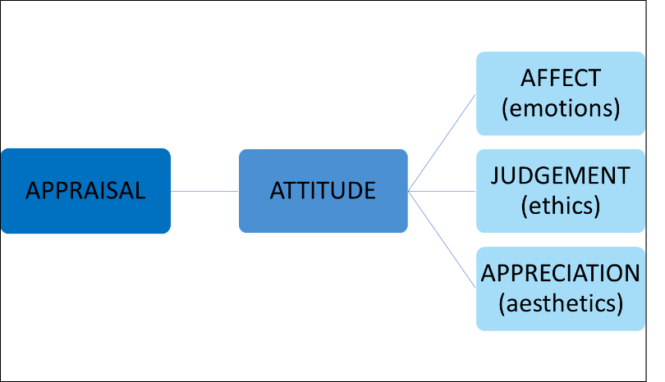
Eight undergraduate German-speaking translation students, trained in Appraisal Theory, manually annotated the dataset. Working in pairs, the students identified evaluative expressions in the source text and analysed the corresponding translation strategies. The annotation process consisted of four distinct steps: identifying evaluative expressions, annotating the Attitude type, annotating the translation strategy (equivalence or alteration), and annotating translationese effects (explicitation or implicitation). In the first step, identifying evaluative expressions, two annotators in each pair collaboratively identified evaluative expressions within the text. In the second step, annotating the Attitude type, a single annotator from each pair classified the identified expressions using the Appraisal framework, marking them according to their Attitude type (Affect, Judgment, or Appreciation). The students identified and marked single-word expressions bearing Appraisal. The third step involved annotating the translation strategy, where the annotators indicated the specific translation strategy used for each evaluative expression. Finally, in the fourth step, the annotators identified the translationese effects, noting where the translators used explicitation and implicitation. Our annotation scheme, based on Appraisal Theory, is presented in Figure 1. The same scheme was used by Imamovic et al. (2024) in their study on the annotation of Attitude within the Appraisal Theory using ChatGPT.
Figure 1: Appraisal scheme based on Appraisal Theory (Martin & White 2005)
In the final step, the students’ annotations were cross-checked and corrected by two trained linguists who agreed on the final assignment of the labels. We did not conduct an Inter-Annotator Agreement (IAA) test. Instead, we used expressions where students reached a consensus. Their annotations were then reviewed by two researchers, who discussed unclear cases and made a final decision.
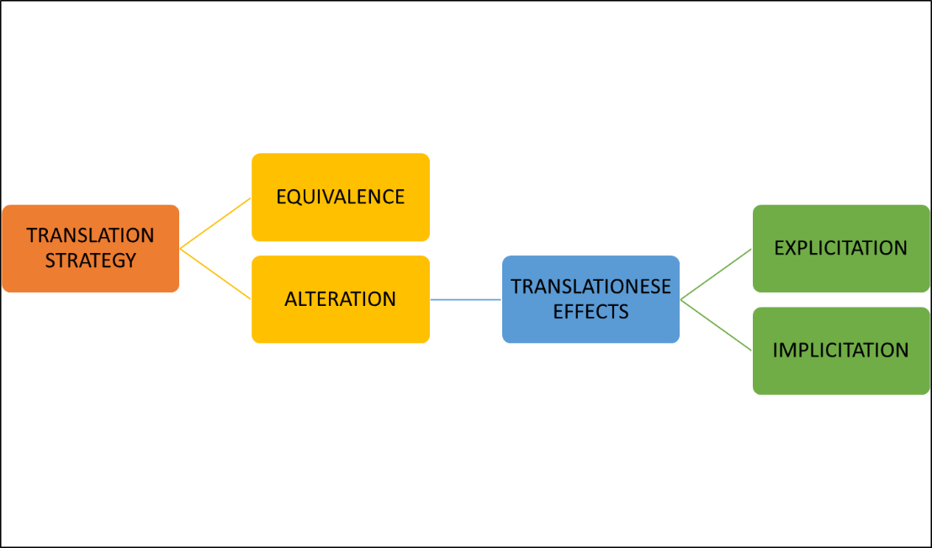
In this study, we consider the translation strategy alteration to lead exclusively to a translationese effect that falls into either the explicitation or implicitation category. That is, when translators use alteration, they either make the evaluative meaning more explicit in the target text or render it in a more neutral or implicit manner. Importantly, alteration does not result in translation effects such as shining through or normalisation. The scheme used for translation analysis is presented in Figure 2.
Figure 2: Translation analysis scheme including translation strategy and translationese effects
- Results and discussion
  - Translation strategy and effects of Attitude types on translation strategy
The annotators identified 305 evaluative expressions in a total of four texts. For these evaluative expressions, the results show that translators preferred systematic equivalence in translation over alteration. A total of 241 (79%) expressions were tagged as instances of equivalent translation versus 64 (21%) alterations out of the total 305 translated evaluative expressions. This is expected and in line with the TED talk translation guidelines. Moreover, the clear preference for equivalence is observed equally across all four texts, despite the variation in Attitude types across those texts as well as the number of evaluative instances found in the texts. Indeed, there was no significant variation between the texts concerning translation strategy (Chi² df = 3, p-value = 0.1462).
Although the sample consisted entirely of instances of evaluative language, these instances were distinguished by Attitude type, namely Affect, Judgement, and Appreciation. Unlike the translation strategy, the Attitude type varied substantially between texts. The distribution across the texts is presented in Figure 3, where red represents significant disassociation and blue represents association. The variation was tested with the Pearson Chi² (df = 6, p-value = 3.319e-10).
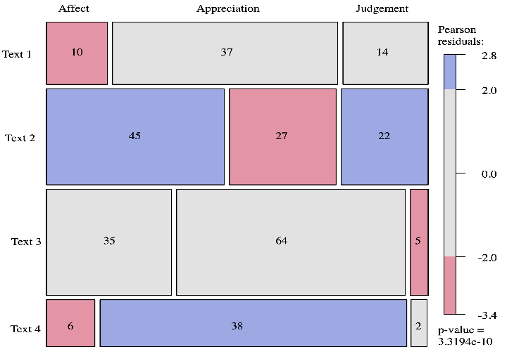
Figure 3: Variation of Attitude types between texts
The person residuals show that Text 1 is highly disassociated with Affect, while Text 2 is highly associated with Affect and Judgement but disassociated with Appreciation. Text 3 is disassociated with Judgement, whereas Text 4, the opposite of Text 1, is highly associated with Appreciation, yet disassociated with Affect. Note that this interpretation is based on the residuals, not the frequencies. The residuals are calculated with the Chi-square statistic and take into account the overall frequencies. They are determined by a comparison between observed frequencies and the frequencies that one would expect if there were no variations between the texts. This degree of variation between the texts needs to be borne in mind when interpreting and evaluating the results below, since any patterns observed for the effects of Attitude type on translation may be the result of text variation.
  - Translations of Attitude types and the impact of Attitude type on translationese
Next, we address the second research question, which examines the possible effects of Attitude type on translation strategies and translationese effects. Although the majority of evaluative expressions in the translations belong to the equivalence category, 64 instances belong to alteration. This number is non-negligible, especially given the explicit instructions to avoid alteration. We cannot know if this is related to the language function of evaluation since our sample consists exclusively of evaluative instances, but we need to determine if Attitude type played any role in translation strategy or translationese effects.
Firstly, we look at the possible effects of Attitude type on translation strategy. These results are striking in that there appears to be no significant difference between the translation strategies for each of the Attitude types (Chi² test, p-value = 0.8971, df=2). This suggests that the Attitude type expressed does not affect whether the translator uses a direct equivalence or some kind of alteration. Figure 4 presents the distribution of translation strategies concerning Attitude type.
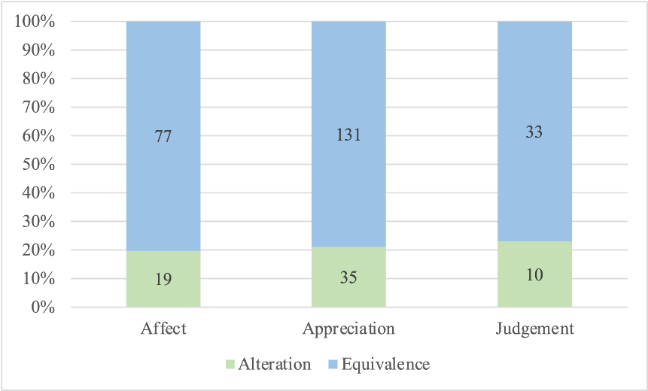
Figure 4: Attitude types across translation strategies
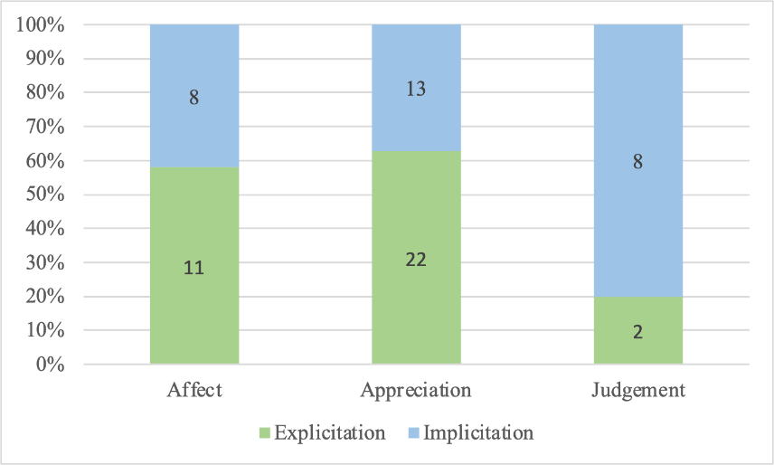
Finally, we consider translationese effects in situations where the translation strategy has been alteration. Two types of alteration were annotated: explicitation and implicitation. If we zoom in on just the evaluative utterances where the translator altered the expression, we do see a possible impact from the Attitude type of Judgement. Although not significant, with only eight occurrences of explicitation versus two occurrences of implicitation, it is potentially indicative of the effect of the expression of some Attitude type on translation (two-tailed Fisher Exact, p=0.06676). The occurrences in question are examined qualitatively below in Section 4.4. Figure 5 presents the distribution and proportions of Attitude type concerning translationese effects.
Figure 5: Attitude types across translationese effects
  - Qualitative analysis
In the next step, we perform a qualitative analysis of the observed translation patterns. The TED guidelines on translation explicitly say that if equivalence is not possible, then the translators should opt for implicitation in the target language. In this section, we analyse examples where the translators clearly deviated from the guidelines and instead chose an explicit translation.
The Judgment categories, within the context of the alteration translation strategy, were analysed qualitatively. Of the ten instances of Judgment, two were translated explicitly, while eight were rendered implicitly. We will first focus on the explicitations, i.e., instances where the translator did not follow the guidelines.
Regarding explicitation, the English words shaking and consequence were translated into German with zerstören (‘destroy’) and Resultat (‘result’), respectively; see the context from the dataset in examples (4) and (5) below. The two German equivalents are considered to be more explicit because of the more specific meaning they convey. According to the Duden dictionary (Duden 2025) the German verb zerstören has two meanings: 1) ‘damage/harm’ and 2) ‘ruin’, while the English verb to shake has ten different meanings in its transitive form in the Merriam Webster dictionary (Merriam-Webster n.d.), including ‘to lessen the stability’ or ‘to brandish’, but no meaning of ‘to damage’ or ‘to ruin’, which is stronger and much more specific in its meaning.
- Using Google Earth you can witness trawlers – in China, the North Sea, the Gulf of Mexico – shaking the foundation of our life support system, leaving plumes of death in their path.
Mit Hilfe von Google Earth kann man Trawler beobachten, in China, in der Nordsee, im Golf von Mexiko, die die Basis unseres Lebenserhaltungssystems zerstören und Todesstreifen hinterlassen.
‘With the help of Google Earth, one can observe trawlers – in China, in the North Sea, in the Gulf of Mexico – that are destroying the foundation of our life support system and leaving death zones behind.’
- This is the consequence of not knowing that there are limits to what we can take out of the sea.
Das ist das Resultat, wenn man nicht weiß, dass es Grenzen dafür gibt, was wir den Meeren entnehmen dürfen.
‘This is the result when one does not know that there are limits to what we are allowed to take from the seas.’
The English source word consequence used in (5) has four different meanings in the Merriam Webster dictionary (Merriam-Webster n.d.), including the meaning “something produced by a cause”, which is the closest correspondence to the German word Resultat (‘result’). However, here again, we observe a stronger and more specific meaning, as Resultat means ‘result’ or ‘outcome’ in a more specific way.
When examining the eight instances of Judgment translated as implicitation, we observed that the English words were more specific and had a stronger connotation, while their German equivalents were rendered more neutrally. Examples of such words include concern, care, trawling, drowned down, stripped and critical. We will illustrate the translation of critical and concern in examples (6) and (7).
- We need to get out ahead of fishing impacts and work to understand this critical part of the ocean.
Wir müssen dem Schaden durch die Fischerei zuvorkommen und daran arbeiten, diesen wichtigen Teil des Ozeans zu verstehen.
‘We must prevent the damage caused by fishing and work on understanding this important part of the ocean.’
The word critical means ‘vital’, ‘indispensable’ or ‘crucial’, whereas its German equivalent used in the translation under analysis means just ‘important’ (see example (6)).
- I want to share with you my personal view of changes in the sea that affect all of us, and to consider why it matters that in 50 years, we’ve lost – actually, we’ve taken, we’ve eaten – more than 90 percent of the big fish in the sea; why you should care that nearly half of the coral reefs have disappeared; why a mysterious depletion of oxygen in large areas of the Pacific should concern not only the creatures that are dying, but it really should concern you.
Ich möchte mit Ihnen meine persönliche Sicht auf die Veränderungen des Meeres teilen, die uns alle betreffen, und überlegen, warum es von Bedeutung ist, dass wir in 50 Jahren mehr als 90 Prozent der großen Meeresfische verloren haben oder genauer gesagt: genommen und gegessen haben. Warum es uns etwas ausmachen sollte, dass fast die Hälfte der Korallenriffe verschwunden sind, warum der rätselhafte Rückgang an Sauerstoff in großen Teilen des Pazifiks nicht nur die Kreaturen betreffen sollte, die dort sterben, sondern auch Sie.
‘I would like to share with you my personal view on the changes in the sea that affect us all, and reflect on why it matters that, in 50 years, we have lost more than 90 percent of the large ocean fish—or more precisely: taken and eaten them. Why it should matter to us that almost half of the coral reefs have disappeared, why the mysterious decline in oxygen in large parts of the Pacific should not only affect the creatures that die there, but also you.’
In example (7), the English verb concern, which may mean both ‘to be related to’ and ‘to be a care/a trouble’, is repeated twice, leaving space for the reader to interpret the meaning. The German verb betreffen has only the meaning of ‘to be related to’ and no further meaning containing ‘care’ or ‘trouble’. In this way, although the German translation is more specific, it differs in its connotation from the English original, as the meaning of ‘care’ and ‘trouble’ gets lost in translation.
However, overall, it is impossible to draw firm conclusions about explicitation and implicitation in terms of evaluation at this point, as no clear or predictable translation patterns can be established when looking at the translations. However, we can observe that emotionally charged words were occasionally translated more explicitly in German (2 times), but more frequently, they were downtoned (8 times). Further data would be necessary to make more definitive conclusions, which we intend to address in our future studies.
- Conclusion and future work
In this study, we analyse the translation of evaluative expressions in TED talks through the lens of Appraisal Theory, with a focus on how different types of Attitude (Affect, Judgment, and Appreciation) are translated from English into German. The analysis has revealed that the majority of the Appraisal expressions were translated as direct equivalents, which is consistent with the translation guidelines provided to TED translators, in which they state that equivalence should be aimed for. However, we also show that, despite these instructions, a substantial number of expressions were altered. We interpret these alterations as cases of implicitation or explicitation.
Our findings indicate that the distribution of Attitude types across the four TED talks did not significantly affect the choice of translation strategy. Moreover, no significant differences were observed in the use of Attitude types across the texts. We show that the preferred translation strategy is equivalence, which maintains the evaluative intent of the source text while adapting to the linguistic norms of the target language. Most of the Appraisal expressions in our dataset are translated as the closest counterpart, and this holds regardless of the Attitude type. The majority of evaluative expressions (79%) were translated as direct equivalents from English into German. This suggests that translators generally adhered to the guidelines provided by TED, in which they directly transferred the evaluative expressions to the target language. However, the remaining 21% of expressions involved either implicitation or explicitation, suggesting that the translators occasionally chose either to translate the expressions more explicitly in German or a more neutral manner. It would be important to consider whether there were other alternatives, i.e. if the translators chose lexical items that were more frequent in the same contexts in the target language or if they did it for other pragmatic reasons. However, this aspect falls outside the scope of this study.
The qualitative analysis shows that most of the alteration cases of the Judgment expressions in our dataset were implicitly translated. This suggests that while the general trend was toward equivalence, Judgment expressions might be more prone to downtoning evaluation in translation. However, due to our small data sample and great variation between texts, it is hard to make any broad generalisations.
In our future work, we aim to expand the current analysis to a larger dataset. We plan to use the patterns from manual annotation to formulate queries for a larger quantitative analysis. Then, we plan to employ an automated emotional intensity scoring system for the English texts, which will assign emotion scores ranging from 1 to 5 to specific lexical items. Once the emotion scores have been assigned, the next step is to extract the corresponding sentences from the corpus that contain these emotionally charged expressions, along with their German translations. In this way, a systematic analysis of the translations will be conducted to assess how the emotional intensity is either preserved or altered in the German language.
- Limitations
Our results contribute to a better understanding of cross-linguistic differences in expressing evaluation and offer practical insights for translators focusing on this language pair. However, several limitations should be considered in this study. First, the English transcripts were annotated by students who are non-native English speakers, which may have impacted their comprehension of evaluative meanings. The students’ proficiency in English could have influenced their ability to interpret and annotate the evaluative expressions. Second, in the German translations, evaluative expressions were not annotated in terms of their specific Attitude types. Instead, the analysis focused on whether these expressions were altered, omitted, or directly translated. In our future research, we plan to investigate how different types of attitudes are expressed and transferred in translations.
Additionally, the training phase and the refinement of the annotation guidelines were time-consuming processes, which may have affected the efficiency of the annotation process. Furthermore, the results of this study are specific to the texts analysed and cannot be generalised to other text types or genres.
It is also important to mention that in our study, we did not fully consider the context surrounding the evaluative expressions in the source or target text. However, the natural collocations of evaluative expressions may differ between the two languages, which could explain some of the results. Although this was beyond the scope of this study, analysing the context in more detail could prove very insightful and would be a promising avenue for future research. Also, it would be valuable to include non-evaluative instances alongside evaluative expressions to examine whether, and to what extent, evaluative language influences the choice of translation strategies.
Finally, expanding the study by involving a larger number of human annotators and including more texts would be advisable to increase the robustness and applicability of the findings. In our future studies, we also plan to analyse the differences between translated and non-translated texts, specifically German translations of TED talks and German original TED talks.
References
Bąk, Halszka. 2023. Issues in the translation equivalence of basic emotion terms. Ampersand 11: 100128. doi: 10.1016/j.amper.2023.100128.
Baker, Mona. 1993. Corpus linguistics and translation studies. Implications and applications. In Baker, Mona & Francis, Gill & Tognini-Bonelli, Elena (eds.), Text and Technology. In Honour of John Sinclair. Amsterdam: John Benjamins. 233–50.
Duden. 2025. Duden online. Cornelsen Verlag GmbH. (https://www.duden.de.) (Accessed 2024-19-12).
Fronhofer, Nina-Maria. 2020. Emotion concepts in context – a contrastive analysis of English and German discourse. Augsburg: Universität Augsburg. (Doctoral dissertation.)
Gellerstam, Martin. 1986. Translationese in Swedish novels translated from English. In Wollin, L. & Lindquist, H. (eds.), Translation Studies in Scandinavia. Lund: CWK Gleerup. 88–95.
Hansen-Schirra, Silvia & Neumann, Stella & Steiner, Erich. 2012. Cross-linguistic corpora for the study of translations. Insights from the Language Pair English-German. Berlin: de Gruyter.
Hoek, Jet & Evers-Vermeul, Jacqueline & Sanders, Ted JM. 2015. The role of expectedness in the implicitation and explicitation of discourse relations. In Proceedings of the Second Workshop on Discourse in Machine Translation (DiscoMT), 17 September 2015. Lisbon, Portugal. 41–46.
House, Juliane. 2006. Communicative styles in English and German. European Journal of English Studies 10: 249–67.
Imamovic, Mirela & Deilen, Silvana & Glynn, Dylan & Lapshinova-Koltunski, Ekaterina. 2024. Using ChatGPT for annotation of attitude within the Appraisal Theory. Lessons learned. In Proceedings of the 18th Linguistic Annotation Workshop (LAW-XVIII). St. Julians, Malta: Association for Computational Linguistics. 112–23.
Klaudy, Kinga. 2008. Explicitation. In Baker, Mona & Saldanha, Gabriela (eds.), Routledge encyclopedia of translation studies (2nd edition). London: Routledge. 104–08.
Klaudy, Kinga & Károly, Krisztina. 2005. Implicitation in translation. Empirical evidence for operational asymmetry in translation. Across languages and cultures 6(1): 13–28.
Kranich, Svenja. 2016. Contrastive Pragmatics and Translation. Amsterdam: John Benjamins Publishing.
Merriam-Webster. n.d. (https://www.merriam-webster.com/dictionary.) (Accessed 2024-19-12).
Meyer, Thomas & Webber, Bonnie. 2013. Implicitation of discourse connectives in (machine) translation. Proceedings of the Workshop on Discourse in Machine Translation (DiscoMT), August 9, 2013. Sofia: Bulgaria: Association for Computational Linguistics. 19–26.
Mohammad, Saif M. & Salameh, Mohammad & Kiritchenko, Svetlana. 2016. How translation alters sentiment. J. Artif. Int. Res. 55(1): 95–130.
Olohan, Maeve & Baker, Mona. 2000. Reporting that in translated English. Evidence for subconscious processes of explicitation? Across languages and cultures 1(2): 141–58.
Oster, Ulrike. 2023. Translating emotions. A corpus-based study of the conceptualization of ANGER in German-Spanish translation. Languages in Contrast 23(2): 199–225. doi: 10.1075/lic.00027.ost.
Qian, Shenbin & Orasan, Constantin & Do Carmo, Felix & Li, Qiuliang & Kanojia, Diptesh. 2023. Evaluation of Chinese-English machine translation of emotion-loaded microblog texts. A human annotated dataset for the quality assessment of emotion translation. In Proceedings of the 24th Annual Conference of the European Association for Machine Translation. Tampere, Finland: European Association for Machine Translation. 125–35.
Salameh, Mohammad & Mohammad, Saif & Kiritchenko, Svetlana. 2015. Sentiment after translation. A case-study on Arabic social media posts. In Proceedings of the 2015 Conference of the North American Chapter of the ACL: Human Language Technologies. Denver, Colorado: Association for Computational Linguistics. 767–77.
Sugimoto, Cassidy R. & Thelwall, Mike & Larivière, Vincent & Tsou, Andrew & Mongeon, Philippe & Macaluso, Benoit. 2013. Scientists popularizing science: Characteristics and impact of TED Talk presenters. PLoS ONE 8(4): e62403. doi:10.1371/journal.pone.0062403.
TED. n.d. TED Translation guidelines. (https://www.ted.com/participate/translate/guidelines) (Accessed 2025-16-09).
Teich, Elke. 2003. Cross-linguistic variation in system and text. A methodology for the investigation of translations and comparable texts. Berlin: de Gruyter.
Thormodsæter, Øyvind. 2021. The idiomaticity of emotion in English and Norwegian. A corpus-based contrastive investigation of the phraseology of the three English-Norwegian verb pairs enjoy-nyte, love-elske, and like-like. Oslo: University of Oslo. (Doctoral dissertation.)
Toury, Gideon. 1995. Descriptive translation studies and beyond. Amsterdam: John Benjamins.
Troiano, Enrica & Klinger, Roman & Pado, Sebastian. 2020. Lost in back-translation. Emotion preservation in neural machine translation. In Proceedings of the 28th International Conference on Computational Linguistics (online). Barcelona, Spain. 4340–54.
Zufferey, Sandrine & Cartoni, Bruno. 2014. A multifactorial analysis of explicitation in translation. Target. International Journal of Translation Studies 26(3): 361–84.
Mirela Imamović
Lübecker Str. 3
31141 Hildesheim
Germany
e-mail: imamovic@uni-hildesheim.de
Silvana Deilen
Lübecker Str. 3
31141 Hildesheim
Germany
e-mail: deilen@uni-hildesheim.de
Ekaterina Lapshinova-Koltunski
Lübecker Str. 3
31141 Hildesheim
Germany
e-mail: lapshinovakoltun@uni-hildesheim.de
Dylan Glynn
2 Rue de la Liberté
93200 Saint-Denis
France
e-mail: dsg.up8@gmail.com

https://www.ted.com/
https://www.ted.com/participate/translate/guidelines

