Cognitive load in translating ideological texts: An eye-tracking study of translators’ pupil diameter
Fatemeh Parham, Allameh Tabataba’i University
Mina Mirzaee, Allameh Tabataba’i University
Abstract
This study investigates the potential effect of translators’ ideology and cognitive abilities on their cognitive load during the translation process. An eye-tracking experiment was conducted to examine how translators’ cognitive load – measured by average pupil diameter – varied based on their ideological positioning, as reflected in their national identity, when instructed to translate texts according to the standards of the Islamic Republic of Iran Broadcasting (IRIB). Eight participants were selected to complete ten translation tasks involving ideologically loaded texts. The experiment took place in the Cognitive Laboratory at the University of Tehran, Iran. Cognitive load was assessed through pupil diameter measurements. Following the translation tasks, participants completed a national identity questionnaire as an indicator of ideological alignment, as well as a cognitive ability test. The findings indicate that both ideology and cognitive ability significantly influenced average pupil diameter, suggesting that translators experienced higher cognitive load when their ideological stance aligned with the translation brief and when they possessed higher cognitive capacity.
Keywords: National identity; Ideology; Eye-tracking; Cognitive load; Pupil diameter
- Introduction
The notion of ideology is often associated with a set of beliefs, assumptions, and values, which has rendered it a highly debated and contentious topic (Rojo López & Ramos Caro 2014). The role of ideology in shaping the translation process has been extensively discussed in academic discourse (Brook 2012). Ideology in translation manifests not only in the translated text itself but also in the translator’s voice, perspective, and the broader significance of the text for the target audience. Consequently, translation decisions are influenced by translators’ cultural affiliations and ideological positions, which may not always align with dominant power structures (Tymoczko 2003).
Group ideologies emerge within specific societal contexts, reflecting the underlying structure of a given society. The ideological identity of a group serves to classify its members, defining inclusion and exclusion criteria as well as the behaviors expected for membership (Van Dijk 1995). In this sense, national identity can be understood as an ideological construct.
Munday (2008) argues that translation and interpreting are not only communicative and textual activities, but also cognitive processes undertaken by translators and interpreters. Cognitivism emphasizes the role of complex mental processes in shaping human behavior, making cognitive mechanisms a key area of study in translation research (Anderson 1995). Ideologies play a crucial role in social cognition, positioned at the intersection of individual and societal domains. They influence cognitive processes among group members, affecting discourse planning and comprehension (Van Dijk 1995).
In a 2014 study, Rojo López and Ramos Caro examined the impact of translators’ ideological stances on their translation processes, particularly in terms of the time required to find suitable translations for ideologically charged terms. Their findings indicated that when translators encountered words or expressions that conflicted with their personal ideologies, decision-making was impeded, resulting in longer search times for appropriate translations. Rojo (2015) further highlights that translation scholars have sought to understand how translators process entire texts during translation. To explore this, researchers have turned to psycholinguistic methodologies, employing tools such as eye-tracking technology. By analyzing translators’ eye movements, researchers can gain valuable insights into cognitive load and decision-making processes. Cognitive load—also referred to as cognitive effort—denotes the extent of cognitive resources allocated to completing translation tasks (Vieira 2016).
To investigate cognitive effort in translation more precisely, scholars have increasingly adopted eye-tracking technology—a method that allows researchers to observe real-time reading and decision-making behaviors. Eye-tracking provides access to various cognitive indicators such as gaze duration, fixations, saccades, and pupil dilation, all of which contribute to a nuanced understanding of the translator’s mental workload (Hvelplund 2011). Krings (2001) used eye-tracking to explore problem-solving strategies in translation, providing a deeper understanding of how translators approach complex tasks. Vieira (2016) examined the cognitive effort required in post-editing machine translation outputs. The study revealed that post-editing demands significant cognitive resources, as evidenced by increased fixations and longer gaze durations, and it also highlighted the problem-solving strategies involved in comparing and correcting machine translations. Arabbeigi (2021) combined EEG and eye-tracking technologies to examine the cognitive processes of professional and non-professional translators. The findings suggested that professional translators, due to their greater experience and familiarity with translation tools, manage cognitive load more effectively, divide attention more efficiently, and address translation challenges with greater proficiency.
In the domain of audiovisual translation, Zahedi and Khoshsaligheh have conducted a number of empirical studies using eye-tracking to explore how viewers process subtitles. In a 2022 study, they challenged earlier findings suggesting that two-line subtitles inherently attract more attention than one-line subtitles. They argued that prior conclusions might have been confounded by differences in subtitle length rather than line number. Using an SMI eye-tracker to monitor the eye movements of 32 Iranian viewers while watching a subtitled scene from A Prophet (2009), they found that, when length was controlled, viewers paid significantly more attention to one-line subtitles. Furthermore, longer subtitles attracted more attention than shorter ones, regardless of line number. Retrospective interviews indicated that participants generally preferred shorter and two-line subtitles.
In their 2019 study, Zahedi and Khoshsaligheh examined attention allocation to lexical and functional words in subtitles. The eye-tracking data showed that content words received significantly more attention than function words, as reflected in higher fixation durations, greater fixation counts, and longer first fixations. Conversely, function words were skipped more frequently, suggesting a differential pattern of cognitive processing based on word type. Their 2025 study turned to the subtitling strategy of inserting humor even when the source dialogue is not humorous. They used eye-tracking to assess viewers’ attention allocation while watching a humorous and a non-humorous version of the same scene from Superchondriac (2014). The results revealed that humorous subtitles elicited significantly greater viewer attention than their non-humorous counterparts. Interviews showed that some viewers appreciated the added humor, which they found culturally resonant and entertaining, while others found it distracting, confusing, or ideologically misaligned. In a 2020 study, the same authors used eye-tracking to investigate whether Persian subtitles written with full or half space between words affected viewers’ reading behavior. 32 participants watched two French films, each with two versions of subtitled segments: one using half spaces and the other using full spaces. Although the statistical difference was not significant, words written with full space attracted more attention. Heatmap analysis suggested that the visual split introduced by the full space led viewers to perceive the components as separate elements, disrupting holistic word recognition.
On the other hand, many studies have explored ideology and national identity in translation. For instance, Mousavi Razavi & Allahdaneh (2018) investigated translation strategies for cultural elements in Iranian “resistance” literature and found that retention was the most commonly used strategy. Moreover, studies by Ahmadi & Parham (2022), Parham (2019), and Farahzad & Ehteshami (2011) have addressed issues of identity and national identity in translation, examining both verbal and non-verbal elements as reflected in texts and paratexts. These studies explore how cultural, social, and political factors influence the representation of identity in translation, focusing on the interplay between language, culture, and the translator’s role in shaping national and personal identities. Through their analysis of various textual forms and accompanying paratexts, they demonstrate how translation practices can either reinforce or challenge dominant cultural narratives and ideologies.
To date, however, no research in Iran has examined the ideology or national identity of translators using a cognitive approach. The present study addresses this gap by employing eye-tracking technology to investigate the impact of translators’ ideology and national identity on the cognitive load they experience during translation. Specifically, by analyzing changes in pupil diameter, the study aims to show how ideology, as expressed through national identity, influences the cognitive effort involved in translating ideologically charged texts.
- Method
  - Aim and hypothesis
The current study examines the effect of translators’ ideologies, which is reflected in their national identity score, on their cognitive load when translating ideologically loaded texts in line with the Islamic Republic of Iran Broadcasting (IRIB) standards. The IRIB standards constitute a set of regulatory guidelines designed to ensure that media content, including translations, aligns with the country’s Islamic values, political ideologies, and national identity. These guidelines prioritize the representation of religious principles and the reinforcement of state-approved cultural and political narratives. As a result, content that conflicts with these ideological frameworks is subject to modification or censorship. IRIB standards thus play a significant role in shaping translation practices, mandating that translated materials conform to these cultural and ideological norms. In the present study, all participants were educated Iranian citizens who were already well-acquainted with the IRIB standards. Therefore, simply informing them that the translations should adhere to these standards was sufficient to ensure their understanding of the expectations and requirements.
This study utilizes the methodology proposed by Rojo López & Ramos Caro (2014), modifying the design and variables to align with the objectives of the current research. Rojo & Ramos (2014) established that a translator’s ideology significantly affects their translation speed and accuracy. Words that oppose a translator’s ideological views may slow the translation process and cause delays, while words that align with their views can expedite the process.
Drawing on the work of Rojo López & Ramos Caro (2014), it was hypothesized that translators with higher national identity scores would demonstrate lower cognitive load, as indicated by smaller pupil diameters, when translating texts in alignment with the IRIB standards. This hypothesis is supported by previous findings indicating that pupil dilation serves as a reliable index of cognitive processing load, with larger pupil diameters associated with greater cognitive demands such as memory retrieval, language comprehension, and attentional control (Mihelčič & Podlesek 2023). Furthermore, since the cognitive load experienced during task performance is influenced by an individual’s cognitive abilities, a second hypothesis posited that translators with higher cognitive ability would experience lower cognitive load. This assumption aligns with research in cognitive load theory, which suggests that individuals with greater cognitive capacity or expertise can manage cognitive demands more efficiently (Sweller et al. 2011).
  - Participants
The study involved eight native Persian speakers, all of whom were students of English translation at Allameh Tabataba’i University in Iran. The sample included one female PhD candidate, three female Bachelor’s degree graduates, and four male Master’s students, with ages ranging from 23 to 46.
The number of participants was limited due to the high costs and technical demands associated with cognitive studies, particularly those involving eye-tracking technology. Additionally, recruiting a more homogeneous group was not feasible, as participation in such studies typically attracts only a limited number of volunteers. Although the sample is somewhat heterogeneous in terms of academic level and age, given the exploratory nature of the study, this variation can contribute to a broader understanding of the phenomena under investigation.
Before participating in the study, all individuals provided informed consent, acknowledging that their participation was voluntary. They were assured of the anonymity of their data and informed of their right to withdraw from the study at any time without any consequences. To ensure the accuracy and reliability of the eye-tracking data, participants’ visual acuity was evaluated to confirm normal or corrected-to-normal vision, thereby minimizing potential biases associated with visual impairments.
  - Instruments
This study utilized a combination of tools to collect data, including an eye-tracker, translation tasks, and two questionnaires. Each instrument is described in detail below.
    - Eye-tracker
The eye-tracking device used was the Tobii TX300, a screen-mounted system with a sampling frequency of 300Hz, a reported accuracy rate of 4%, and a precision rate of 3%. The system was positioned at the bottom of a computer monitor and featured four purple indicator lights for participant identification. Data collected by the device was accessible in both MS Excel and MP4 video formats.
    - Translation tasks
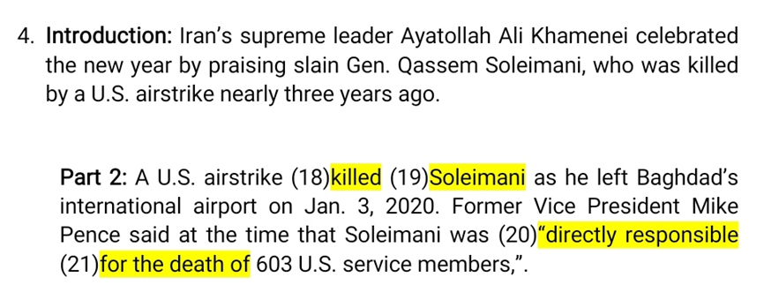
Ten translation tasks were developed for this study, each consisting of two English text segments sourced from the Fox News Media website. These texts were carefully selected for their inclusion of ideologically loaded terms and expressions, which were subsequently categorized according to the subcomponents of the national identity questionnaire: cultural, linguistic, social, political, territorial, and religious. Figure 1 illustrates how ideological terms and expressions were marked based on the cultural component of the national identity questionnaire.
Figure 1: Sample task – researcher version
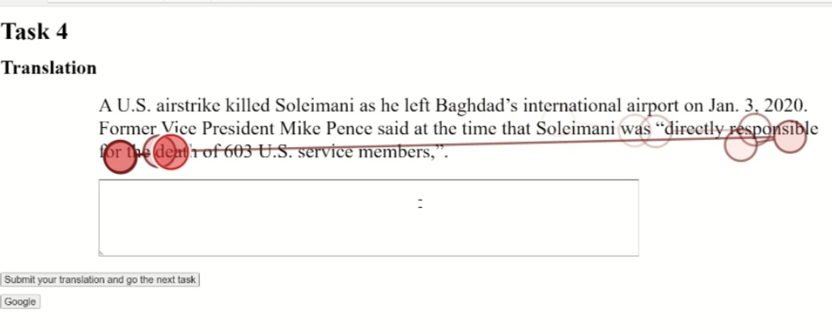
In each of the ten tasks, the initial segment provided the contextual background, referred to as the introduction (see Figure 2), while the subsequent segment was designated for translation into Persian by the participants, termed translation (see Figure 3). The cumulative word count for these translation segments across all ten tasks was 355 words. The creation of these tasks involved the use of Tobii Pro Lab 181.1 Software, which was employed to encode ideological terms and expressions, with this information kept confidential from the participants. This encoding allowed for later identification and analysis of these terms using data from the eye-tracker.
Figure 2: Sample task, introduction part – participant version
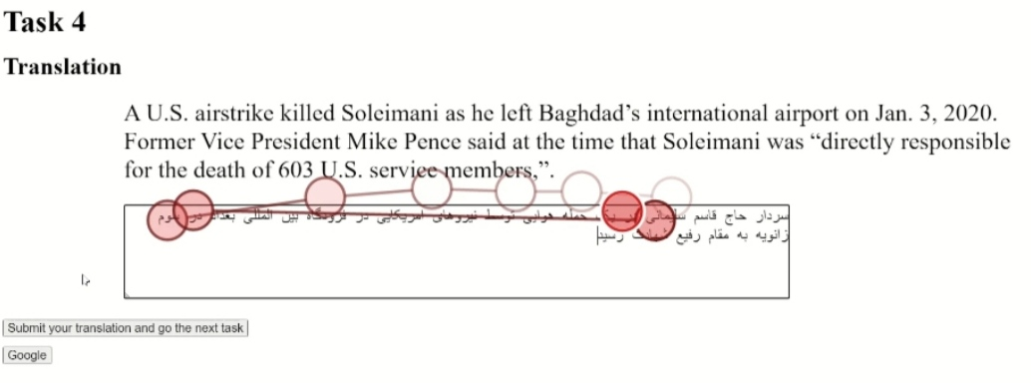
Figure 3: Sample task, translation part – participant version
    - National Identity Questionnaire
To assess the participants’ ideological positioning, the study employed the National Identity Questionnaire developed by Rastegar & Rabani (2013) in the field of sociology. Although not originally designed for translation studies, this instrument was selected for its relevance to the study’s focus on national identity as a form of ideological representation. Drawing on Van Dijk’s (1998) conceptualization of ideology as the foundation of social identity and group interests, national identity in this study is understood as a construct that reflects both individual and collective dimensions of belonging. Specifically, it is defined as a unique part of our identity that allows us to recognize our cultural and political self within a specific territory. It has both an individual or mental aspect and a collective one. National identity is a shared feeling among people who naturally belong together and have common interests, history, and destiny (Rastegar & Rabani 2013).
The questionnaire includes 25 items across six thematic domains: Cultural (items 1–8), Linguistic (items 9–12), Social (items 13–16), Political (items 17–19), Territorial (items 20–22), and Religious (items 23–25). These domains collectively capture various aspects of national identity, providing a comprehensive measure of the participants’ ideological orientation. While the questions are designed to address key dimensions of national identity, they are carefully worded to avoid sensitive topics that could cause discomfort or anxiety. By steering clear of controversial or overtly political and religious issues, the questionnaire ensures that participants feel safe and comfortable providing honest answers. The responses were quantified using a Likert scale to gauge the extent of agreement or identification with each item.
The questionnaire was administered after the completion of the translation tasks, following a ten-minute rest period in the laboratory. Participants were assured of the confidentiality and anonymity of their responses to further reduce response bias and promote candid participation.
    - Cognitive Abilities Questionnaire
In addition to the National Identity Questionnaire, the study utilized the Cognitive Abilities Questionnaire, developed by Nejati (2013) in the field of cognitive psychology. This instrument is designed to measure participants’ cognitive abilities across seven key components: Memory (items 1-6), Inhibitory Control and Selective Attention (items 7–12), Decision-making (items 13–17), Planning (items 18–20), Sustained Attention (items 21–23), Social Cognition (items 24–26), and Cognitive Flexibility (items 27–30). The questionnaire consists of 30 items in total, each assessing a distinct aspect of executive functioning. Participants’ cognitive abilities were quantified based on their responses to these items, providing a comprehensive measure of their cognitive performance.
The Cognitive Abilities Questionnaire employs a five-point Likert scale, where participants rate each statement from 1 (almost never) to 5 (almost always), with reverse scoring applied to items 24, 25, and 26. This scoring system allows for an in-depth assessment of cognitive functions related to memory, attention, decision-making, and flexibility. The questionnaire was administered to participants after completing the translation tasks, following a ten-minute rest period in the laboratory to ensure that their cognitive performance was not influenced by fatigue. Responses to this questionnaire were kept confidential, with participants assured that their answers could not be traced back to them personally.
  - The pilot study
The pilot study involved one participant and initially included 18 tasks, encompassing a total of 730 words for translation. The pilot was conducted in the laboratory setting under the supervision of two neuroscience specialists. The findings from the pilot indicated that the study design required modifications. Specifically, the duration of the experiment was excessively long, with the participant needing approximately two hours to complete all 18 tasks. Additionally, the keyboard failed to correctly display the Persian alphabet labels. As a result, the number of tasks was reduced to ten, and the keyboard was replaced to improve accuracy and minimize participant fatigue.
  - Data collection
The study was conducted in the Cognitive Laboratory at the Faculty of Psychology and Education, University of Tehran, Tehran, Iran. Participants arrived at the laboratory as scheduled, ensuring a smooth and timely process. The eye-tracking laboratory was specifically designed to provide a quiet, controlled environment with standardized lighting, essential for minimizing distractions and ensuring the accuracy of the data. The laboratory was equipped with two critical systems: an eye-tracker and a computer running the necessary software for data collection.
To ensure optimal data quality, the participants were instructed before the experiment to refrain from using any eye or eyebrow makeup on the day of the experiment, as such products could interfere with the eye-tracker’s ability to capture accurate data. Additionally, participants were informed that long eyelashes could obstruct the eye-tracker’s functionality, emphasizing the importance of these precautions.
Upon arrival at the laboratory, participants were given a tour of the eye-tracking setup. They were shown two computers: One was dedicated to the eye-tracker system, which participants would use during the experiment, and the other was reserved for researchers to operate the eye-tracking software and monitor data collection in real time. After the tour, participants were provided with a set of five key instructions for the experiment. They were instructed to complete the translation tasks in accordance with the IRIB standards and to align their work with the national belief system. Participants were also informed that there was no time limit for completing the tasks, allowing them to work at their own pace. The internet was made available for research purposes, and participants were encouraged to notify the researchers of any technical difficulties they encountered. They were also asked to leave personal electronic devices, including mobile phones and smartwatches, outside the laboratory to minimize distractions and ensure the integrity of the experiment.
Once the instructions were given, laboratory specialists began the process of calibrating the eye-tracking equipment through some tasks. These tasks included maintaining a fixed horizontal gaze, blinking, and tracking the moving circle. While participants performed these tasks, laboratory specialists adjusted and verified the calibration of the equipment.
After calibration, participants proceeded with the translation tasks, which were completed using the eye-tracking system. The system automatically stopped once the translation tasks were finished. After completing the tasks, participants were given a fifteen-minute break and were then asked to fill out the two questionnaires. At this point, participants were unaware of the study’s specific objectives and were only instructed to complete the translation tasks and the questionnaires. They were reassured that their responses to the questionnaires would be kept confidential, ensuring they could answer honestly without concern for any repercussions.
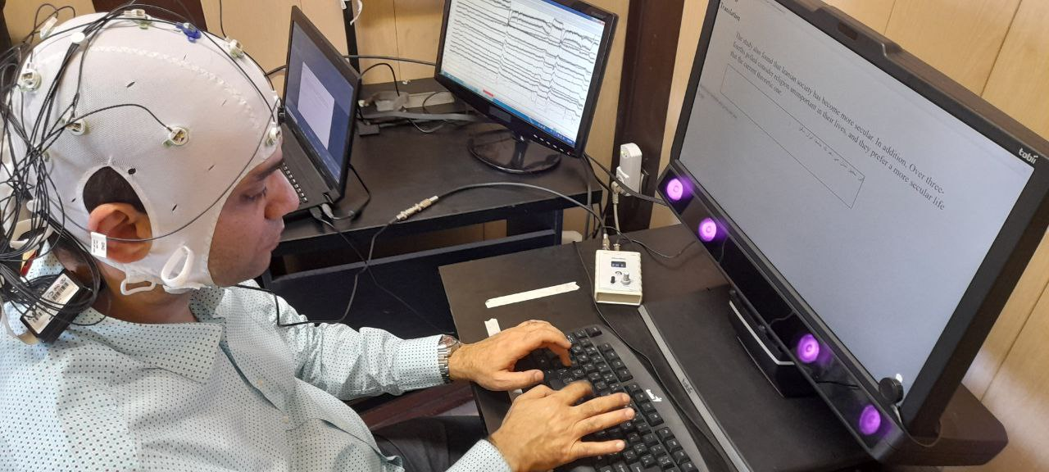
Alongside the eye-tracking system, an electroencephalography (EEG) device was also used to collect data on participants’ brain activity during the translation tasks. Although both eye-tracking and EEG data were gathered simultaneously, the present study focuses solely on the analysis of the eye-tracking results. Figure 4 illustrates a participant engaged in the experimental setup, seated at the eye-tracking station while wearing the EEG cap, offering a visual representation of the data collection environment in the laboratory.
Figure 4: A participant in the laboratory
- Results and discussion
As delineated in the preceding sections, the participants’ ideological positioning was evaluated using the National Identity Questionnaire. This instrument implemented a five-point Likert scale to measure responses. The scoring rubric was as follows: responses of strongly agree were assigned a score of 1; agree was assigned a score of 2; neutral received a score of 3; disagree was given a score of 4; and strongly disagree was assigned a score of 5. An example statement from the questionnaire is “I feel connected to Iran’s history”.
Table 1 presents the national identity scores of participants across six components: Cultural, Linguistic Social, Political, Territorial, and Religious. Each row corresponds to an individual participant, with each column indicating their score in one of these components. For example, Participant 3 scored 18 in the Cultural component, 4 in Linguistic, 13 in Social, 15 in Political, 14 in Territorial, and 15 in Religious, yielding a total score of 79. These scores offer insight into how participants relate to different components of national identity.
Table 1: Participants’ National Identity Scores
Row Labels | Cultural | Linguistic | Social | Political | Territorial | Religious | Total | National Identity Level
Participant 1 | 17 | 5 | 17 | 10 | 6 | 11 | 66 | High
Participant 2 | 22 | 7 | 18 | 13 | 12 | 10 | 82 | Low
Participant 3 | 18 | 4 | 13 | 15 | 14 | 15 | 79 | Low
Participant 4 | 19 | 6 | 10 | 8 | 7 | 6 | 56 | High
Participant 5 | 19 | 7 | 13 | 14 | 11 | 12 | 76 | Low
Participant 6 | 15 | 7 | 15 | 9 | 7 | 8 | 61 | High
Participant 7 | 13 | 6 | 12 | 7 | 4 | 4 | 46 | High
Participant 8 | 19 | 4 | 19 | 13 | 13 | 12 | 80 | Low
Subsequently, the median was calculated for each component of the questionnaire as well as for the overall national identity score across all participants. The median total score was 71, with individual scores ranging from 46 to 82. Each participant’s total score was then compared to this median. Scores above 71 were categorized as representing a lower level of national identity, while those below 71 were considered to indicate a higher level of national identity. In other words, a score below the median was interpreted as indicative of a high level of national identity, reflecting a strong congruence with the country’s national values. Conversely, a score above the median was regarded as indicative of a low level of national identity, suggesting a deviation from the prevailing national beliefs. For instance, Participant 2, who scored 82 on the National Identity Questionnaire, exceeded the median score of 71, thereby reflecting an ideological stance that diverges from the country’s national values. In contrast, Participant 6, with a score of 61, exhibited a high level of alignment with national beliefs.
Table 2 presents the cognitive abilities scores of participants across seven components of executive functioning. Each row corresponds to a single participant, while each column reflects scores for specific cognitive components: Memory, Inhibitory Control and Selective Attention, Decision-making, Planning, Sustained Attention, Social Cognition, and Cognitive Flexibility. For instance, Participant 4 received scores of 12 in Memory, 18 in Selective Attention, 6 in Decision-making, 8 in Planning, 14 in Social Cognition, and 9 in Cognitive Flexibility, resulting in a total score of 78. Following data compilation, the median score was calculated for each component, as well as for the overall cognitive abilities score across all participants. The median total score was 72.42, with scores ranging from 58 to 90. Each participant’s total score was then compared to this median. Scores above 72.42 were classified as indicating a lower level of cognitive abilities, while those below this threshold were considered indicative of a higher level of cognitive abilities. For example, Participant 7 obtained a total score of 64, which falls below the median and thus reflects a high level of cognitive abilities. In contrast, Participant 8’s score places them in the low cognitive abilities category.
Table 2: Participants’ Cognitive Abilities Scores
Participant | Memory | Selective Attention | Decision Making | Planning | Sustained Attention | Social Cognition | Cognitive Flexibility | Total | Cognitive Abilities Level
Participant 1 | 10 | 13 | 11 | 6 | 13 | 14 | 11 | 78 | Low
Participant 2 | 10 | 11 | 7 | 6 | 7 | 10 | 7 | 58 | High
Participant 3 | 10 | 16 | 7 | 3 | 4 | 13 | 9 | 62 | High
Participant 4 | 12 | 18 | 6 | 8 | 8 | 14 | 9 | 75 | Low
Participant 5 | 11 | 17 | 11 | 3 | 9 | 12 | 11 | 74 | Low
Participant 6 | 14 | 18 | 18 | 7 | 11 | 13 | 9 | 90 | Low
Participant 7 | 6 | 13 | 11 | 6 | 6 | 12 | 10 | 64 | High
Participant 8 | 10 | 14 | 16 | 9 | 9 | 12 | 8 | 78 | Low
Median | 10.4 | 15.2 | 10.9 | 5.7 | 8.4 | 12.4 | 9.4 | 72.42 | ---
In the subsequent phase of analysis, a comprehensive examination of participants’ average pupil diameter (APD) was conducted to evaluate fluctuations in cognitive load across three distinct categories of visual and textual engagement: ideologically loaded terms and expressions, English texts (inclusive of both ideological and non-ideological content), and the entire screen. The first and most focused category—ideologically loaded terms and expressions—was isolated to assess the cognitive effort specifically triggered by ideological content. Given that pupil dilation is a well-established physiological indicator of cognitive load and attentional focus, analyzing APD in response to these terms provides insight into how ideological positioning may affect mental effort during translation. The second category captured APD values associated with the full body of English texts presented during the tasks, without isolating or excluding any specific content. This category reflects the participants’ general engagement with the complete source material and offers a broader view of their overall cognitive effort in the act of translation. Lastly, the inclusion of the entire screen as a baseline reference was intended to account for any peripheral visual activity and overall visual load during the translation task, beyond the text itself. Table 3 presents the percentage distribution of average pupil diameters across the three categories for each participant, providing a nuanced perspective on cognitive effort during the translation task. By comparing the APD values for ideologically loaded terms to those for the full English text, the ratios shed light on the relative cognitive load associated with processing ideological content. Ratios exceeding 100% suggest that ideological words require greater cognitive effort than the full text, while ratios below 100% indicate that ideological words are processed with less cognitive load. The results show that most participants exhibit a relatively small difference in cognitive load between ideological words and the full English text, with the ratios mostly clustering around 100%. However, there are some variations, with a few participants demonstrating higher cognitive load for ideological words, as indicated by ratios above 100%, and others showing slightly lower cognitive effort, as seen in ratios below 100%.
Table 3: Average pupil diameter on ideological words and expressions; English texts and entire screen
Types of Average Pupil Diameter (APD*) | P1 | P2 | P3 | P4 | P5 | P6 | P7 | P8 | Average
Average pupil diameter on ideological words | 3.87 | 3.33 | 3.64 | 3.92 | 3.85 | 3.41 | 3.99 | 2.49 | 3.56
Average pupil diameter on English texts | 3.88 | 3.32 | 3.62 | 3.90 | 3.82 | 3.32 | 4.00 | 2.51 | 3.50
Average pupil diameter on entire screen | 3.91 | 3.32 | 3.67 | 3.92 | 3.85 | 3.30 | 4.05 | 2.50 | 3.56
Ideological words APD / English texts APD | 99.74% | 100.30% | 100.55% | 100.51% | 100.79% | 102.71% | 99.75% | 99.20% | 101.71%
Ideological words APD / Entire screen APD | 98.98% | 100.30% | 99.18% | 100.00% | 100.00% | 103.33% | 98.52% | 99.60% | 99.86%
*APD=Average Pupil Diameter
In order to measure the impact of ideology—reflected in national identity score—as well as cognitive abilities score on cognitive load—as reflected in average pupil diameter on ideological words—an Analysis of Variance (ANOVA) was conducted. The results are presented in Table 4.
Table 4: Effect of ideology (National Identity Score) and cognitive abilities score on cognitive load (average pupil diameter on ideological words)
 | Df | Sum of Squares | Mean Square | F value | Pr(>F)
National Identity | 1 | 10.4309 | 10.4309 | 283.27 | p < 0.0001***
Cognitive Abilities | 1 | 2.0816 | 2.0816 | 56.53 | p < 0.0001***
Residuals | 85 | 3.1299 | 0.0368
Signif. codes: 0 ‘***’ 0.001 ‘**’ 0.01 ‘*’ 0.05 ‘.’ 0.1 ‘ ’ 1
The results of the ANOVA analysis provide clear evidence that both national identity and cognitive abilities significantly influence cognitive load during the translation of ideologically loaded texts. Specifically, national identity exhibited a strong main effect on average pupil diameter (F(1,85) = 283.27, p < 0.0001), indicating that variation in national identity is a predictor of cognitive effort. Participants with higher national identity scores demonstrated significantly larger average pupil diameters when translating ideologically sensitive content, which is indicative of heightened mental processing. This finding runs counter to the initial hypothesis, which predicted that stronger alignment with national ideology—combined with higher cognitive ability—would ease cognitive load by making the translation task more intuitive or ideologically aligned.
Instead, the data suggest that participants whose national identity was more aligned with the ideological content may engage more deeply or critically with ideologically charged material, leading to an increase in cognitive effort. This could be attributed to the internal negotiation between personal ideological alignment and the requirements of rendering meaning in another language, particularly when the text reflects state-endorsed viewpoints. The increased pupil dilation, therefore, might not reflect difficulty in comprehension per se but rather heightened attention, evaluation, or emotional engagement triggered by ideological salience.
Cognitive abilities also had a statistically significant effect on average pupil diameter (F(1,85) = 56.53, p < 0.0001), suggesting that participants with higher cognitive ability scores experienced greater cognitive load during translation tasks. While this might appear paradoxical, one possible explanation is that individuals with higher cognitive capacity may approach the task with more elaborate problem-solving strategies, deeper semantic processing, or heightened self-monitoring—each of which increases mental effort. Rather than indicating inefficiency, the larger pupil diameters in these participants may reflect a more effortful and engaged mode of processing.
Taken together, the findings underscore the importance of both ideological orientation and individual cognitive capacity in shaping the cognitive demands of translation. Translators who strongly identify with national ideologies may not simply reproduce ideological content passively; rather, their engagement with such material appears to involve deeper cognitive processing. Similarly, those with high cognitive abilities do not necessarily experience translation as easier or less effortful—instead, their approach to the task seems to involve more complex mental operations.
These results carry broader implications for understanding cognitive load in ideologically sensitive translation contexts. They suggest that alignment with ideological content does not uniformly reduce mental effort, and that cognitive abilities may amplify rather than mitigate processing demands when dealing with ideologically loaded material. Such insights are critical for designing translator training programs and for interpreting physiological data in translation studies, particularly when ideological positioning plays a central role. However, it is important to acknowledge that these findings are based on a limited sample size and should therefore be interpreted with caution. Further research with larger and more diverse participant groups is necessary to confirm the generalizability of these patterns.
- Conclusion
This study investigated how translators’ national identity and cognitive abilities influence cognitive load during the translation of ideologically loaded texts. By employing eye-tracking data—specifically pupil diameter—the research offered empirical insights into the mental effort required when translating content aligned with state-imposed ideological standards. The findings revealed that both national identity and cognitive abilities had a statistically significant effect on cognitive load. Contrary to initial expectations, higher alignment with the national ideology was associated with increased cognitive effort, as was higher cognitive ability. These results suggest that ideological alignment does not necessarily ease the mental demands of translation; instead, it may intensify cognitive engagement, possibly due to increased personal investment or heightened sensitivity to ideological cues.
The study contributes to ongoing discussions in translation studies about the intersection of cognitive effort, ideology, and translator subjectivity. It also underscores the importance of considering individual differences when evaluating translator performance or designing training programs. However, the findings are not generalizable due to the study’s small sample size and context-specific nature. Methodological constraints and potential uncontrolled variables may also limit the broader applicability of the results.
Nonetheless, this research provides a valuable empirical foundation for further exploration of cognitive load in ideologically sensitive translation contexts. Future studies with larger and more diverse samples are needed to validate and expand upon these findings, as well as to explore additional psychological, cultural, or contextual factors that may shape the cognitive demands of translation.
References
Ahmadi, Shirin & Parham, Fatemeh. 2022. Features of identity in translational and non-translational children’s literature. Language and Translation Studies 55(3): 121–53.
Anderson, John R. 1995. Cognitive psychology and its implications (4th edition). New York: W.H. Freeman and Company.
Arabbeigi, Faezeh. 2021. Translational problems and use of digital resources. A process-oriented comparative study of professional vs. non-professional translators. Tehran: Allameh Tabataba’i University. (Master’s thesis.)
Brook, Johnathan. 2012. The role of translation in the production of international print news. Three Case studies in the language direction Spanish to English. The University of Auckland (Doctoral dissertation.)
Farahzad, Farzaneh & Ehteshami, Samar. 2011. Identity in translation. Iranian Journal of Translation Studies 9(35): 45–56.
Hvelplund, Kristian Tangsgaard. 2011. Allocation of cognitive resources in translation. An eye-tracking and key-logging study. Copenhagen: Copenhagen Business School. (Doctoral dissertation.)
Krings, Hans P. 2001. Repairing texts. Empirical investigations of machine translation post-editing processes, translated by G. S. Koby. Kent, OH: The Kent State University Press.
Mihelčič, Matjaž & Podlesek, Anja. 2023. Cognitive workload affects ocular accommodation and pupillary response. Journal of Optometry 16(2): 107–15.
Mousavi Razavi, Mir Saeed & Allahdaneh, Bahareh. 2018. Cultural elements in the English translations of the Iranian resistance literature. A textual, paratextual, and semiotic analysis. Journal of Language and Translation 8(1): 15–30.
Munday, Jeremy. 2008. Introducing translation studies. Theories and applications (2nd edition). London: Routledge.
Nejati, Vahid. 2013. Cognitive Abilities Questionnaire. Development and evaluation of psychometric properties. Advances in Cognitive Science 15(2): 11–19.
Parham, Fatemeh. 2019. National identity in Persian translated immigrant literature. In Barciński, Łukasz (ed.), National identity in literary translation. Berlin: Peter Lang. 193–201.
Rastegar, Yaser & Rabani, Ali. 2013. An analysis of national identity and its sextet dimensions in Isfahan City. Jouranl of Applied Sociology 24(2): 1–20.
Rojo López, Ana María & Ramos Caro, Marina. 2014. The impact of translator’s ideology on the translation process. A reaction time experiment. MonTI Special Issue. Minding Translation. 247–71. doi: 10.6035/MonTI.2014.ne1.8
Rojo, Ana María. 2015. Translation meets cognitive science. The imprint of translation on cognitive processing. Multilingua 34(6): 721–46. doi: 10.1515/multi-2014-0066.
Sweller, John & Ayres, Paul & Kalyuga, Slava. 2011. Cognitive load theory. New York: Springer.
Tymoczko, Maria. 2003. Ideology and the position of the translator. In what sense is a translator ‘in between’? In Calzada-Perez, Maria (ed.), Apropos of ideology. Translation studies on ideology – Ideologies in translation studies. Manchester: St. Jerome Publication. 181–201.
Van Dijk, Teun A. 1995. Discourse analysis as ideology analysis. In Schäffne, Christina & Wenden, Anita L. (eds.), Language and peace. London: Routledge. 17–33.
Van Dijk, Teun A. 1998. Ideology. A multidisciplinary approach. London: Sage.
Vieira, Lucas Nunes. 2016. Cognitive load in post-editing of machine translation. Evidence from eye movements, subjective ratings, and think-aloud protocols. Newcastle: Newcastle University. (Doctoral dissertation.)
Zahedi, Saber & Khoshsaligheh, Masood. 2019. Eye tracking function and content words in Persian subtitles. Language Related Research 10(4): 313–38.
Zahedi, Saber & Khoshsaligheh, Masood. 2020. Attention allocation to words with full space and half space in two subtitled French movies. An eye tracking study. French Language and Translation Research 3(1): 119–39. doi: 10.22067/rltf.2021.32533.0.
Zahedi, Saber & Khoshsaligheh, Masood. 2022. Eyetracking the impact of subtitle length and line number on viewers’ allocation of visual attention. Translation, Cognition and Behavior 4(2): 331–52. doi: 10.1075/tcb.00058.zah.
Zahedi, Saber & Khoshsaligheh, Masood. 2025. Reading of humor-added subtitles of foreign films in Persian. An eye-tracking study. Language Related Research 16(3): 29–52.
Fatemeh Parham
Allameh Tabataba’i University
Faculty of Persian Literature and Foreign Languages
26th Street, Saadat Abad
Tehran, Iran
e-mail: parham@atu.ac.ir
Mina Mirzaee
Allameh Tabataba’i University
Faculty of Persian Literature and Foreign Languages
26th Street, Saadat Abad
Tehran, Iran
e-mail: minamirzaee93@gmail.com

