The Impact of Translating Inspirational Quotes on Emotional Intelligence: A Case Study of Senior Students Majoring in Translation
Amir Hosein Shafiei, Shahid Bahonar University
Masoud Sharififar, Shahid Bahonar University
Gholamreza Rohani, Shahid Bahonar University
Abstract
The popularity of inspirational quotes has grown significantly in recent years, particularly on social media and many social spaces. These quotes are known for their concise and uplifting messages, which offer individuals struggling with stress, tension, and depression a sense of motivation, assurance, and fulfillment. Despite their widespread use, limited research has been conducted on the effects of such sentences on translation trainees. To address this gap, the researchers in this quantitative study endeavored to scrutinize the impact of translating inspirational quotes on the emotional intelligence of senior English translation students of Shahid Bahonar University of Kerman. For this purpose, a non-probability sample of 30 participants was randomly assigned to either an experimental or control group. The experimental group was exposed to translating inspirational quotes during six weekly fifteen-minute sessions, while the control group did not receive any intervention. Emotional intelligence levels were measured in both groups before and after the intervention through questionnaires. The findings demonstrated a significant positive effect of translating inspirational quotes on emotional intelligence. As a result, this study suggested that translating inspirational quotes has the potential to enhance emotional intelligence in translation trainees.
Keywords: translating inspirational quotes, emotional intelligence, translation trainees
- Introduction
Investigation regarding the psychology of translation and translators has drawn the attention of many researchers to this interdisciplinary field in modern translation studies (Hubscher-Davidson & Lehr 2021: 9). As a result of this attention, many theories and variables have been imported from the psychology field into translation studies, such as emotional intelligence (Hubscher-Davidson & Lehr 2021).
Emotional intelligence relates to “the extent to which people functionally identify, express, understand, regulate and use their own and others’ emotions” (Szczygiel & Mikolajczak 2018: 3). According to MacCann et al. (2020: 175), being intelligent and industrious is not enough to be successful in academic contexts, but a third factor is also required. This factor is emotional intelligence, which plays a crucial role in trainees’ academic performance. The research finding demonstrated that trainees could better learn and perform in the classroom when their emotional intelligence level improves (MacCann et al. 2020: 171). Moreover, Hubscher-Davidson (2013: 9) asserted that emotional intelligence significantly affects the performance of interpreters and translators. This influence is evident in how a translator or an interpreter conducts the following processes: communicating with the target culture or readers, assessing the requirements and expectations of the target readers, adapting to new circumstances, transferring the message of the source language to the target language, and managing stress and anxiety during translating and interpreting (Hubscher-Davidson 2013). Although emotional intelligence plays a crucial role in translating, translation trainers do not work on trainees’ emotional intelligence to improve it during translation training (Çoban & Telci 2016: 119).
Afterward, inspirational quotes are popular aphorisms that are applied in daily language and social media by all ages and backgrounds (Al-Jarf 2021: 9). These inspiring sentences discuss various themes like success, lifestyle, competition, and determination (Al-Jarf 2021: 2). Furthermore, inspirational quotes have been incorporated into diverse clinical and educational settings to increase motivation, assurance, empowerment, and fulfillment in individuals suffering from stress, tension, and depression (Bedrov & Bulaj 2018). Considering the popularity of inspirational quotes among individuals, including trainees, Laeli & Kusumaningrum (2018: 513) recommended that translation trainers could apply these quotes in translation classes as an approach in order to instruct translation trainees. However, previous studies have not considered the impact of translating inspirational quotes on the emotional intelligence of translation trainees to comprehend whether there is a significant relationship between translating these sentences and emotional intelligence. Consequently, the purpose of this study was to find a logical answer to the following question:
- RQ1: Does translating inspirational quotes have any significant effect on the emotional intelligence level of senior English translation students of Shahid Bahonar University of Kerman?
Furthermore, the following null hypothesis was formulated and tested in this research:
- H₀₁: Translating inspirational quotes has no significant effect on the emotional intelligence level of senior English translation students of Shahid Bahonar University of Kerman.
- Literature review
Inspirational quotes as positive sentences with an encouraging effect are widespread nowadays in many public settings, such as educational institutions and professional workplaces (Braida et al. 2022). Due to the popularity of these sentences among individuals, particularly students, instructors can utilize these sentences in the classrooms (Laeli & Kusumaningrum 2018: 510). When Laeli & Kusumaningrum (2018) applied inspirational quotes as a new training method in the translation classes, they realized that students not only exhibited a significant level of interest in translating inspirational quotes but also demonstrated a preference for this type of text over other texts, which they usually translated in their translation classes. In another study, Ameri (2010: 102) stated that quotations assist students in learning a foreign language better, particularly in skills like writing and speaking; thus, teachers can utilize these quotes during teaching. The researcher also pointed out another feature of quotations, which is their ability to convey moral messages using concise language. Thus, trainers by applying quotes in the classes can teach ethics in addition to academic content. Moreover, according to Miller (2020), applying inspirational quotes in classrooms can assist trainers in transforming the atmosphere of classes. For example, teachers can engage students by applying wordplay-based quotes or those that offer fresh insights into life. Miller (2020) also proposed that quotations can be used as a kind of treatment, known as bibliotherapy, to address trainees’ issues. Furthermore, curricula can incorporate inspirational quotes from successful individuals as a motivational tool to encourage students to reflect on their educational goals and the key factors or traits that contribute to success (Brann & Sloop 2006). In the subsequent research, Mokhtarzadeh et al. (2020) asserted that learning abstract vocabulary is difficult for students, but the learning process gets easier through inspirational quotes. In other words, the result of the research demonstrated that students who learned abstract vocabulary in inspirational quotes remembered the meaning of these words better than students who learned conceptual vocabulary through simple sentences.
Inspirational quotes can also be used in other fields. For example, Poon (2016) examined a mobile application, Pacifica, designed to eliminate stress, worry, and depression. One of the strategies employed in this application was the use of inspirational quotes to assist individuals experiencing these issues. The results demonstrated that patients who utilized the application were able to quickly develop a sense of control and self-efficacy in addressing their health concerns.
Furthermore, inspirational quotes can be integrated into motivational modules to promote motivation in individuals (Czuchry & Dansereau 2005). Additionally, these sentences can assist individuals struggling with mental illnesses to be treated (Littlechild et al. 2013).
The subsequent variable of this research is emotional intelligence. According to Salovey & Mayer (1990), emotional intelligence is composed of emotion (an organized answer to different events that this answer may have a positive or negative effect on individuals) and intelligence (an extensive group of abilities like acting, dealing, and thinking that an individual applies in response to various events). Although there is a cluster of different terminologies for emotional intelligence (emotional literacy, emotional quotient, personal intelligences, and interpersonal intelligence), among all these terms exist shared similarities in the definition of emotional intelligence (Dulewicz & Higgs 2000; Cherniss 2004). In other words, all of these terminologies define emotional intelligence as a group of abilities including 1) recognizing emotions in self and others, 2) applying emotions to ease a process, 3) realizing the effect of emotions in the behavior of oneself and others, 4) controlling emotions in oneself. In the following studies, the researchers have scrutinized previous literature on the interaction of translation studies and emotional intelligence.
First, Çoban & Telci (2016) stated that the current curriculum in translation training does not include teaching non-cognitive skills such as emotional intelligence to students, although this factor can be critical in the training of translators. that educators must pay more attention to this factor since improving emotional intelligence in trainees can lead to acquiring skills that assist trainees in managing stress during translation, accepting criticism, and fighting in the face of difficulties. Consequently, trainers should consider the importance of emotional intelligence in translation training.
In another research, Hubscher-Davidson (2016) described trait emotional intelligence (trait EI) as the way in which individuals realize, control, and utilize their emotions. Moreover, in this investigation, the researcher examined the trait EI scores in professional translators and the relationship of this variable with job satisfaction and occupation success. The finding demonstrated that the trait EI score differs between literary and non-literary translators. Additionally, there are positive relationships between trait EI and job satisfaction, and also trait EI and occupation success. Consequently, Hubscher-Davidson (2016) suggested that the investigators can predict some translators’ demeanors by conducting more research on the trait EI.
Moreover, Akpur (2020) examined previous literature on the positive relationship between emotional intelligence and academic achievement. Afterward, the researcher endeavored to reassess this prior research finding through a meta-analysis approach to realize whether there is a positive association between emotional intelligence and academic achievement. Eventually, the investigation’s finding validated the common presupposition, and the researcher asserted that emotional intelligence plays a critical role in academic achievement.
In the subsequent research, Hubscher-Davidson & Lehr (2021) declared that emotional intelligence plays a significant role in translators’ performance since translators must know how to control their emotions while translating. For instance, some factors affecting translators’ emotions include stress from delivering the accepted project on time, the type of text a translator works on, daily events, and working conditions. Therefore, emotional intelligence is an ability that assists translators in adjusting rapidly, dealing with changes, being motivated and optimistic, and grasping opportunities (Hubscher-Davidson & Lehr 2021).
Finally, Ghobadi et al. (2021) introduced emotional intelligence as one of the predictors of human learning. Additionally, in this research, the investigators endeavored to find out whether the emotional intelligence level of participants can predict their translation quality. Although the researchers presupposed there is a positive relationship between emotional intelligence and translation quality, the findings revealed that there is no strong relationship between these two variables.
- Method
This pre-experimental study (Williams & Chesterman 2002) assessed the effect of translating inspirational quotes as a class activity on the participants’ emotional intelligence level. Hence, the researchers utilized a questionnaire to gather data. The subsequent sections elaborate on the research instrument, participant demographics, data collection procedure, and data analysis.

3.1. Instrumentation
To gather the necessary data, the researchers employed the Trait Emotional Intelligence Questionnaire-Short Form (TEIQue-SF) in printed format. The TEIQue-SF (see Appendix A), a questionnaire developed by Petrides & Furnham (2006), is a validated and reliable instrument (Siegling et al. 2015; Pérez-Díaz & Petrides 2019) for the general measurement of emotional intelligence. It consists of thirty items, each rated on a Likert scale from 1 (Completely Disagree) to 7 (Completely Agree).

3.2. Participants
For this participants-oriented research (Saldanha & O’Brien 2014), the researchers selected thirty senior English translation students from Shahid Bahonar University of Kerman (a province in the southeast of Iran) using purposive sampling, which is a type of non-probability sampling method. They were selected due to their more academic experience in translation techniques and optimal language proficiency level. This group of participants consisted of twenty-four females and six males who were all part of the same translation class. Consequently, they were homogenized in terms of instructor, learning content, and academic degree. It is worth mentioning that the total number of eligible participants for the research was restricted since there was only one group of senior translation trainees at Shahid Bahonar University. Moreover, the age range of the participants was from 21 to 25. Eventually, gender did not play a significant role in the current research.

3.3. Data collection procedure
In order to conduct the data collection process, the researchers took the necessary steps before beginning the process. Firstly, the researchers discussed the research project with a translation trainer to ensure his satisfaction with the data collection process to be conducted in his class. Upon receiving a positive response, the researchers selected the sample, including 30 senior translation students, and then clarified the research project to them. The data collection process was scheduled to take place over eight sessions with one session per week. The students were informed that they needed to be present in the first and last sessions, and each session would last approximately fifteen to twenty minutes, held in the last quarter of the class. After explaining the research project to the students, the researchers sought their consent to participate in the data collection process, and all the students expressed their willingness to participate.
In the first data collection session, the 30 subjects selected based on purposive sampling were randomly assigned to two groups, namely control and experimental, with 15 participants (12 females and 3 males) in each group. Subsequently, the researchers distributed TEIQue-SF among the participants to determine their initial emotional intelligence level (pre-test). Emotional intelligence was the dependent variable of the research. After about a quarter of an hour, the participants delivered the completed questionnaire to the researchers, and then the initial data collection session was terminated.
In the subsequent sessions (from the second to the seventh session), the experimental group was asked to translate various inspirational quotes (treatment phase), while the control group was dismissed. In other words, the researchers prepared between three to six inspirational quotes (see Appendix B) in printed form for each session and distributed them among the experimental group participants. The number of selected quotes for each session was based on the duration of the session and the participants’ translation speed. Furthermore, the quotes were sourced from BrainyQuote (n.d.) and QuoteFancy (n.d.) and belonged to successful and influential individuals such as Mahatma Gandhi, Albert Einstein, and Sir Alex Ferguson.
In the final data collection session, all the participants were given TEIQue-SF once again to determine their final emotional intelligence level (post-test). After completing the questionnaire, the researchers gathered them and then finalized the data collection process. It needs to be noted that all factors related to the research were identical between the control and experimental groups in the process of data collection except the treatment (translating inspirational quotes) which was received only by the experimental group in the last quarter of data collection sessions.

3.4. Data analysis procedure
The researchers utilized version 26 of the Statistical Package for the Social Sciences (SPSS) as the statistical software to assess the gathered data. To draw logical conclusions, the researchers conducted several comparisons using independent and paired samples t-test analyses. These comparisons included an intra-comparison between the control group’s pre-test and post-test, an intra-comparison between the experimental group’s pre-test and post-test, an inter-comparison between the control group’s pre-test and the experimental group’s pre-test, and an inter-comparison between the control group’s post-test and the experimental group’s post-test. Additionally, tests of normality, homogeneity of groups in terms of pre-test assessments of the variable, and homogeneity of variance were conducted. The researchers also employed graphs and tables to present the data analysis in a clear and concise manner.
- Results and discussion

Descriptive statistics of the variables
The descriptive statistics of the variable by group are demonstrated in Table 1.
Table 1: Descriptive statistics of the variable by group
Group |  | N | Minimum | Maximum | Mean | SD | Variance
Control Group | Pre-test (Emotional Intelligence) | 15 | 101.00 | 181.00 | 128.5333 | 24.74691 | 612.410
Control Group | Post-test (Emotional Intelligence) | 15 | 102.00 | 154.00 | 125.2000 | 18.49401 | 342.029
Control Group | Valid N (listwise) | 15
Experimental Group | Pre-test (Emotional Intelligence) | 15 | 103.00 | 160.00 | 128.8000 | 15.65795 | 245.171
Experimental Group | Post-test (Emotional Intelligence) | 15 | 121.00 | 166.00 | 140.2000 | 16.16522 | 261.314
Experimental Group | Valid N (listwise) | 15
4.1.1. Participants’ grouping
The research involved 30 participants who were equally divided into two groups – control and experimental. Each group had 15 participants with 12 females and 3 males in both. Therefore, each group represented 50% of the total sample size.
Table 2: Description of the control and experimental groups
 |  | Frequency | Percent | Valid Percent | Cumulative Percent
Valid | Control Group | 15 | 50.0 | 50.0 | 50.0
Valid | Experimental Group | 15 | 50.0 | 50.0 | 100.0
Valid | Total | 30 | 100.0 | 100.0
Table 2 shows that there were no missing data for any of the participants, as the Valid Percent and Percent columns are identical for both groups. Overall, the table indicates a balanced distribution of participants across the control and experimental groups. This is significant for ensuring the validity of any comparisons or conclusions drawn from the study.
4.1.2. Descriptive statistics of emotional intelligence pre-test scores
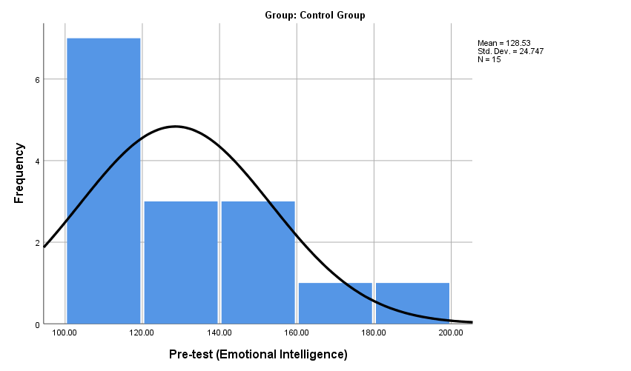
In the control group, the emotional intelligence pre-test scores of 15 participants ranged from 101 to 181, with the minimum and maximum scores, respectively. The mean score was 128.53 and the standard deviation was 24.74 as represented in Figure 1. Similarly, for the experimental group, the pre-test emotional intelligence scores ranged from 103 to 160, with a mean score of 128.80 and a standard deviation of 15.66 as indicated in Figure 2.
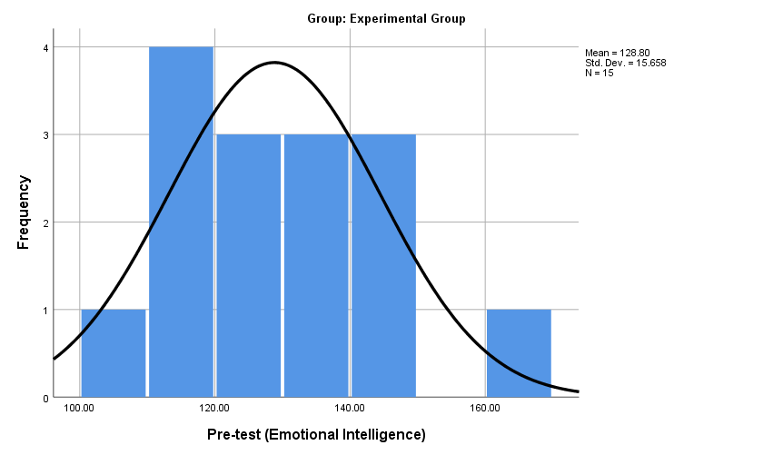
Figure 1: Emotional intelligence pre-test scores. The control group
Figure 2: Emotional intelligence pre-test scores. The experimental group
4.1.3. Descriptive statistics of emotional intelligence post-test scores
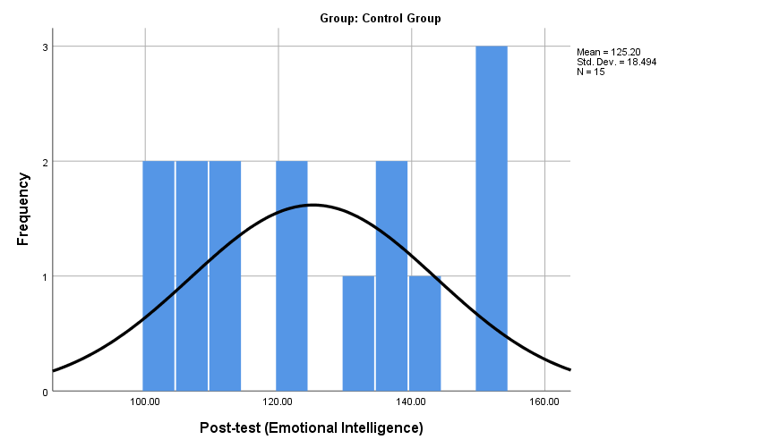
In the control group, the emotional intelligence post-test scores of 15 participants ranged from 102 to 154, with the minimum and maximum scores, respectively. The mean score was 125.20 and the standard deviation was 18.49 as shown in Figure 3.
Figure 3: Emotional intelligence post-test scores. The control group
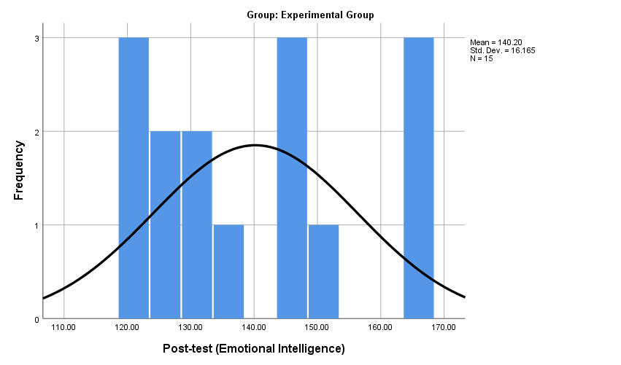
Similarly, for the experimental group, the post-test emotional intelligence scores ranged from 121 to 166, with a mean score of 140.20 and a standard deviation of 16.17 as represented in Figure 4.
Figure 4: Emotional intelligence post-test scores. The experimental group
4.1.4. Tests of normality
The normality of the data in each group was assessed using Kolmogorov-Smirnov and Shapiro-Wilk estimates (see Table 3).
Table 3: Tests of normality
Group |  | Kolmogorov-Smirnovª |  |  | Shapiro-Wilk
 |  | Statistic | df | Sig. | Statistic | df | Sig.
Control Group | Pre-test (Emotional Intelligence) | .174 | 15 | .200* | .895 | 15 | .080
Control Group | Post-test (Emotional Intelligence) | .162 | 15 | .200* | .911 | 15 | .139
Experimental Group | Pre-test (Emotional Intelligence) | .128 | 15 | .200* | .968 | 15 | .827
Experimental Group | Post-test (Emotional Intelligence) | .161 | 15 | .200* | .898 | 15 | .090
*. This is a lower bound of the true significance.
a. Lilliefors Significance Correction
The results revealed that there were no significant deviations from normality, as evidenced by p-values exceeding the significance level of .05 in all cases. Thus, parametric analyses can be conducted safely, assuming normality.

Homogeneity of groups in terms of pre-test assessments
Before the commencement of the main study, an independent-sample t-test was conducted to compare the pre-test scores of the experimental and control groups with the aim of ensuring homogeneity between the two groups at the beginning of the study (see Table 4).
Table 4: Homogeneity of groups in terms of pre-test assessments
 | GROUP | N | Mean | t | df | Sig.
Pre-test Emotional Intelligence | Experimental | 15 | 128.80 | -.035 | 28 | .972
Pre-test Emotional Intelligence | Control | 15 | 128.53
The descriptive statistics of the emotional intelligence pre-test assessments for both groups were presented in Table 4, indicating that the emotional intelligence scores for the control and experimental groups were 128.5333 and 128.8000, respectively. The standard deviations for emotional intelligence were 24.74691 and 15.65795 for the control and experimental groups, respectively.
The results of the independent-sample t-test performed to compare the pre-test assessments of emotional intelligence in the control and experimental groups were also presented in Table 4. Before the t-test was performed, Levine’s test for equality of variances was conducted (Saldanha & O’Brien 2014). It was found that the assumption of equal variances was satisfied for emotional intelligence (F = 3.229, p = .083).
Moreover, the t-test results revealed that there was no significant difference between the control and experimental groups in terms of their pre-test scores, regardless of whether equal variances were assumed (t = -.035, df =28, p = .972) or not (t = -.035, df = 23.661, p =.972). The mean difference between the two groups was -.26667, demonstrating that the experimental group had slightly higher pre-test scores than the control group, but this difference was not statistically significant.
Finally, these findings indicate that the control and experimental groups were comparable at the outset of the study since no significant differences were detected in their pre-test assessments of emotional intelligence.

Answering the research question
To examine the research question of this study concerning the effect of translating inspirational quotes on the emotional intelligence of senior English translation students of Shahid Bahonar University of Kerman, both between-group and within-group analyses were conducted. Initially, an independent-sample t-test was conducted to identify any differences in emotional intelligence post-test scores between the groups (see Table 5). Before conducting the main statistical analyses, the assumptions of normality and homogeneity of variance were verified. The results indicated that there were no deviations from the assumptions.
Table 5: Independent-sample t-test for emotional intelligence development in two groups
 | Group | N | Mean | SD | t | df | Sig.
Post-test (Emotional Intelligence) | Control Group | 15 | 125.2000 | 18.49401 | -2.365 | 28 | .025
Post-test (Emotional Intelligence) | Experimental Group | 15 | 140.2000 | 16.16522
Table 5 presents the group statistics and independent-sample t-test results for the post-test scores between the control group and experimental group. The group statistics indicate that the experimental group had a higher mean score (M = 140.20, SD = 16.17) compared to the control group (M = 125.20, SD = 18.49) on the post-test.
The independent-sample t-test results showed a significant difference in the mean scores of the two groups (t(28) = -2.365, p = .025, two-tailed). The mean difference was -15.00 (SE = 6.34), with a 95% confidence interval ranging from -27.99 to -2.01. These results indicate that the experimental group had significantly higher post-test scores in emotional intelligence than the control group. Additionally, Levene’s test for equality of variances was conducted, and the results indicated that the assumption of equal variances was met (F=.737, p = .398). However, the t-test results also showed that the equal variance assumption was not necessary to be met for the significant difference to be found (t(27.508) = -2.365, p = .025, two-tailed) as represented in Figure 5.
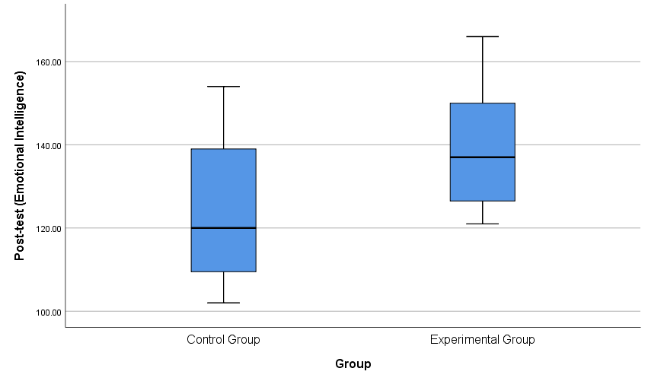
Figure 5: Post-test emotional intelligence development in the control and experimental groups
Subsequently, two paired-sample t-test analyses were conducted to examine any within-differences in emotional intelligence scores between the pre- and post-tests in each group. Before the main statistical analyses, normality and homogeneity of variance assumptions were checked, and no deviations from the assumptions were found.
Table 6: Paired-sample t-test analyses for emotional intelligence development pre & post-test scores in two groups
Group |  |  | Mean | N | SD | r | t | df | Sig.
Control Group | Pair 1 | Pre-test (Emotional Intelligence) | 128.53 | 15 | 24.74691 | .762 | .806 | 14 | .434
Control Group | Pair 1 | Post-test (Emotional Intelligence) | 125.20 | 15 | 18.49401
Experimental Group | Pair 1 | Pre-test (Emotional Intelligence) | 128.80 | 15 | 15.65795 | .521 | -2.77 | 14 | .015
Experimental Group | Pair 1 | Post-test (Emotional Intelligence) | 140.20 | 15 | 16.16522
Table 6 presents the results of a paired-sample t-test comparing the pre-test and post-test scores of emotional intelligence for a control group and an experimental group. For the control group, the mean difference between pre-test and post-test scores was 3.33333 (SD = 16.01636, SEM = 4.13541), with a 95% confidence interval ranging from -5.53623 to 12.20290. The t-score was 0.806 with 14 degrees of freedom, and the p-value was .434. For the experimental group, the mean difference between pre-test and post-test scores was -11.40000 (SD = 15.89609, SEM = 4.10435), with a 95% confidence interval ranging from -20.20296 to -2.59704. The t-score was -2.778 with 14 degrees of freedom, and the p-value was .015.
Table 6 also reports the correlation coefficients and p-values between the pre-test and post-test scores for each group. For the control group, the correlation coefficient was .762 (p = .001), indicating a strong positive correlation between the two variables. For the experimental group, the correlation coefficient was .501 (p = .057), indicating a moderate positive correlation between the two variables.
The effect size for this paired-sample t-test was calculated using Cohen’s d (Saldanha & O’Brien 2014). For the control group, the effect size is d = 0.21, which is considered a small effect. For the experimental group, the effect size is d = -0.93, which is considered a large effect.
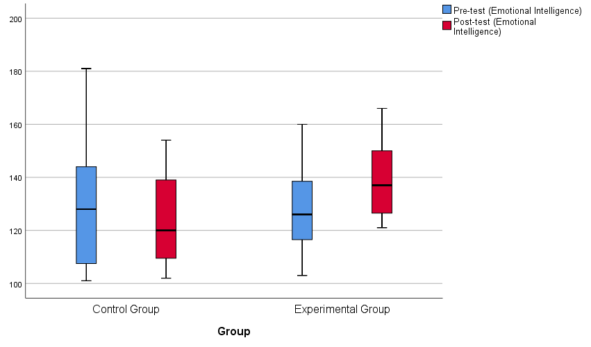
In summary, Table 6 shows that the control group did not have a significant change in emotional intelligence scores from the pre-test to the post-test (t(14) = 0.806, p = .434). In contrast, the experimental group showed a significant increase in emotional intelligence scores (t(14) = -2.778, p = .015). The effect size for the experimental group was large, indicating a meaningful difference between pre-test and post-test scores (see Figure 6). Consequently, hypothesis₀₁ was rejected, and it can be concluded that translating inspirational quotes positively affected the emotional intelligence level of senior English translation students of Shahid Bahonar University of Kerman.
Figure 6: Boxplot for emotional intelligence pre- and post-test assessments in two groups
- Conclusion
In this investigation, the researchers endeavored to determine whether translating inspirational quotes has any significant effect on the emotional intelligence level of senior English translation students of Shahid Bahonar University of Kerman. The results demonstrated that translating inspirational quotes in translation classes could significantly increase the emotional intelligence of trainees. Consequently, translating inspirational quotes had a positive impact on emotional intelligence in the current study.
Besides the positive impact of translating inspirational quotes on emotional intelligence, translating these sentences in translation classes can also have other benefits for both trainers and trainees. It is significant for translation educators from several perspectives. First, considering the succinct features of inspirational quotes (Al-Jarf 2021: 9), translating them in translation classes takes less time than other texts. Consequently, teachers can save more time in classes by applying these quotes. Second, inspirational quotes are concise sentences (Miller 2020); if teachers utilize them in translation classes, they can assess the students’ translations more easily, quickly, and accurately. Third, inspirational quotes are full of positive energy (Braida et al. 2022: 417). Thus, teachers can apply these quotes in the classrooms to create a pleasant atmosphere for learning. Eventually, the use of inspirational quotes can increase the text variety in translation classes.
It can also be beneficial for students because of two reasons. First, translating inspirational quotes can make classes more enjoyable for trainees since these quotes are golden sayings from celebrities and successful individuals whom people praise for their achievements (Laeli & Kusumaningrum 2018: 512). Thus, translating inspirational quotes can be absorbing for trainees. Second, one of the main features of inspirational quotes is their ethical content (Ameri 2010: 96). Successful people have stated these didactic quotes based on their own life experiences (Laeli & Kusumaningrum 2018: 511); therefore, utilizing them in classes can give valuable lessons to trainees in addition to instructing translation.
Furthermore, this study represented a preliminary step in exploring the effects of translating inspirational quotes on translation trainees. Nevertheless, it's important to approach the findings with caution due to the limited number of participants in the study. Hence, future research could be conducted to investigate the effects of translating inspirational quotes on the emotional intelligence of senior translation students from other universities to determine whether the results of this study can be generalized. Additionally, further studies could be conducted on different groups of participants, such as sophomores and juniors, to determine whether their findings align with the results of this study. Moreover, subsequent researchers could explore the long-term effects of translating inspirational quotes to compare their findings with the current study, which focused on short-term impacts. Finally, future research could compare the performance of translation trainees when translating inspirational quotes versus other texts typically used in translation classes to identify possible differences in quality and the reasons behind them.

Appendix A: The short form of TEIQue (Petrides & Furnham 2006)
1. Expressing my emotions with words is not a problem for me. | 1 | 2 | 3 | 4 | 5 | 6 | 7
2. I often find it difficult to see things from another person’s viewpoint. | 1 | 2 | 3 | 4 | 5 | 6 | 7
3. On the whole, I’m a highly motivated person. | 1 | 2 | 3 | 4 | 5 | 6 | 7
4. I usually find it difficult to regulate my emotions. | 1 | 2 | 3 | 4 | 5 | 6 | 7
5. I generally don’t find life enjoyable. | 1 | 2 | 3 | 4 | 5 | 6 | 7
6. I can deal effectively with people. | 1 | 2 | 3 | 4 | 5 | 6 | 7
7. I tend to change my mind frequently. | 1 | 2 | 3 | 4 | 5 | 6 | 7
8. Many times, I can’t figure out what emotion I'm feeling. | 1 | 2 | 3 | 4 | 5 | 6 | 7
9. I feel that I have a number of good qualities. | 1 | 2 | 3 | 4 | 5 | 6 | 7
10. I often find it difficult to stand up for my rights. | 1 | 2 | 3 | 4 | 5 | 6 | 7
11. I’m usually able to influence the way other people feel. | 1 | 2 | 3 | 4 | 5 | 6 | 7
12. On the whole, I have a gloomy perspective on most things. | 1 | 2 | 3 | 4 | 5 | 6 | 7
13. Those close to me often complain that I don’t treat them right. | 1 | 2 | 3 | 4 | 5 | 6 | 7
14. I often find it difficult to adjust my life according to the circumstances. | 1 | 2 | 3 | 4 | 5 | 6 | 7
15. On the whole, I’m able to deal with stress. | 1 | 2 | 3 | 4 | 5 | 6 | 7
16. I often find it difficult to show my affection to those close to me. | 1 | 2 | 3 | 4 | 5 | 6 | 7
17. I’m normally able to “get into someone’s shoes” and experience their emotions. | 1 | 2 | 3 | 4 | 5 | 6 | 7
18. I normally find it difficult to keep myself motivated. | 1 | 2 | 3 | 4 | 5 | 6 | 7
19. I’m usually able to find ways to control my emotions when I want to. | 1 | 2 | 3 | 4 | 5 | 6 | 7
20. On the whole, I’m pleased with my life. | 1 | 2 | 3 | 4 | 5 | 6 | 7
21. I would describe myself as a good negotiator. | 1 | 2 | 3 | 4 | 5 | 6 | 7
22. I tend to get involved in things I later wish I could get out of. | 1 | 2 | 3 | 4 | 5 | 6 | 7
23. I often pause and think about my feelings. | 1 | 2 | 3 | 4 | 5 | 6 | 7
24. I believe I’m full of personal strengths. | 1 | 2 | 3 | 4 | 5 | 6 | 7
25. I tend to “back down” even if I know I’m right. | 1 | 2 | 3 | 4 | 5 | 6 | 7
26. I don’t seem to have any power at all over other people’s feelings. | 1 | 2 | 3 | 4 | 5 | 6 | 7
27. I generally believe that things will work out fine in my life. | 1 | 2 | 3 | 4 | 5 | 6 | 7
28. I find it difficult to bond well even with those close to me. | 1 | 2 | 3 | 4 | 5 | 6 | 7
29. Generally, I’m able to adapt to new environments. | 1 | 2 | 3 | 4 | 5 | 6 | 7
30. Others admire me for being relaxed. | 1 | 2 | 3 | 4 | 5 | 6 | 7
1 2 3 4 5 6 7
Completely Disagree Completely Agree

Appendix B: A sample of inspirational quotes
- “Live as if you were to die tomorrow. Learn as if you were to live forever” (Mahatma Gandhi).
- “No problem can be solved from the same level of consciousness that created it.” (Albert Einstein).
- “Once you bid farewell to discipline, you say goodbye to success” (Sir Alex Ferguson).
- “The more you know, the more you know you don’t know” (Aristotle).
- “It is not in the stars to hold our destiny but in ourselves” (William Shakespeare).
- “It is not the years in your life that count, it’s the life in your years” (Abraham Lincoln).
References
Akpur, Uǧur. 2020. A systematic review and meta-analysis on the relationship between emotional intelligence and academic achievement. Educational Sciences: Theory & Practice. 20(4): 51–64. doi: 10.12738/jestp.2020.4.004.
Al-Jarf, Reima. 2021. Enhancing EFL freshman students’ reading skills with inspirational quotes. Asian Research Journal of Arts & Social Sciences. 13(4): 1–11. doi: 10.9734/ARJASS/2021/v13i430219.
Ameri, Alireza. 2010. Revisiting quotes from educational perspective. An inquiry into the multifarious applications of grand quotes in English language pedagogy. Journal of Language and Translation. 1(2): 87–103.
Bedrov, Alisa & Bulaj, Grzegorz. 2018. Improving self-esteem with motivational quotes. Opportunities for digital health technologies for people with chronic disorders. Frontiers in Psychology. 9: 1–5. doi: 10.3389/fpsyg.2018.02126.
Braida, Barbara & Rodríguez-Ferreiro, Javier & Hernández, Mireia. 2022. The foreign language effect on motivational quotes. Bilingualism. Language and Cognition 26(2): 1–9. doi: 10.1017/S1366728922000505.
BrainyQuote. n.d. Inspirational quotes at BrainyQuote. (https://www.brainyquote.com/) (Accessed 2024-01-05).
Brann, Darrell W. & Sloop, Shawnee. 2006. Curriculum development and technology incorporation in teaching neuroscience to graduate students in a medical school environment. Advances in Physiology Education. 30(1): 38–45. doi: 10.1152/advan.00068.2005.
Cherniss, Cary. 2004. Emotional intelligence. In Spielberger, Charles (ed.), Encyclopedia of applied psychology. Academic Press. 315–319.
Çoban, Fadime & Telci, Ümmügülsüm A. 2016. The role and importance of emotional intelligence in the acquisition of translation skills and translator training. Does a translator or interpreter need emotional intelligence? The Journal of International Lingual, Social and Educational Sciences. 2(2): 118–125.
Czuchry, Michael & Dansereau, Donald F. 2005. Using motivational activities to facilitate treatment involvement and reduce risk. Journal of Psychoactive Drugs. 37(1): 7–13. doi: 10.1080/02791072.2005.10399744.
Dulewicz, Victor & Higgs, Malcolm. 2000. Emotional intelligence – A review and evaluation study. Journal of Managerial Psychology. 15(4): 341–372.
Ghobadi, Mehdi & Khosroshahi, Sadaf & Giveh, Fatemeh. 2021. Exploring predictors of translation performance. Translation & Interpreting. 13(2): 65–78. doi: 10.12807/ti.113202.2021.a04.
Hubscher-Davidson, Séverine. 2013. Emotional intelligence and translation studies. A new bridge. Meta. 58(2): 324–346. doi: 10.7202/1024177ar.
Hubscher-Davidson, Séverine. 2016. Trait emotional intelligence and translation. A study of professional translators. Target. 28(1): 132–157. doi: 10.1075/target.28.1.06hub.
Hubscher-Davidson, Séverine & Lehr, Caroline. 2021. Improving the emotional intelligence of translators. A roadmap for an experimental training intervention. Cham: Springer Nature.
IBM Corp. 2019. IBM SPSS Statistics for Windows, version 26.0. New York: IBM Corp.
Laeli, Asfia N. & Kusumaningrum, Retno D. 2018. Reflection on implementing quotes as attractive media related to student motivation in learning English-Indonesian translation. English Language and Literature International Conference (ELLiC) Proceedings. 2. 510–514.
Littlechild, Brian & Smith, Andrew H. & Meredith-Windle, Glynis & Gale, Tim & Lloyd, Michele & Hawley, Cristopher. 2013. Recovery approaches in mental health. A qualitative evaluation of the Whole Life Therapy programme for persons with schizophrenia. Health 5(3A): 582–587. doi: 10.4236/health.2013.53A077.
MacCann, Carolyn & Jiang, Yixin & Brown, Luke E. R. & Double, Kit S. & Bucich, Michaela & Minbashian, Amirali. 2020. Emotional intelligence predicts academic performance. A meta-analysis. Psychological Bulletin. 146(2): 150–186. doi: 10.1037/bul0000219.
Miller, Dan L. 2020. Quotations add interest and lend authority to classroom lessons. The Clearing House. A Journal of Educational Strategies, Issues and Ideas. 94(1): 8–14. doi: 10.1080/00098655.2020.1826896.
Mokhtarzadeh, Mehri & Farjami, Hadi & Mokhtarzadeh, Monireh. 2020. Can inspirational quotes help the recall of abstract vocabulary? Journal of Applied Linguistics and Applied Literature: Dynamics and Advances. 8(2): 141–157. doi: 10.22049/jalda.2020.26848.1182.
Pérez-Díaz, Pablo A. & Petrides, K V. 2019. The Spanish-Chilean trait emotional intelligence questionnaire-short form. The adaptation and validation of the TEIQue-SF in Chile. Journal of Personality Assessment. 103(1): 67–79. doi: 10.1080/00223891.2019.1692856.
Petrides, K. V. & Furnham, Adrian. 2006. The role of trait emotional intelligence in a gender‐specific model of organizational variables. Journal of Applied Social Psychology. 36(2): 552–569.
Poon, Steven K. 2016. Pacifica: Stressed or worried? An app to help yourself (mobile app user guide). British Journal of Sports Medicine. 50(3): 191–192. doi: 10.1136/bjsports-2015-095747.
QuoteFancy. n.d. Inspirational quotes on beautiful wallpapers. (https://quotefancy.com/) (Accessed 2023-11-12).
Saldanha, Gabriela & O’Brien, Sharon. 2014. Research methodologies in translation studies (1st ed.). New York: Routledge.
Salovey, Peter & Mayer, John D. 1990. Emotional intelligence. Imagination, Cognition and Personality. 9(3): 185–211. doi: 10.2190/DUGG-P24E-52WK-6CDG.
Siegling, Alex B. & Vesely, Ashley K. & Petrides, K. V. & Saklofske, Donald H. 2015. Incremental validity of the trait emotional intelligence questionnaire–short form (TEIQue–SF). Journal of Personality Assessment. 97(5): 525–535. doi: 10.1080/00223891.2015.1013219.
Szczygiel, Dorota & Mikolajczak, Moïra. 2018. Is it enough to be an extrovert to be liked? Emotional competence moderates the relationship between extraversion and peer-rated likeability. Frontiers in Psychology. 9. 1–9. doi: 10.3389/fpsyg.2018.00804.
Williams, Jenny & Chesterman, Andrew. 2002. The map. A beginner’s guide to doing research in translation studies (1st ed.). Manchester: St. Jerome Publishing.
Amir Hosein Shafiei, M.A.
Department of Foreign Languages
Faculty of Literature and Humanities
Shahid Bahonar University
e-mail: amirhosein.shafiei379@gmail.com
Masoud Sharififar, Associate Professor
Department of Foreign Languages
Faculty of Literature and Humanities
Shahid Bahonar University
e-mail: m.sharifi@uk.ac.ir
Gholamreza Rouhani, Assistant Professor
Department of Foreign Languages
Faculty of Literature and Humanities
Shahid Bahonar University
e-mail: r.rohani@uk.ac.ir

