Mapping Postgraduate Research Trends in the Sociology of Translation in Iran
Hossein Bahri, Kharazmi University
Mahvash Gholami, Kharazmi University
Abstract
Using data from abstracts and methodology sections of a total of 48 MA theses and PhD dissertations on the sociology of translation in Iran, this study renders a map of the 2009–2022 postgraduate research trends in the field. The researchers focused on, among other issues, the frequency of investigated areas and their sub-divisions as well as the most frequently used translation theories and models by the researchers. The findings of the study suggested that while the number of studies on the subject was relatively smaller than other investigated translation areas in the country, research on the sociology of translation remained popular over the 14-year period, witnessing a marked increase in 2019 and then followed by a sharp decrease presumably due to the Covid-19 pandemic. Furthermore, Bourdieusian theoretical frameworks and context-oriented research methodologies were vastly employed in the studies. The authors have concluded that the subject is still unmapped and open to many avenues for investigation in the Iranian context. Implications of the findings were discussed. Finally, a tentative map of postgraduate research on the sociology of translation in Iran was proposed.
Keywords: context-oriented research; mapping; postgraduate; research trend; Bourdieu; translation sociology

Introduction

The development of a sociology of translation (SoT) is primarily a twenty-first-century phenomenon. Scholars in the field of translation studies took an interest in the sociological aspects of translation since early 2000s (Wolf 2005; Pym 2006; Snell-Hornby 2006; Heilbron & Sapiro 2007; Chesterman 2009; Baker 2010). A cursory search of translation programmes on the internet indicates that studying the SoT has gained momentum in educational institutions around the world within the last ten years.

Simultaneous with what happened in other regions of the world, the same period witnessed the burgeoning of translation departments and student intake in Iran. This, in turn, has contributed to a surge in postgraduate translation programmes in Iranian academic settings in general and in studying the SoT in particular.

Meanwhile, a major cause for concern among many Iranian postgraduate translation students has been identifying the gaps in the field to choose appropriate research topics. One serious problem is the scarcity of up-to-date information about research on the SoT in Iran. The findings of earlier studies also highlight a dearth of systematic research into the SoT in Iranian settings (Nouraey & Karimnia 2012, 2015; Karimnia & Nouraey 2013; Karimnia & Aboutalebi 2014; Sanatifar 2019). The current researchers’ personal communications with translation students attest to the fact that many postgraduate students have fuzzy pictures about the topics and areas covered in the field. Additionally, finding relevant theoretical frameworks and choosing appropriate research models are among other main obstacles that postgraduate students must overcome in their projects.

To find the solutions to the mentioned problems, this study aims to investigate major areas and sub-branches of the SoT as well as the frequency of the areas that were researched by Iranian postgraduate students. Moreover, the theoretical frameworks and models that were used by the researchers should be identified. Finally, contextual information about respective educational institutions where the studies had been carried out was required to interpret the findings. In line with these objectives, the following research questions were raised:

Which areas and sub-branches of the SoT were investigated by the Iranian postgraduate translation researchers?

Which translation theories and models were adopted by the Iranian postgraduate translation researchers?

What types of research methodologies and methods were used in the studies?

Which universities and disciplines had the highest number of studies?

Theoretical background

The call for a sociological focus on translation dates back to the late 1980s when Mossop (1988) suggested emphasising translation as a unique form of cultural production. He raised the need to examine the role of institutions such as corporations, churches, governments, and newspapers in translation theories. In his opinion, the political and social goals of the institutions affect the general approach of translation. According to him, institutions are the main actors in the translation process and serve the goals of their own groups, movements, and audiences by producing translations. This also highlights the role of institutional translators in the translation process, which is a separate area of research in the SoT. However, it was not until the early 2000s when the study of the SoT witnessed an increase in importance and dimensions. Consequently, many translation scholars have referred to this development using terms such as a new turn, approach or perspective (Wolf 2005; Pym 2006; Snell-Hornby 2006; Doorslaer 2007; Inghilleri 2009; Angelelli 2014; Sapiro 2014; Berneking 2016; Munday 2016).

The sociological approach to translation studies emphasises the role of the translator as an agent who is actively involved in translation practice in various social contexts. Translation scholars have identified different research areas with respect to their perspective on the SoT. For example, Wolf (2007), in her work entitled “The emergence of a sociology of translation”, has delineated three broad areas: first, sociology of the translation agents, which examines the main agents involved in the production of translation, including the translators, publishers, editors, commissioners, and other agents; second, sociology of the translation process, which investigates the social procedures contributing to the development of translation product from the beginning to the final stage; and finally, sociology of the translation product, that explores translation transfer to different social contexts and its role as a cultural product.

In the same book, Heilbron & Sapiro (2007) proposed consideration of three dimensions in which translations are embedded in their social contexts: first, the make-up of the global field of cultural exchanges; second, the political and economic restrictions affecting those cultural exchanges; and finally, the role of intermediary agents and the importing and receiving processes in the recipient country.

Based on a broad definition, Inghilleri (2009: 279) stated that the areas and domains dealing with the SoT include the study of training institutions where translator education takes place; the methodologies and didactics; the relationship between translator education and translation profession; the interconnection between research and pedagogy; the social structure and make-up of professional associations; the personal and professional careers of translators and interpreters; the role of translation in the international marketing of cultural products; the impact of market demand on the translation profession; the role of translation and interpreting in expressing social and political movements; translation and globalization; translation and activism; and the agency of translators. Therefore, the vast territories of the SoT outlined by her definition can be incorporated into at least four major areas of research described by Williams & Chesterman (2002), i.e. translation history, translation ethics, translator training, and the translation profession.

Interestingly, Chesterman (2009) himself promoted the idea of founding the new field of translator studies, highlighting the cultural, cognitive, and sociological characteristics of translators. Each of these agent-oriented properties would in turn constitute a separate branch of translator studies. According to Chesterman (2009: 19), the sociological branch deals with observable behaviour of translators as individuals, groups or institutions, their social status, networks, and how they interact with members of other groups and with the technology. Since translators are not the only agents in the process of translation, Chesterman (2009: 20) included other agents in his model such as publishers, editors, commissioners, etc. Based on the above-mentioned definitions, Table 1 compares major areas of the SoT as proposed by different scholars.
Table 1: Key areas of the SoT as proposed by different scholars
Scholars→  Key Areas↓ | Wolf  (2007) | Heilbron & Sapiro (2007) | Chesterman (2009) | Inghilleri (2009)
Sociology of the translation agents (translators, publishers, editors, etc.) | √ | ------------- | √ | -----------
Sociology of the translation process (social procedures; development of translation product) | √ | ------------- | -------------- | -----------
Sociology of the translation product (in different social contexts; as a cultural product) | √ | ------------- | -------------- | -----------
Global field of cultural exchanges | √ | √ | -------------- | -----------
Political and economic restrictions | √ | √ | -------------- | -----------
Intermediary agents and the importing processes | √ | √ | √ | -----------
Study of training institutions | √ | ------------ | -------------- | √
Study of methodologies and didactics | √ | ------------ | -------------- | √
Impact of translator education on translation profession | √ | ------------ | -------------- | √
Connection between research and pedagogy | √ | ------------ | -------------- | √
Structure of professional associations | √ | √ | -------------- | √
Professional careers of translators and interpreters | √ | ------------ | √ | √
translation in international marketing and as cultural products | √ | √ | -------------- | √
Impact of market demand on the translation profession | √ | √ | -------------- | √
Role of translation in expressing social and political movements | √ | √ | -------------- | √
Translation in a globalised world | √ | √ | -------------- | √
Translation and activism | √ | √ | √ | √
Behaviour of translators as agents, groups, or institutions | √ | √ | √ | √
Agents’ social status | √ | √ | √ | √
Agents’ networks | √ | √ | √ | √
Agents’ interactions with other groups (and technology) | √ | √ | √ | √

Table 1 indicates that the tripartite model proposed by Wolf (2007) covers the main areas delineated by other experts. Heilbron & Sapiro’s (2007) socio-economic proposal mainly deals with the sociology of translation agents and translation product, but it does not address the translation process, or the educational, or cultural aspects. The behavioural agent-oriented model offered by Chesterman (2009) seems to ignore those areas related to the process and product of translation.

Although we can state that the broad encyclopaedic definition by Inghilleri (2009) is one of the most comprehensive arrangements that deals with many areas of research on the SoT, Wolf’s (2007) definition is the most systematic. Therefore, for the sake of systematicity and representativeness of key areas, the authors of the current study decided to use Wolf’s (2007) definition to draw a tentative map of research on the SoT and to portray which of those areas had been explored by Iranian postgraduate students.

Figure 1 illustrates a basic map of the SoT based on Wolf (2007). The illustration displays the three broad areas (i.e. sociology of the translation agents, sociology of the translation process, and sociology of the translation product) depicted in Table 1 as a tentative extension of a map of translation studies by Doorslaer (2007) on which he placed the sociological approach under the branch marked approaches of his proposal. In addition to the major topics and areas of research, there are some sociological theories and models adopted from the field of sociology. These theories and models facilitated the integration of sociological research methods into the interdiscipline of translation.
Figure 1: Tentative map of the SoT based on Doorslaer (2007) and Wolf (2007)

Chief among the sociological theories and models that were borrowed by the field of translation studies are Bourdieu’s theoretical frameworks, Latour’s Actor-Network Theory (ANT), and Luhmann’s theory of social systems (Buzelin 2005; Inghilleri 2005, 2009; Tyulenev 2012, 2013). These theories, in turn, have brought in several key terms such as field, habitus, capital, actor, and network, each of which constitutes an area of investigation in the sociology of translation (Inghilleri 2003; Gouanvic 2005; Vorderobermeier 2014).
The aim of the sociology of translation is to study translation from a sociological point of view. In fact, sociology is a far-reaching field of study. It deals not only with sociological phenomena, but also with many cultural, political, and economic arenas. Since there are other approaches to the study of translation in general, it is sometimes difficult, for example, to differentiate between cultural and sociological areas.
In the present study, the researchers decided that activism was mainly a sociological area of research, as it is exercised via the translators’ agency (Dimitriu 2010; Wolf 2012). Because of this interconnection, it is not easy to fix the borderline between the fields. For example, based on Inghilleri’s (2009) definition, many areas related to translator education and training were classified under the sociological domain, but we know that they are also investigated, for example, within functional and psychological approaches. To solve this problem, the scope of the present research was narrowed down so that predominantly cultural, ideological, and educational issues were excluded from the scope of the study. This was also in line with the mainstream definitions and models (Pym 2006; Heilbron & Sapiro 2007; Wolf 2007; Chesterman 2009).

Methods
For data collection, the authors of the study used GANJ IranDoc database (https://ganj.irandoc.ac.ir/#/), which is run by the Iranian Research Institute for Information Science and Technology. While the database is not a specialised bibliography such as the Translation Studies Bibliography (TSB), it provides information about postgraduate dissertations, theses, and research proposals in most fields of study in Iran including translation. Considered to be the largest academic treasure in Iran, it contains over 1,200,000 research documents. Moreover, the database is used to conduct similarity checks and literature reviews.
The researchers used the phrase sociology of translation and its key areas (used as search terms) displayed in Table 1 along with their Persian equivalents to search relevant documents. Persian translations of key terms were used to find studies written in Persian. From a total of 5672 studies related to translation, the search yielded 293 studies (5.2%), which had the label of sociology of translation or were tagged as such. Subsequently, both authors of the study examined and double-checked each title, abstract, and its keywords to see if the study was related to the SoT. After sifting through all the 293 studies, we found 48 MA theses and PhD dissertations on the SoT, which provided us with raw data for the present research.
In the next phase of the research, the files related to the 48 studies were downloaded from the GANJ IranDoc repository and the titles, abstracts, keywords, and methodology sections of these studies were analysed. The results are presented in the analysis and discussion section. A point that should be clarified here is that the MA translation programmes at Iranian universities commenced in 2002. The establishment of the first PhD translation programme in Iran was in 2014. While these dates are the starting points for the study of postgraduate translation research at Iranian universities, in practice most of the documented postgraduate research on translation in general and of the SoT in particular were carried out within the years 2009–2022. Hence, the studies investigated in the present research were conducted within the same period.

Analysis and results
This section presents the analysis that led the present researchers to their findings and discussion about the current study. Using descriptive statistics (i.e. frequencies and percentages), the collected data was analysed to get a general picture of the study.
First, qualitative data was coded or labelled to be quantified and more easily analysed. Then, demographic information related to the studies was presented in a table. Subsequently, to investigate the research questions, the researchers interpreted and made sense of the patterns and relationships by drawing inferences and exploring connections between the findings and the research questions. Double-checking and inter-coder reliability checks were used as procedures to ensure the accuracy and completeness of the results. Finally, the researchers proposed a conceptual map of postgraduate research trends in the SoT in Iran.
To check the consistency between the two coders, the coding instances were checked to see if both coders agreed on the coding decisions (Mackey & Gass 2016). Table 2 depicts the Pearson correlation and inter-coder reliability index for the two researchers’ decisions.
Table 2: Pearson correlation and inter-coder reliability index
Coders | Sig. (2-tailed) | Correlation  Coefficient | Inter-Coder Reliability  Index
Researchers 1 and 2 | .000 | 0.725** | 0.840
** Correlation is significant at the 0.01 level (2-tailed).

Demography
Table 3 presents gender and academic level of the Iranian postgraduate researchers. The number of MA students was 5 times more than PhD students. One reason is that MA programmes commenced in 2002 while PhD programmes started in 2014. Second, there is more intake at MA level whereas only 3 universities offer PhD programmes. The number of female postgraduate researchers was 2.2 times more than their male counterparts. This implies that postgraduate research on the SoT is dominated by female researchers in Iran.
Table 3: Gender and academic level of the Iranian postgraduate researchers
Sex | MA | PhD | Total
Male | 12 | 3 | 15
Female | 28 | 5 | 33
Total | 40 | 8 | 48

Investigating the research questions
The first research question dealt with the areas and sub-branches of the SoT that were explored by the Iranian postgraduate researchers. To answer the first research question, the authors of the study conducted a qualitative content analysis of the abstract sections of the 48 studies. Using double-checks and the information in Table 1 as a guide, we were able to determine the areas and territories of the SoT that were investigated by the Iranian postgraduate students. A summary of descriptive statistics for the areas and sub-branches of the SoT as investigated by Iranian postgraduate researchers is depicted in Table 4.
Table 4: Areas/sub-branches of SoT as investigated by the researchers
No. | Area/Sub-Branch | Frequency (N) | Percentage (%)
1 | Translators’ Capital | 10 | 10.20
2 | Translators’ Habitus | 9 | 9.18
3 | Agency | 8 | 8.16
4 | Translation Profession | 8 | 8.16
5 | Role of Translation in Society | 5 | 5.10
6 | Translators’ Status | 5 | 5.10
7 | Translators’ Field | 4 | 4.08
8 | Translators’ Job Market | 4 | 4.08
9 | Translation Movements | 4 | 4.08
10 | Translators’ Activism | 3 | 3.06
11 | Translation and Power | 3 | 3.06
12 | Translators’ Image | 3 | 3.06
13 | Publication Industry | 3 | 3.06
14 | Translation Ethics | 3 | 3.06
15 | Role of Translators in Society | 3 | 3.06
16 | Translation of Bestsellers | 2 | 2.04
17 | Translators’ Job Success | 2 | 2.04
18 | Translators’ Job Expectations | 2 | 2.04
19 | Translator and Interpreter Associations | 1 | 1.02
20 | Translators’ Perceptions | 1 | 1.02
21 | Translators’ Resistance | 1 | 1.02
22 | Translation Policy | 1 | 1.02
23 | Translators’ Trajectories | 1 | 1.02
24 | Translators as Actors (Actants) | 1 | 1.02
25 | Patronage | 1 | 1.02
26 | Translation and Modernization | 1 | 1.02
27 | Translators’ Identity | 1 | 1.02
28 | Invisibility of Translators | 1 | 1.02
29 | Translators’ Income | 1 | 1.02
30 | Translation and Globalization | 1 | 1.02
31 | Networks | 1 | 1.02
32 | Translators’ Gender | 1 | 1.02
33 | Social Construction of Technology | 1 | 1.02
34 | World System of Translation | 1 | 1.02
35 | Translators’ Personality | 1 | 1.02
The table shows 35 different areas (sub-branches) investigated by the postgraduate researchers. Some studies covered more than one area of investigation and some areas were investigated by more than one study. Hence, the percentage for each area was calculated based on the number of its frequency. As illustrated in Table 4, translators’ capital was the most frequently studied area among the Iranian postgraduate researchers, followed by translators’ habitus, agency, and the translation profession. Other frequently studied areas included role of translation in society, and translators’ status.
Hence, the focus of the studies was on the translators (as translation agents), and that is a primary goal of the SoT. Based on the information in Table 4, we proposed a tentative map of postgraduate research on the SoT in Iran (see the Appendix). The second research question asked about the translation theories and models that were adopted by the researchers. Again, the authors of the study carried out a qualitative content analysis of the abstract and methodology sections of the 48 studies and by using double-checks and peer verification, they were able to extract the following translation theories and models as shown in Table 5.
Table 5: Translation theories/models used by Iranian postgraduate researchers
No. | Translation Theory/Model | Frequency (N) | Percentage (%)
1 | Bourdieu’s Theoretical Frameworks | 19 | 36.54
2 | No Theory Mentioned | 7 | 13.46
3 | Latour’s Actor-Network Theory (ANT) | 3 | 5.77
4 | Chesterman’s Model | 3 | 5.77
5 | Paloposki’s Model | 3 | 5.77
6 | Tymoczko’s Model | 2 | 3.85
7 | Venuti’s Model | 2 | 3.85
8 | Needs Analysis Model | 2 | 3.85
9 | Luhmann’s Social Systems Theory | 1 | 1.92
10 | Ayyad and Pym’s Model | 1 | 1.92
11 | Sela-Sheffy’s Model | 1 | 1.92
12 | Habermas’ Theory of Communicative Rationality | 1 | 1.92
13 | Bolouri’s Model | 1 | 1.92
14 | Dam and Zethsen’s Model | 1 | 1.92
15 | Lefever’s Space Theory | 1 | 1.92
16 | Deleuze and Guattari’s Space-Related Theory | 1 | 1.92
17 | Heilbron’s Theory | 1 | 1.92
18 | Pieta’s Model | 1 | 1.92
19 | Liang’s Model | 1 | 1.92
Table 5 indicates that Bourdieusian theoretical frameworks was the most common theory used by the researchers (in 19 studies, more than a third of all investigations), followed by No Theory Mentioned (7 studies), Latour’s Actor-Network Theory (3 studies), Chesterman’s Model (3 studies), and Paloposki’s Model (3 studies). These major translation theories and models accounted for more than two thirds (73%) of all postgraduate studies. It is worthy to mention that in some studies more than one theoretical framework was used. Hence, some researchers approached the problem under investigation from different perspectives.
The third research question investigated the types of research methodologies and methods that were used in the studies. The authors of the present study used Saldanha & O’Brien’s (2014) work as a reference for determining the typology of research methodologies and methods. Tables 6 and 7 respectively portray different typologies of the research methodologies and methods used by Iranian postgraduate researchers interested in the SoT.
Table 6 illustrates the four research methodologies proposed by Saldanha & O’Brien (2014). It shows that context-oriented research comprised almost half of all studies conducted in the field of the SoT, followed by participant-oriented research accounting for a third of the studies. The two broad methodologies constituted more than 80% of all studies. This finding was in line with the nature and definition of the SoT, which deals with the behaviour of people (participants) in the society (context). Therefore, the people (including translators, publishers, editors, and other agents) and the external factors and circumstances in which they produce translations were more important than the product or process of translation. As Table 6 depicts, while product-oriented research comprised 18% of the studies, no study was based on process-oriented research methodology.
Table 6: Research methodologies adopted by Iranian postgraduate researchers
No. | Research Methodologies | Frequency (N) | Percentage (%)
1 | Context-Oriented Research | 23 | 47.91
2 | Participant-Oriented Research | 16 | 33.33
3 | Product-Oriented Research | 9 | 18.75
4 | Process-Oriented Research | 0 | 0
As depicted in Table 7, both case study and survey study methods accounted for about 44% and 25% of research methods adopted by Iranian postgraduate researchers. This means that the two methods constituted about 69% of all research methods adopted by Iranian postgraduate researchers. From an educational point of view, this denotes the importance of teaching case study and survey study methods to postgraduate researchers who conduct research on the SoT. It is notable that from the 21 case studies 14 studies (67%) were multiple case studies. According to Yin (2003: 42), multiple case designs, if conducted appropriately, can present strong evidence of an incident, and hence are superior to single-case studies. Consequently, more Iranian researchers in the field of translation sociology opted to study multiple cases in their postgraduate projects.
Table 7: Research methods adopted by Iranian postgraduate researchers
No. | Research Method | Frequency (N) | Percentage (%)
1 | Case Study | 21 | 43.75
2 | Survey Study | 12 | 25
3 | Critical Discourse/Content Analysis | 8 | 16.66
4 | Mixed Method (Qualitative and Quantitative) | 7 | 14.58
Based on the findings, another research method that was frequently used in research on the SoT was the survey study, which was indicative of the growing importance of participant-oriented research methodology. Interestingly, most of the mixed method studies were based on a combination of case study and survey study methods.
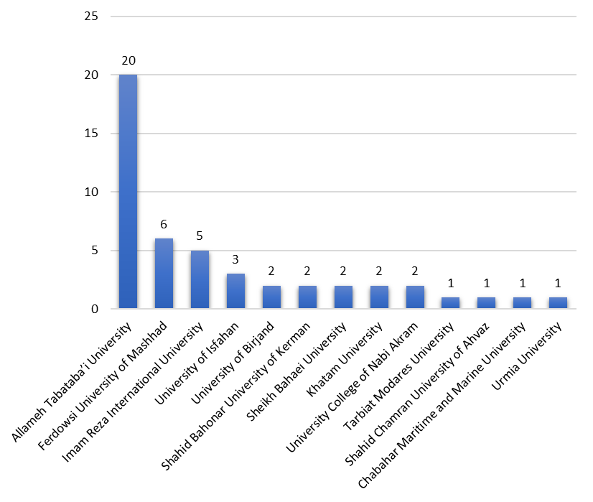
The fourth and final research question explored the universities and the disciplines, which had the highest number of studies conducted on the SoT at postgraduate level in Iran. Figure 2 illustrates 13 Iranian universities, where postgraduate studies on the SoT were conducted between 2009 and 2022. With 20 studies, Allameh Tabataba’i University set the record of the highest number of postgraduate studies on the SoT in Iran. The university’s location is in the capital, Tehran, and it is the leading centre for translation research in Iran with some academics specialised in the SoT. The university offers both MA and PhD programmes in translation, and it can be regarded as the hub of sociological research on translation in Iran. The next university on the chart is Ferdowsi University of Mashhad with six studies. Located in the northeast of Iran, the university offers both MA and PhD programmes and together with Allameh Tabataba’i University, they conducted more than half of all studies on the SoT in Iran.
Figure 2: Number of postgraduate studies on the SoT at Iranian universities (2009–2022)
Figure 3 depicts the percentages for the disciplines in which the researchers carried out postgraduate studies on the SoT in Iran. Ninety two percent of the studies were conducted by translation students and the rest (8%) were carried out by history students. This denotes that history and historiography are closely related to the SoT and, hence some studies on this subject were carried out at history departments by the students of history.
Figure 4 shows years of publication of studies conducted on the SoT at Iranian universities (2009–2022). Based on the information demonstrated on the chart, there is one peak in the year 2019. While the general trend seems to be rather constant during the decade of 2009–2018 (on average two studies per year), the sharp increase in the number of studies in 2019 could be due to the graduation of the first wave of PhD students who had enrolled in 2014. Most of these graduates studied at Allameh Tabataba’i University and Ferdowsi University of Mashhad.
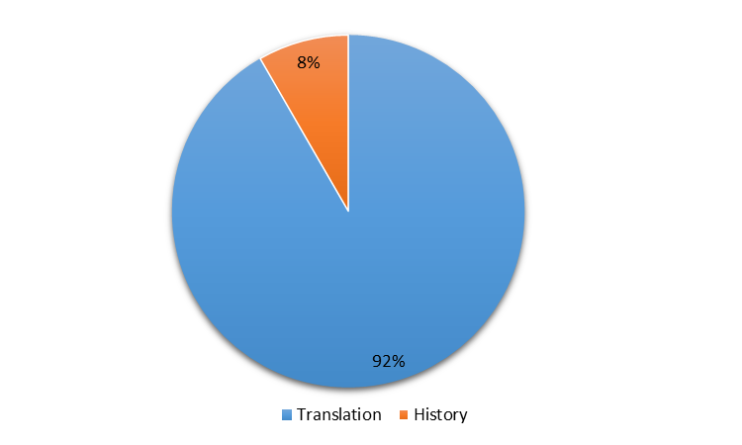
Figure 3: Percentages for disciplines researching the SoT at Iranian universities (2009–2022)
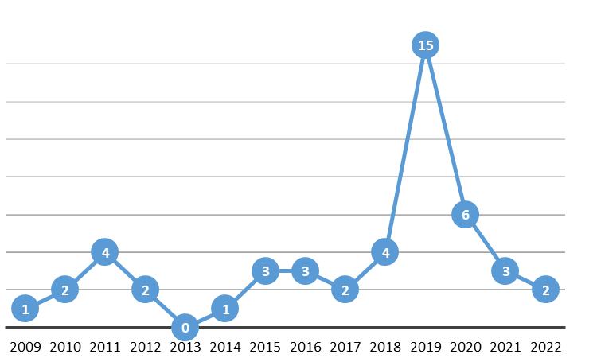
Figure 4: Years of publication of studies conducted on the SoT at Iranian universities (2009–2022)
Presumably, the novelty and originality of the topics and areas of research on the SoT attracted the attention and interest of many PhD students in Iran, explaining the significant increase in the number of studies on the SoT. However, due to the restrictions imposed after 2019 as a result of the Covid-19 pandemic, which prevented many researchers from collecting data from potential participants and attending contextual translation activities, a sharp decrease can be witnessed from 2020–2022. It is expected that with the lifting of restrictions, the country will experience another boom in the SoT research from 2023 onwards.

Discussion and conclusion
The current study is an attempt to map postgraduate research trends in the SoT in Iran. To do so, the authors of the study delved into postgraduate research on the SoT, which was conducted at Iranian universities within the 14-year period of 2009–2022. We investigated the areas of the SoT that were studied by postgraduate researchers; the translation theories and models that were adopted by the students; and the research methodologies and methods used in the respective studies. Additionally, contextual information regarding the academic institutions where the studies had been carried out, was used to interpret the findings. The areas explored in the studies were reported in Table 4.
The results indicated that translatorial issues such as translators’ capital, translators’ habitus, agency, and professionalism were among the most frequently explored areas. While the authors of the present study opted to delimit this research to the postgraduate studies inside Iran, it seems that in terms of area, theory, and methodology, at least some of the recent sociological studies by postgraduate students in Iran were inspired by the influential work of Haddadian-Moghaddam (2014) who had investigated agency of translators¹.
A close look at the investigated areas reveals that still many gaps exist in the study of the SoT in Iran that should be filled. For example, the sociology of the translation process is an almost neglected area of research in Iran. Key social factors influencing the translation process such as power relations, race, ethnicity, class, and religion have been totally ignored by the researchers. Additionally, vital agency topics such as translators’ roles in bringing about Iranian nationalism, and in diaspora as well as Iranian translators’ life histories, behaviours, working processes, attitudes and motivations are lacking in the studies. Research on the mentioned areas can shed light on these sociological aspects of translation practice in Iran. Moreover, the less frequently explored topics and the unmapped themes can be identified by referring to Tables 1 and 4.
Another interesting finding of the study was the diversity of translation theories and models that were incorporated into the studies. This should encourage translation researchers to continue the trend by further exploring these and other new theories and models from other disciplines, which entails learning from and collaborating with researchers from other disciplines.
The results also showed that more than one third of the studies were based on Bourdieusian theoretical frameworks and almost half of them used context-oriented research models such as multiple case studies. Interestingly, some studies adopted a mixed-method approach by combining surveys, archives, and interviews to triangulate their data collection and research methodologies and hence to increase the reliability of their findings (Dörnyei 2007; Saldanha & O’Brien 2014; Mackey & Gass 2016). In fact, the prevalence of case studies and surveys (or their combination in mixed methods) as a characteristic of research on the SoT was first stated by Pym (2006). Finally, analysis of contextual information about the universities where the studies had been conducted revealed that the SoT was investigated by both translation and history postgraduate students. It was also found that Allameh Tabataba’i University and Ferdowsi University of Mashhad were the two main centres for studying the SoT at postgraduate level in Iran. As there was a sharp increase in the number of sociological studies in 2019 probably due to the graduation of PhD students, it is very likely that the current trend will continue in the foreseeable future due to the growing interest and as more MA and PhD students are enrolled in translation programmes². Investigating the reasons behind this surge in the number of studies on the SoT could be an interesting research topic.
The findings of this study attest that providing a map of postgraduate research on the SoT in Iran is beneficial not only for Iranian researchers, but also for those who are interested in studying the SoT elsewhere as it helps them to draw an indigenous map of the SoT. Hence, based on the findings, the researchers proposed a tentative map (see the Appendix) of postgraduate research on the SoT in Iran. As Simeoni (2007: 188) states:
Mapping that circulation of ideas and the resulting practices in terms of the methods being used is not easy, but it is an indispensable step on the long and winding road of conceptualizing translation as an original object of study. […] The map need not be fixed. Indeed, it constantly evolves.
The proposed map indicates that, in the current Iranian context, the study of the SoT is relatively unexplored and open to novel ideas and themes for investigation. It is hoped that future researchers would fill the gaps by examining the unmapped areas.
This research was limited to studying postgraduate research on the SoT in Iranian universities. It is important to note, however, that to gain a comprehensive view of research trends in an area of translation in each country, one should investigate various sources of data, including those obtained from academic journals and publications. Such an investigation had already been carried out by Sanatifar (2019) who found only seven studies on the SoT in the two leading Iranian translation journals. Hence, the present research is more comprehensive in terms of duration, scope, and number of studies.
Finally, the qualitative analysis in our study was based on the subjective judgement of the researchers, especially regarding decisions on what represents a SoT research area or a translation model. Considering this limitation and the rapid developments in the SoT, more relevant studies are required in the future to consolidate our findings and to present a more accurate and detailed map of postgraduate research in the SoT in Iran.

Notes
1. Esmaeil Haddadian-Moghaddam’s book entitled Literary Translation in Modern Iran: A sociological study was first developed at Rovira i Virgili University in Spain as a doctoral dissertation and later revised at KU Leuven University in Belgium during and after his postdoctoral fellowship. It was finally published by John Benjamins Publishing Company in 2014.
2. After 2019, due to the Covid-19 pandemic the bright prospects for a surge in research in the sociology of translation waned and hence the number of studies decreased over the ensuing years.

References
Angelelli, Claudia V. 2014. The Sociological Turn in Translation and Interpreting Studies. Amsterdam: Philadelphia: John Benjamins.
Baker, Mona (ed.). 2010. Critical Readings in Translation Studies. London: Routledge.
Berneking, Steve. 2016. A sociology of translation and the central role of the translator. The Bible Translator 67(3): 265–281. doi:10.1177/2051677016670232.
Buzelin, Hélène. 2005. Unexpected allies: How Latour’s Network Theory could complement Bourdieusian analyses in translation studies. The Translator 11(2): 193–218. doi.org/10.1080/13556509.2005.10799198.
Chesterman, Andrew. 2009. The name and nature of translator studies. Hermes 42: 13–22.
Dimitriu, Ileana. 2010. Activism and the intensity of the local: Translation, cultural politics and the East European ‘Other’. In Boéri, Julie & Maier, Carol (eds.), Compromiso Social y Traducción/Interpretación. Translation/Interpreting and Social Activism. Granada: ECOS. 48–58.
Doorslaer, Luc V. 2007. Risking conceptual maps: Mapping as a keywords-related tool underlying the online Translation Studies Bibliography. Target 19(2): 217–233.
Dörnyei, Zoltan. 2007. Research Methods in Applied Linguistics. Oxford: OUP.
Gouanvic, Jean-Marc. 2005. A Bourdieusian Theory of Translation, or the coincidence of practical instances: Field, ‘habitus’, capital and ‘illusio’. The Translator 11(2): 147–166.
Haddadian-Moghaddam, Esmaeil. 2014. Literary translation in modern Iran: A sociological study. Amsterdam: John Benjamins.
Heilbron, Johan & Sapiro, Gisèle. 2007. Outline for a sociology of translation: Current issues and future prospects. In Wolf, Michaela & Fukari, Alexandra (eds.), Constructing a sociology of translation. Amsterdam: John Benjamins. 93–108.
Inghilleri, Moira. 2003. Habitus, field and discourse. Interpreting as a socially situated activity. Target 15(2): 243–268.
Inghilleri, Moira. 2005. The Sociology of Bourdieu and the construction of the ‘object’ in translation and interpreting Studies. The Translator 11(2): 25–145. doi.org/10.1080/13556509.2005.10799195.
Inghilleri, Moira. 2009. Sociological approaches. In Baker, Mona & Saldanha, Gabriela (eds.), Routledge Encyclopaedia of Translation Studies. Abingdon; New York: Routledge. 279–282.
Karimnia, Amin & Aboutalebi, Azadeh. 2014. A Meta-Analysis of papers published in translation studies journal over the period 2002–2012 Based on Chesterman’s classification of translation models. Iranian Journal of Translation Studies 11(44): 7–22.
Karimnia, Amin & Nouraey, Peyman. 2013. Towards a global model for translation studies trends: Is it the question of backing to square one? Wulfenia 20(9): 145–155.
Mackey, Alison & Gass, Susan M. 2016. Second language research: Methodology and design. London: Routledge.
Mossop, Brian. 1988. Translating institutions: A missing factor in translation theory. TTR: traduction, terminologie, rédaction 1(2): 65–71. doi.org/10.7202/037019ar.
Munday, Jeremy. 2016. Introducing translation studies: Theories and applications. London: Routledge.
Nouraey, Peyman & Karimnia, Amin. 2012. A meta-look at current translation studies trends in Iran: Insight from translation studies M.A theses. British Journal of Social Sciences 1(1): 94–116.
Nouraey, Peyman & Karimnia, Amin. 2015. The map of translation studies in modern Iran: An empirical investigation. Asia Pacific Translation and Intercultural Studies 2(2): 123–138. doi.org/10.1080/23306343.2015.1059009.
Pym, Anthony. 2006. On the social and the cultural in translation studies. In Pym, Anthony & Shlesinger, Miriam & Jettmarová, Zuzana (eds.), Sociocultural aspects of translating and interpreting. Amsterdam: John Benjamins. 1–25.
Saldanha, Gabriela & O’Brien, Sharon. 2014. Research methodologies in translation studies. Abingdon: Routledge.
Sanatifar, Mohammad S. 2019. Translator studies in Iran: Sociological, cultural, and cognitive gaps in the translation studies map. In Ojeda, Beatriz M. & Muñoz, María L. R. (eds.), Translation in and for society: Sociological and cultural approaches in translation. Córdoba: UCO Press. 117–148.
Sapiro, Gisèle. 2014. The sociology of translation: A new research domain. In Bermann, Sandra & Porter, Catherine (eds.), A companion to translation studies. Oxford: Wiley Blackwell. 82–94. doi:10.1002/9781118613504.
Simeoni, Daniel. 2007. Between sociology and history: Method in context and in practice. In Wolf, Michaela & Fukari, Alexandra (eds.), Constructing a sociology of translation. Amsterdam: John Benjamins. 187–204.
Snell-Hornby, Mary. 2006. The turns of translation studies: New paradigms or shifting viewpoints? Amsterdam: John Benjamins.
Tyulenev, Sergey. 2012. Applying Luhmann to translation studies: Translation in society. London: Routledge.
Tyulenev, Sergey. 2013. Translating in the public sphere: Birth pangs of a developing democracy in today’s Russia. SALALS 31(4): 469–479. doi.org/10.2989/16073614.2013.864443.
Vorderobermeier, Gisella M. 2014. Remapping habitus in translation studies. Amsterdam: Rodopi.
Williams, Jenny & Chesterman, Andrew. 2002. The map: A Beginner’s guide to doing research in translation studies. Manchester: St. Jerome.
Wolf, Michaela. 2005. Die vielsprachige Seele Kakaniens. Translation als soziale und kulturelle Praxis in der Habsburgermonarchie 1848 bis 1918. Graz: Karl-Franzens-Universität. (Postdoctoral thesis.)
Wolf, Michaela. 2007. Introduction: The emergence of a sociology of translation. In Wolf, Michaela & Fukari, Alexandra (eds.), Constructing a sociology of translation. Amsterdam: John Benjamins. 1–36.
Wolf, Michaela. 2012. The sociology of translation and its ‘activist turn’. Translation and Interpreting Studies 7(2): 129–143.
Yin, Robert. 2003. Case study research: Design and methods. Thousand Oaks, CA: Sage.
Hossein Bahri (corresponding author)
Department of Foreign Languages
Faculty of Literature and Humanities
Kharazmi University
No. 49, South Mofateh Ave.
15719-14911, Tehran, Iran
E-Mail: hbahri@khu.ac.ir
Mahvash Gholami
Department of Foreign Languages
Faculty of Literature and Humanities
Kharazmi University
No. 49, South Mofateh Ave.
15719-14911, Tehran, Iran
E-Mail: mahvashgholami@khu.ac.ir

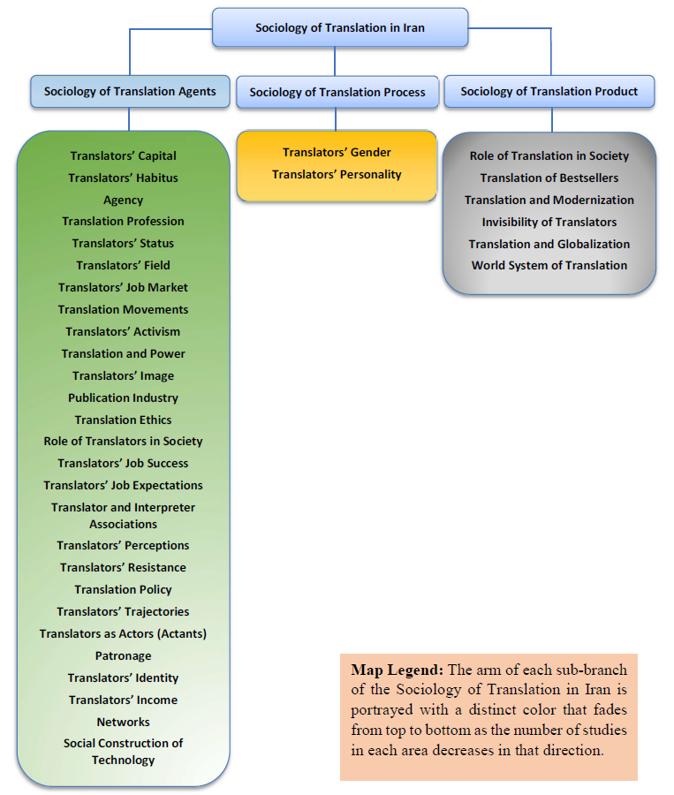
Appendix: Tentative map of postgraduate research on the sociology of translation in Iran (2009-2022)

