Chinese Literary Translation in Spain Up Until 2020: A Quantitative Approach of the Who, What, When and How

Irene Tor-Carroggio and Sara Rovira-Esteva¹

Abstract
Translations of Chinese literature have traditionally been scarce in Spain. The aim of this paper is to provide an overview of both the development and current state of Chinese literature translated in Spain. Working from a database including 695 entries of translated books into Spain’s official languages, our analysis reveals that the number of translations has increased sharply in recent decades and now seems to be levelling out. It also establishes that Laozi’s Dao De Jing is the most translated work, philosophy and novels are clearly the most popular genres and there has been a steady increase in direct translations, among other findings.

Keywords: Chinese literature, Chinese-Spanish translation, Chinese-Catalan translation, Chinese-Galician translation, Chinese-Basque translation, literary translation, history of translation

1. Introduction

1.1. Socio-cultural context
According to the Panorámica de la edición española de libros 2017 (Overview of Spanish Book Publishing 2017) drafted by the Ministerio de Cultura y Deporte (Spanish Ministry of Culture and Sport) (2018), translations represented 21.1% of the total Spanish editorial production in 2017. This market share represents a 36.8% increase in the number of translated titles compared to the previous year. Translations from English accounted for 51.1% of translated works and all of the most translated languages experienced a significant increase in comparison with 2016, the most notable being from Italian (146.2%), Swedish (39.3%), English (37.5%), Japanese (30.3%) and Portuguese (26.8%). As opposed to a more developed translation market of other distant languages in Spain, such as Japanese (Wang 2016), Chinese is not mentioned in this document, probably due to the discrete presence the translations from this language in this country. The same applies to other official languages in Spain, such as Catalan. As Prado-Fonts (2001) noted, the translation of Chinese literature into Catalan is not the result of careful planning, but is rather more spontaneous in nature. This comes as no surprise, given Spain’s weak tradition in Sinology (Wang 2016). The long-established scarcity of Chinese-Spanish translations has had an impact on the academic and more theory-oriented study of translation for this language combination (Ciruela 2003). This has resulted in Spanish sinological studies lagging behind countries such as France, the United Kingdom and Germany (Ciruela 2003). Wang (2016: 65) already noticed that, “the translation of Chinese literature in Spain has not yet reached a satisfactory level, and many original works are still ignored.” Given the fact that China has never been colonised by a western power, and unlike ex-colonies which are closer to powerful western countries, Chinese culture is considered to be more distant and less accessible. In other words, Chinese texts are viewed as marginalised texts in dominant cultures (Wang 2016: 67). The paradox comes when what is considered to be “peripheral literature” in China is viewed as peripheral literature in Western countries, but for different reasons than in China. For example, Rovira-Esteva (2016) observes that in China Chun Sue’s Beijing Doll is seen as peripheral culture because it gives voice to non-mainstream culture. In contrast, it is considered peripheral in the West because the original is in Chinese and “target readers have to overcome a series of stereotypes associated with that before they approach it on equal terms with other foreign literatures” (Rovira-Esteva 2016: 202).

However, according to the data on the 26 most frequently translated languages for literary translation in Europe collected by the UNESCO’s Index Translationum (Budapest Observatory 2011), the future of translation from Chinese into European languages looks promising:

Translations from that [Chinese] literature did not stand out until 2002-2003 but then climbed well above the rest. Chinese is likely to occupy a position among the first fifteen source languages of new translated titles published in Europe in the future.

Prado-Fonts (2011: 3) pointed out that Chinese contemporary authors are being increasingly translated into Spanish, finally filling a gap that was both inexplicable and embarrassing. This upward tendency had already been noticed by other sinologists, such as Ciruela (2003: 108), who sees in said trend an end to the cultural disconnection that has characterised Spain and China for decades. Nonetheless, Chinese literature is not a mainstream choice for the average (and euro-centric) Spanish reader, as its anecdotical presence in libraries, bookstore shelves and media testifies. Prado-Fonts (2011) claims that this recent interest in Chinese literature is often dominated by commercial authors whose works are not necessarily tagged “quality”. Also, this change responds to publishing houses opting for works that reinforce our own orientalist expectations that some Chinese authors are willing to satisfy. Rovira-Esteva’s (2016: 203) analysis of the paratexts of the translations into English, Spanish and Catalan of Chun Sue’s Beijing Doll also shows that these were domesticated “to conform to target audience expectations (i.e. mainstream ideology) in order to ensure success in terms of market indicators.” Traditionally, the Chinese authors translated into Spanish were either chosen randomly or picked by scholars who almost pleaded with publishing houses and very often translated the works themselves (Prado-Fonts 2011: 4). In fact, renowned scholars translating Chinese classical works is not a rarity given the considerable difficulty this task entails, which cannot be surmounted unless many years are devoted to the study of the work concerned (Ciruela 2003).

Spain is not the only country in which translating Chinese works is infrequent. Lovell
(2010) claimed that, despite the strenuous efforts on the part of post-Mao Chinese authors in their quest for an international audience, in countries such as the USA and the UK, the presence of Chinese translations has always been very modest. The reason for this is not only the aversion to reading translations in Anglophone cultures, but also the idea that persisted for a long time that Chinese literature was more of a source of socio-political information about China (and even propagandistic) rather than works with a literary value (Lovell 2010: 202), and in fact, Chinese modern literature has been labelled as “poor”. Lovell (2010) also observed that among the limited selection of translated Chinese authors, some have not obtained their fellow countrymen’s approval. This is the case of Gao Xingjian, who, despite being awarded the Nobel prize, is not well-known in the Mainland and is not considered to be a good representative of Chinese literature.

The growing presence of China in the media due to its re-emergence as an economic superpower has resulted in Chinese culture awakening more interest, including its literature (Sáiz-López 2015). Yet, and as Prado-Fonts (2011: 5) notes, interest in Spain is more of a sociological rather than literary nature. In fact, the Taiwanese literary critic Hsia (1967, in Prado-Fonts 2008) had already complained about Chinese writers paying excessive attention to Chinese national issues. Spanish readers want to know what Chinese people read, what they write and how they live in order to gain a deeper insight into the country that is supposed to (or is already) ruling the world (Prado-Fonts 2011: 5). In the same vein, Marin-Lacarta (2012) alleges that the literary value of Chinese works is given less importance, or even overlooked to highlight its documentary value. Marin-Lacarta (2012: 46) claims the literary works that arrived in Spain before 2000 were mainly realistic, historical and autobiographic novels. Prado-Fonts (2008) exemplifies this lack of literary interest with the reception of the Spanish translations of Qian Zhongshu’s Fortress besieged (1946) and Nobel laureate Gao Xingjian’s Soul mountain (1990). Their literary richness and merit have been ignored and are interpreted in an exotic vein which feeds the orientalist view readers, and even critics, hold of Chinese literature (Prado-Fonts 2008: 202). Rovira-Esteva (2016) also illustrates the lesser importance attached to the literary value of Chinese works with Chun Sue’s Beijing Doll, which she considers to be more important for the western audience for its criticism of Chinese mainstream ideologies and institutions rather than for its literary quality. This stands in stark contrast to what some Chinese authors endorse. Gao Xingjian, for instance, defends what he calls “cold literature”: a radical depoliticization of literary works (Prado-Fonts 2008: 262; Lovell 2010). Nonetheless, Rovira-Esteva and Sáiz-López (2008) mention the aesthetic values of some works (for example, the use of new creative techniques) among the reasons behind the selection of a Chinese work to be translated for foreign consumption. Yet, for Rovira-Esteva and Sáiz-López (2008), this is not the only factor taken into account: the literary prizes awarded, censorship and the intermediation of previously existing British, French and American translations also play a decisive role.

Although the type of works chosen to be translated seem to have slightly changed with the translation of authors such as Yu Hua, Yan Lianke and Mo Yan, Marin-Lacarta (2012) examined some paratexts concerning the latter’s translated works and confirmed that current editorial and media practices fail to convey what really stands out most in Mo Yan’s prose: its contrasts, fantasy and magic realism, and humour, among many other literary features. Blaming only the meta culture and reception process for this would be inaccurate, since Maoism created a conception of literature linked to socialist realism until the 1970s, which had an impact not only on the authors at the time, but also on the idea that earlier authors had to be eliminated from the history of domestic literature. Whatever the case, and as Marin-Lacarta (2012) notes, this phenomenon has relegated Chinese literature to a marginal position in Spain. Conversely, Rovira-Esteva (2016: 202) claims that the mere fact some texts have been selected to be translated and that they are marketed to reach middlebrow readership in Spain entails a “shift from the periphery of the Chinese literary system to a more central position in the target literary system.”

1.2. Research background
Research into Chinese-Spanish translation is far from abundant. We can find a handful of papers analysing specific Chinese works, such as that comparing the different translations of Ma Jian’s Beijing Coma or Mo Yan’s The Garlic Ballads (Ku 2014 and 2016, respectively). On the other hand, there are a few which focus on specific authors as, for example, Martín Ríos (2007) on Wen Yiduo’s poetry, Mi Tian (2018) presenting the figure of Marcela de Juan or Rovira-Esteva and Tor-Carroggio (2020) on Sanmao’s Sahara Diaries reception through translator’s footnotes.

As far as more comprehensive studies are concerned, Arbillaga’s (2003) seminal work should be mentioned. Her bibliographical study not only includes both direct and mediated translations of Chinese works into Spanish, including translations carried out in Spain, but also some translations published in China and Latin America. Her corpus comprises a total of 228 works originally written in Chinese. Prado-Fonts (2009) is also one of the few authors offering a brief overview of Chinese-Spanish translation from a historical and critical perspective. Marin-Lacarta (2012: 114) analysed a corpus of 84 Chinese works written from 1917-2009 translated into Spanish or Catalan. Wang (2016) carried out a corpus-based study on Chinese narrative translated into Spanish, including novels, stories, biographies and autobiographies. The list was extracted from the Spanish Ministry of Culture and UNESCO’s Index Translationum. A total of 69 works by 41 different authors were recovered, six of which were classical works, 15 belonged to modern literature and 48 were contemporary literature. Her corpus revealed that the number of translations from Chinese into Spanish is much more modest compared to other countries and that many Chinese works land in Spain via the mediated translation of other languages such as English and French. In fact, as Rovira-Esteva points out (2016: 204), the decision to translate a book is often based on its prior success in the English translation or because the publisher has been offered translation rights by an international agency. This clearly shows Spain’s dependence on other European cultures that are more powerful, and proves the asymmetrical power relations between languages and cultures, and that translation tends to be a transmission rather than dialogue (Wang 2016). In this vein, Rovira-Esteva (2016: 204) affirms that the Chinese and Spanish cultures function as “minor” cultures in contact with Anglo-Saxon culture and, in turn, Spanish and Catalan cultures function as “major” cultures in relation to Chinese.

1.3. Objectives and research questions
The research carried out thus far consists of either partial studies mainly focusing on just one language pair, author or genre, or out-of-date studies that end in 2012. Therefore, there are no recent studies analysing data extracted from an updated and extensive corpus that can offer a thorough overview of either the evolution Chinese literature has experienced in Spain or its current state. This is precisely the aim of this paper, which will focus on the development and status quo of the Chinese literary works translated into any of Spain’s official languages, namely, Spanish, Catalan, Galician and Basque. In order to achieve this aim, we attempt to respond to the following research questions:

- Whose works are translated and who translates them?

- What is translated in terms of genres and which are the most translated Chinese literary works?
- When have the translations been published and can an evolution over time of all of the above-mentioned variables be traced?
- How have these translations been carried out as far as language pairs and teamwork is concerned?

1.4. Data and methodology
The open-access database La literatura china traducida en España (Chinese literature translated in Spain)² was used (Rovira-Esteva et al. 2019-2021). This database attempts to include all the Chinese literary works (namely poetry, essay, short story, novel, comic, philosophy and theatre) translated directly or through a mediating language into all of Spain’s official languages published in Spain. Only translations published as printed books or with an ISBN are considered eligible and the selection ranges from Juan Cobo’s translation of Precious Mind for Enlightening the Mind in the 16th century to the latest translations published in 2019, such as Liu Cixin’s The Wandering Earth. Up to April 2020, the database included more than 700 different entries. One entry can correspond to the translation of more than one work, for example anthologies. Different editions³ of the same translation are gathered under the same entry, are counted only once in this study and the date in which they were first published is the one taken as a reference.
The information collected in this database has been retrieved through a number of different sources, mainly the catalogue of the Spanish National Library, the Spanish ISBN database, the Index Translationum, the catalogue of the Library of the Autonomous University of Barcelona, the websites “China Traducida y por Traducir”⁴ and “Asiared”⁵, general press, the online catalogues of publishing houses, personal libraries and through personal communication with Spanish translators who revised the entries mentioning them and let us know which information was missing. The data in each entry has been maintained as shown in the translations’ paratexts so, for instance, authors’ names and publishing houses appear as they are printed in the books, whether or not in the official pinyin transcription or belonging to bigger publishing groups, respectively.
The above-mentioned database can be consulted online, but it is a dynamic, open-ended project, constantly being updated and, therefore, constantly in progress. In order to facilitate our analysis, we exported the data to an excel file in February 2020, when the database included a total of 695 entries. For the purpose of data analysis some adjustments had to be made. First, the works that had been assigned more than one genre were retagged taking into account a quantitative criterion. More specifically, the genre was decided based on how many works of each genre were included in that specific translation. For example, in Invisible Planets (edited by Ken Liu) there are both short stories and essays revolving around science fiction but, given that the former outnumber the latter, the final genre tag assigned to this book was short story. However, this kind of adjustment was only necessary in four cases. The same quantitative criterion was applied to two books that combine both direct and mediated translation. For example, if in a specific anthology the number of poems translated through a language different from Chinese exceeds that of those translated directly from Chinese, that book’s type of translation was tagged as mediated.
When presenting the names of, for example, the most prolific translators or the most translated authors, efforts were made to create top ten lists, but this was not possible when more than one translator or author had the same number of translations published in Spain. In these cases, lists have either been shortened or extended so that this problem is avoided or so that no one is left out arbitrarily. The titles of the translations are presented in English to make the paper easier to read, but an annex has been added showing the correspondence between the original title and its translations into English and Spanish.

2. Results and discussion

As previously mentioned, our analysis has been carried out based on a database including 695 entries in total. More specifically, it comprised 618 translations into Spanish (88.9%), 56 into Catalan (8.1%), 15 into Basque (2.2%) and 6 into Galician (0.9%). The results have been divided into four different subsections for more clarity: the who (original authors, translators and publishers), what, when and how.

2.1. The “who” in Chinese literary translation in Spain
2.1.1. The original authors

The database contains a total of 400 identifiable authors. In this section, those cases in which the authorship was tagged as anonymous or various authors have been ignored. In the light of the results obtained, it can be clearly stated that the most translated Chinese author in Spain is Laozi –with 74 versions of his Dao De Jing identified–, followed by another philosopher, Sunzi –with 37 versions of his The Art of War– (see Figure 1). This contradicts Arbillaga’s (2003: 181) findings, since, according to her, Mao Zedong was the most translated author. Arbillaga (2003: 181) also affirmed that, with the exception of some poems, Mao had never been directly translated from Chinese in Spain. However, our data contradicts her findings, since our database includes at least five of his works (essays) directly translated from Chinese in the 1970’s.

Our ranking includes authors cultivating almost all the genres under study except for theatre. Another important fact to bear in mind is that all the authors depicted in Figure 1 are men and that different regions of Greater China are represented, namely, Mainland China (Mao Zedong, Mo Yan), Hong Kong (Tony Wong) and Taiwan (Jimmy Liao). Obviously, and given the historical times they lived in, it is impossible to classify Laozi, Sunzi, Li Bai, Confucius, Du Fu and Wang Wei in these geographical terms. Also, these ten most translated authors belong to very different historical moments, ranging from the 6th century BC (Laozi, for example) to the present time (Mo Yan and Jimmy Liao, for instance).
It is worth mentioning that, among this top-ten of the most translated authors, some have only one work which has been repeatedly translated, i.e. has dozens of versions (such as Laozi or Sunzi), whilst others have a wide range of their literary production translated, such as Jimmy Liao or Mo Yan.

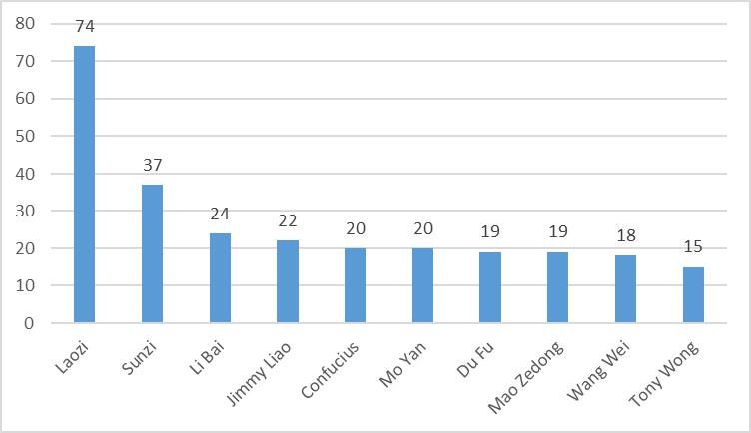
Figure 1 Top 10 most translated Chinese authors in Spain

This same ranking was built, classifying authors by genres. Regarding poetry, the major poets of the Tang dynasty have been widely translated. In fact, all the poets in Figure 2 belong to the Tang dynasty, except for Su Dongpo and Li Qingzhao, who lived during the Song dynasty, another splendorous age of Chinese poetry. The latter is also the only poetess ranking among the most translated Chinese poets.

It must be noted that the different translations do not necessarily correspond to the same original texts, since in most of the cases, the translated books adopt the form of anthologies, in which translators often selects the poems at their will.
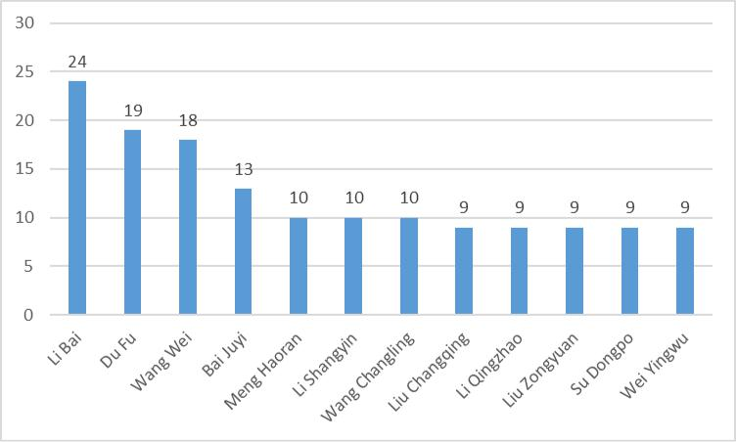
Figure 2 Number of books of Chinese poets translated in Spain

Concerning novels, 19 novels of Mo Yan have been translated into Spanish to date (Figure 3). The other author who has more than ten books in Spanish translation is Luo Guanzhong, although this is a special case that needs to be further explained. Luo Guanzhong’s main novel is Romance of the Three Kingdoms, which has been translated by an amateur translator by splitting the original work into several parts that have been published separately i.e., the 14 translations correspond to different chapters of the same original text. The other Chinese Nobel laureate, Gao Xingjian, is also among the most translated authors, although the number of his translations (6) greatly differs from that of Mo Yan’s (19).

Out of the 14 authors listed, nine are still alive (all except for Luo Guanzhong, Ba Jin, Lanling Xiaoxiaosheng, Li Yu and Lao She) and the work (or part of it) of three of them has been banned in China for different reasons. That is the case of Gao Xingjian, Wei Hui and Hong Ying. Novel is the literary genre in which more women have been translated: three out of the 14 listed, more specifically Wang Anyi, Wei Hui and Hong Ying.
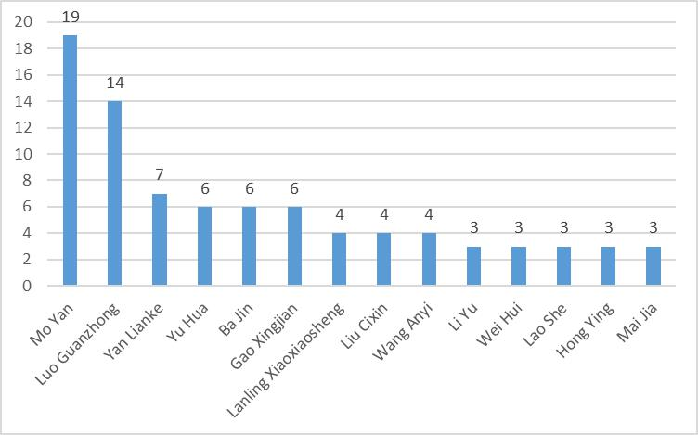

Figure 3 Most translated Chinese novelists in Spain

As for the Chinese essays translated in Spain, only three authors have been translated more than once, namely Mao Zedong (11), Gao Xingjian (4) and Lu Xun (2), the former and the latter’s texts containing socio-political theories or insights, while Gao Xingjian’s writings deal rather with literary and aesthetical issues. As for philosophical works, Laozi and Sunzi are predictably the most translated authors, followed by Confucius (Figure 4). Yet, it must be pointed out that the number of times Laozi’s Dao De Jing has been translated is more than twice as high as that of Sunzi’s The Art of War. These extraordinarily high figures concerning the number of different translations of both the works of Laozi and Sunzi can only be explained by their influence and interest beyond sinological circles. Their sayings not only place them in a high position as universal philosophers, but also have been taken by the common people as models of behaviour and attitude in front of life or in one’s professional scene.

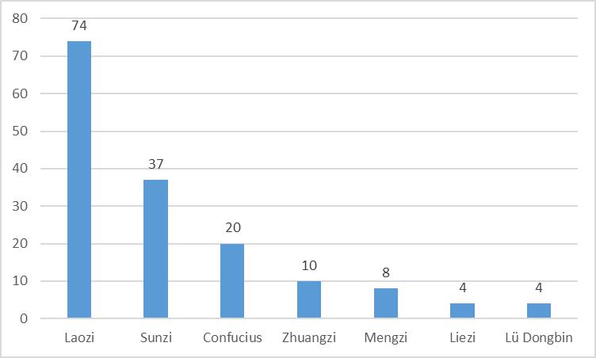

Figure 4 Most translated Chinese philosophers in Spain

The short stories penned by the Taiwanese writer and illustrator Jimmy Liao have been widely translated, more specifically into Spanish (Figure 5)⁶. Two women are included in the top most translated short story writers: Sanmao and Zhang Ailing. They have three and two books, respectively, translated into both Spanish and Catalan, a privilege not many Chinese authors can claim. The translations of three of the most translated short story writers (Jimmy Liao, Sanmao and Zhang Ailing) are concentrated in the hands of the same translators and publishing houses.
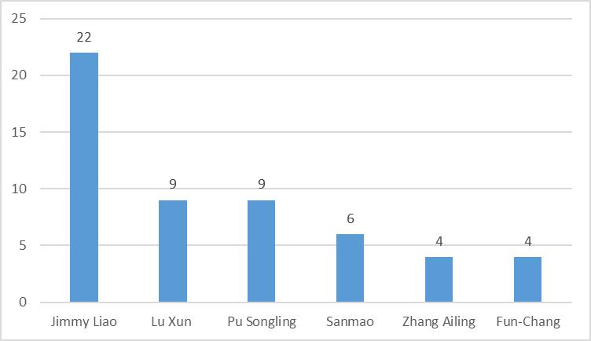

Figure 5 Most translated Chinese short story writers in Spain

Given the fact that theatre is not a popular choice among Spanish publishing houses, it is not surprising that no particular name stands out when analysing this particular genre from Chinese origin. In contrast, regarding comics, the names of Tony Wong (15 translations in total) and Selena Lin (10 translations in total) tower above the rest. In these two cases it is two publishing houses, Iced Lands and Filabo, respectively, that are responsible for all their translations published in Spain.

Generally speaking, the fact than one author has many translations does not necessarily mean that his/her works are more widely known in Spain. For example, in the case of Gao Xingjian, there are 11 different translations of only four of his works, while out of the 20 works authored by Mo Yan, 17 correspond to different originals. In the case of Yan Lianke and Yu Hua, there is only one version of their translated works (eight and six, respectively). Ba Jin and Lao She have three of their works translated in Spain, but amongst these the former’s Family has four different translations and the latter’s Camel Xiangzi two. Lanling Xiaoxiaosheng and Li Yu have four and three different versions of the same book, respectively. These examples illustrate the fact that for reasons which need to be further explored some books have been the object of several translations, while others keep on being ignored and are still consigned to oblivion.

2.1.2. The translators

To date, our database contains the translations of 414 different translators in total. Out of these, more than half of them are men, while one third are women (Figure 6). Almost 8% of the translators could not be assigned a sex, mainly because we just had their initials or Chinese names in pinyin, which made it more difficult to guess.
It is also worth noting that in 50 of the entries the identity of the translator is unknown. This is mainly due to the traditionally low value attributed to the translator’s work, which has often kept the translator invisible from the editorial process. This situation has slightly improved in Spain since 1996 with the enactment of the Copyright Law.
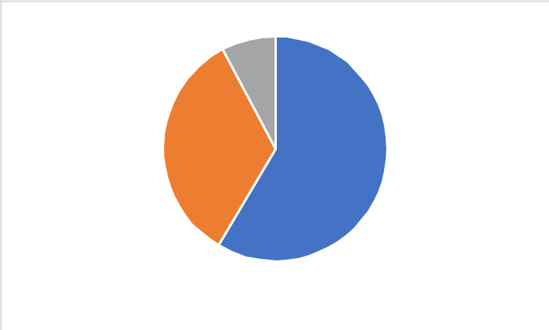

7.7%

33.8%

58.5%

Male Female Unknown

Figure 6 Translators’ sex

Out of the 414 translators, we found that a total of 183 (44,2%) translate directly from Chinese. Almost half of them were men (48.4%), whilst 39.1% were women. There were 23 translators who could not be gendered for the above-mentioned reasons.

Table 1 shows the list of translators that have translated directly from Chinese the most. As can be seen, all of them translate into Spanish and, apart from some exceptions, they have experience translating at least two different genres. The case of Jordi Ainaud deserves specific mention, since the number of translations he has carried out of just one author’s books (Jimmy Liao) launches him immediately to the number one position of the most prolific translators in Spain’s ranking, although the texts are extremely short. The two most versatile translators are Gabriel García-Noblejas and Laureano Ramírez, since they both cover four different literary genres. Table 1 also includes two translators of Chinese origin, namely Chen Guojian and Imelda Huang. The former is a Vietnam-born hispanist of Chinese origin who has been living in Spain since the 1990s, while the latter was born in Taiwan in the late 1950’s. It is quite interesting to note that amongst these prolific translators we find very different profiles: scholars or at some point in time university-based translators (Ainaud, García-Noblejas, Suárez, Ramírez and González), schoolteachers (Piñero), priests (Preciado and Elorduy) or professional translators (Cuadra). Some translators even fit in more than one category. This is the case of Suárez and Ainaud, who, apart from working (or having worked) at Spanish public universities, also have long professional careers as freelance translators.

Table 1 The most prolific translators translating from Chinese in Spain

TRANSLATOR | NUM. | GENRES TRANSLATED
 | TRANSLATIONS
Jordi Ainaud | 24 | Short story
Gabriel García-Noblejas | 18 | Novel, philosophy, poetry, short
 |  | story
Blas Piñero | 16 | Novel, poetry
Anne-Hélène Suárez | 16 | Novel, philosophy, poetry
Iñaki Preciado | 14 | Novel, philosophy, poetry
Laureano Ramírez | 11 | Essay, novel, philosophy, short story
Chen Guojian | 10 | Poetry
Belén Cuadra | 7 | Novel, theatre
Carmelo Elorduy | 7 | Philosophy, poetry
Enrique P. Gatón | 7 | Short story
Pilar González | 7 | Essay, philosophy, poetry
Imelda Huang | 7 | Short story


Obviously, this list changes if we examine which translators have translated each of the genres under study the most (Table 2). In some cases, only the name of one translator is presented. This is not due to the genre only having been translated by that translator, but to this person having translated more than one text belonging to that specific genre.

Table 2 Most prolific translators according to genres

GENRE | TRANSLATOR | NUM. OF TRANSLATIONS
Comic | Josep Oriol López | 3
Essay | Pilar González España | 2
Novel | Blas Piñero | 13
 | Belén Cuadra | 6
Philosophy | Gabriel García-Noblejas | 8
 | Iñaki Preciado | 7
 | Carmelo Elorduy | 6
Poetry | Chen Guojian | 11
 | Anne-Hélène Suárez | 7
Short story | Jordi Ainaud | 23
 | Gabriel García-Noblejas / Enrique P. Gatón & Imelda Huang | 5
Theatre | Alicia Relinque | 2

Despite the translators translating directly from Chinese into Catalan and Basque not being so prolific, we detected some names that have significatively contributed to bringing closer together Chinese literature and some specific regions in Spain. Table 3 reveals who these translators are and what genres they have contributed to the most. In contrast, the three direct translations into Galician that we are aware of have all been translated by different translators.

Table 3 The most prolific translators into Catalan and Basque

TARGET | TRANSLATOR | GENRES TRANSLATED
LANGUAGE | (num. of translations)
Catalan | Seán Golden & Marisa | Novel, philosophy
 | Presas (4)
 | Manel Ollé (4) | Essay, philosophy, poetry, short story
 | Carla Benet (3) | Essay, novel, short story
 | Eulàlia Jardí (3) | Novel
 | Sara Rovira (3) | Novel
Basque | Mailen Marin | Novel
 | & Aiora Jaka (2)
 | Rafa Egiguren (2) | Poetry


2.1.3. Publishing houses

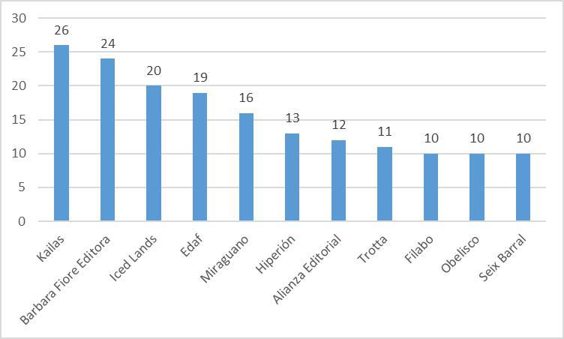
A total of 293 different publishing houses were identified. Figure 7 illustrates the publishing houses that have made the greatest efforts to translate Chinese literature in Spain. All of them publish in Spanish. Kailas has published 26 translations, 15 of which are some of the works of the Nobel Prize winner in Literature 2013, Mo Yan. The rest include classical philosophical works and mainly novels from different authors such as Zhang Wei, Jia Pingwa and Lu Xun, to name but a few. Kailas has even published Chinese poetry, more specifically the Nobel Prize in Peace 2010 Liu Xiaobo’s poems. Barbara Fiore Editora follows close with 24 translations, 23 of which belong to the same author: the illustrator Jimmy Liao. Iced Lands has only published translations of Chinese comics (20) and almost all of them are Tony Wong’s works. Filabo is also a publishing house specialising in comics and has published only the translation of Selena Lin’s comics into Spanish (10). None of the publishing houses shown in Figure 7 has launched any collection specifically devoted to Chinese literature. Yet, both Trotta and Seix Barral have a collection reserved for Oriental works, called “Pliegos de Oriente” (Oriental Sections) and “Biblioteca Oriental” (Oriental Library), respectively. These are not the only publishing houses in Spain offering this type of collection. Conversely, we have found just one offering a series exclusively devoted to China, namely the “Biblioteca de China Contemporánea” (Library of Contemporary China), edited by Edicions Bellaterra. This publisher is represented only with one translation in our database as it mainly publishes academic essays about contemporary China originally not written in Chinese, and falls outside the scope of the database and the present study.

Figure 7 Number of Chinese literary works published by Spanish publishing houses

Regarding the Catalan, Basque and Galician publishing houses most interested in publishing Chinese literature, it can be observed that no particular publisher stands out in either the Galician or the Basque case. This is due to the scarce number of translations in each of these languages. Conversely, there are Catalan publishing houses that have shown visible interest in Chinese literature, such as Proa (with six translations of both philosophical works and poetry) and Columna (with four translations, mostly from Gao Xingjian).

Last but not least, this section on the who in Chinese literature has been translated in Spain should include at least a short mention of the role which Peña (1997) calls protranslators. Protranslators are those people or institutions that ultimately promote interest for a literary work through translation subsidies, awards or other incentives that encourage its translation. In this case, into Spanish. Rovira-Esteva and Sáiz-Lopez (2008: 637) pointed out that finding out the identity of protranslators is key to answering the question of why certain books have been selected for translation in front of others. They concluded that, since many of the translations of their corpus were mediated, the protranslators had to be placed outside the Spanish culture. Arbillaga (2003: 181) also claims that, thanks to Chinese institutional protranslators who have provided Spanish translations, we have been able to enjoy many of their works of literature. As Zauberga (2005: 73) points out, translations of minor cultures mostly start with a wish to become known generated on the source culture, rather than a need from the target culture. In sum, there is some evidence that many translations from Chinese literature that have reached the Spanish reader either have originally been carried out in China to promote their literature abroad and later distributed in Spain, or have been introduced through western mediating languages.

Another key factor to be considered within the protranslators category is awards. Gao Xingjian has had all his books translated in Spain just after he was awarded the Nobel Prize in 2000. Mo Yan was not unknown to the Spanish reader before being awarded the Nobel prize in 2012, since eight of his books had already been translated before. However, the Nobel prize clearly boosted direct translations of his works. Before the Nobel, six out of the eight available translations were mediated, while eleven of the twelve translations published after being awarded the prize were direct.

2.2. The “what” in Chinese literary translation in Spain
A total of 282 original works were identified, which have resulted in 508 different translations so far. It must be borne in mind that in the latter number we include all the translations with different originals, regardless of whether they have been published as one single book. Each Chinese original work corresponds to 1.8 translations on average. However, we have observed that certain works have been translated only once while others have been retranslated a considerable number of times.

Figure 8 reveals that the genre which has been translated the most in Spain is philosophy (30.1%), but this needs to be contextualised, since the variety of philosophical works translated is limited: Laozi’s Dao De Jing and Sunzi’s The Art of War represent more than half of the translations of this genre. The 74 different versions of the Dao De Jing have been published by 70 different publishing houses, many of which no longer exist. The oldest edition dates back from 1931 (which means that it is close to a century old) and the newest one was published before exporting the data for this article. This represents almost one new translation per year. Out of the 74 different versions, only 36% are direct translations, while the rest are mediated translations or undetermined. It is also worth mentioning that out of the 34 mediated translations, one took German as the mediating language, six French and 25 departed from an English version (at least 13 mediating English translations were identified). The German mediating translation was carried out by Richard Wilhelm in 1910 which, according to Arbillaga (2003: 180) is considered to be the second translation of the Dao De Jing into a western language.
Novels are the second genre most translated, with 166 translations (23.9%). This comes as no surprise since, according to Genette, (1997: 97) the novel genre “is universally said to be more of a ‘seller’ than any other genre.” In this case, the titles chosen for translation are more varied. Short stories follow close behind, with 142 translations (20.4%). Poetry is the fourth most popular genre (15.0%), whilst comics (5.3%), essays (4.5%) and theatre plays (0.9%) are the least popular options. The latter, for example, only accounts for six translations in our database.

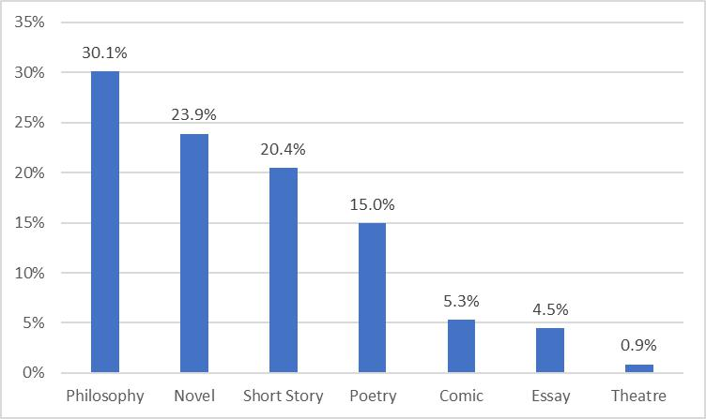

Figure 8 Percentage of literary genres translated from Chinese in Spain

According to Arbillaga (2003), philosophical works were also the most translated works (she collected around 100), followed by short stories (46), essay (34), poetry (33) and novel (15). It must be stressed that her corpus also included translations published in China, without which the availability of some genres in Spain, such as essay, would be non-existent. In any case, with the data at hand, it can be assumed that novels have gained more prominence in recent years.

It was observed that the editorial choices regarding genres differ from one language to another. According to Figure 9, philosophy is the most popular genre in Chinese-into-Spanish translations (31.7%), while Catalan editors have prioritised the translation of Chinese novels (30.4%). Basque publishing houses have opted for translating more Chinese short stories
(40.0%) while Chinese poetry is the most translated genre in Galician (50.0%). Taking into account that the translation of Chinese into Basque and Galician started later, it can be said that its evolution is in line with that of Spanish and Catalan, since short stories and poetry had a relevant role when the translation of Chinese literature kicked off in Spain.

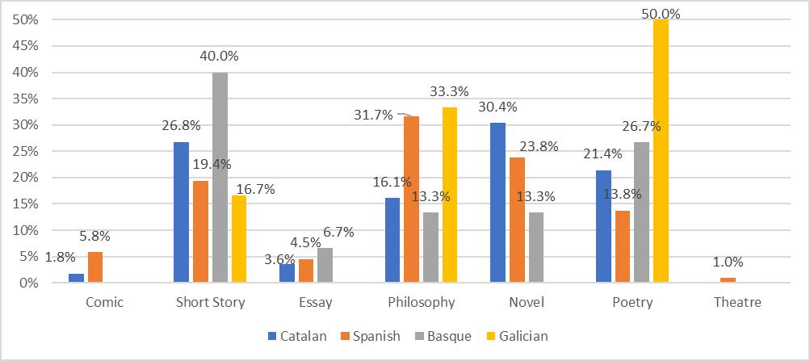

Figure 9 Percentage of translations per genre according to the target language

Regarding specific Chinese literary works that have been translated the most in Spain, it was found that the following have been translated at least four times: Laozi’s Dao De Jing (74); Sunzi’s The Art of War (37); Book of Changes (14); Zhuangzi (11); Confucius’ Analects

(11); Pu Songling’s Strange Stories from a Chinese Studio (9); Confucius, Mengzi, Zisi and Zenzi’s Four Books (7); Mao Zedong’s Quotations of Chairman Mao (6); Mao Zedong’s Poems (6); Lanling Xiaoxiaosheng’s The Plum in the Golden Vase (4); Ba Jin’s Family (4); and Lü Dongbin’s The Secret of the Golden Flower (4) (Figure 10). Also, we found 196 translations lacking an equivalent original work, which we tagged as no original reference in the database. This category includes anthologies of short stories, old sayings, legends and poems, as well as collections of essays. In short, this tag comprises selections of works from various authors (including anonymous works) that were published independently in China.

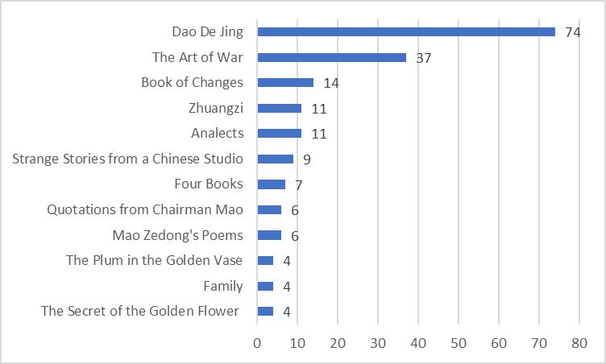
Figure 10 Chinese literary works with at least four translations into Spanish

Arbillaga (2003) also found the Dao De Jing to be the most translated work, followed by The Book of Changes. Yet, Arbillaga’s results do not completely match our findings. This could be explained given 2001 was the year in which Arbillaga’s (2003) research ended: 21 new translations of the The Art of War have been carried out since 2001, accounting for 36.6% of the total of translations of this work in the database. In contrast, only five new translations of The Book of Changes have been published since then.

Although almost all genres are represented in this ranking (with the exception of theatre and comic), the presence of philosophical works is the strongest. Nonetheless, Arbillaga (2003:

- found some important works to be missing, such as Buddhist classics and a complete edition of the classical works that Confucius interpreted. Fortunately, the situation reported by Arbillaga has improved and nowadays two different versions of the so-called four books of Confucianism can now be found in Spanish through mediated translation. As far as Buddhist classics is concerned, the number of records retrieved from our database when we used the keyword Buddhism was 26, which proves that the situation has also been reversed in this respect.

Obviously, this list varies if we analyse each of the target languages included in our database. As far as Spanish is concerned, the ranking coincides with that of Figure 10. Regarding Catalan, our database includes 20 translations of books that do not have a homonymous equivalent in Chinese. Laozi’s Dao De Jing and Sunzi’s The Art of War have been translated into Catalan five and three times, respectively. The rest of Chinese works under the Catalan-language umbrella have just been translated once. As regards Basque, our database includes seven translations with no original reference and two translations of Pu Songling’s Strange Stories from a Chinese Studio. The remaining Chinese works into Galician have been translated just once. In the case of Galician, there are no translations of the same original Chinese work and our database includes four works that do not have a homonymous equivalent in Chinese. What has been noticed is that, despite the discrete number of translations in both Basque and Galician, the most translated work in both Spanish and Catalan, Laozi’s Dao De Jing is also among the literary works translated in these two languages whereas Sunzi’s The Art of War remains untranslated in Basque.
Table 4 shows the Chinese titles that have been translated the most according to each of the genres studied. Undeniably, the role played by anthologies is of great importance, since almost all genres present selections including works of different authors (for instance, the large number of anthologies of poems). Neither theatre plays nor comics are included as the translations do not have a Chinese original in common.

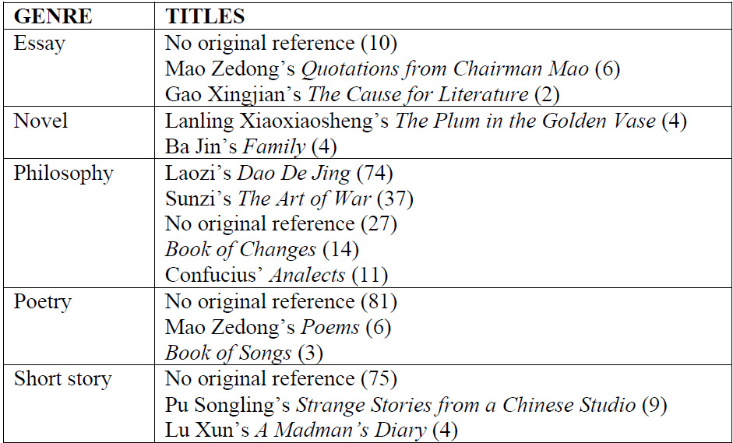
Table 4 Most translated literary works in Spain according to their genre

By way of conclusion to this section, it is worth reflecting on the possible reasons behind this retranslation phenomenon. While this translatological practice in mainly found for those Chinese classics held in high regard, it is by no means limited to them. Although the issue of copyright has undoubtedly had an impact on what is eligible for translation, there are many of the Chinese classics that are still unknown by the Spanish public, such as Book of Documents, Book of Rites or the Spring and Autumn Annals. To date we have been unable to establish whether retranslations are due to previous versions considered inadequate or outdated in some respect, or simply the publisher or translator are unaware of previous translations. If the answer is mainly the latter, this article and the database it took the data from could help fill in this gap.

2.3. The “when” in Chinese literary translation in Spain

More than 60% of the translations analysed were published in the last two decades, as Figure 11 shows. There were four translations in which this information could not be retrieved. Since the current decade is not over yet, it cannot be stated that this rising tendency translation from Chinese in Spain is coming to an end. Yet, it is already obvious that the number of translations is levelling out. Therefore, our analysis based on empirical data only partially confirms the upward trend foreseen by the Budapest observatory (2011) and also pointed out by some sinologists (Ciruela 2003, Prado-Fonts 2011).

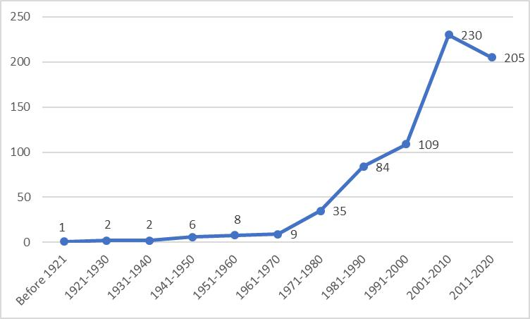
Figure 11 Number of Chinese literary translations in Spain across time

According to our data, the number of literary translations published in Spain per year is 23 for the 2001-2010 decade and 22.7 for the 2011-2019 period on average.
Arbillaga (2003) had also detected the rise in Chinese literary translations in the early 2000s and this allowed her to talk about the birth of Sinology in this country. This researcher had considered the 90s to be the most prolific decade for the translation from Chinese, which had started to take off in the 60s. From our data it can be seen that the number of translations from that decade was clearly surpassed by that of the following decade.
Figure 12 points out that translations into Spanish were the earliest, followed by those into Catalan. More specifically, the former appeared in the 16th century while the latter appeared in the 1920s. In contrast, translations into Basque and Galician had to wait until the 1980s to see the light. In these two cases, and unlike Catalan and Spanish, no clear upward trend can be highlighted. In fact, the translation of Chinese works into these two co-official languages still keeps a very low profile, with only three translations into both Basque and Galician in the last decade.

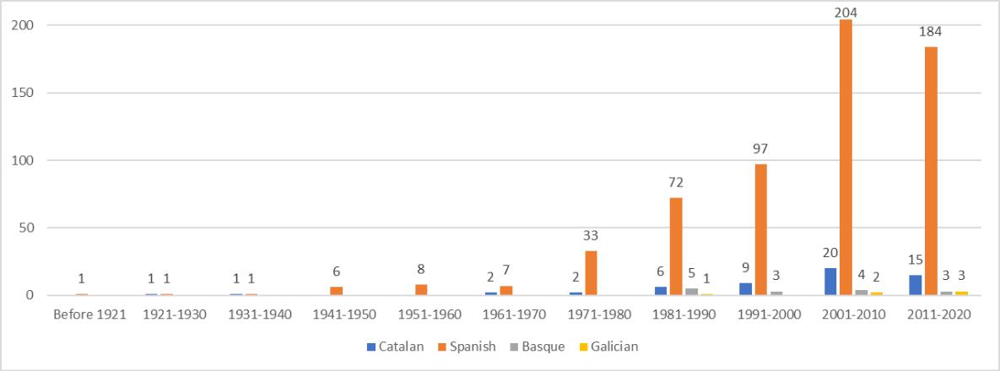
Figure 12 Evolution of Chinese literary translations into Spain’s official languages
Regarding the evolution according to literary genres, it can be said that the predominance of philosophy has not been constant throughout the years, with the 1990s and the 2000s being the decades in which this genre has stood out the most on the translation scene. Although the current decade is not over yet, it is obvious that the predominance of this genre will end as the number of translated novels continues to rise. It must be noted that the translated novels in our database cover a wider range of original works than in the case of philosophy. In fact, the number of Chinese novels translated has enjoyed a steady growth ever since the 1970s. Figure 13 clearly shows this upward trend. It is also worth highlighting that the books tagged as philosophy mainly refer to canonical works on political or religious thought in our database, which makes it a relatively closed category, while new novels and short stories are constantly being written and published. Therefore, the number of eligible originals is much higher in the case of novels and short stories than of canonical philosophical works.
The case of short stories is also worth noting, since it was the preferred genre to translate in the 1980s. This relatively high presence of short stories among the available Chinese literature in Spain could be explained by the fact that through anthologies editors can offer a wider range of authors, topics and literary styles in one single work, which in the context of a society that does not know much about Chinese literature, can be a less risky endeavour. In other words, anthologies are a literary buffet where readers are given the chance to taste new and different dishes before they can decide what they like or dislike. Anthologies also seem to be the preferred option of Chinese protranslators to sponsor Chinese literature in foreign languages.

Yet, and although its presence has always been quite significant in proportion to the total number of translations published, the number of Chinese novels translated this last decade is almost double that of short stories. Theatre plays and comics started to be translated in the 2000s, but no clear tendency has been spotted so far, although from the data it can be stated that to date translations of theatre plays occupy a residual position. The case of comics is surprising for this genre experiencing a sudden and very significant rise in the 2000s while its translation has been almost imperceptible since 2011. This might be the result of Iced Lands going out of business around 2009 and Filabo reorienting its business. This rise in the previous decade could be a collateral effect of the success of Japanese manga in the west, in general, and, Spain, in particular, but there is no way to prove this hypothesis empirically.
As a matter of fact, Serra-Vilella (2016: 54) in her research in the translation of Japanese books in Spain for the 1900-2014 period explicitly leaves out the translation of comics, due to their high number, which in her own words, would merit a PhD dissertation in itself.

Nonetheless, and regardless of the genre, it is undeniable that the number of translations performed from Chinese is constantly increasing in Spain, as Figures 11, 12 and 13 evidence.
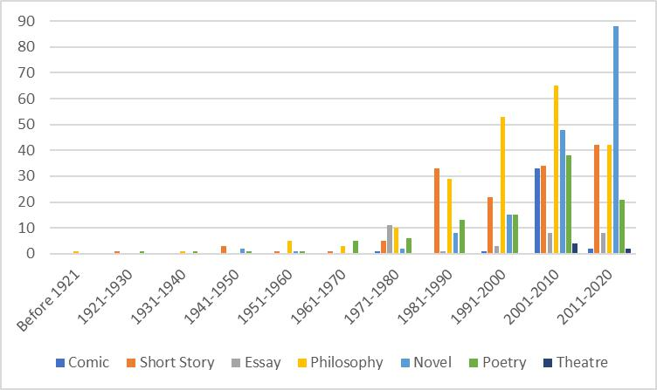
Figure 13 Number of translations per genre throughout history

2.4. The “how” in Chinese literary translation in Spain

Regarding the translators’ work dynamics, 83.3% of the translations are the result of individual work. In contrast, 14.4% of the translations analysed were carried out by a team of two or more people. These results do not coincide with those of Rovira-Esteva and Sáiz-López (2008: 635), whose research on Chinese female literature translation in Spain found that at least in 32% of the works in their corpus had been translated by a team of two translators or a translator and a native reviewer. To elucidate the internal dynamics of cooperative translation teams would require a case by case qualitative analysis, which falls outside the scope of the present study. However, our corpus includes teams of more than two translators, and fixed duos than have worked together on several occasions. In our study, around 18% of the cases could not be examined because the name of the translator or translators was unknown.

Although the number of translations into Catalan, Galician and Basque is scarcer than that of translations into Spanish, it must be acknowledged that the number of direct translations into these co-official languages is identical (and sometimes even higher) to the number of mediated translations (Figure 14). In the case of Spanish, 50.3% of the translations were carried out directly from Chinese, while 35.3% were translated from other languages, mostly English (62.4%) and French (24.31%).

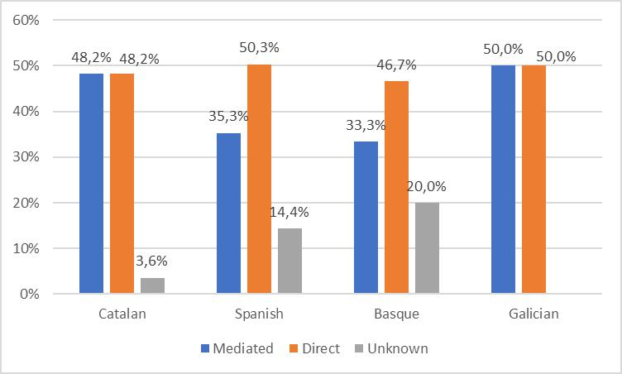
Figure 14 Type of translation per target language

Figure 15 shows that direct translations outnumber mediated ones in the case of short stories (88), essays (17), novels (84), poetry (71) and theatre (5). Yet, in the case of novels, the number of direct and mediated translations does not differ much. Only philosophical works (the most numerous) have been translated mostly from an intermediate language. It is also worth mentioning the high number of titles for which the kind of translation carried out is not specified, especially in the case of comics. The authors of this paper must admit we have not been able to check every single translation in paper format personally, but whenever possible the publishers or librarians were contacted to request this information.

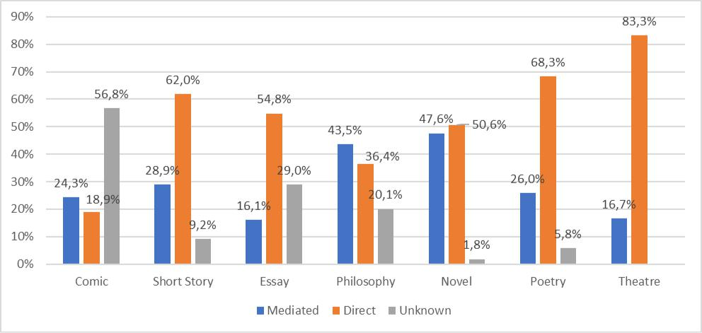
Figure 15 Type of translation per genre

The first translation that appeared in the 16th century was carried out directly from Chinese but after that it was not until the 1940s that the next direct translation appeared (Figure 16). Since then, direct translation from Chinese has been on the rise. Mediated translation has also been very present and has followed the number of direct translations closely. However, as Marin-Lacarta (2012: 92) points out, the information about mediated translations is often forgotten, hidden or disguised. In other words, when the researcher cannot find information about the type of translation, the most likely option is that we are faced with a mediated translation. Consequently, if we add the number of indirect and unknown translations, the number is always higher than direct ones. Contrary to what she expected, she observed an increase of mediated translations from 2001 to 2009 (Marin-Lacarta 2012: 284). In this sense, according to our data, it was not until the 2010s that a clear difference is observed between the number of direct and mediated translations, but still the sum of indirect and unknown outnumbers direct ones. Yet, with the data corresponding to the last decade we can affirm direct translations currently outnumber those through mediating languages. This leaves room for hope for translators translating directly from Chinese, as well as readers who place a higher value on direct translations. It can also be stated that in the present decade the number of titles not specifying the type of translation performed has decreased, probably because more direct translations are published, which is something editors feel particularly proud of and like to underline in, for example, book covers. Actually, a clear change of trend can be observed if we analyse given publishing houses. For instance, Kailas, Mo Yan’s main publisher, radically changed its policy regarding this after he was awarded the Nobel Prize. All in all, it should also be expected that as both sociocultural mutual understanding increases and there are more and more graduates of Chinese studies, direct translations will become more valuable in the eyes of the readers and the size of the critical mass willing to read direct translations will also increase. Hopefully, all of this will drive publishers to back direct translations, even they might be a little more expensive than mediated translations.
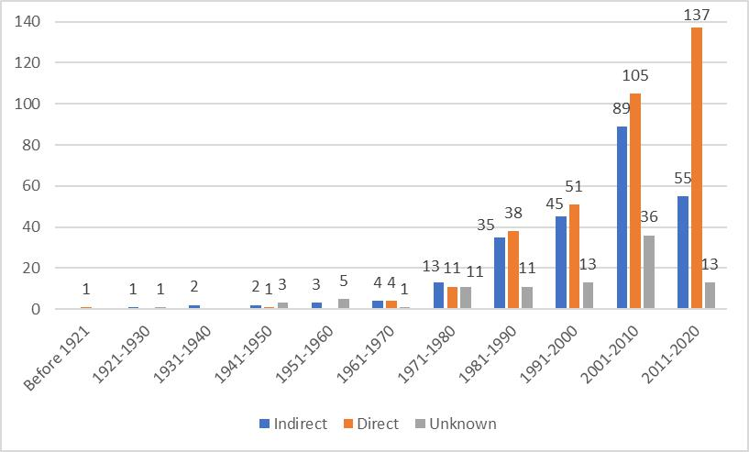
Figure 16 Type of translation through history

Arbillaga (2003) ascertained that there was a similar number of direct and mediated translations when she carried out her analysis and highlighted that some of the direct translations were actually carried out in China. Since Arbillaga’s (2003) study did not take into account those cases in which this information was unknown and included many translations performed in China by Chinese hispanists (which is technically inverse translation and cannot be equated with those carried out by Spanish native speakers translating to their mother tongue), her results must be taken with caution.

3. Conclusions

This study is mainly an empirical quantitatively based approach to offer an overview of the history and current situation of translated Chinese literature in Spain’s four official languages (i.e. Spanish, Catalan, Basque and Galician). Compared to previous studies, this research presents a large-scale, systematic and updated analysis of our object of study, comprising a total of 400 Chinese authors, 414 translators, 282 original works, 695 translated books and 293 publishers.

Our analysis has shown that Chinese literature in Spain is mainly translated into Spanish and Catalan. It is undeniable that, by and large, the number of translations of Chinese literary works into Spain’s official languages is constantly increasing, although it seems to be levelling off. This rise could partially be ascribed to Gao Xingjian and Mo Yan being awarded a Nobel Prize in Literature in 2000 and 2012 respectively, since this had an undoubtedly positive impact on the three genres these authors cultivate, i.e., novel (Gao Xingjian and Mo Yan), essay (Gao Xingjian) and theatre (Gao Xingjian). Yet, the most translated genre thus far is philosophy, although the variety of works translated is very limited, with Sunzi’s The Art of War and, especially, Laozi’s Dao De Jing being the most translated works. Nonetheless, and for the first time, the most popular genre in the last decade has been the novel. The number of direct translations is also on the rise, with the gap between mediated and direct translations becoming increasingly more pronounced decade after decade. There are currently slightly more men than women performing these direct translations from Chinese and their occupations are varied, ranging from university professors and full-time freelance translators to priests. It should be expected that the more direct translations are carried out, the more Spanish culture is empowered in the face of other major cultures and the less asymmetrical power relations among cultures will be.

This paper could be a starting point of future studies. For example, the paratexts of Chinese translations in Spain could be investigated to analyse the power relations underlying in the circulation processes of literary translation. Furthermore, and also in connection with paratexts, Serra-Vilella (in press) suggests that the names of some of the translators working with the Japanese-Spanish official languages combination are sometimes used as a resource to advertise or to give prestige to a translation. This type of “editorial paratext” could also be evaluated in the Chinese case. Serra-Vilella (in press) also proposes carrying out an analysis of the Japanese into Spanish translations in a diachronic way while contrasting it with the historical context. This could also be an interesting option in the Chinese case to try to justify the editorial decisions made in this regard. The role of protranslators, not only of different agents patronising the translations, but also of awards or films, could be studied in more detail. Another future avenue of research that was also recommended by Prado-Fonts (2008) is the quality of the reception of the translations, which are usually interpreted superficially, but also the quality of the translations themselves and its correlation with the type of translation. In addition, it would be interesting to find out why Laozi’s Dao De Jing, Sunzi’s The Art of War or other highly translated works have been retranslated so many times. The reason might be related to the different applications these two works can have, since philosophy can be applied to different aspects of life or work. Last but not least, reception studies concerning the opinion of both the general reader, sinologists, translators or even publishers on a number of questions related to those translations, such as the variety and quality of the versions available could be carried out.

Our research is not without its limitations, the main one being the risk that the database consulted is still missing some translations or some of its entries being incomplete. For example, those books containing poems of different poets and that have not been examined in person run the risk of not having all their authors included in the database, especially if they do not appear on the cover. Also, since the information presented in the translations’ paratexts does not always coincide with the current official transcription, it is possible that in some cases we haven’t been able to match the different transcriptions of the same names. This is due to some publishing houses deliberately hiding information or making it confusing. For example, it is likely that some of the translation duos indicated consisting of both a Chinese and a Spanish native speaker are not always real “translation” teams. Rather it is likely that in some cases the Chinese speaker performed the translation, which was later proofread by the Spanish partner. Yet, this is not usually specified in the books, since both persons are tagged as translators. This may have somehow biased the results of our analysis.

We believe the descriptive nature of our paper has contributed to a greater understanding of the history translation of Chinese literature in Spain. So far, the selection of works to be translated seems quite erratic, with a few literary works with dozens of translations while others, including masterpieces are consigned to oblivion. Given the lack of apparent strategy when selecting Chinese works for translation, we hope that this overview will guide both Spanish translators and editors to make more informed decisions when choosing the Chinese works to be translated into any of Spain’s official languages.

Notes

¹ Both authors are equally responsible for the contents of this paper, since both revised and complemented each other’s work via a dialectic process. As they often work together, they have the internal policy of alternating the order of their names in the signature to minimise the impact this might have in external assessment exercises.
² See https://dtieao.uab.cat/txicc/lite/ [last accessed 1 April 2020]
³ In this paper, the concept of “edition” is understood as a new printing of an already existing translation that incorporates some changes either in the text itself or the paratext accompanying it.
⁴ See http://china-traducida.net/ [last accessed 1 April 2020] ⁵ See http://www.asiared.com/ [last accessed 1 April 2020]
⁶ Jimmy Liao is, as a matter of fact, a picture book writer, but no distinction has been made between “picture book” and “short story” in our case.

References
ARBILLAGA, Idoia. 2003. La literatura china traducida en España. Murcia: Publicacions de la Universidad de Alicante, 2003.

BARRY, Virginia. 2007. “Red – the New Black: China-UK Publishing.” London. Report. BUDAPEST OBSERVATORY. 2011. “Publishing Translations in Europe: Trends 1990-2005.” Aberystwyth. Report.

CASAS-TOST, Helena, ROVIRA-ESTEVA, Sara, VARGAR-URPÍ, Mireia. Submitted. Investigar la traducción de productos culturales chinos: retos y dificultades metodológicas en la creación de bases de datos sobre cine y literature.

CIRUELA ALFÉREZ, Juan José. 2003. Algunas reflexiones sobre la traducción chino-español: presente y futuro. In GARCÍA PEINADO, M. A., ORTEGA, E. Panorama actual de la investigación en traducción e interpretación. Granada: Atrio, 2003, pp. 103-108.

GENETTE, Gérard. 1997. Paratexts: Thresholds of Interpretation. Cambridge: Cambridge University Press, 1997.
KU, Menghsuan. 2014. El estudio de las traducciones de Beijing coma en español, inglés y chino. In Estudios de Traducción, 2014, vol. 4, pp. 115–27. https://doi.org/10.5209/rev_ESTR.2014.v4.45371.

KU, Menghsuan. 2016. El otro y el yo, las porras vs. el café: soluciones de traducción para los elementos culturales en las versiones castellanas de ‘Las baladas del ajo’, de Mo Yan. In Estudios de Traducción, 2016, vol. 6, pp. 81–92. https://doi.org/10.5209/estr.53005. LOVELL, Julia. 2010. Chinese literature in the global canon: The quest for recognition. In

TSU, J., WANG, D. Global Chinese Literature: Critical Essays. Leiden: Brill Press, 2010, pp. 197–217.

MARIN-LACARTA, Maialen. 2012. La recepción de traducciones literarias por su valor documental: el caso de la literatura china moderna y contemporánea en España. In MARTINO, P., ÁRBOL, A., JARILLA, S. Caleidoscopio de traducción literaria. S.l.: Dikynson, 2012, pp. 45-56.

MARTÍN-RÍOS, Javier. 2007. La traducción de poesía china moderna. El caso de Wen Yiduo (1899-1946). In Puentes, 2007, vol. 7, pp. 7-14.

MI Tian. 2018. Marcela de Juan (黄玛赛): los inicios de los trasvases culturales entre China y España en el siglo XX. In Quaderns: Revista de Traducció, 2018, vol. 25, pp. 203–16. MINISTERIO DE CULTURA Y DEPORTE. 2018. Panorámica de la edición española de libros 2017 [online]. Available at ˂https://sede.educacion.gob.es/publiventa/d/21499C/19/0˃ PEÑA, Salvador. 1997. El traductor en su jaula: hacia una pauta de análisis de traducciones. In MORILLAS, E., ARIAS, J.P. El papel del traductor. Salamanca: Colegio de España, 1997, pp. 19-57.

PRADO-FONTS, Carles. 2001. Del xinès al català, traduccions per generació espontània. In Quaderns, revista de traducció, 2001, vol. 6, pp. 107-117.

PRADO-FONTS, Carles. 2008. De literaturas frías y asediadas: narrativa china y sinófona contemporánea en España. In Studi Ispanici, 2008, vol. 33, pp. 251-265. PRADO-FONTS, Carles. 2009. China, Literatura. In LAFARGA, L., PEGENAUTE, F. Diccionario histórico de la traducción en España. Madrid: Gredos, 2009, pp. 1-4. PRADO-FONTS, Carles. 2011. ¿El fin de la gran muralla? In Revista de libros, 2011, vol. 177, pp. 3-5.
ROVIRA-ESTEVA, Sara. 2016. The (mis)use of paratexts to (mis)represent the Other: Chun Sue’s Beijing Doll as a case study. In Onomázein. Revista de filología, lingüística y traducción, 2016, vol. 34, pp. 187-208. doi: 10.7764/onomazein.34.11

ROVIRA-ESTEVA, Sara, SÁIZ-LÓPEZ, Amelia. 2008. La traducción de la literatura femenina china y la construcción cultural de género. In SAN GINÉS, P. Nuevas perspectivas de investigación sobre Asia Pacífico. Granada: Universidad de Granada, 2008, pp. 633-653.

ROVIRA-ESTEVA, Sara; CASAS-TOST, Helena; TOR-CARROGGIO, Irene; VARGAS-URPÍ, Mireia. 2019-2022. La literatura china traducida en España. Base de datos en acceso abierto. https://dtieao.uab.cat/txicc/lite. doi: 10.5565/ddd.uab.cat/214778.

ROVIRA-ESTEVA, Sara, TOR-CARROGGIO, Irene. 2020. N. de la T.: dícese de un elemento controvertido. Análisis de la recepción de las notas del traductor en la traducción del chino de Diarios del Sáhara. In Onomázein. Revista de filología, lingüística y traducción, 2020, vol. 50. doi: 10.7764/onomazein.50.02. https://ddd.uab.cat/record/203524
SÁIZ-LÓPEZ, Amelia. 2015. Lectura e interculturalidad. Estudio de caso sobre la recepción literaria china en el contexto español. In Ocnos: Revista de estudios sobre lectura, 2015, vol. 13, pp. 129-142.

SERRA-VILELLA, Alba. 2016. La traducció de llibres japonesos a Espanya (1900-2014) i el paper dels paratextos en la creació de l’alteritat. PhD thesis, Universitat Autònoma de Barcelona, Spain.

SERRA-VILELLA, Alba. In press. Quién traduce literatura japonesa en España: Agentes en la traducción y publicación. In Onomázein. Revista de filología, lingüística y traducción, vol. 52. doi: 10.7764/onomazein.52.08

WANG, Chenying. 2016. La traducción de la literatura china en España. In Estudios de Traducción, 2016, vol. 6, pp. 65-79.

ZAUBERGA, Ieva. 2005. A Knock at the Door: On the Role of Translated Literature in Cultural Image Making. In Across Languages and Cultures, 2005, vol. 6, no. 1, pp. 67–78.

ANNEX

This annex shows the correspondence between the English translation as it appears in this paper, the corresponding title of the first complete translation published in Spain, the original title in Chinese characters and pinyin transcription and the authors’ names in Chinese characters and pinyin transcription. The list of literary works is ordered alphabetically according to the title in English.

ENGLISH TITLE | SPANISH TITLE | CHINESE TITLE | AUTOR
A Madman’s Diary | Diario de un loco (1971) | 狂人日  记 (Kuangren  Riji) | 鲁迅 (Lu Xun)
Analects | Tratados morales y políticos: Según los textos de Confucio y de sus discípulos TsengChen, Tchu-Hi y otros (1959) | 论语 (Lun Yu) | 孔子 (Confucius)
Beijing Coma | Pequín en coma (2008) | 北京植物人  (Beijing  Zhiwuren) | 马建 (Ma Jian)
Beijing Doll | La muñeca de Pequín (2003) | 北京娃娃  (Beijing Wawa) | 春树 (Chun Shu)
Book of Changes | I Ching (1971) | 易经 (Yi Jing) | Unknown
Book of  Documents | Untranslated | 书经 (Shu Jing) | Unknown
Book of Rites | Untranslated | 礼记 (Li Ji) | Unknown
Book of Songs | Libro de los cantos (2013) | 诗经 (Shi Jing) | Unknown
Camel Xiangzi | La verdadera historia del  Camello Xiangzi  (2011) | 骆驼祥子 (Luotuo  Xiangzi) | 老舍 (Lao She)
Dao De Jing | El evangelio del Tao: del libro sagrado Tao te ching (1931) | 道德经 (Dao De  Jing) | 老子 (Laozi)
Family | La familia (1982) | 家 (Jia) | 巴金 (Ba Jin)
Fortress Besieged | La fortaleza asediada (1992) | 围城 (Weicheng) | 钱钟书 (Qian Zhongshu)
Four Books | Los cuatro libros (1954) | 四书 (Si Shu) | 孔子 (Confucius), 孟子 (Mengzi), 子思 (Zisi) & 曾子 (Zenzi)
Invisible planets | Planetas invisibles (2017) | (No original reference) | 陈楸帆 (Chen  Qiufan), 刘慈欣  (Liu Cixin), 夏笳  (Xia Jia), 糖匪 (Tang Fei), 郝景芳 (Hao Jingfan),  马伯庸 (Ma  Boyong) & 程婧  波 (Cheng  Jingbo)
Poems | Mao y la revolución china. Seguido de treinta y siete poemas de  Mao Tse-Tung  (1968) | 毛泽东诗词 (Mao  Zedong Shici) | 毛泽东 (Mao  Zedong)
Precious Mind for  Enlightening the  Mind | Libro chino intitulado Beng Sim Po Cam que quiere decir Espejo rico del claro corazón, o Riquezas y espejo con que se enriquezca, y donde se mire el claro y limpio corazón (1592) | 明心宝鉴 (Ming  Xin Bao Jian) | 范立本 (Fan  Liben)
Quotations of Chairman Mao | El libro rojo (1976) | 毛主席语录 (Mao  Zhuxi Yulu) | 毛泽东 (Mao  Zedong)
Romance of the Three Kingdoms | El romance de los tres reinos (2014) | 三国演义 (San  Guo Yan Yi) | 罗贯中 (Luo  Guanzhong)
Soul Mountain | La montaña del alma (2001) | 灵山 (Ling Shan) | 高行健 (Gao  Xingjian)
Spring and  Autumn Annals | Untranslated | 春天秋天  (Chuntian  Qiutian) | Unknown
Strange Stories from a Chinese Studio | Cuentos extraños (1941) | 聊斋志异 (Liao  Zhai Zhi Yi) | 蒲松龄 (Pu  Songling)
The Art of War | Los trece artículos sobre el arte de la guerra (1974) | 孙子兵法 (Sunzi  Bingfa) | 孙子 (Sunzi)
The Cause for Literature | En torno a la literatura (2003) | 文学的理  由 (Wenxue de Liyou) | 高行健 (Gao  Xingjian)
The Garlic Ballads | Las baladas del ajo (2008) | 天堂蒜臺之歌  (Tiantang Suantai zhi Ge) | 莫言 (Mo Yan)
The Plum in the Golden Vase | Jou Pu Tuan: novela erótica china (1978) | 肉蒲团  (Rouputuan) | 兰陵笑笑生  (Lanling  Xiaoxiaosheng)
The Secret of the Golden Flower | El secreto de la flor de oro (1955) | 太乙金华宗旨  (Taiyi Jinhua  Zongzhi) | 吕洞宾 (Lü  Dongbin)
The Wandering Earth | La tierra errante (2019) | 流浪地球  (Liulang Diqiu) | 刘慈欣 (Liu  Cixin)
Zhuangzi | Los diálogos de  Chuang Tse (2005) | 庄子 (Zhuangzi) | 庄子 (Zhuangzi)

Acknowledgements

We want to thank la Fundació Institut Confuci de Barcelona for funding the database from where the data for the present research were retrieved. This study has also been partially funded by the Departament de Traducció, d'Interpretació i d'Estudis de l'Àsia Oriental (Universitat Autònoma de Barcelona). Both researchers are members of TXICC research group and are grateful to the rest of members, especially Mireia Vargas-Urpí and Helena Casas-Tost, for their insightful comments on the first version of the manuscript.

In SKASE Journal of Translation and Interpretation [online]. 2023, vol. 16, no. 1 [cit. 2023-07-30]. Available online at http://www.skase.sk/Volumes/JTI24/pdf_doc/05.pdf. ISSN 1336-7811

