The Future of Fansubs:
Facing the Advent of Legal Anime on Streaming Platforms
Miki Sakuma

Abstract
Fansubs, short for “subtitles by fans”, have played an essential role in promoting anime outside of Japan. The first successful anime series, Astro Boy, was first broadcast on television in Japan in 1963. Surprisingly, it was not until the 1990s that the Japanese anime industry started to sell anime abroad. This exporting was made easier for the industry since Japanese anime had already gained popularity in many countries thanks to the efforts of amateur fan translators, (Leonard 2004: 7). However, the future of fansubs might be at risk from emerging streaming sites for legal anime such as Netflix and Amazon Prime video, since out of principle, fansubbers do not create subtitles for licensed anime. In my research, I will consider the potential survival of fansubbing, in spite of these streaming platforms, from various perspectives. A few prominent fansubbing groups, for instance, the group of fansubbers for the website called Viki, which allows the user to watch Asian TV series and films, have been highlighted by several researchers such as Dwyer (2016) and Pérez González (2020). However, little academic attention has been paid to the risk of fansubbing due to the increasing number of streaming platforms for anime. My research will fill this gap by casting light on the several possibilities for the future of fansubs.

Keywords: fansubs, subtitling strategies, cultural references, Japanese anime, legal anime streaming sites

1. Introduction

Anime, Japanese-style animated television series or films, have become popular worldwide in recent years. Fansubs (short for subtitles created by fans) also contributed to this global success of many Japanese anime series. In actual fact, it was fansubbers who introduced Japanese anime to the world for the first time (Díaz Cintas and Muñoz Sánchez 2006; Lee 2011). Japan started to produce anime, a specific type of hand-drawn animation, in the early 1910s, and it became popular in the country in the 1960s. Surprisingly, it was not until the 1990s that the Japanese anime industry started to sell anime to other countries. Paving the way for this, in the 1980s fansubbers started to create subtitles for unlicensed anime for the purpose of free distribution to other fans outside Japan. Since Japanese anime had already gained popularity in many countries thanks to the efforts of amateur fan translators, the Japanese anime industry could sell their anime to other countries without difficulties (Leonard 2004: 26). However, despite the fansubbers’ remarkable contribution to the anime industry, the number of fansubs has seen a sharp decline in recent years. This is also due to emerging legal anime streaming sites. This is because fansubbing is based on a principle of creating subtitles for unlicensed anime only. Additionally, because of new rules on digital content especially in Western countries, several websites to watch fansubbed anime got banned and were removed (Massidda 2020: 197-199). In this research, I will consider whether fansubs are likely to survive despite a sharp decrease in the need for this kind of activity following the regularization of anime broadcasting. First, I will examine fansubs’ historical background and unique features, and then analyse both the negative and positive aspects of fansubbing. Lastly, I will examine other potential ways for fansubbers to survive.
Additionally, I will illustrate my argument with examples from three different fansubbed anime episodes: Candy Candy (1976), Kitarō of the Graveyard (Hakaba Kitarō in Japanese) (2008) and Azumanga Diou (2002) and an anime episode, translated by a professional translator in Crunchyroll: Gegege no Kitarō (2018). The anime programs that I chose for this research provide good illustrations of the characteristics of fansubbing. It is worth noting that an episode of a Japanese anime series is generally about 25 minutes long.

2. Understanding Fansubs

Understanding fansubs is essential to consider the future of this activity. Today, fansubs exist for films, TV series, video games and anime made outside Japan. Pérez González (2020) refers to the fansubbing activities for American TV programs and video games as “post anime fansubbing” since their works have only recently been recognized while anime fansubs begun in the 1980s. This article focuses only on fansubs for Japanese anime since fansubs originally started for Japanese anime, and still actively work on Japanese anime TV series.

  - Historical Perspective
First, I will examine fansubbing from a historical point of view. Fansubs have a close relationship with the evolution of Japanese anime in the world. As stated above, it was thanks to fansubs that Japanese anime first became known to the world (Díaz Cintas and Muñoz Sánchez 2006; Lee 2011). Japan started to produce anime in 1917, and Astro Boy (Tetsuwan Atomu in Japanese) (1963), which was one of the first Japanese 25-minute animated television series, is considered as the first successful anime programme (Yamaguchi 2013). Additionally, Yasuo Yamaguchi considers that Astro Boy catalysed the growth of the anime industry. Although anime became very popular in Japan thanks to this successful anime series, North Americans could not watch original anime works in their country at that time. The Japanese anime industry did not try to promote Japanese anime abroad despite their increasing popularity in Japan. Sean Leonard (2004: 26) also points out that “During 1976-1993, (however,) Japanese companies did not think that they would be able to sell much to America in terms of entertainment goods.” American fansubbers took the initiative in promoting Japanese anime to the world. Thanks to them, Japanese animation companies today bring significant financial income to Japan.
Some researchers (Leonard 2004; Pérez González 2007) have examined the history of fansubs in depth, however, in this research I will highlight only the significant events relating to the future of anime fansubs.

    - Fansubber’s Outstanding Efforts
Fansubs began among members of anime fan clubs in the United States in the 1980s. Leonard notes that the translation booklets created by fans for Japanese animation at clubs and conventions marked the beginning of fansubs (2004: 11). Fansubbing went on to become popular among fans in the 1990s thanks to inexpensive tools for subtitling (Díaz Cintas and Muñoz Sánchez 2006: 37; O’Hagan 2009: 94).
Fansubbers created subtitles despite several difficulties in the 1980s. These efforts are noteworthy. First of all, obtaining Japanese anime was particularly difficult at that time. The only way to watch anime outside Japan in the 1970s, 1980s and the early-1990s was on video cassettes (Leonard 2004). Needless to say, it took time and cost money to get video cassettes from Japan. To make matters worse, the frequent copying of cassettes impaired their quality. Second, adding subtitles to video cassettes was also extremely difficult. For instance, in the case of the first fansubbed anime, Lupin III (1986), it cost $4,000 and took about one hundred hours to put subtitles on an episode lasting 25 minutes (Leonard 2004: 16).
Fansubbers made such great efforts to create anime subtitles not only because of the lack of the opportunities to watch anime but also because of the desire to watch the original versions. Japanese anime were often considerably modified when they were broadcast in foreign countries. In the case of the United States, animation distribution companies usually Americanized Japanese anime by changing the Japanese names and deleting Japanese cultural elements (Lee 2011; Pérez González 2007). Moreover, since animation in America usually only targeted children, any sexual and violent elements featuring in Japanese anime were generally removed (Pérez González 2007; Hatcher 2005; NHK 2015). Interestingly, Pérez González points out that “the transformations that the original texts underwent during the translation process meant that the viewers could not even identify anime as a Japanese program.” (2007: 268). Japanese anime fans’ disappointment in the considerable modifications made to anime spurred them to create subtitles for Japanese original anime.
Another factor that motivated fansubbers was to fill the time gap to watch anime. In fact, in the 1980s and 1990s, even though some licensed anime were broadcast in foreign countries, it took a few months, and sometimes several years, before the anime released in Japan were made available outside the country (Lee 2011: 7). Despite the difficulties of creating fansubs in the 1980s and 1990s, some fans created subtitles for Japanese anime because they wanted to watch the original versions as soon as possible.

    - Two Significant Events in Fansubbing
This section will examine two significant events in the history of fansubs. The first occurrence is the digital transformation such as the advent of Web 2.0 platform in the early 2000s (O’Hagan 2009: 94). Thanks to digitalization, fansubbing became much easier, faster and less expensive (Lee 2011; Massidda 2020; Pérez González 2007). Additionally, amateur translators began to use open-source software and crowdsourcing platforms thanks to digitalization, and these systems allowed fansubbers to collaborate even if they were in different places. Additionally, these tools have enabled fansubbers to support each other in order to improve their subtitles, with positive impact on the quality of fansubbed anime (Hatcher 2005: 527; Massidda 2020: 195). Consequently, digitalization served as a spur for the popularity of fansubs since the number of websites featuring fansubbed anime increased as a result of digitalization.
However, in more recent years fansubbing has become less popular following the advent of streaming platforms which show anime, such as Netflix, Amazon Prime video, Crunchyroll and Funimation (Ho 2019). This is the second significant event in the history of fansubs. In actual fact, as pointed by Ho, the author of an American video game website, Polygon, the number of fansubbed programs has shrunk dramatically since around 2010 (2019). On the other hand, several academic researchers such as Dwyer (2016), Pérez González (2020) and Wang (2017) have cast light on a few prominent fansubbing activities. For instance, Dwyer (2016) highlights a Singapore-based website Viki that allows the user to watch Asian TV series and films, and Wang (2017) focuses on YYeTs, which is the largest fansub group in China. Although a few subtitling groups have gained attention from academic researchers, the fact that the number of fansubbing activities has considerably decreased cannot be ignored.

  - Characteristics of Fansubbing

In this part, I will examine the significant features of fansubs. Understanding these characteristics is also crucial to analyse the potential future of fansubs.

    - Fansubbers’ Strong Motivation
One of the significant characteristics of fansubbing is the strong motivation of fansubbers, who pursue their activity as a hobby. (Lee 2011). In other words, fansubbers devote their time to create fansubs not for money, but for their love of anime. In general, there is no remuneration for fansubbing (Hatcher 2005; O’Hagan 2009). In addition, being part of a fan community can also be a motivation for fansubbers (Lee 2011). In actual fact, fansubbing usually requires teamwork. There are several different steps involved in creating subtitles for anime such as translation, timing, typesetting, encoding and so on (Díaz Cintas and Muñoz Sánchez 2006), and these tasks are normally done by different people (Hatcher 2005). Thus, in general an amateur fan translator belongs to a fan community, and the members of the community work together to create a website for fansubbed anime.

    - Unique Subtitling Strategies
Fansubbers also produce some outstanding special effects that in general are not found in subtitles created by professional translators. Díaz Cintas and Muñoz Sánchez present Ferrer Simó’s list of unique subtitling strategies: “using different fonts, colours and glosses, adding notes and information about fansubbers, translating opening and closing credits, changing the position of subtitles, adopting longer subtitles” (2006: 47). I will also highlight some of the unique technical features of fansubbing.
First, fansubs often feature different colours. In particular, fansubbers regularly use various colours when translating opening and ending songs. For instance, in the episode of Candy Candy, the fansubber uses two different colours for the English subtitles in the opening and ending Japanese songs. The Japanese lyrics, which are written as romaji (in other words in the Latin alphabet), appear as salmon pink and the English translation is in white. This allows the audience to easily recognize that two different languages appear on the screen. Additionally, as stated, fansubbers often use various different fonts for their subtitles. Subtitles with different colours and fonts are eye-catching. However, it is also true that the audience might pay too much attention to the subtitles because these subtitles are standing out. Pérez González explains that “professional subtitlers are advised to stick to ‘coloured pale white (not “snow-bright” white)’ on the grounds that “a too flashy pigment would render them tiring to the viewers’ eye” (2007: 268). Professional film subtitles are usually subtle in order to ensure that viewers focus on the images and sounds.
Besides, amateur subtitlers sometimes use a karaoke effect for opening and ending songs on anime. With this effect, the lyrics of the opening and ending songs are highlighted by changing the colour of the words. For instance, in the opening song of Kitarō of the Graveyard the viewers see three different subtitles: the English translation, the Japanese lyrics in romaji and the Japanese lyrics using the Japanese writing system, which consists of three different writing systems: hiragana, katakana and kanji. In this opening song, the karaoke effect is applied only to the Japanese lyrics. In addition to the karaoke effect, the positions of the subtitles in this opening song are noteworthy. The Japanese lyrics in romaji can be seen on the top of the screen and the Japanese lyrics in the Japanese writing system on the right side, while the English translation is at the bottom. Furthermore, viewers need to read the Japanese lyrics in the Japanese writing system, which can be seen on the right side, from top to bottom (see Figure I). Reading from top to bottom is not uncommon in Japan. For instance, Japanese newspapers are usually printed from top to bottom. However, the viewers of fansubbed anime may find it difficult to read words downwards even though they might have some knowledge about the Japanese language.
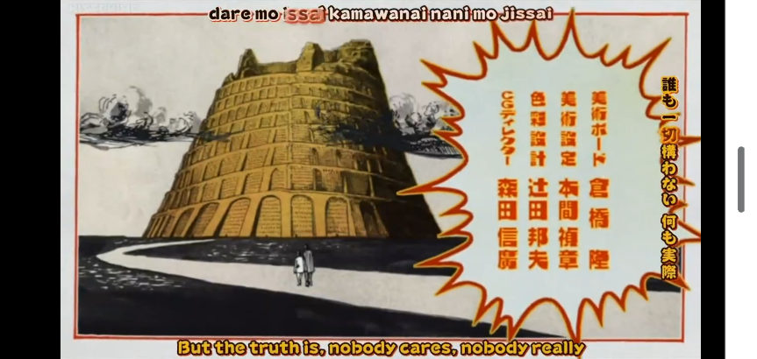
The English translation

The Japanese lyrics in the Japanese writing system, which is written from top to bottom.
The Japanese lyrics in romaji.
Figure I Examples of Unique Fansubbing Strategies
Another exceptional feature of fansubbing is the adding of notes to anime. These notes can provide an explanation or fansubbers’ comments on anime (Díaz Cintas and Muñoz Sánchez 2006). A good example of notes features in the episode of Azumanga Daiou, which describes students’ daily life in a Japanese high school. A note appears at the beginning of the first episode of this animation with an explanation of the unique Japanese two-man comedy show called “Tsukkomi”. The note says:

Translation notes: Towards the end of this episode, Tomo talks about ‘Tsukkomi.’ This is a popular comedy act in the Kansai region. One person says something stupid (Boke) and the other person corrects them through physical contact (Tsukkomi), which usually takes the form of a slight beating.

This note is much longer than a typical note in a fansubbed anime. However, the purpose of this note is the same: to help anime viewers understand the anime story, and especially Japanese cultural elements. The note is obviously useful for people who do not know about “Boke” and “Tsukkomi” in order to understand the sense of humour that the director of this anime wants to convey to the viewers.
Another type of note in fansubs is used to express the fansubbers’ thoughts (Pérez González 2020). For example, the episode of Candy Candy features a note by the fansubber: “Waai-!! It’s coming!” at the beginning of the programme. “Waai-” is a Japanese word, which means “Yeah” in English. This comment expresses the fansubber’s joy and excitement at watching this episode. This kind of comment conveys the fansubber’s personal point of view. Some viewers may find this kind of comment intrusive, especially when fansubbers force their interpretation onto the viewers. Although these comments do not always occur in fansubbed anime, it is worth noticing the fact that some fansubbers express their thoughts by using a headnote.

    - Adding Information about Fansubbers
Providing information about fansubbers is also a key feature of fansubs. For instance, in the fansubbed Candy Candy, the e-mail address and website address of the fansubber appear on the top of the screen at the beginning of the episode. It is rare to see the information about translators in commercialized anime and movies especially in Western countries. For instance, we rarely see the names of film and anime translators on films projected at the cinema or on DVD covers in these countries. However, the popular streaming platform Netflix shows the translator’s name after the main program (Timed Text Style Guide 2021). This new movement by the online streaming giant Netflix would encourage the companies that offer streaming services or film distribution companies to present the translator credit to the audience.

    - Copyright Issues
Another aspect that should be considered is copy right. Some researchers, such as Hatcher (2005), Massidda (2020) and Lee (2011), have examined in depth copyright issue concerning fansubbing. This section will consider a few essential points regarding copyright issues. First, copyright laws are different from country to country. Hatcher notes that fansubs can be considered legal because of the more relaxed Japanese attitude towards some elements of copyright law (2005: 524). Japan is an exceptional country, since fansubbing is considered illegal in many countries (Díaz Cintas and Muñoz Sánchez 2006). The main reason why fansubbing is regarded as an illegal activity is to protect the copyright of the author and the producer of the original source material. In addition, adding subtitles to the original anime might damage the author’s reputation if the translation by amateur translators is of poor quality (Hatcher 2005: 524). Moreover, fansubbing not only creates subtitles, but it also distributes anime to other fans. Hatcher points out that “by distributing the work to others, fansub groups violate the right to distribution.” (2005: 524) Besides, due to new rules on digital content such as the European Directive on Copyright in the Digital Single Market (2019), several websites for fansubbed anime got banned and were taken down (Massidda 2020: 197-199). Massidda actually highlights several cases of removal of the websites that contain fansubbed TV shows and films (2020: 197-199). For instance, according to her, “a Swedish court stated that unlicensed distribution of subtitles is a crime” in 2019 and a website for fansubbed content needed to be removed, and the concerned fansubbers had to pay a fine (2020: 199). The strict legal regulations that are applied to websites for fansubbed anime undoubtedly discourage anime fansubbers to continue their activities.
Although fansubbing is regarded as illegal in many countries, in many cases Japanese anime production and distribution companies do not impose sanctions against fansubbing. There are several reasons why these companies ignore fansubs. First, it costs money to enforce their right to control fansubbers’ illegal activity (Hatcher 2005: 537; Lee 2011: 5). Fansubbers may be located in various foreign countries, and hiring a lawyer to protect their original source audiovisual product, especially against people outside Japan, is not cheap. Additionally, dealing with illegal actions on the Internet is also complicated (Díaz Cintas and Muñoz Sánchez 2006: 45). Second, Japanese anime distribution companies admit that fansubs can be a useful tool to promote anime in foreign countries (Díaz Cintas and Muñoz Sánchez 2006: 44). Last, these companies are also afraid of generating negative reactions from fansubbers if they impose copyright law on them (Hatcher 2005: 538). After all, fansubbers are anime fans. The anime companies do not want to decrease the number of fans by enforcing copyright law on them. Besides, in general, fansubbers withdraw their fansubbed anime from the Internet once the anime is licensed for commercial distribution (Díaz Cintas and Muñoz Sánchez 2006; Lee 2011). Nevertheless, it is true that even after fansubbers remove their fansubbed animation from the Internet, this cannot be entirely deleted. Some people might have already downloaded the anime and might therefore keep it on their computers. However, “no fansubs for licensed anime” is a key principle for fansubbers (Hatcher 2005: 532; Leonard 2004: 22).

3. Subtitles by Professional Subtitlers vs. Fansubs

If viewers do not appreciate anime subtitles by amateur fans, it is very likely that fansubs will disappear one day. What kind of subtitles by professional subtitlers or fansubbers most effectively describe Japanese anime for non-Japanese speaking viewers?

  - Disadvantages of Fansubbing
Díaz Cintas and Muñoz Sánchez state that “commercial, subtitled versions of anime shows are generally considered to be higher quality, both technically and linguistically, than fansubs” (2006: 44). As they point out, it is true that professional subtitles feature several outstanding aspects. To give an example, according to the director of content operations at Ellation, which undertakes the translation of Crunchyroll anime, Ellation’s professional translators around the world translate the anime series into 10 different languages within a few hours of Japanese broadcast. Compared with fansubs, the professional translation company’s ability to translate one episode (lasting about 25 minutes) in 2 to 3 hours is noteworthy since it usually takes 5 to 7 hours for fansubbers to translate an episode of the same length (Lee 2011: 11). Moreover, what distinguishes subtitles by professional translators is not just speed but quality. Ellation has a system to check errors and improve the quality of subtitles (Ho 2019). For instance, I found only two errors in the professional subtitles of an episode of Gegege no Kitarō on Crunchyroll’s website. In contrast, in the fansubbed episode of Hakaba Kitarō, there are about nine translation mistakes. Both Gegege no Kitarō (2018) and Kitarō of the Graveyard (2008) were created based on a manga called Hakaba no Kitarō (1960), which is a story about the adventures of Kitarō, the survivor of a ghost tribe of Japanese supernatural monsters called yōkai. Therefore, even though the titles are different, these two episodes are based on the same story and characters. Despite the close similarity between these two episodes, the number of errors differs considerably. Since in general fansubbers immediately remove the fansubbed anime that become officially available to the public, it is extremely difficult to compare fansubs with professional subtitles for the same anime episode. Thus, two different episodes of the same anime series were compared in this article.
In the case of fansubs, the quality varies from one fansubber to another. As explained above, it is true that the quality of fansubs has improved thanks to new technology such as open-source software, which enables amateur translators in different locations to work together in order to improve their translation (Hatcher 2005: 527; Massidda 2020: 196). However, this does not apply to all fansubbers. Díaz Cintas and Muñoz Sánchez (2006: 47) also note that “given the amateur nature of this translation practice and the languages involved, particularly Japanese, mistakes tend to be fairly common”. Additionally, Lukasz Bogucki (2009: 56), who undertook a close analysis of subtitle errors made by an amateur translator, concludes that if amateur translators’ knowledge of the source language is limited, they tend to misunderstand the original text and make errors, resulting in a considerable difference in subtitle quality between professional and non-professional translators. The author focuses on subtitles for films, but I also note a large gap between professional and amateur anime translators, which is apparent in the difference in terms of number of errors between the episode translated by a professional translator, Gegege no Kitarō (2018) and the fansubbed episode, Kitarō of the Graveyard (2008). Additionally, about 24 translation errors were detected in the episode of Candy Candy that is analysed in this research. This fansubbed anime was added to a website called Internet Archive, which contain fansubbed anime, in 2017, and this proves that the quality of some fansubs is low still these days.

  - Benefits of Fansubbing
Despite this negative aspect of fansubbing, we can appreciate several benefits that are not available in professional subtitles. First, fansubbers are very familiar with the content of anime, and their deep knowledge of anime enables them to efficiently explain the genre to their viewers. Some researchers actually claim that not only being an expert of the original and target languages but also having deep knowledge about anime, in particular anime series is essential for anime translators (Díaz Cintas and Muñoz Sánchez 2006; Pérez González 2007; Shefrin 2004).
I will consider below how fansubbers’ familiarity with anime influences its translation. As examined in the previous chapter, fansubs often provide necessary information to help viewers comprehend the content, especially cultural elements, through special effects such as notes, different colours and fonts. (Díaz Cintas and Muñoz Sánchez 2006; Pérez González 2007). In section 2, I presented an example of a note on an episode of Azuma Daioh, which is the note at the beginning of the episode about “Tsukkomi”. As this example shows, notes usually help anime viewers understand cultural elements and enjoy the anime more.
Another benefit of fansubs is that they offer more occasions to enjoy the original elements of anime (Díaz Cintas and Muñoz Sánchez 2006). For instance, English fansubs include a few Japanese words such as “chan”, “san” and “kun”, which are Japanese honorific titles. Japanese honorific titles indicate the relationship between the speakers. Since these kinds of honorific titles are uncommon in other languages, translating them is not easy. For instance, if someone speaks to a woman calling her “san”, it shows that he/she respects her and maintains a certain distance between them. In general, “san” is put after either a family name or the first name. When this honorific title is inserted after a surname, it can be translated as “Mr.” or “Ms. (Mrs, or Miss)” in English. However, when “san” is added to the first name, since adding “Mr.” or “Ms (Mrs, or Miss)” to a given name is not common in English, translating this Japanese honorific word to English is challenging. In most cases, English translators do not translate “san” that is attached to a given name. In contrast to “san”, if a person calls a woman “chan”, we can understand that their relationship is close, and that the speaker’s status is usually superior to the recipient’s. “chan” is normally inserted after a given name. As in the case of “san” after the first name, it is very difficult to translate this honorific title “chan” since these words do not exist in English. Fansubbers usually preserve these honorific titles in their translation. Some viewers may not know what “san” and “chan” mean, but subtitles usually come with visual images, and these visual images help the audience figure out what these words mean. Any viewers who are familiar with these honorific expressions would prefer to find these Japanese words in the subtitles because they help them understand the relationship between the interlocutors better.
Moreover, fansubbers often translate not only the dialogues but almost all of the written text in anime, such as newspaper headlines and city names, while professional translators often ignore written text. For instance, note the following in Gegege no Kitarō, whose subtitles were created by professional translators: a huge vampire tree is killing many people in the centre of Shibuya, and the people witnessing the horrible tragedy are exchanging messages with their friends on smartphones. Their messages are, “What’s going on? (my translation)”, “The message was marked as read but no reply (my translation)”, “Are you alright? (my translation)” and “Write to me (my translation)” as in Figure II. The audience may be interested to know what is written in the smartphone messages. However, since these messages are not translated in professional English subtitles, they cannot access these remarkable information. Besides, this image lasts for two seconds, which is long enough for most viewers to read the words, and would therefore also allow the time for viewers to read the subtitles.

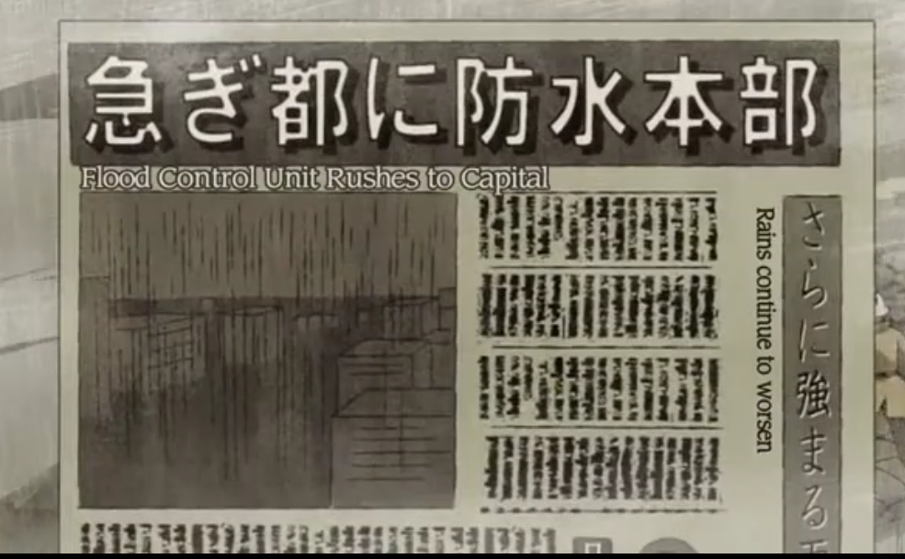
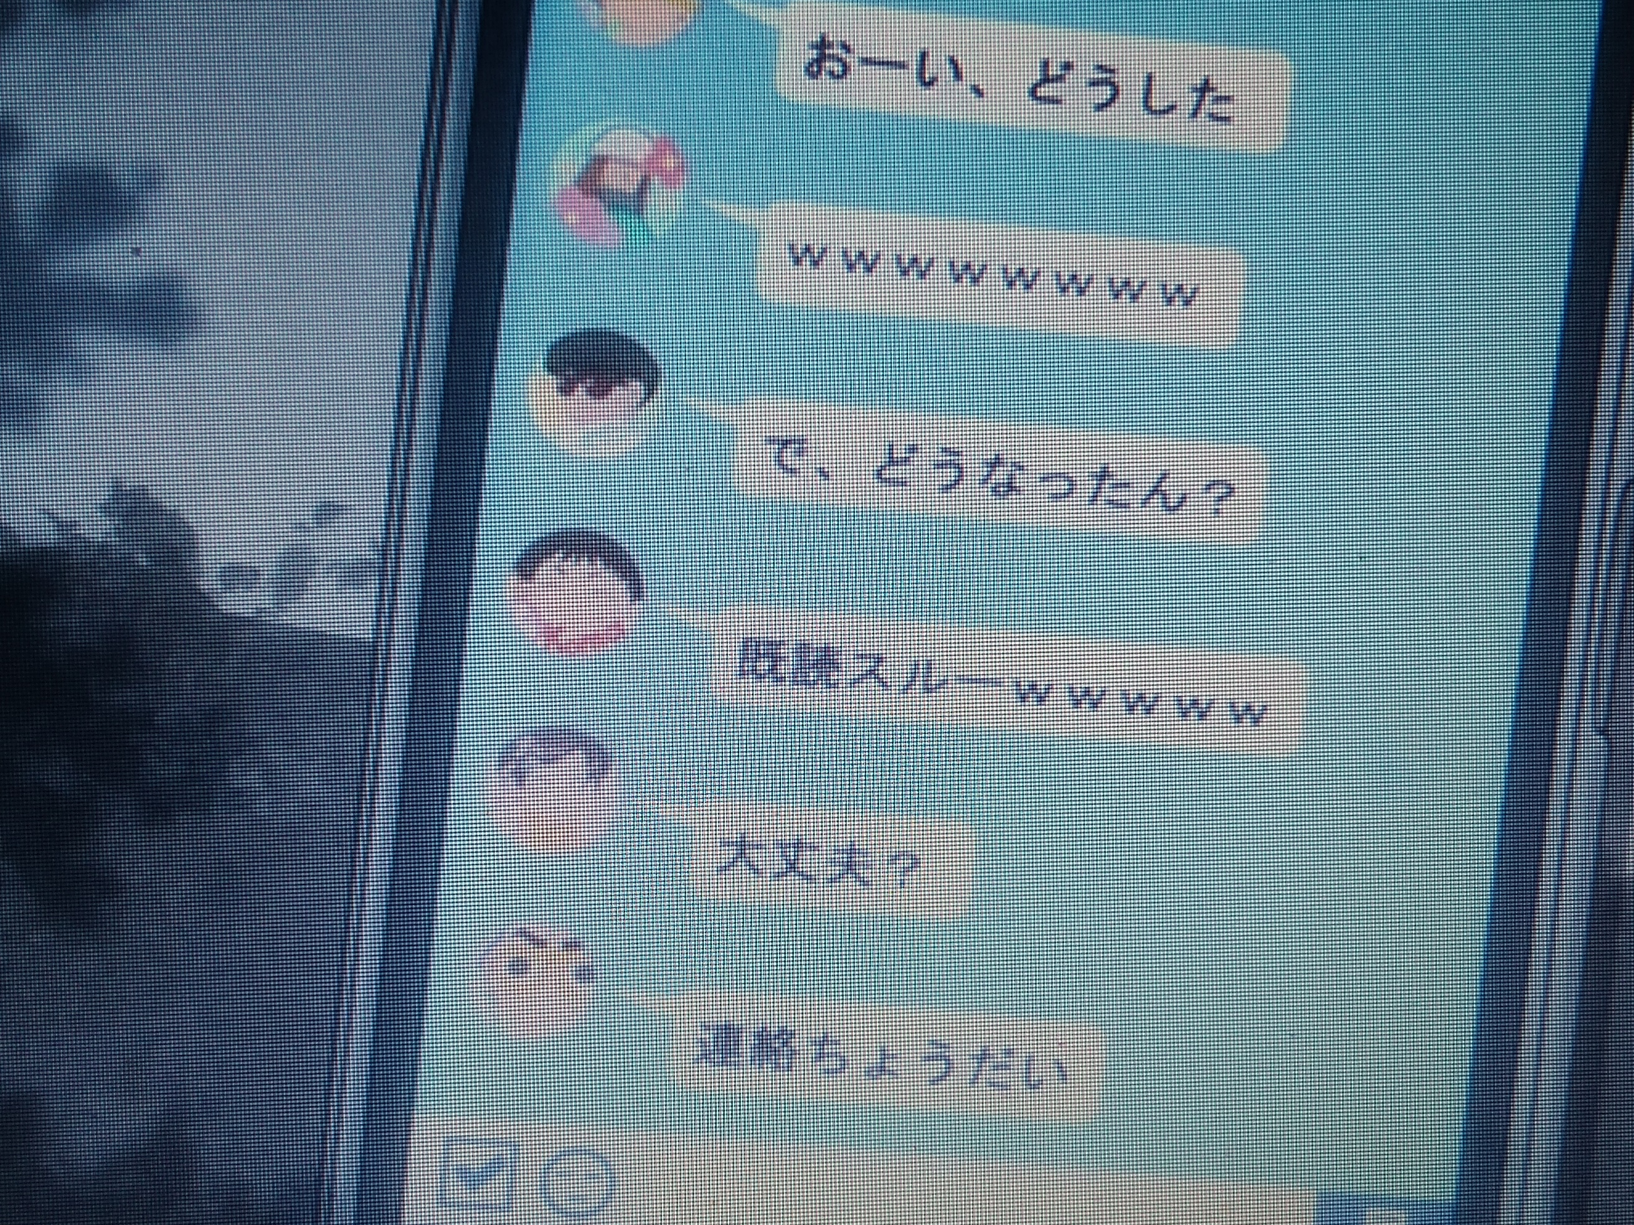

Figure II Professional Subtitles Figure III Fansubs
In contrast, in the fansubbed anime, Hakaba Kitarō, the fansubber translated even the written texts that we cannot read because the texts do not remain on screen long enough, making them difficult to read. Figure IV shows the subtitles for the newspaper headlines. Viewers have less than one second to read these subtitles, which is very short. However, if viewers want to know what is written in the newspaper, they can stop the video or rewind it.
As shown above, in terms of written texts in anime, we can note a significant difference between professional and non-professional fansubs. One of the reasons why professional translators have a tendency not to translate written words might be because the time they have to produce subtitles is very limited. As discussed in the previous section, the subtitlers working on Crunchyroll need to finish subtitling an episode (about 25 minutes) in a few hours in order to broadcast it as soon as it is aired in Japan.
In conclusion, although the quality of some fansubs is poorer than professional subtitles, viewers are often given more explanations about the Japanese language and culture in fansubbed anime. Additionally, subtitlers sometimes retain Japanese words in their translation.

4. Several Possibilities for the Future of Fansubs

We considered the disadvantage and benefits of fansubbing in comparison with professional translation. While the quality of some fansubs is poor, in general fansubbers explain fansubbed anime well since they are generally expert in the source materials. Additionally, the audience of fansubbed anime can usually get information about written texts, which professional subtitlers do not translate, and enjoy Japanese cultural elements since fansubbers have a tendency to preserve these references in their subtitles. This section examines how these features of fansubbing influence the future of fansubbers and also how they may survive despite the advent of legal streaming anime platforms.

  - Constant Demand for Fansubs
First, I will consider whether anime viewers really need fansubs, in other words illegal fansubbed anime streaming websites. As stated in the second section, the principal rule is that when an anime is licensed for commercial distribution, fansubbers remove the fansubbed version from their websites (Díaz Cintas and Muñoz Sánchez 2006; Lee 2011). In recent years, viewers can watch anime legally much more than before thanks to authorized anime on simultaneous streaming platforms. However, some anime still remain unlicensed. Anime distribution companies do not acquire the rights for commercial distribution of all anime, especially classic programmes. In addition, a licensing agreement for an anime does not usually last indefinitely (Basile 2016). Therefore, even though the demand for fansubs has decreased due to the emerging streaming platforms which show anime, fansubs will always be needed for unlicensed anime.
Additionally, even when a Japanese anime becomes licensed, it is not translated into all other languages. The number of target languages for legal anime streaming websites is still limited, even though many streaming platforms which show anime offer multilingual translations.
Furthermore, many viewers are confronted with the difficulty of watching their favourited anime through legal anime simultaneous streaming sites. First, some streaming platforms such as Netflix and Amazon Prime video charge viewers a subscription fee. Additionally, although anime are available on some authorized websites such as Crunchyroll for free, only paying members are allowed to watch an anime episode on the same day as it is aired in Japan (Gigazine 2012). Non-paying members need to wait for at least a week to watch the latest anime (Gigazine 2012). Moreover, different anime are available from one legal distribution website to another. If people have several favourite anime, they may need to subscribe to a number of different streaming services to watch them. As explained, in general fansubbers do not create subtitles for licensed anime. However, some fansubbers might create fansubs for licensed anime because of the complexity of watching anime on these authorized streaming platforms.

  - The Great Influence of Fansubs on Professional Subtitles
In examining the future of fansubs, we cannot ignore the fact that although fansubbers are amateur translators, their influence on professional subtitlers can be outstanding.

    - Fans’ Great Impact on the Production Processes
Thanks to the advancements of digital technology, consumers can participate in society more easily (Pérez González 2013: 160) and influence production processes more than before. In fact, Time Magazine chose “users” as the Person of the Year in 2006 reflecting their power to influence through new technologies (quoted in O’Hagan 2009: 96). Currently, the word “prosumer” is often used to describe consumers’ increasing participation in the production process.
To take an example, Japanese fans changed the subtitles of a film The Fellowship of the Ring (2001), which is one of the Lord of the Rings Trilogy. Some fans in Japan were not satisfied with the subtitles shown in film theatres because the translation did not correspond to that of the novels written by Tolkien (quoted in Shinohara, 2012: 226). The Japanese film distribution company took note of the fans’ disappointment and decided to adopt the preferred translation when they released the DVD version of the film (Shinohara 2012: 226). This shows that consumers take part in society more, and producers cannot ignore the power of the consumer, in particular fans.

    - Examples of Fansubs’ Influence on Professional Subtitles
In the case of fansubbing, fansubbers produce subtitles, and at the same time they are essential anime consumers in their capacity as anime fans. Nowadays, anime distribution companies pay much more attention to fans’ reaction and some of them try to adopt fans’ translation preferences on their subtitles. In fact, some professional translators have begun to adopt some of the effects usually employed in fansubs. For example, we can find a unique fansub’s feature in the episode of Gegege no Kitarō translated by a professional translator. As fansubbers usually do, the professional translator retains a few Japanese words such as “yokai” and “geta”. For the word, “yokai”, whose meaning is “a class of supernatural monsters, spirits, demons in Japanese folklore”, the translator probably chose not to translate this word into the target language because a lot of viewers may already be familiar with this word. In fact, Gegege no Kitarō is the story of various “yokai”. Additionally, the word, “yokai” has become well-known because of a role-playing video game called “Yo-kai watch”, which is sold worldwide. As for the word “geta”, which denotes Japanese traditional wooden sandals, some viewers may not understand what it means even with the visual image on the screen. Professional translators tend to omit cultural (in particular non-Western cultural) elements (Pérez González 2007). However, Crunchyroll’s professional translator did not hesitate to retain these Japanese words in their subtitles.
In the case of Crunchyroll, this company was originally an illegal website for fansubbed anime series (Gigazine 2019). It may not be surprising that viewers find some similarities between the subtitles in Crunchyroll and fansubs since some of their subtitlers were formerly amateur fan subtitlers. However, other researchers such as, Yuko Shinohara, also point out that some anime DVD subtitles allow viewers to insert pop-ups and notes (2018). It is obvious that some anime production/distribution companies add these functions to DVDs due to the influence of fansubbing.
As examined, fans have a great influence on the production process. Fansubs, which are created by anime fans are no exception. Therefore, we can say that the unique features of fansubs such as keeping Japanese cultural elements in subtitles and adding notes, are likely to remain in professional anime subtitles.

  - Several Other Ways to Survive for Fansubbers

The following sections also considers other ways to survive for fansubbers from various perspectives.

    - Amateur Translator’ Involvement in Media
In this part, I discuss how fansubbers continue their activities in a broader sense. First of all, it is worth noting that some fansubbers go on to become professional translators, especially for anime streaming websites like FunimationNow and Crunchyroll. Other fansubbers prefer to create subtitles at their leisure and continue their activities as amateur anime subtitlers. Apart from anime fansubs, there are other ways for amateur translators to be involved in translation, in particular in the field of media such as Facebook’s “crowdsourced translation” (O’Hgan 2009: 112), TED’s “Open Translation Project” (Pérez González 2013: 64), Al Jazeera’s “crowdsourced translation” (Pérez González 2013: 165). These media companies and organizations use a system that allows non-professional translators to contribute to their translation services. Besides, the prominent website Viki, which offers fansubbed Asian TV series and shows and films, is under Japanese e-commerce giant Rakuten. Rakuten acquired Viki in 2013 for the purpose of increasing its quota of advertising and getting paid members for advertisement-free and high-definition videos (Dwyer 2016: 151).
We will focus on a few remarkable aspects of these translation platforms for non-professional translators. The first feature is that these media companies and organizations often make good use of crowdsourcing platforms in order to get translation support from individuals. Taisuke Okabe examines in depth how fans cooperate and concludes that fans can acquire the necessary knowledge, information and skills by cooperation with other fans, while at the same time supporting other fans based on what they have learned from fan members (2015: 14). Some enterprises and non-profit organizations make good use of fans’ ability to cooperate with other members. Moreover, in general, these professional translation devices allow non-professional translators to not only cooperate with one another, but also to take part in translation when they want, at their own pace, with less stress. The condition of engaging in these translation services can correspond to amateur translators’ ambitions. Another noteworthy aspect is that non-professional translators can improve the accuracy of their translation through these media crowdsourcing platforms. To take an example, Facebook uses a system in which users can evaluate translations by non-professional translators by voting (O’Hagan 2009: 112) According to O’Hagan, this system works well in terms of improving the quality of non-professional translation. As discussed in the previous chapter, low accuracy is one of the weaknesses of some fansubs. Therefore, a system that enhances the quality of translation by non-professional translators on these platforms has a positive impact for fansubbers because it makes up for the shortcomings of amateur translators. In actual fact, some fansubbing groups have made use of this kind of system. For instance, Italian fansubbing communities such as ItaSta and Subsfactory, also use the feedback system to ensure the quality of fansubbers’ translation (Massidda 2020: 196).
Besides, professional translators are not usually willing to participate in this type of translation if they are not paid (O’Hagan 2009: 114). Some professional translators are concerned about the threat of this new business model, which leverages non-professional translators since professional translators may lose their jobs because of the increasing number of amateur translators participating in media translation. However, for non-professional translators, these platforms by media companies such as Facebook and Al Jazeera provide great opportunities to make a significant contribution to translation services in media.
The demand for multilingual translation has been rapidly increasing because of the increasing number of legal anime streaming sites (Gigazine 2015). Thus, the people in charge of these legal anime streaming sites may in the near future create a crowdsourcing translation platform for amateur translators, similar to Facebook. In fact, a few entertainment companies make use of fandom’s influence to feed into their translation services.

    - Fansubs only for Fansubbers
Finally, I will consider the case in which fansubbers translate anime subtitles only for themselves and for their fan members rather than for distribution to other viewers. In fact, Hatcher points out that “because fansubbers want prestige within their community, they even have an incentive to be innovative in this area.” (2005: 529) These anime subtitles by amateur translators are more creative and artistic (Díaz Cintas and Muñoz Sánchez 2006: 51). To take an example, as explained in the second section, the fansubber of the episode of Kitarō of the Graveyard translated almost all of the written texts, even those that are shown too quickly for viewers to read. The fansubber would have translated these written words not for the viewers but for his or her own pleasure or with the intention of catching the eye of other members of their fan community.
Moreover, for fansubbers, translating anime can be a tool to express enthusiasm, emotion, and thoughts about their favourite anime. Shefrin states that “as active participants, fans often appropriate corporate-generated imagery, and then embellish or transform it with personal artistic expressions such as poetry, songs, paintings, scholarly essays, creative fiction, photographs, digital films, collages, or clothing.” (2004: 273) In the case of fansubbers, their way of presenting their feelings and thoughts about their favourite anime is by creating subtitles. In this sense, some fansubbers will surely continue to create subtitles for their favourite anime because subtitling is a means of self-expression. Whether an anime is licensed or not is not important for them.
Besides, some fansubbers may express their reinterpretation of their beloved anime through other means such as painting, cosplay and creative fiction. In fact, creative activities for anime are increasingly popular in Japan. In particular, “doujinshi” is a common artistic activity among anime fans. “Doujinshi” are amateur manga publications based on the original characters and plot of an anime. Although the copyright issue concerning “doujinshi” is under discussion, “doujinshi” have gained popularity in Japan. For instance, comiket, short for comic markets, which are defined as “exhibitions and sales of self-published publications ‘doujinshis’ centred around manga, anime, video games, and other related genres,” have become one of the most popular events in Japan. Concerning copyright issues, in general Japanese society accepts “doujinshi” since this activity by fans can play a role in promoting anime, while most other countries prohibit creative publications based on an anime’s original characters and stories to protect the copyright for anime production and distribution companies (Hatcher 2015: 524). With the increasing number of authorized anime streaming websites, the demand for fansubbing is decreasing. It is hardly surprising that some fansubbers may switch their way of expressing their feelings and thoughts about their favourite anime from subtitles to other means such as “doujinshi”.

5. Conclusion
As discussed in this article, because of the increasing number of legal anime being screened on streaming platforms such as Netflix, Amazon Prime video and Crunchyroll, the demand for fansubs has been decreasing, since fansubbers have a principle of not creating subtitles for licensed anime for other fans. Besides, this article notes that new rules on digital content especially in Western countries also discourage fansubbers to continue their activities. Before considering the future prospects of fansubs, this study highlighted the genre’s history and outstanding characteristics. Above all, fansubbers’ strong motivation to create subtitles for their favourite anime is crucial. Furthermore, while conventional subtitlers try to make their subtitles as discreet as possible, fansubs are much more visible. Fansubbers use eye-catching colours and fonts, and sometimes add notes to subtitles. We also examined the disadvantages and benefits of fansubbing in comparison with professional subtitlers. The main weakness of fansubbing is its poor quality. However, since amateur fan translators are very familiar with fansubbed anime, they are often particularly good at explaining them. Additionally, the audience of fansubbed anime can often appreciate Japanese cultural elements in fansubs since fansubbers tend to retain these items in their translation.
In conclusion, it is likely that fansubs for Japanese anime will continue to survive in various ways. Some researchers have cast light on certain fansubbing activities that are involved in media such as Facebook and TED and e-commerce such as Viki, which was acquired by Rakuten. This article also admits that some fansubbing groups will continue their works in partnership with private companies and organizations such as Facebook and TED. At the same time, this article highlights that there will always be a demand for fansubs for unlicensed anime, and fansubs in various languages are in demand. Additionally, some fansubbers do not pursue their activities for other fans, but as a way of expressing their passion and enthusiasm for their favourite anime. Moreover, we cannot ignore the power of fans in current times. Fansubs have also had a significant influence on professional subtitles. Some companies that provide legal anime streaming services may make use of the power of fansubbers in the near future.

Notes

1 Candy Candy, which I analyse in this research is episode 1 from Internet Archive, added in 2017.
2 Kitarō of the Graveyard (Hakaba Kitarō) (2008), which I analyse in this research is episode 6 from Dailymotion, added in 2018.
3 Azumanga Daiou (2002), which I analyse in this research is episode 1 from Internet Archive, added in 2017.
4 Gegege no Kitarō (2018), which I analyse in this research is the first episode of Crunchyroll, added in 2018.
5 According to an article on the CNN website on 29 July 2019, “after seven years of consecutive growth, the anime industry set a new record in 2017 of ¥2.15 trillion ($19.8 billion), driven largely by demand from overseas”.
6 Romaji, in other words romanization of Japanese is the Japanese written language using Latin script.
7 Hiragana and Katakana is the basic phonetic alphabet. While Hiragana is the most commonly used in Japanese, Katakana is mainly used to write loanwords such as “restaurant” and “cinema”. Kanji are Chinese characters, which have different meanings and pronunciations. Many words in Japanese are written in Kanji.
8 Strictly speaking, “Tsukkomi” is not always through physical contact. It can be through words only.
9 From 00:00:16 to 00:00:20
10 In Japan, films often indicate the name of the subtitler at the end.
11 According to Merriam-Webster online dictionary, manga means “Japanese comic books and graphic novels considered collectively as a genre”.
12 The translation errors in opening and ending songs are not included.
13 In the case of English, the main honorific titles are Mr., Mrs., Miss and Ms., but they do not indicate the relationship between the speakers.
14 From 00:03:36 to 00:03:38.
15 At 00:16:33
16 An article written by Grossman on 13 December 2016.
17 According to Collins online dictionary, prosumer means “a person who both consumes and produces a particular commodity”, “a consumer who is involved in the design of a company’s products” and so on.
18 At 00:05:08.
19 At 00:20:09.
20 According to an online multilingual dictionary, Definitions.net.
21 The definition is by the Comic Market Community. References Basile, Michael. 2016. FUNimation vs. Aniplex: How Anime Licensing Work. In Digital Fox Media. 16 Feb. Available at: <www.digitalfox.media/explained/funimation-vs-aniplex-anime-licensing-works/>. (Accessed: 29 December 2019). Bogucki, Lukasz. 2009. Amateur Subtitling on the Internet. In Audiovisual Translation –Large Transfer on Screen-, Díaz Cintas, Jorge and Anderman, Gunilla (eds.), London, Palgrave Macmillan, pp. 49-57. Díaz Cintas, Jorge & Muñoz Sanchez, Pablo. 2006. Fansubs: Audiovisual Translation in an Amateur Environment. In the Journal of Specialized Translation, 2006, no. 6: 37-52. Dwyer, Tessa. 2016. Multilingual Publics: Fansubbing Global TV. In Contemporary Publics: Shifting Boundaries in New Media, Technology and Culture, Marshall, P. David, D’Cruz, Glenn, McDonald, Lee, Katja (eds.) London: Palgrave Macmillan, 2016, pp. 145-162. Gigazine Editorial Department. 2012. Business Model of Crunchyroll reduces 70% of illegal downloading by releasing the Japanese anime almost simultaneously as in Japan (M. Sakuma, Trans.). In Gigazine, 22 March. Available at: <www.gigazine.net/news/20120322-anime-crunchyroll-taf2012/>. (Accessed: 17 January 2020). Gigazine Editorial Department. 2015. What kind of Path have Fansubs followed? (M. Sakuma, Trans.). In Gigazine, 29 Jun. Available at: <www.gigazine.net/news/20150629-fansub-japanese-cartoon/>. (Accessed: 29 December 2019). Hatcher, Jordan S. 2005. Of Otakus and Fansubs: A Critical Look at Anime Online in Light of Current Issues in Copyright Law. In Scripted, 2005, vol. 2, no. 4, pp. 544-571. Ho, Solei. 2019. The Future of Anime Fansubs in a Simulcast World. In Polygon, 9 Jan. Available at: <www.polygon.com/2019/1/9/18171014/anime-fansubs-translation-streaming-crunchyroll>. (Accessed: 12 January 2020). Jozuka, Emiko. 2019. Japanese Anime: From ‘Disney of the East’ to a Global Industry Worth Billions. In CNN, 29 July. Available at: <www.edition.cnn.com/style/article/japan-anime-global-identity-hnk-intl/index.html>. (Accessed: 28 December 2019). Lee, Hye-Kyung. 2011. Participatory Media Fandom Working on the Disjuncture of Global Mediascape: a Case Study of Anime Fansubbing. In Sage journals, 2011, vol. 33, no. 6, pp. 2-20. Leonard, Sean. 2004. Progress Against the Law: Fan Distribution, Copyright, and the Explosive Growth of Japanese Animation [PDF]. Available at: <http://web.mit.edu/seantek/www/papers/progress-columns.pdf>. (Accessed: 4 December 2019). Massidda, Serenella. 2020. Fansubbing: Latest Trends and Future Prospects. In The Palgrave Handbook of Audiovisual Translation and Media Accessibility, 2020, 1st ed., pp.189-208. Timed Text Style Guide: General Requirements. In Netflix, 9 July 2021. Available at: < https://partnerhelp.netflixstudios.com/hc/en-us/articles/215758617-Timed-Text-Style-Guide-General-Requirements>. (Accessed: 17 January 2022). NHK. 2015. Can the Japanese anime launch a counterattack? -The future of the overseas exports and new strategies- (M. Sakuma, Trans.). In Today’s Close-up, 23 February, no. 3620. Available at: <www.nhk.or.jp/gendai/articles/3620/index.html>. (Accessed: 8 December 2019). O’Hagan Minako. 2009. Evolution of User-generated Translation: Fansubs, Translation Hacking and Crowdsourcing. In the Journal of Internationalization and Localization, 2009, vol. 1, no. 1, pp. 94-121. Okabe, Taisuke. 2015. The Structure of Subculture Generated by the Internet Community (M. Sakuma, Trans.). In AD Studies, 2015, pp. 12-16. Pérez González, Luis. 2007. Fansubbing Anime: Insights into the “Butterfly Effect” of Globalization on Audiovisual Translation. In Perspectives Studies in Translatology, 2007, vol.14, no 4, pp. 260-277. Pérez González, Luis. 2013. Amateur Subtitling as Immaterial Labour in the Digital Media Culture -An Emerging Paradigm of Civic Engagement. In the International Journal of Research into New Media Technologies, 2013, vol. 19, no. 2, pp. 157-175. Pérez González, Luis. 2020. Fan Audiovisual Translation. In Routledge Encyclopedia of Translation Studies, 2021, 3rd ed., pp. 172-177. Shefrin, Elana. 2004. Lord of the Rings, Star Wars, and Participatory Fandom: Mapping New Congruencies between the Internet and Media Entertainment Culture. In Critical Studies in Media Communication, 2004, vol. 21, no. 3, pp. 261-81. Shinohara, Yuko. 2012. How can film subtitles meet an audience’s expectations? In Journal of the Japan Association for Interpreting and Translation Studies, 2012, vol. 12: 209 – 28. Shinohara, Yuko. 2018. Traductology about Subtitles of Films: Japanese Films and English Subtitles (M. Sakuma, Trans.). Kyoto: Koyoshobo, 2018. Wang, Dingkun. 2017. Fansubbing in China – With Reference to the Fansubbing Group YYeTs. In The Journal of Specialised Translation, 2017, vol. 28, pp. 165-190. Yamaguchi, Yasuo. 2013. The Evolution of the Japanese Anime Industry. In Nippon Com, 20 December. Available at: <www.nippon.com/en/features/h00043/>. (Accessed: 4 March 2020). Audiovisual Resources Azuma, Kiyohiko. (Writer), & Nishikiori, Hiroshi. (Director). (2002, 8 April). Azumanga Daioh (Episode 1) [TV series episode]. In Azumanga Daioh production committee. Child High School Student. TV Tokyo cooperation. Posted by Jason, Scott (2017) in Internet Achieve. Available at: <https://archive.org/details/fansub_Azumanga_Daioh>. (Accessed: 17 January 2020). Mizuki, Shigeru. (Writer), & Chioka, Masatoshi. (Director). (2008, 15 February). Hakaba Kitarō (Episode 6) [TV series episode]. In Hakaba Kitarō production committee. Mizugami Sama [The Water God, Trans. Sakuma]. Toei Animation Co., Ltd. Posted by Skippygranola (2018) in Dailymotion. Available at: <https://www.dailymotion.com/video/x6hqabg>. (Accessed: 11 January 2020). Mizuki, Shigeru. (Writer), & Ishiyama, Tomiyuki. (Director). (2018, 1 April). Gegege no Kitarō (Season 6, Episode 1) [TV series episode]. In Kanou, Y., Sagawa, N., Nagatomi, Daichi., & Takami, S. (Producers). The Day Yōkai Awoke. Fuji Television Network, Inc; Yomiko Advertising Inc; Toei Animation Co., Ltd. (2018) Posted in Toei Animation Co., Ltd (Editor) (2018, 31 Mars) in Crunchyroll. Available at: <https://www.crunchyroll.com/fr/gegege-no-kitaro>. (Accessed: 17 January 2020). Igarashi, Yumiko. (Writer), & Imazawa, Tetsuo. (Director). (1992). Candy Candy [Film]. (A short film) Toei Animation Co., Ltd. Posted by Wayback Machine (2017) in Internet Achieve. Available at: <https://archive.org/details/fansub_Candy_Candy>. (Accessed: 29 January 2020). Miki SAKUMA LIRCES, University of Côte d’Azur, FRANCE e-mail: miki.sakuma@etu.univ-cotedazur.fr In SKASE Journal of Translation and Interpretation [online]. 2023, vol. 16, no. 1 [cit. 2023-07-30]. Available online at http://www.skase.sk/Volumes/JTI24/pdf_doc/04.pdf. ISSN 1336-7811

