Translation Across Discourse Communities and Generic Conventions:
A Corpus-Based Investigation of the Betwixt and Between of Religious Scholarly Articles’ Abstracts Translated from Arabic into English
Waleed Bleyhesh al-Amri, Taibah University, Saudi Arabia

Abstract
Translation of research abstracts is one of the most common forms of scientific communication in the world, if not “the” most common. Since English is frequently employed as the standard language of knowledge, the majority of research articles are published in English, or at the very least include English abstracts. In addition to this goal of research promotion, abstract translation is a requirement for Arabic journals to be accepted by the relevant authorities and/or indexing agencies.
The purpose of the current study is to investigate the results of this translation activity by focusing on the ways in which the discourse community’s accepted practices and text-type generic conventions are commuted and communicated across linguistic and cultural barriers. It focuses in particular on religious academic papers written in Arabic for specialized Islamic journals and examines the English abstracts of these papers for indications of conformity and/or non-conformity with academic abstract-writing best practices established in the English language research circles.
A bilingual corpus comprising 102 abstracts—51 Arabic originals and 51 English translations—is selected from indexed academic Islamic journals for this study, and both manual and automatic text analysis tools are used to examine the data. The overarching goal is to examine if these translations adhere to the expected academic abstracts formation convention of the receptive discourse community rather than just whether they successfully convey the intended information.

Keywords: Research abstracts, Islamic studies, Discourse practices, Macro moves, Writing tradition, Translation approach.

Introduction

Scientific research is the driving force behind human advancement and the surest way to deeper intellectual insight. In order to promote their findings, claim priority over scientific discoveries, simply be seen and recognized, and/or fulfil basic publishing requirements, researchers and institutions, the world over, either originally publish their work in English or have it translated into this scientific lingua franca of the world (Ammon 2001; Tardy, 2004; Hamel, 2007). Hence knowledge is becoming more and more a globalized commodity and with it comes the opening up and expansion of the translation market. In fact, abstracts and patents translation are some of the biggest drivers behind the need for translation services these days. A case in point is the World Intellectual Property Organization (WIPO) putting out a call for expressions of interest (EOI) in 2020 in a massive contract for ongoing translation from German, Spanish, French, and Russian into English. Huge as it is (estimated at USD 4.39–5.49m of approximately 52,000 documents per year (about 26 million words)), the contract notably covers the relatively narrow area of the Patent Cooperation Treaty documents, namely patent abstracts and patentability reports.
This upsurge is so strongly felt that research of an inherently local nature, like that of Islamic scholars specializing in religious areas, systematically gets translated into English albeit in the form of abstracts. This is more of an incumbent duty than a self-instigated drive to promote this kind of research. Encouraged to it by indexing bodies, and the now-established academic practice, journals specializing in all fields of knowledge require researchers to supplement their articles with English abstracts.
However, given that the prevailing translation strategy is that of literalism, all this systematic and concerted effort begs the question about the utility and usefulness of this academic practice for the intended global readership, particularly in areas virtually untouched by Western academic training. Islamic studies is prominent among these. It is a well-established field of knowledge with millennia of deep-rooted discursive and conventional practices, unlike, for instance, pure science disciplines which are modelled on their Western counterparts and in which specialists are well-trained either in the West or at the hands of those who obtained their degrees from the West.
What happens when the two totally divergent discursive practices cross paths thanks to the transformative act of translation? Do these translations take into their stride the expected generic conventions of abstract formation known in English to fulfil their knowledge promotion goal? Or do they ride roughshod over them to get over with the instructed task much to the detriment of the target reader understanding?
To answer these questions, the current article closely investigates the mechanics of interaction and identifies structural regularities/irregularities that arise from the crossover of texts through the mediatory act of translation in an English/Arabic parallel corpus of religious scholarly articles abstracts.
The aim is also not to catalogue or provide an inventory of the myriad mistranslations found in these texts, although some telling examples will be highlighted as much as they serve the purpose of this research, but rather to arrive at the overall translation strategy that permeates these and how conforming/non-conforming is the final output to the discursive practices expected in the receptive community. The scope is further narrowed by culling data solely from academic journals, rather than theses or dissertations, which are, more than not, the outcome of a single researcher’s effort. Academic articles gain greater currency and are the output of multiple corrective agents.

Abstract writing and translating: Conventions and practices

Abstracts are meant to be self-contained, autonomous works. They are supposed to act as standalone documents, often with a beginning, middle, and end. The abstract provides a brief but comprehensive summary of the contents of the article (APA, 7th edition). Although abstracts may be considered as parts of research articles, most often they act as independent discourses (Van Dijk, 1980). Bhatia (1993) places abstracts as an independent genre in the domain of academic discourse. He defines an abstract as a factual summary meant to give the reader an exact and concise knowledge of the full article. He defines the information it contains as follows:
- What the author did.
- How the author did it.
- What the author found.
- What the author concluded.

Abstracts have well-set norms and conventions in academia, the world over. Academic writing pays particular attention to these and stipulates that they are followed (Moten, 1998).
In a bid to enhance their international visibility and/or to meet certain indexing criteria, journals mandate researchers by editorial policies to have the abstracts of their manuscripts translated into English as a pre-requisite for publication. The Scopus journal selection criteria stipulate that to be considered for review, all journals should meet a number of minimum criteria. Among them is that the journal in question must: “Have content that is relevant for and readable by an international audience, meaning: have English language abstracts and titles”. Such a practice is intended to help increase the size of the academic community that the publications serve (Pezzini, 2003). Even in cases where non-English national languages are used for journal articles, “it is not unusual for journals published in languages other than English to expect the author to write an English abstract of their article” (Lorés, 2004). The majority of Arabic journals included in the Arab Citation and Impact Factor (Arcif) list stipulate that two abstracts and keyword lists, one in English and the other in Arabic, must be provided with every publication.
One must keep in mind, nevertheless, that text production is rooted in established customs and traditions and is not an act of pure invention. For successful translation across the various academic communities, this reality must be acknowledged. Jernudd and Baldauf (1987) provide the following telling diagram of the parameters that are involved in text production in academia:

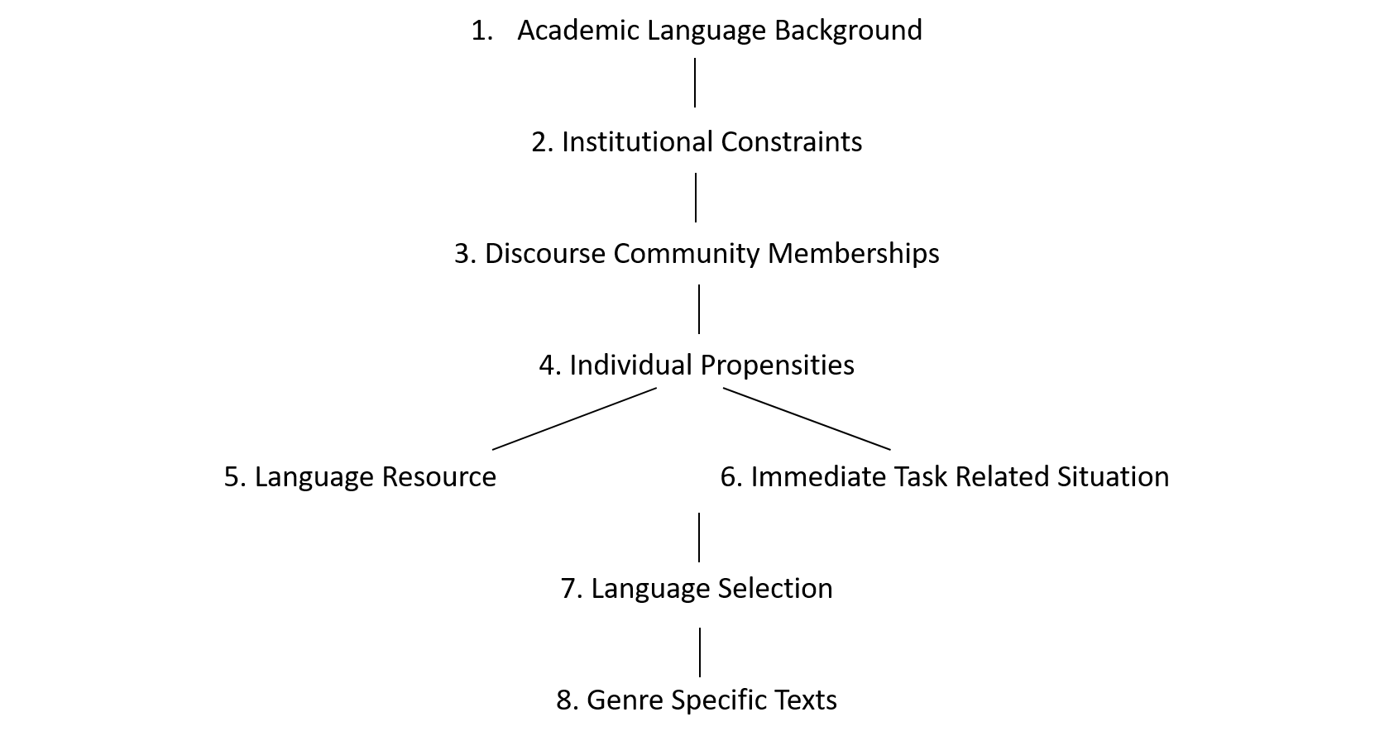
Diagram 1: Academic Text production parameters (quoted in Swales, 1990: 104)

As for those who attempt to carry out cross-linguistic, cross-cultural, and cross-disciplinary comparisons, Melander et al. (1997: 268) offer the following worthy-of-note alert: “Comparative studies of abstracts need to be undertaken with some care: indeed we have learnt some lessons too late. Abstract subtype, specialty, language policy, and discourse community characteristics all interact in the making of these seductively short and rhetorically simple texts”.
It stands to reason that such a prevalent translation practice has not gone unnoticed by researchers. Because of its pervasiveness and the fact that it lends itself easily to close scholarly scrutiny, there are plenty of articles investigating it across different language pairs and fields of study (Kyrychuk, 2019; Carolia and Baihaqi, 2019; Cheng, 2020). Translation between Arabic and English is one such language pair. There are some studies available (cf. Alharbi and Swales, 2011; Alhuqbani, 2013; Al-Ali and Alliheibi, 2015; Al Zumor, 2021), however, the fact that none of them specifically looked at the translation of abstracts of religious texts from Arabic into English shows that, up until now, far too little attention has been paid to the features and discourse practices transfer in such a pervasive and developing discursive exercise. The current study is a modest step in that direction and attempts to investigate and achieve the following objectives:
- Examine the primary discursive characteristics of scholarly religious writings in the Arab world and the institutional frameworks that shape them.
- Whether the translation of academic religious articles abstracts fulfill the discursive practices and generic conventions of the receptive community.
- Highlight the forces that drive either the convergence or the divergence of these norms as adopted by West vs. East discourse communities.

Corpus, Method, and Procedures

Islamic writing has a long history of scholarship; yet, it is only recently that this legacy has taken on a strictly academic appearance. Additionally, it is only quite recently that this academic output has been made available to the wider public through translation. Little is known about the discursive features of this output, especially through the kaleidoscope of comparative studies. In this paper, I examine 102 Arabic and English paired abstracts dealing with the language of religious sub-disciples drawn from four Arcif-indexed (Arab Citation and Impact Factor) specialized journals (Table 1 below).
In addition to their geographical distribution, which spans over three Arab countries, these journals publish for academics from all over the world and are not country bound, and hence are quite representative of the overarching discourse community characteristics. The researched abstracts are chosen from the most recent issues of these publications in order to identify broad patterns. This is done in order to more accurately determine both the most recent discursive practices and translation practices used by these scholarly groups.

No. | Title | Publisher | Impact factor  (Arcif Analytics) | Code | No. of abstracts |  |  | Word count
 |  |  |  |  | Arabic | English | Arabic |  | English
 | Islamic Research Journal | General Secretariat of Senior Scholars. KSA | 0.0545 | J1 | 6 | 6 | 591 |  | 861
 | Journal of Sharia Sciences and Islamic Studies | University of Sharjah (UoS), UAE | 0.1233 | J2 | 17 | 17 | 2699 |  | 3181
 | Jordan Journal of Islamic Studies | Al al-Bayt University, Jordan | 0.0637 | J3 | 15 | 15 | 2255 |  | 3185
 | Journal of Cherishing the Two Glorious Revelations | Endowment for Cherishing the Two Glorious Revelations,  KSA | - | J4 | 13 | 13 | 2059 |  | 2981
Total |  |  |  |  | 51 | 51 | 7604 |  | 10208
Grand total |  |  |  |  | 102 |  | 17,812
Table 1: General overview of the studied corpus

I use the Critical Contrastive Rhetoric (henceforth CCR) technique to examine the texture of the researched texts to find genre-related and structural regularities and/or irregularities within and across them (Kubota and Lehner, 2004). This approach qualitatively encourages reflection on the preferred “discourse patterns of the target language and [evaluates] how these practices might reinforce cultural binaries and assimilation.” Additionally, it sees writing as a social activity involving human agency rather than just a reflection of societal mores. The CCR highlights the importance of rhetorical evolution and supports research into how a particular language’s rhetoric adopts new styles as a consequence of internal and external circumstances.
The culled corpus is examined using a combination of corpus methodology and linguistic analysis, manually through close examination and automatically using the available linguistic inquiry tools (primarily #LancsBox, released by Lancaster University) for overall phenomena that are not easily manually detected. This analysis helps to better achieve the goals of this paper.
The results will be compared to existing findings from comparative studies on cross-communicative abstract translation methods. I also examine the abstract pairs’ groupings of macro-moves and micro-steps as well as any language-specific patterns. The conclusions will be deduced from this analysis.

Move analysis: Macro moves

Many studies that dealt with abstracts focus more on the textual organization rather than on microlinguistic choices (cf. Cava, 2011). Beginning with Swales’ work in 1990, texts became recognized to be arranged in different ‘moves’ and research that followed suit then mushroomed (cf. Bhatia, 1993, Dos Santos, 1996, Huckin, 2001, Hyland, 2000, Martin, 2003, Samraj, 2005). Out of this extensive research, a regular pattern, arranged in moves ranging between four and five, was identified and pointed out in academic abstracts writing. Each move fulfills a certain communicative function. A “move has to be considered as a genre stage which has a particular minor communication purpose to fulfill, which in turn serves the major communicative purposes of the genre” (Dos Santos, 1996).
Accordingly, the standards of abstract writing are set as such by writing regulatory bodies like the American Psychological Association (APA) and the American National Standards Institute (ANSI). According to ANSI/NISO Z39.14-1997 (p. 3), content elements of the full abstracts should include purpose, methodology, results, conclusions and other information. The purpose section is to state the primary objectives, scope or reasons for the study, the methodology is to describe techniques or approaches, the results is to describe the effects of the study, and the conclusion is to describe the implications of the results, recommendations, evaluations, applications, suggestions, etc.
This study takes a five-move model as the subject of the investigation (as in Table 2 below). It incorporates the work of earlier genre analysts who came to the conclusion that abstracts often include four to five steps (e.g., Swales, 1990; Dos Santos, 1996; Swales and Feak, 2009).

Move | Name | Function (after Hyland 2000)
Move 1. (M-1) | ‘Background’ (Dahl); Introduction (several authors); Situating the research (Dos Santos). | Establishes context of the paper and motivates the research or discussion.
Move 2. (M-2) | ‘Present Research’; Purpose (Hyland); Announcing Present Research (Dahl); Presenting the research (Dos Santos); Introduction (Swales). | Indicates purpose, hypothesis, outlines the intention behind the paper
Move 3. (M-3) | ‘Method’; Methods/Materials; Methodology; Describing the methodology (Dos Santos; Swales). | Provides information on design procedures, assumptions, approach, data, etc.
Move 4. (M-4) | ‘Results’; Product (Hyland); Summarizing the results (Dos Santos; Swales); | States main findings or results, the argument, or what was accomplished
Move 5. (M-5) | ‘Conclusion’; Comments on Results; Discussion (Swales); Discussing the research. | Interprets or extends results beyond scope of paper, draws inferences, points to applications or wider implications.
Table 2: Move Structure (rhetorical structures)

Each move’s frequency of recurrence was statistically tallied and summed for the purposes of this study. The findings are shown in Table 3 and are visually shown in Chart 1 below. The five-move model in Table 2 was used to code and evaluate each abstract in the corpus using the parameters it establishes. The findings in this section display the movement analysis in the 51 abstracts in Arabic sub-corpus. The results are nearly identical in the English sub-corpus, which is a close translation of the Arabic originals.

Move | (M-1) Background | (M-2)  Purpose | (M-3)  Method | (M-4)  Results | (M-5)  Conclusion
Count | (J1)2-(J2)6-(J3)6-(J4)13  =27 | (J1)6-(J2)17-(J3)12-(J4)13  = 48 | (J1)3-(J2)8-(J3)3-(J4)0  = 14 | (J1)5-(J2)11-(J3)10-(J4)13 =39 | (J1)0-(J2)1-(J3)3-(J40)  =4
Table 3: Abstracts macro moves frequency in corpus

Out of the 51 Arabic abstracts in the corpus 27 M-1, 48 M-2, 14 M-3, 39 M-4 and 4 M-5 moves were identified as per each move’s markers (found in Table 4 below). These words/phases were culled both manually and from a word frequency list and identified as research-related. They are used for observing language use in each move.

Move | Arabic marker Arabic | Translation
(M-1) Background | - | -
(M-2) Purpose | - يهدف إلى  - يتناول/ تناول  - جاء لتثبت  - يبحث في  - خُصص لـ  - هذا البحثُ محاولةٌ  - يسلط الضوء  - يســعى إلــى  - يتغيا  - جاء لتميط اللثام  - يستعرض  - عمد إلى  - تناول بالدراسة | - Aims for  - Deals/Dealt with  - Came to prove  - Looks into  - Dedicated to  - Is an attempt at  - Sheds light on  - Endeavors to  - Came to reveal  - Overviews  - Intended to  - Dealt with
(M-3)  Method | - تتبع  - اعتمد (المنهج)  - جمع (الآراء)  - البحث في إجابات عن  - يتبع )منهجــاً(  - المنهج الذي توسلت فيه فدار في فلك  - نهج إلى | - Traced  - Adopted (a method)  - Gathered (opinions)  - Looked for answers for  - Follows (a method)  - The method adopted revolved around  - Took (as method)
(M-4)  Results | - من أبرز النتائج  - أثبتُ أنّ  - انتهى إلى جملة من النتائج  - توصل إلى عدة نتائج  - أظهر  - نبَّه إلى  - أبان  - من النتائج التي تأدى إليها  - أسفر عن )نتائج(  - تبين (من خلال الدراسة)  - كانت من أهم النتائج | - Among the most outstanding results are  - I proved that  - Came up with a host of results.  - Reached a number of results  - Revealed  - Drew attention to  - Made clear  - Among the results lead to  - Unveiled (results)  - It became clear  - The most important results are
(M-5)  Conclusion | - ويظهر (مما سبق)  - نستنتج (من هذا) | - )This( shows  - We conclude (from this)
Table 4: Moves markers

Findings and discussion

Given the time-honored practice of Islamic scholarly writing, which abounds with set rules and traditions, embarking on this research, one was expecting to find a plethora of formulaic expressions which are the staple hallmark of such scholarly output. The following abstract is an illustrative example (Example 1) of which:

All Praises to Allah, and Peace and Blessings be on the Imam of all Messengers, our Prophet Mohammed, and his Family and Companions. This research is a study and investigation of a part of (The Great Treasures of the Perceptions of Revelation and Facts of Interpretation for Abi Al-Barakat Al Nasfy) (who deceased in 710 AH) by the Scholar Ibrahim bin Ibrahim Al Ganagi, known as "Basilah" (from the beginning of Al Araf till verse no. 10). The Nature of this study requires dividing the research into an introduction, two main sections, conclusion and index. The introduction includes the following points: the importance of that subject, the reasons for choosing it, previous studies, the investigation methodology, and the research plan The researcher has employed the analytical descriptive method in this study. As for the first main section, the study section, it includes the identification of Ibrahim Basilah and his book (The Great Treasures of the Perceptions of Revelation), in addition to two topics: the first topic is the identification of Ibrahim Basilah and it consists of three requirements: the first is his name, kinship, birth, and origin, the second is his scientific life and influences, the third is his teachers and students, and the fourth is his death. The second topic is the identification of the footnotes of (The Great Treasures of the Perceptions of Revelation), and it consists of three requirements: the first is the importance of this book and the documentation of its attribution to the author, the second is the author's methodology and resources regarding this book, and the third is the description of the manuscript version. The second main section, the investigation section, includes the investigation of a part of (The Great Treasures of the Perceptions of Revelation) in relation to the first ten verses of Al-Araf Finally, the conclusion which includes the main results and recommendations. Then the index of resources and references. Peace and Blessings be on our Prophet Mohammed, and all Praises to Allah.
(Journal of Sharia Research and Studies, issue number 145. Pp. 117-8)

It is easy to detect, through the employment of these long-cherished formulaic expressions (highlighted in bold above), marking the beginning and end of the exposition, traces of a well-established discursive practice that is hard to dispose of (cf. Kaddoura, 2009). However, the transition into academia proper through research paper writing has necessitated, to put it mildly, a modification in form and phrasing. This is supported by the fact that the examined journals are indexed, indicating that they have met certain approval standards, and by the style of writing used in the selected abstracts. Doing away with these opening and closing formulaic expressions, the vast majority of the abstracts in the corpus (48 out of 51) start out right away with a purpose (M-2) marker outlining what the researcher accomplished with phrases like, “This research aims for/deals with/looks into, etc.” and finish with a summary of the findings. However, using writing customs such as the ones above was discovered to be the uncommon exception.

Chart1: Abstracts macro moves frequency in the corpus

This raises issues about the nature of genre in a globalizing world. On the one hand, there are generally accepted standards for what a research article or an abstract should look like within a specific disciplinary field, which are doubtless reinforced by academic and journal editorial practices, and on the other hand, there are well-established regional writing traditions that are expected to endure after all requirements have been met.
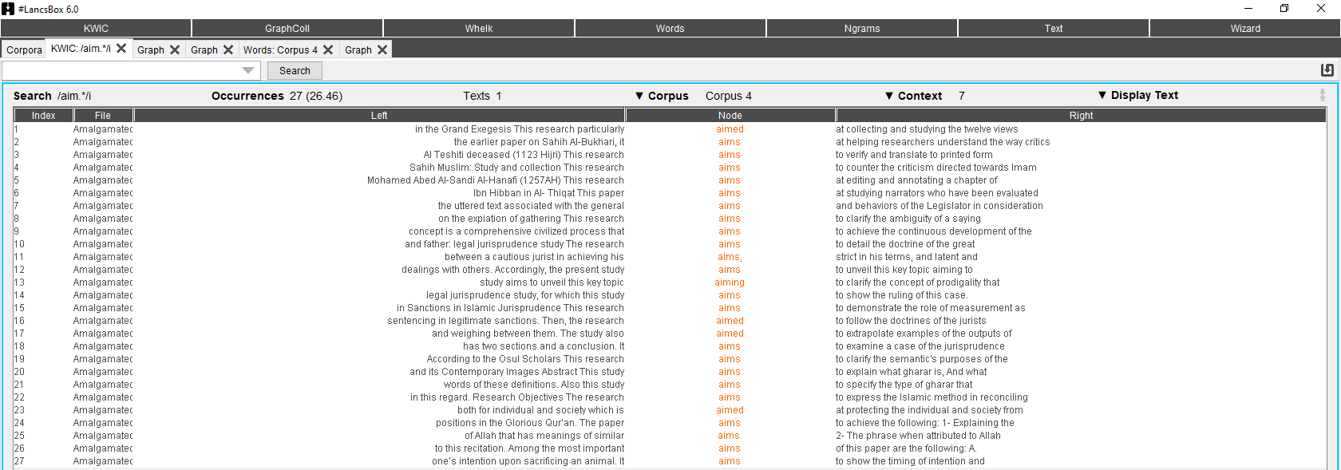
Figure 1. #LancsBox result of purpose move using ‘aim’ lemma

It has to be said that the influence of English-language rhetorical style on global academic communication is now being felt throughout much of the academic world. Indeed, Martin (2003), writing about the then-current situation in Spain, suggests that Anglo-American rhetoric seems to be winning out over the traditional national ‘socio-culture’. This is what Venuti (1995) calls the ‘authoritative plain style’, the one employed routinely by academics. Authors that fail to comply run the risk of being considered incompetent and scientifically illiterate (Bennet, 2007). For such a prevalent practice that bulldozerises any traces of local discourse practices, the term ‘epistemicide’, coined by the Portuguese sociologist Boaventura de Sousa Santos (2005) to describe one of the more pernicious effects of globalization upon developing countries, is often used (cf. Bennet, 2007; Masaka, 2017; Price, 2021; Eybers, 2022).
This trend may not be particularly novel; Clyne observed in 1987 that the enormous flow of scientific knowledge along with academics’ desire to share and communicate “have led to some alleviation of [cultural] differences” (p. 215). Ventola (1994), Taylor and Chen (1991), and Cmejrkova (1994) all discovered comparable observations. As a result, Atkinson (2004: 285) has claimed that the professional-academic culture “would partly overlap with national culture, but would also in part be shared with [similar cultures] in other parts of the world.”
Yet it has to be said as Kramsch and Thorne (2002: 99) point out: “Because we tend to take our genres for natural and universal […] we don’t realize the local flavor they bring to the global medium”. It has been observed that the intrinsic writing protocols of English language and Arabic language cultures may be somewhat different. Alharbi (1997: 92) observes that: “The English writer employs a wide variety of structural devices to engage the reader’s attention and provide technical assistance. By contrast, the rhetorical protocol of the Arabic culture focuses on the message and undervalues the format”. This is felt in the corpus at hand where a more straightforward, information-laden discourse is employed.
As for M-1, background, Alharbi and Swales (2011) published a relevant paper in which they describe the similarities and differences between a corpus of Arabic and English abstracts that were written by author-translators. The study found that more attention to background information in the English abstracts. This finding is supported by this research which found that out of the 51 Arabic original abstracts 27 contained some sort of background information. It is important to note that had it not been for the editorial policy of the Journal of Cherishing the Two Glorious Revelations which stipulates that the researcher provides a structured abstract containing the ‘research topic’, which could give context-establishing information, the number of such abstracts would very well have been limited to 14.
A pertinent noticeable feature in the abstracts in my corpus is the absence of gap indications. Samraj (2005: 5) notes “one common way in Anglophone communities is to point a gap in previous research, which then provides a justification for the research about to be reported.” None of the abstracts under study, though, made an effort to describe the gap in prior research or how they intended to fill it in.
Using words like “the research adopts/follows a descriptive/analytical method” without specifying what this method is or how it was used to arrive at the conclusions is another characteristic of the corpus under investigation that stands out as being overly clichéd. This is why I counted these out and only included in the statistics above that only 14 out of the 51 Arabic abstracts mention M-3 (Method). Paying false kudos to this move in this manner is yet another indicator of a globalized form of academic writing, which is only shown some sort of awareness by academics who are not properly trained. Islamic disciplines scholars mainly get their degrees locally and are not as exposed to Western methods of research as their counterparts in other disciplines who are mainly educated and trained in the West.

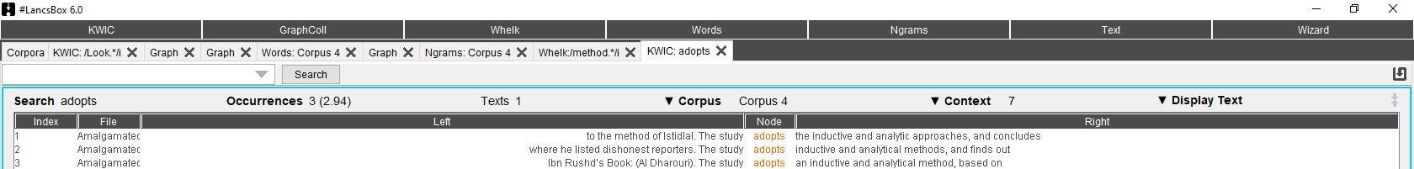
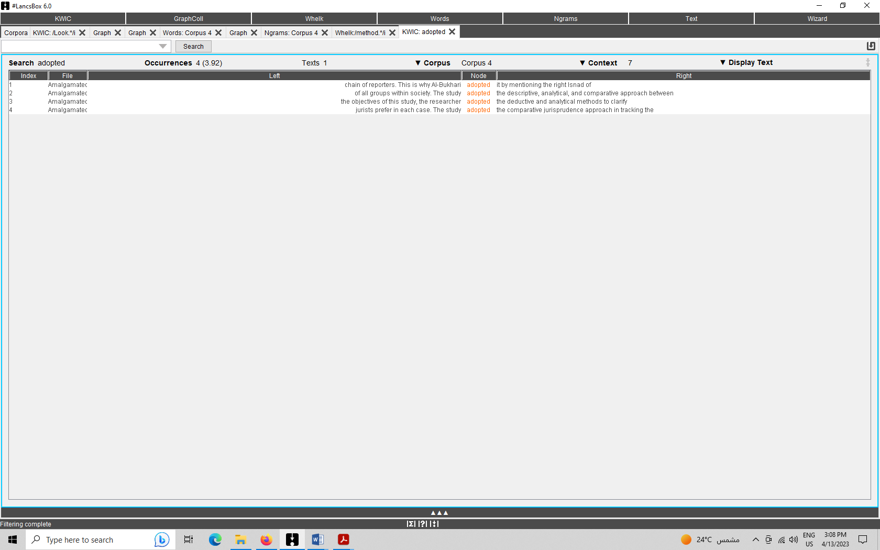
Figure 2. #LancsBox result of method move using ‘adopt’ lemma

One other major palpable aspect in this moves analysis is how few abstracts featured the M-5 move, namely conclusion, which is reflective and is meant to interpret and/or extend results beyond the scope of the paper, draw inferences, point to applications or wider implications (Table 2 above). Just 4 of the 51 Arabic abstracts in the corpus offered a tangible conclusion of any type. This is particularly remarkable because scholars specialized in Islamic disciplines, especially tend to opt for a rhetoric of assertive and interpretive judgments that can be attributed to the culture’s long tradition of commentary and textual exegesis (Alharbi and Swales, 2011). This is yet another aspect of adopting the new globalized format at the expense of cherished old ways of text production.
Further, it has been observed that certain abstracts in the corpus give a table of contents of the article (like in Example 1) rather than a genuine abstract with clearly identified and well-defined movements, although presenting weakly discernible evidence of structural changes. This can be a result of inadequate instruction in this type of writing.
This research makes it obvious that the global model has had a significant impact on abstract writing in Islamic fields of study and that few of the traditional textual traditions have permeated this newly developed genre. In light of this, one would assume that this type of writing is readily comprehensible by academics all over the globe. There are still several issues, though, that seriously jeopardize comprehensibility and may well defeat the purpose.

Comprehensibility at stake

We have so far only dealt with the 51 original Arabic abstracts, but a careful examination of the English translations of these abstracts may disclose a completely different tale and lead to a different conclusion.
The journals at hand follow different policies as to how these translations are delivered. Some employ their own English native, near-native speakers to carry out these translations instead of the authors, namely, J1 and J4 (personal communication). Others, representing an English-proficient institution, like the UAE-based Sharjah University, naturally set the translation standards higher than average, and thus their translated abstracts reflect better English as does J2. Yet another sizable portion of Islamic journals leaves the authors to their means to provide translations for these abstracts which more often than not result in poor quality, machine translation-like output, e.g., J3. That the journal is indexed, does not automatically guarantee the quality of the translation. The following abstract (Example 2) serves as an illustration for this point:

Original Translation | Revised Translation
Sheikh Mustafa Sabri’s position on the belief of the modern mental school in the judiciary and fate  This research dealt with the allegations of modern mental school in the judiciary and fate, and  demonstrated their shameful attitude to the doctrine of justice and fate - the sixth pillar of faith -  following the campaign promoted by orientalists against the doctrine of justice and fate; in which they  claimed that the reason for Muslims' delay was a belief in fate and a cause of laziness, lethargy and unemployment s role in responding to them and the suspicions raised by them and influenced by some  religious scholars’ doctrine, the research concludes by calling on scientists to revive the doctrine of the judiciary and its considerable impact and motivation to pursue and act with an understanding of its companionship. | Position of Sheikh Mustafa Sabri Regarding Modern Rationalistic School's Beliefs on the Subject of Predestination  This research dealt with the allegations of the modern rationalistic school regarding the issue of predestination. It demonstrated their shameful attitude to the doctrine of predestination – the sixth pillar of faith (Imān) –  following the campaign promoted by orientalists against the doctrine of predestination in which they  claimed that the reason for the Muslims’ backwardness was their belief in fate which proved to be a cause of laziness, lethargy and unemployment. Therefore, the secret behind their advancement is to rid themselves of believing in fate.  The paper explains Sheikh Mustafa Sabri’s stand and role in responding to them and the calumny they raise which even influenced some  Muslim religious scholars. The research concludes by calling on scholars to realize the doctrine of predestination bearing in mind its considerable impact on motivation to engage in hard work as much as the Companions and their Fallowers understood it.

The translation of this abstract is of such bad quality that it is scarcely understandable. Although the improved version is not the final one (for instance overlooking sentence structure, redundancy and unclearness), it goes on to show that a more careful translation would have, at least, managed to get the message across. These and other comparable errors that can be identified in the corpus are shown in the following table:
Arabic phrase | Translations found in the corpus | Correction
المدرسة العقلية | Mental school | (pseudo) Rationalistic school
القضاء والقدر | Judiciary and fate | Fate and predestination
باب السماع | The chapter on hearing | The issue of listening (to music)
تحقيق المخطوطات | The realization of manuscripts | Manuscript editing
رزق القاضي | Judge’s decision | Judge’s wages
مروي بالوجادة | Reported through al-wijādah | Reported through having a verified writing by the earlier narrator (al-Wijādāh)
الاستدراك الأصولي | Fundamentalist criticism | Jurisprudential appraisal
مشكل القراءات | The different ways of reciting the Qur’an | Knotty issues arising from difference in modes of Qur’anic reading
دقائق المعاني | Meticulous meanings | Subtle meanings
مقاصد الشريعة | Islamic concept | Overall objectives of Islam
التشريك (بين الجد والإخوة) | socialization between grandfather and brothers | The grandfather and brothers partaking in inheritance.
سد الذريعة | Filing pretext | Prohibition of evasive legal devices
شرط الاعتقاد | Standard Faith | The criterion of firm belief
شرك العبادة | The trap of worship | Association in acts of worship
المناسبة (علم قرآني) | Occasion | Relevance (in the Qur’an)
القياس (الفقه) | Measurement | Deductive analogy (al-Qiyās) (jurisprudence)
العقوبات والكفارات | Sanctions and expiations | Penalties and atonements
فقه النوازل المعاصرة | Jurisprudence of calamities | Jurisprudence of modern-day issues
التنظير | Endoscopy | Theorizing
المشترك اللفظي | Verbal subscribers | Polysemy
Table 5: Examples of mistranslated Islamic jargon

Research has demonstrated that academics use machine translation to do this duty when left to their own devices and without having their manuscripts reviewed by the journals to which they submit them. (cf. Tongpoon-Patanasorn and Griffith, 2020; Dahmash, 2020; Suryani and Fitria, 2022; Alamri and Al-Amri, 2023).
It follows from this that the translations in the corpus under study take on a literal approach and thus by undiscerningly reflecting the unaltered author’s voice, they stand accused of a lack of connection with the target audience. Following conventional sentence construction and text-building techniques that do not translate well and failing to take this into consideration when translating for a global audience will only make the situation worse. In fact, the corpus of this study reflects many of the problems identified in Khoshafah (2018), such as lengthy, complicated sentences, repetition, ambiguity, and repetition. Some abstracts are found to be very long and contain a lot of redundant details; others are laconic and provide hardly any information. This idea is shown in the example that follows (Example 3):

Standard Faith for Polytheism in Worship
The unification of divinity (worship) includes deism, so who believes in God Almighty with acceptance and consent, his place of benefit and harm is necessary, and, on the contrary, that the polytheism of the deity is also a polytheist in the deism, and hence deity is closely related to the trap of worship, i.e., there is no polytheism except with the belief of benefit and harm. This is true in terms of origin and the normal state, in which worship is based on consent and acceptance, and in which there is harmony between the visible and the invisible, but each origin has an exception, and the normal state may be reversed, so there may be a discrepancy between the visible and the invisible. Then, it is possible to imagine a trap - and worship - without believing in benefit and harm, so one engages in divinity - and unites - without believing in deism. An example of this is the one who worships God alone with the intention of agreeing to the familiarity, the habit, and the fathers, not with the belief of benefit and harm, and this can be explained in that if his preacher changes, he abandons worship. A group of polytheists knew the truth of the Prophet, may God’s prayers and peace be upon him, and they did not follow him just because they hated violating the customs of their fathers: {Rather, they say, Indeed, we found our fathers upon a religion, and we are in their footsteps [rightly] guided} [Az-Zukhruf: 22]. These people certainly did not hope in their polytheism any benefit or harm from their idolaters, but they knew that this is not the case, where many polytheists worshiped it thinking that it is so. In this research, we study and investigate the meaning of polytheism by going through the following topics: Introduction: Worship between Sunnah and Marjaa. First: the infidelity. Second: polytheism. Third: the truth about polytheism. Fourth: The truth of the trap of worship. Fifth: The words of scholars in the trap of worship. The conclusion then contains a summary of what was released and investigated in the matter.

Two experiments and a text analysis of 1,640 articles in marketing journals, showed that scholars write unclearly in part because they forget that they know more about their research than readers, a phenomenon called “the curse of knowledge.” Knowledge, or familiarity with one’s own research, exacerbates three practices that make academic writing difficult to understand: abstraction, technical language, and passive writing (Warren et al., 2021). It is often believed that this kind of less interactive rhetoric can make considerable processing demands on the part of readers, especially for those unaccustomed to this style of writing. In contrast, English-using academic cultures are generally considered to prefer a more interactive ‘reader-friendly’ rhetoric, with shorter sentences, ample rhetorical clues, and structural devices such as metadiscoursal labeling and step-by-step sequencing, all of which are thought to assist the reader (Duszak, 1997; Tardy, 2004; Yakhontova, 2003).
Graetz (1985) studied English-language abstracts from a range of subjects. As a result, she says:

The abstract is characterized by the use of past tense, third person, passive, and non-use of negatives. It avoids subordinate clauses, uses phrases instead of clauses, words instead of phrases. It avoids abbreviations, jargon, symbols and other language structures which might lead to confusion. It is written in tightly worded sentences, which avoid repetitions, superlatives, adjectives, illustrations, preliminaries, descriptive details, examples, footnotes.
(Graetz, 1985: 125, cited by Swales, 1990)

It must be remembered that scholarly registers of various languages do differ according to culture. When translating, these discrepancies should be taken into account. It is anticipated that the translated abstracts would depart from the original texts in some way given the probable disparities between distant languages at all levels. However, because translation occurs across languages with asymmetric relationships (English vs. Arabic) and because of the overtly literal translation technique, it turns out that a new sort of “diglossia” is produced through these translated abstracts (Calaresu, 2011; Peterlin and Južnič, 2020). In translation studies, this type of translation product is often called “translationese” which distinctly demonstrates awkwardness and unidiomaticity, a cross between the two languages involved (Zhang and Toral, 2019).
One telling example of this is the use of “May Allah/God have mercy on him/her” as a standard translation for the expression “رحمه الله”. This expression is particularly heavily used is Islamic discourse to pay homage to a deceased, usually a scholar, who merits respect. The phrase “May God have mercy on him” is a correct and usable phrase in written English. Yet it is often used to express sympathy or regret for someone who has done something wrong or is suffering a difficult situation. For example, “John was so kind and generous - may God have mercy on him.”; “May God have mercy on our Congress,” said a leader who condemned the measure” (cf. Ludwig.guru). However, is never pragmatically used for the same purpose indented by the Arabic phrase and its literal translation. A more idiomatic translation would be to say: “the late” and name the person, to put “May he rest in peace” after the name, to put the date of death after the name i.e. so-and-so (d. 860), or simple taking a generic view and not translating it at all knowing that it is not the agreed convention in English academic writing to follow the names of the deceased with such honorific expressions.
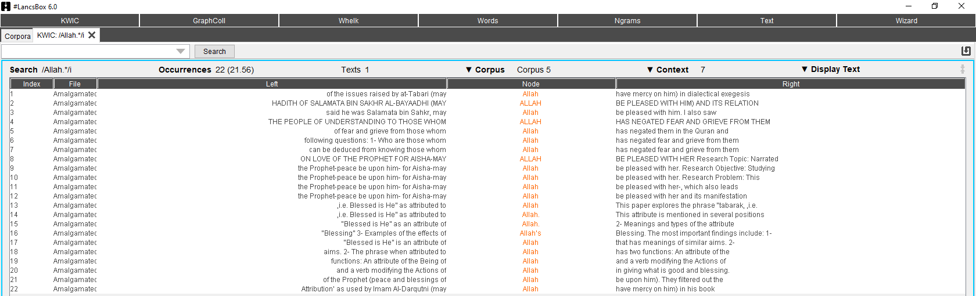
Figure 2. #LancsBox use of honorific expressions is translated religious abstracts

The lack of a standard dictionary for specialized Islamic branches of knowledge (Quran, Sunnah, Fiqh, ʿAqdah) and a culture-specific lexicon from which translators can draw, further exacerbates the translator’s predicament (cf. El-Zeiny, 2017; Almarwaey and Ahmad, 2021). The results are, at best, non-standard discretional/idiosyncratic translations, high use of transliteration, and/or translations that are inadequate or flat-out incorrect (see Table 5 above). This further complicates this field of study and puts it at a remove from its larger global audience.
This implies that a more involved strategy must be taken when translating research abstracts of Islamic studies as a whole. Such an approach must be in keeping with the target academic community’s preferred writing style as well as its macro discursive practices. Their linguistic expectations are so satisfied. According to House (1977), a translated informative text must adhere to target-language criteria for both the register and the content schema in order to successfully communicate. Readers of abstracts anticipate being able to quickly access certain bits of information that give them the broad strokes of the topic at hand.

Concluding remarks

In order to determine whether the translation of academic religious articles abstracts satisfies the discursive practices and generic conventions of the receptive community, this study examined the main discursive characteristics of scholarly religious writings in the Arab world as well as the institutional frameworks that shape them. Additionally, it meant to draw attention to the factors that influence the convergence or the divergence of these norms as adopted by West vs. East discourse communities.
Drawing on a sample corpus of articles from peer-reviewed academic publications specialized in Islamic fields of study, it is demonstrated how the forces of globalization, which push English to become the standard scientific language, have affected even this incredibly traditional field of study. This is especially apparent in how it reflects the conventions of academic abstract writing, which suggest that in order for this type of text to effectively communicate, certain macro moves must be undertaken.
This general practice is a step in the direction of promoting such research and making it accessible to a larger global population, especially when combined with the initiative to have these journals reviewed and indexed, which requires that translation of the abstract be supplied with each submission. However, there are significant cultural challenges that have to be addressed in terms of text production and translation techniques. The Arabic flourishy writing style, as compared the more direct English writing style, is marked by repetitive style known as parallelism (cf. Beeston, 1974; Abdul-Raof, H. 2001; Mehawesh, 2013; Monassar, 2014). This feature is heightened in Islamic writings which are steeped in traditional oratory and reflect several characteristics of residual orality (cf. Ong, 1982; Hatim, 2004). Not promoting the epistemic practice of grafting an English style over original Islamic writings, yet the translation has got to be aware of it and, in turn, try to tone it down for the benefit of serving the purpose for which it is initiated.
Overall, the findings of this research are applicable to writing and translation since it is desirable to make use of the standard textual rules and patterns when dealing with this type of text. Such knowledge may be useful when it comes to developing materials for translator training, in addition to helping newcomers to the academic discourse community who struggle to generate short and coherent abstracts.

References

Abdul-Raof, H. (2001) Arabic Stylistics: A Course Book, Harrassowitz Verlag, Wiesbaden.
Al Zumor, A. (2021), “Exploring Intricacies in English Passive Construction Translation in Research Articles’ Abstracts by Arab Author-Translators”, SageOpen, September, pp. 1-11
Al-Ali, M. and Alliheibi, F. (2015), “Struggling to retain the functions of passive when translating English thesis abstracts”, Pragmatics, Vol. 25 No 2, pp.129–148.
Alamri, H. and Al-Amri, A. (2023), “Arabic-English Machine Translation (MT) Quality: Exploring Researchers’ Perspectives and Challenges”, Proceedings of the 14th International Multi-Conference on Complexity, Informatics and Cybernetics (IMCIC 2023), pp. 176-182.
Alharbi, L. and Swales, J. (2011), “Arabic and English abstracts in bilingual language science journals: Same or different?” Languages in Contrast, Vol. 11 No. 1, pp. 70–86.
Alhuqbani, M. (2013), “Genre-based analysis of Arabic research article abstracts across four disciplines”, Journal of Educational and Social Research, Vol. 3 No. 3, pp.371-382.
Almarwaey, A. and Ahmad, U. (2021), “Semantic change of hijab, halal and islamist from Arabic to English”, 3L The Southeast Asian Journal of English Language Studies, Vol. 27 No.2, pp. 161-176
Ammon U. (2001), The Dominance of English as a Language of Science Effects on Other Languages and Language Communities, De Gruyter Mouton, the Hague.
Beeston, A. (1974), “Parallelism in Arabic Prose”, Journal of Arabic Literature, Vol. 5, pp. 134-145.
Bennet, K. (2007), “Epistemicide! The Tale of a Predatory Discourse”, S. Cunico and J. Munday (Eds.) Translation and Ideology, special issue of The Translator, Vol. 13 No. 2, 2007. 151-169.
Bhatia, V. (1993), Analyzing genre: Language use in professional setting, London Group: London and New York.
Calaresu, E. (2011), “The declining status of Italian as a language of scientific communication and the issue of diglossia in scientific communities”, International Journal of the Sociology of Language, Vol. 210, pp. 1-16.
Carolia, D. and Baihaqi, A. (2019), “Translation Procedures in Translating Abstracts of Postgraduate Students of Sultan Ageng Tirtayasa University”, Journal of English Language Teaching and Cultural Studies, Vol. 2, No. 1, pp. 25-38.
Cava, A. (2011), “Abstracting science: A corpus-based approach to research article abstracts”, International journal of language studies (IJLS), Vol. 5 No. 3, pp. 75-98.
Cheng, H. (2020) “Strategies on Chinese-English Translation of Abstracts of Medical Papers”, DEStech Transactions on Social Science, Education and Human Science (https://dpi-journals.com/index.php/dtssehs/article/view/34814).
Clyne, M. (1987) “Cultural differences in the organization of academic texts”, Journal of Pragmatics, Vol. 11, pp. 211–247.
Clyne, M. (1987), “Cultural differences in the organization of academic texts: English and German”, Journal of Pragmatics, Vol. 11, pp. 211−247.
Čmejrkova S. (1994), “Non-native (academic) writing”, S, Čmejrkova, F. Daneš, E. Havlova (Eds.), Writing vs speaking: language, text, discourse, communication. Gunter Narr Verlag: Tubingen, pp. 303−310.
Cmejrkova, S. (1996), “Academic writing in Czech and English”, E. Ventola and A. Mauranen (Eds.), Academic writing: intercultural and textual issues, John Benjamins, Amsterdam, pp. 137–153.
Crystal, D. (1997) English as a global language. Cambridge: Cambridge University Press.
Dahmash, N. (2020), “I can’t live without Google Translate: A close look at the use of Google Translate App by second language learners in Saudi Arabia”, Arab World English Journal, Vol. 11 No. 3, pp. 226–240.
Duszak, A. (1997) “Cross-cultural academic communication: A discourse-community view”, A. Duszak (Ed.)
Culture and Style of Academic Discourse, Mouton de Gruyter: Berlin, pp. 11–39.
Elbadri, M. (1999), A Contrastive Study of the Discourse of English and Arabic Theses’ Abstracts, Advanced Master’s graduation paper, IIUM, Malaysia.
El-Zeiny. I. (2017), “Lexicographic approaches to bridging the lexical gap in translating Islamic Juristic Terms/Concepts into English”, International Journal of Lexicography, Vol. 30 No. 2, pp. 187–224,
Escudero, M. and Swales, J. (2011), “Tracing convergence and divergence in pairs of Spanish and English research article abstracts: The case of Ibérica”, Ibérica, Vol. 21 No. 21, pp. 49–70.
Eybers, O. (2022), “Can Academic Writing Transform Epistemicide to Emancipation?”, International Journal of Educational Organization and Leadership, Vol 30. No. 1, pp. 1-13.
Fakhri, A. (2012), “Nominalization in Arabic discourse: A genre analysis perspective”, R. Bassiouney, E. Katz, (Eds.), Arabic language and linguistics, Georgetown University Press, Georgetown, pp. 145–156.
Hamel. E. (2007), “The dominance of English in the international scientific periodical literature and the future of language use in science”, AILA Review, Vol. 20, N. 1, pp. 53–71.
Hatim, B. (2019) Communication Across Cultures: The Linguistics of texts in Translation, Exeter University Press: Exeter.
Hind M. (1989) “Foreign language abstracting”, C. Picken, (Ed.) The translator’s handbook (2nd ed.), London: Aslib, pp. 350−352.
House J. (1977), A model for translation quality assessment, Gunter Narr Verlag, Tubingen.
Huckin, T. (2001) “Abstracting from abstracts”, M. Hewings, (Ed.) Academic writing in context: Implications and applications. Papers in honour of Tony Dudley-Evan, The University of Birmingham University Press, Birmingham, pp 93-105.
Hyland, K. (2000), Disciplinary Discourses. Social Interactions in Academic Writing, Longman/Pearson Education, Essex.
Kaddoura, A. (2009), The Interpersonal Function in Arabic to English Translation of Personal Growth Religious Discourse, MA Dissertation. Sharjah University.
Khoshafah, A. (2018), “Difficulties of translating Arabic MA and PhD theses abstracts into English: A case study of Ibb University”, MA dissertation, Al-Andalus University for Science and Technology, Yemen.
Kramsch, C. and Thorne, S. (2002), “Foreign language learning as global communicative practice”, D. Block and D. Cameron (Eds), Globalization and language teaching, Routledge, London, pp. 83–100.
Kubota, R., and Lehner, A. (2004), “Toward critical contrastive rhetoric”, Journal of Second Language Writing, Vol. 13 No. 1, pp. 7–27.
Kyrychuk, L. (2019), “Strategic Approaches to Academic Paper Abstract Translation”, Research Trends in Modern Linguistics and Literature, Lutsk: Lesya Ukrainka Eastern European National University, Vol. 2, pp. 65–76.
Li, Y. (2011), A genre analysis of English and Chinese research article abstracts in linguistics and chemistry. Unpublished master thesis, San Diego State University, San Diego, USA.
Lorés, R. (2004), “On RA abstracts: From rhetorical structure to thematic organization”, English for Specific Purposes, Vol. 23 No. 3, pp. 280-302.
Martin, P. (2003), “A genre analysis of English and Spanish research paper abstracts in experimental social sciences”, English for Specific Purposes, Vol. 22 No. 1, pp. 25-43.
Masaka, D. (2017) “Challenging epistemicide through transformation and Africanisation of the philosophy curriculum in Africa”, South African Journal of Philosophy, pp. 441-455.
Mehawesh, M. (2013) “Grammatical Parallelism in the Translation of Advertising Texts with Particular Reference to English and Arabic”, Asian Social Science, Vol. 9 No. 10, pp. 254–263.
Melander, B., Swales, J., and Fredrickson, K. (1997), “Journal abstracts from three academic fields in the United States and Sweden: National or disciplinary proclivities?” A. Duszak (Ed.), Culture and style of academic discourse, Mouton de Gruyter, New York, pp. 251–272.
Monassar, H. (2014), “Parallelisms in Arabic: Morphological and Lexical, Syntactic, and Textual”, International Journal for Innovation Education and Research, Vol. 2 No.11, pp. 68–87.
Moten, A. (1998), A Guide to Research Proposals and Theses Presentation, International Islamic University Malaysia, Kulliyyah of Islamic Revealed Knowledge and Human Sciences.
Ong, W. (1982) Orality and Literacy: The Technologizing of the Word, Routledge: New York.
Pérez-Llantada, C. (2012), Scientific discourse and the rhetoric of globalization: The impact of culture and language, Continuum, London.
Peterlin, A. and Južnič, T. (Eds.) (2020), Academic writing from Cross-cultural Perspectives, Ljubljana University Press, Ljubljana.
Pezzine, O. (2003), “Genre analysis and translation - An investigation of abstracts of research articles in two languages”, Capa, Vol. 2, No. 12, pp. 75-108.
Pezzini, O. (2003), “Genre analysis and translation: An investigation of abstracts of research articles in two languages”, Cadernos de traduçao, Vol. 2 No. 12, pp. 75–108.
Piqué-Noguera, C. (2012), “Writing business research article. abstracts: A genre approach”, Ibérica, Vol. 24, pp. 211-232.
Price, J (2021), “Translation as epistemicide: conceptual limits and possibilities”, Palimpsestes, Vol. 35, pp. 143-155.
Rowley-Jolivet, E. and Carter-Thomas, S. (2005), “Genre awareness and rhetorical appropriacy: manipulation of information structure by NS and NNS scientists in the international conference setting”, English for Specific Purposes, Vol. 24, pp. 41−64.
Samraj, B. (2005), “An Exploration of a genre set: Research article abstracts and introductions in two disciplines”, English for Specific Purposes, Vol. 24, pp. 141-156.
Santos, Boaventura de Sousa (2006) Democratizing Democracy: Beyond the Liberal Democratic Canon (Reinventing Social Emancipation: Towards New Manifestos), Verso Books, New York.
Santos, M. (1996), “The textual organization of research paper abstracts in applied linguistics”, Text, Vol. 16 No. 4, pp. 481-499.
Santoyo, J. (2010), “Translation and cultural identity: Competence and performance of the author-translator”, M. Muñoz-Calvo, C. Buesa-Gomez, (Eds.), Translation and cultural identity: Selected essays on translation and cross-cultural communication, Cambridge Scholars Publishing, Cambridge, pp. 13–32.
Schaffner, C. (2000), “The role of genre for translation”, A. Trosborg (Ed.), Analysing professional genres, John Benjamins, Amsterdam, pp. 209−223.
Suryani, N. and Fitria, T. (2022), “Error Analysis of Abstract Translation in Scientific Writing by Using Google Translate”, JETAL Journal of English Teaching & Applied Linguistic, Vol. 3 No. 2, pp. 33–40.
Suryani, N. and Fitria, T. (2022), “Error Analysis of Abstract Translation in Scientific Writing by Using Google Translate”, Journal of English Teaching and Applied Linguistics (JETAL), Vol. 3 No. 2, pp. 33-40.
Swales, J. and Feak, C. (2009), Abstracts and the writing of abstracts, University of Michigan Press, Ann Arbor, MI.
Swales, M. and Fredrickson, M. (1997), “Journal abstracts from three academic fields in the United States and Sweden: National or disciplinary proclivities?” A. Duszak (Ed.), Culture and style of academic discourse, Mouton de Gruyter, New York, pp. 251-272
Tardy, C. (2004), “The role of English in scientific communication:
lingua franca or Tyrannosaurus rex?” Journal of English for Academic Purposes, Vol. 3, pp. 247–269.
Taylor, G. and Chen, T. (1991) “Linguistic, cultural, and subcultural issues in contrastive discourse analysis: Anglo-American and Chinese scientific texts”, Applied Linguistics, Vol. 12, pp. 319–336.
Tongpoon-Patanasorn, A. and Griffith, K. (2020), “Google translate and translation quality: A case of translating academic abstracts from Thai to English”, Pasaa, Vol. 60 No. pp. 134–163, 2020.
Van Dijk TA. (1980), Macrostructures, Lawrence Erlbaum, Hillsdale, NJ.
Ventola, E. (1994), “From syntax to text-problems in producing scientific abstracts in L2”, S. Cmerjkova and F. Sticha (Eds.), The syntax of sentence and text: A festschrift for Frantisek Danes on his 75th birthday, John Benjamins, Amsterdam, pp. 283–303.
Venuti, L. (1995) The Translator’s Invisibility: A History of Translation, Routledge: London.
Warren, N., Farmer, M., Gu, T. and Warren, C. (2021), “Marketing Ideas: How to Write Research Articles that Readers Understand and Cite”, Journal of Marketing, Vol. 85 No. 5, pp. 42–57.
Yakhontova, T. (2003), English Academic Writing for Students and Researchers, Pais.
Zhang, M. and Toral, A. (2019), “The effect of translationese in machine translation test sets”, WMT 2019 - 4th Conference on Machine Translation, Proceedings of the Conference, pp. 73–8.

Dr. Waleed Bleyhesh al-Amri
Associate Professor of Translation Studies
Department of Languages and Translation
Taibah University, Saudi Arabia

In SKASE Journal of Translation and Interpretation [online]. 2023, vol. 16, no. 1 [cit. 2023-07-30]. Available online at http://www.skase.sk/Volumes/JTI24/pdf_doc/02.pdf. ISSN 1336-7811

Acknowledgement: This study is funded by the Literature, Publishing, and Translation Commission, Ministry of Culture, Kingdom of Saudi Arabia, as part of the Arabic Observatory of Translation.

