Multimodal Analysis of James Bond Film Trailers (Based on “On Her Majesty’s Secret Service,” “The Living Daylights” and “007: Skyfall”)
Mariia Rudenko, Sumy State University, Ukraine

Abstract
The primary function of a film trailer is to advertise the film it represents and to create a compelling first impression that persuades audiences to view the film. This paper examines how various multimodal elements — including visual imagery, verbal dialogue, sound effects, and musical scores — contribute to a more immersive viewer experience and enhance emotional resonance and cognitive processing, thereby shaping audience perceptions of the film. The research employs qualitative analysis of selected trailers from the James Bond franchise. Through thematic analysis, this study aims to elucidate the significance of multimodal strategies in trailer production, ultimately providing insights into effective marketing practices within the film industry. By emphasizing the integration of diverse communicative components, this research seeks to advance the discourse on film marketing and narrative construction.

Keywords: film trailers, visual imagery, verbal dialogue, dynamic music, implicit context, multimodal texts, peak.

1 Introduction

The origins of film trailers can be traced back to 1913, when Nils Granlund, the advertising manager for Marcus Loew Theatres, innovatively spliced together rehearsal footage from the Broadway play The Pleasure Seekers into a brief promotional montage that screened after feature films. This marked the inception of the trailer industry, which at the time was rudimentary, as it was primarily managed by theatres and studios without fully leveraging the commercial and creative potential of trailers. The landscape shifted significantly in 1919 with the establishment of the National Screen Service by Herman Robbins. This company provided an outsourcing solution for theatres and studios, enabling them to delegate the creation of trailers. Robbins’ venture expanded the concept of trailers, allowing for more sophisticated marketing strategies and stylistic developments in the promotion of films (DiStefano 2015).
Films serve as one of the most compelling media for storytelling. The essential strategy for effective marketing lies in their emotional branding. Certain trailers succeed in capturing audience interest and inciting a desire to view the film, while others may fall short, failing to leave a lasting impression and becoming easily forgotten by consumers. This disparity in effectiveness highlights the importance of crafting trailers that not only convey the narrative essence of the film but also resonate emotionally with the target audience (Finsterwalder et al. 2012: 589-590).
When modelling the structure of film discourse, two distinct levels of communication must be considered. The external level encompasses the interaction between the collective author and the audience, whereas the internal level pertains to the dialogue among characters within the film. To facilitate this analysis, it is worth differentiating between ectocomponents and entocomponents. Film trailers are categorized as ectocomponents since they are products of communicative activities that possess inherent meaning and semiotic significance. As ectocomponents, trailers are relatively complete and concise, with a primary focus on serving an advertising function (Shcherbak 2022: 54).
Film trailers have transitioned from simple promotional materials to complex multimodal texts that seamlessly integrate visual, auditory, and linguistic elements. As critical components of film marketing, these trailers not only shape audience expectations but also reflect and influence broader cultural narratives within the cinematic landscape. By employing a range of communicative modes — such as imagery, sound design, and textual cues — they engage viewers on multiple levels, eliciting emotional responses and fostering anticipation.
This paper aims to explore the distinctive characteristics of film trailers as multimodal texts, analyzing the application of key theoretical frameworks and the significance of iconic elements in modern cinema. By way of a case study, the aim of this study is to explore the impact of multimodal communication in film trailers for spy movies on audience engagement and understanding. Explicitly, the research focuses on how the effective integration of various modes of communication, such as visual imagery, verbal dialogue, sound effects, and musical scores, enhances the viewer's emotional engagement and cognitive processing. By investigating these elements, the study seeks to provide insights into multimodal strategies in creating compelling narratives that resonate with audiences, thereby contributing to more effective film marketing practices.

2 Literature review
A significant part of a film’s social circulation is defined by its production as a commodity, initiated by the industry of which it is a part. A film’s commercial status is more than a matter of money of profit. Film circulates as a product, not in a semantic vacuum, but in a mass-cultural environment teeming with related commercial significations (Klinger 1989: 5). Regardless of the genre of the broadcasted mass media (whether it is thriller, detective, comedy, etc.), most of them are intended to entertain the audience (Fekete 2017: 188). Although the main purpose and function of advertising is marketing (commercial), which is related to the promotion of the film product on the market, the trailer also performs an entertaining function; it draws attention to itself and to the film it presents. The trailer is a presentation of the film. It is a “microfilm” that reflects the best characteristics of the product and its genre (Fekete 2017: 188). Accordingly, if the trailer can entertain and thus interest the audience, the potential consumer expects the same reaction from the film product itself.
Trailers are the product of communicative activity, which has its content and semiotic form and is characterized by relative completeness and brevity. The semantic scope of a trailer to a certain extent coincides with the essence of the concept of “advertisement”, which is modelled in marketing by the acronym AIDA, where A – Attention (attracting attention), I – Interest (excitement of interest), D – Desire (activation of desire), A – Action (incitement to action) (Shcherbak 2022: 55).
Trailers are a form of advertising, but they are also a unique form of narrative film exhibition, wherein promotional discourse and narrative pleasure are conjoined (Kernan 2004: 1). According to Hixson, trailers are “clips of film that are shown prior to the featured movie, to advertise other movies” (Hixson 2006: 213-214). They are brief film texts providing a 1- to 3-minute cinematic experience that usually displays images from a specific film while emphasizing the quality; film trailers are created for screening in theatres to promote a film’s theatrical release (Kernan 2004: 1). Thus, film trailers are viewed as “samples” for moviegoers to decide whether they would like to purchase the film if the movie is from a genre they prefer, and they are an integral part of the cinema-going experience (Hixson 2006: 214). Kernan provides the analogy with “window shopping” where the audiences are “shopping” for films when trailers are presented as “free samples” of the films (Kernan 2004: 6). The main purpose of film trailer is to arouse the audience’s curiosity and expectations so that they could be persuaded to see the movie (Maier 2009: 159).
People have some expectations about what they will see when they go to the movies. Watching a trailer for the movie may play a role in a moviegoer’s demand for gratification (Hixson 2006: 211). According to Hesford, the characteristics of the trailer enable its multifaceted perception and indicate a cultural resonance that distracts the viewer from the specific commercial properties of traditional advertising. Thus, a culture of digressive reading positions film as a new form of cinematic expression, in which the negative associations with commercialism are transformed and used as a component of the performative effect, which provides implications for the further perception of the advertised film itself (Hesford 2013).
Nowadays, trailers are evolving from being assembled from discarded film footage to being created by specialized studios and trailer producers. This trend is called “Frankenstein,” which occurs when movie marketers work with production companies that make trailers for the movie. Thus, the marketers take several trailers made by multiple trailer production companies that have tested well and edit them together into a new trailer for the “Frankenstein” effect (Hixson 2006: 214). As a result, the product shall acquire a performative appeal in which the artistry of the presentation of the author’s composition and commercial manipulation are intertwined (Fekete 2017: 189).
According to Kress and van Leeuwen (2001), multimodality involves the integration of semiotic modes – such as image, language, sound, and gesture – into a cohesive discourse. Their framework, foundational for contemporary multimodal analysis, emphasizes that meaning is constructed not by a single mode but by the interrelation between them (Kress & van Leeuwen 2001).
The trailer’s dual function – as both advertisement and narrative – has been widely discussed (Maier 2009; Fekete 2017; Hesford 2013). Maier presents the idea of film trailer being “a multimodal text in which several semiotic modes are combined, and parts of texts created for other purposes are transferred, rearranged and supplemented in order to attain a promotional purpose” (Maier 2009: 159). The film trailer is a multimodal communicative artifact that combines diverse semiotic resources to achieve promotional and narrative purposes.
Film trailers mostly contain well-structured and well-selected shots, which inform and entertain potential audiences. Thus, the information conveyed in a film trailer has two contexts (Maier 2011: 144). The first context is implicitly promotional, which means that the information is relevant to characters and events. The second context is explicitly promotional, which covers information about the names of the file, directors, actors, and so on (Maier 2011: 144-145). The promotional information can be analysed in three dimensions (Maier 2009: 161). The first factor is verbal: oral information is relevant to the advertised movie; meanwhile, spoken information, including words, sentences, and conversation, also needs decontextualization. The second is visual: it includes shots, scenes, subtitles, and transition effects appearing in a film. The third factor is auditory: it refers to speech, music, and sounds and their effect in the film trailer (Xing 2022: 18).

3 Methodology

Film trailers and standard advertisements have some similarities (Finsterwalder et al. 2012):
1) they both contain similar messages that highlight the offer’s features; 2) they comprise slogans and brands; 3) they use the producer’s or manufacturer’s reputation as a level to increase the attractiveness of the offer.
On average, movie trailers range from approximately 1 to 3 minutes in duration, whereas full-length films typically last between 90 and 180 minutes. This results in trailers constituting roughly 1-3% of the overall film length. Trailers serve as a crucial marketing tool, designed to generate anticipation and foster an emotional connection with the audience. Their concise length is carefully curated to showcase the most engaging and visually captivating moments of the film, effectively stimulating curiosity without overwhelming the viewer. Such brevity allows for a focused presentation that encourages potential audiences to seek additional information about the film or attend its screening.

Table 1. Percentage ratio between the length of the movie and the trailer (based on 007 James Bond movies)
Name | Year | Length of the movie (mins) | Length of the trailer (mins.secs) | Percentage
Dr. No | 1962 | 109 | 3.21 | 2.94%
From Russia with Love | 1963 | 115 | 3.36 | 2.92%
Goldfinger | 1964 | 110 | 3.09 | 2.68%
Thunderball | 1965 | 130 | 3.10 | 2.38%
You Only Live Twice | 1967 | 117 | 3.19 | 2.72%
On Her Majesty’s Secret Service | 1969 | 142 | 3.49 | 2.45%
Diamonds Are Forever | 1971 | 120 | 3.39 | 2.78%
Live and Let Die | 1973 | 121 | 3.01 | 2.48%
The Man with the Golden Gun | 1974 | 125 | 3.26 | 2.6%
The Spy Who Loved Me | 1977 | 125 | 3.20 | 2.56%
Moonraker | 1979 | 126 | 3.44 | 2.73%
For Your Eyes Only | 1981 | 127 | 3.46 | 2.72%
Octopussy | 1983 | 131 | 3.28 | 2.5%
A View to a Kill | 1985 | 131 | 2.55 | 1.94%
The Living Daylights | 1987 | 130 | 1.30 | 1%
Licence to Kill | 1989 | 133 | 1.54 | 1.15%
Goldeneye | 1995 | 130 | 2.42 | 1.86%
Tomorrow Never Dies | 1997 | 119 | 2.30 | 1.93%
The World is not Enough | 1999 | 128 | 2.19 | 1.71%
Die Another Day | 2002 | 133 | 2.16 | 1.62%
Casino Royale | 2006 | 144 | 2.30 | 1.59%
Quantum of Solace | 2008 | 106 | 2.28 | 2.15%
Skyfall | 2012 | 143 | 2.33 | 1.61%
Spectre | 2015 | 148 | 2.41 | 1.62%
No Time to Die | 2021 | 163 | 2.36 | 1.44%

Table 1 illustrates that, on average, trailers for James Bond films occupy between 1% and 3% of the total film duration. This proportion is justified by various factors, including marketing effectiveness, psychological impact, standard industry norms, and audience expectations. The concise nature of these trailers is designed to maximize engagement and interest while adhering to established practices within the film industry. By maintaining this relatively brief duration, filmmakers can effectively capture viewer attention and generate excitement for the forthcoming film.
For this study, we have selected three film trailers: On Her Majesty’s Secret Service (Peter R. Hunt, 1969), The Living Daylights (John Glen, 1987), and Skyfall (Sam Mendes, 2012).These trailers were chosen to represent distinct eras in the James Bond franchise: the 1960s, 1980s, and 2010s, featuring different actors as Bond (George Lazenby, Timothy Dalton, and Daniel Craig, respectively) and varying lengths, enabling diachronic analysis of multimodal evolution in trailer production. This selection facilitates an in-depth examination of changes over time, though the narrow corpus of three trailers is acknowledged as a limitation that may restrict broader generalizations about the franchise; future research could expand the sample for greater representativeness. Among these, the first trailer is the longest, with a duration of 3 minutes and 49 seconds, while the second trailer is the shortest at 1 minute and 30 seconds. We have analysed the data gathered from these trailers through three dimensions: verbal, visual, and audial.
To ensure analytical reproducibility, the trailers were segmented according to Maier’s four-stage model: prologue, orientation, complication, and evaluation. Each segment was annotated for verbal elements (e.g., dialogue, voiceover), visual elements (e.g., shots, imagery, transitions), and auditory elements (e.g., music, sound effects) using a qualitative thematic coding approach. Coding categories were derived iteratively from multiple viewings, with themes such as “conflict escalation” or “emotional arousal” emerging from data. Criteria for identifying “peaks” followed Thomsen and Heiselberg (2020), focusing on points of heightened arousal indicated by sudden increases in music tempo, shot pace, volume, or action intensity. Analytical decisions, such as classifying a scene as a “peak,” were based on these observable multimodal clues to maintain transparency and allow for potential replication.
4 Results
According to Maier, in an implicit promotional context, movie trailers can be understood to consist of four stages: prologue, orientation, complication, and evaluation (Maier 2011: 144). The implementation of a four-stage approach in the analysis of film trailers can be justified based on its comprehensive framework for narrative construction and audience engagement.
4.1 On Her Majesty’s Secret Service
The trailer for On Her Majesty’s Secret Service has a runtime of 3 minutes and 49 seconds, accounting for 2.45% of the overall duration of the film. An analysis of the trailer, utilizing Maier’s (Maier 2011) paradigm, is provided in Table 2.
Table 2. Analysis of the film trailer for On Her Majesty’s Secret Service
Stage | Time | Verbal | Visual | Audial
Prologue | 0:00 – 0:53 | Voiceover: describing the atmosphere with Bond  “An avalanche of action: bigger, better, different. Got to be, when he is around”; “Fabulous beauties, all of them dolls. everyone is different, they’ve got to be when he’s around”  Bond: “My name is Bond. James Bond” | 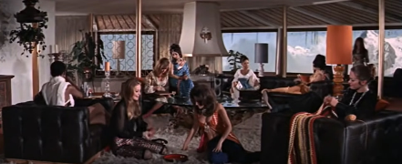  Representation of women sitting in one room  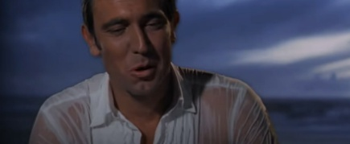  The first vision of the new James Bond | Sounds: avalanche, fireworks, sounds of a fight, the prologue of “James Bond Theme” by Monty Norman
Orientation | 0:54 – 1:43 | Voiceover: “The different Double-O-Seven”  “The different Bond from the same stake”  “Diana Rigg as a Countess, a different Bond woman. This one’s got class. And style” | 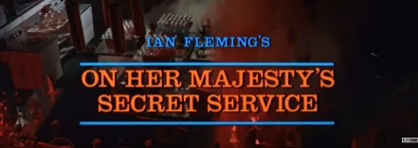  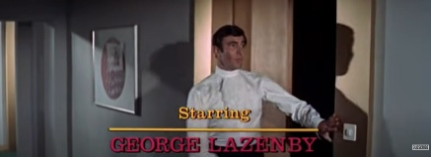  The movie title and the name of the original story’s author  George Lazenby starring as new James Bond | Sound: “James Bond Theme” by Monty Norman
Complication | 1:44 – 2:22 | Narrator: “The villains with a difference”  “Telly Savalas as Blofeld, a new destructive force”  Blofeld talking about his differences as a villain | 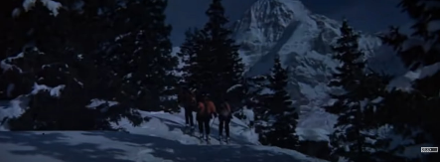  The villains  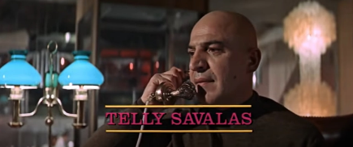  First glance on the main villain | Sounds: the shots of weapon, explosions.
Evaluation | 2:23 – 3:49 | Voiceover: “The creative skills of the cinema’s master filmmakers”; “If you think you know your Bond, think again. This one’s different. This one’s got hot” | 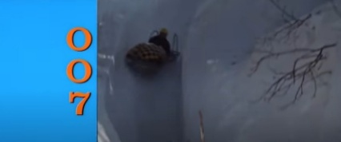  Using 007 sign  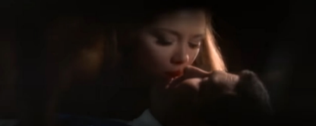  Bond with a woman  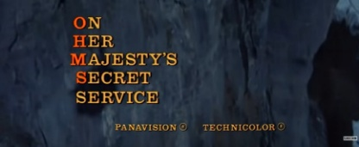  The title of the film | Sound: “All love in the world” by Louis Armstrong, “James Bond Theme” by Monty Norman

The movie trailer for On Her Majesty’s Secret Service presents a largely explicit context (Maier 2011), which means it is focused on actors, film crew, and main characters, primarily highlighting the “new era of Bond” represented by the introduction of George Lazenby as the iconic character. The term “different” is notably reiterated throughout the trailer in various contexts, suggesting the creators intend to emphasize the distinctive nature of the “new” James Bond.
The prologue stage is an optional opening stage in trailers, and it usually suggests the tone of the story and presents a representative situation that could trigger the story’s subsequent development (Maier 2011: 148). The trailer opens with a prologue designed to engage the viewer, beginning with imagery of an avalanche accompanied by a confrontation featuring Bond, although his face is deliberately obscured.
The prologue concludes with the introduction of Bond, who delivers his iconic line, “Bond. James Bond” effectively transitions the viewer to the orientation phase of the trailer. This second stage contextualizes the narrative for the audience, providing essential background information specific to this film (Xing 2022: 21). The whole context that is sketched in the orientation stage makes it possible to understand the rest of the trailer (Maier 2011: 149). The primary emphasis during this phase is on showcasing the actors in prominence. The narration persists within the overarching theme of the “new Bond”, continually reinforcing the concept of “different” that has been established throughout the trailer, as shown in example (1).

(1) Voiceover: The different Bond from the same stake. Diana Rigg as a Countess, a different Bond woman. This one’s got class. And style.

The third stage, complication, serves to introduce the central conflict of the film while offering additional detailed information about the narrative. This phase presents one or more actions that interfere with the main characters’ lives, thereby intensifying the stakes and complicating their circumstances (Maier 2011: 149). In this segment, the viewer is introduced to the primary antagonist, thereby directing attention to Bond’s imminent confrontation with Blofeld. This portion of the trailer features dynamic shootout scenes, enhanced by the auditory impact of gunshots, effectively creating a unique Bond atmosphere and fostering the viewer’s recognition of the spy genre.
The evaluation section interprets the events and their potential outcomes. It can provide not one but several clarifications and interpretations of what has been presented in the previous stage or the outcome of those events (Maier 2011: 150). In On Her Majesty’s Secret Service, the filmmakers are credited in a manner that showcases the film’s artistry, prominently featuring descriptors such as “marvellous” and “simply stunning”, which are cleverly crafted from the initial letters of the film’s title (see Figure 1). At this stage, the trailer refrains from providing clear interpretations of the outcomes; instead, it aims at cultivating an air of mystery and intrigue surrounding the film. This approach offers a subjective assessment of the film, positioning it within a certain context for the viewer, who must ultimately decide whether to engage with the film.
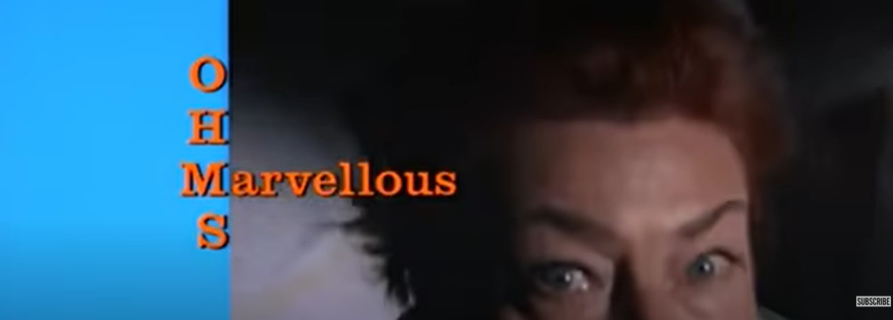
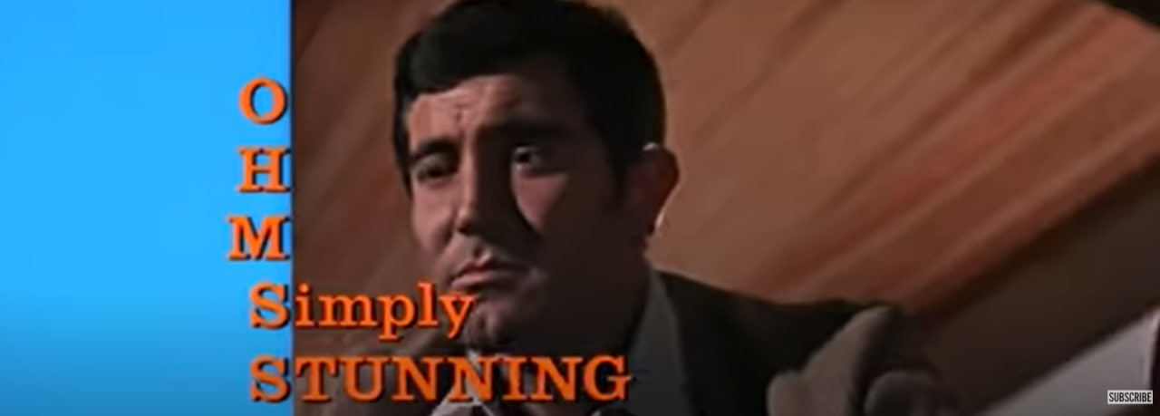
Figure 1. Screenshots from the trailer of On Her Majesty’s Secret Service, 1969.
4.2 The Living Daylights
The Living Daylights, released in 1987, is notable for possessing one of the shortest trailers among the episodes of the James Bond franchise. Short film trailers fulfill several critical functions that contribute to their effectiveness in marketing, including enhanced audience engagement, highlighting unique selling points, and fostering emotional connections through storytelling. By creating excitement and anticipation, trailers engage viewers and stimulate interest in the film. They serve to spotlight distinctive aspects of the film, with research indicating that trailers which effectively emphasize unique attributes are more likely to resonate with potential audiences.
Moreover, short trailers are adept at building emotional connections with viewers, utilizing powerful imagery and sound effects to evoke strong responses. As Garrett asserts, “a trailer, cut well, needs to arouse, provoke, seduce and beguile” (Garrett 2012). This highlights the necessity for trailers to balance information dissemination with intrigue; when they reveal excessive details, viewers may feel as though they have already experienced the narrative, thereby diminishing their motivation to watch the film. Consequently, trailers should cultivate a sense of promise and possibility, tapping into irrational and emotional impulses that invoke desire and necessity (Garrett 2012). Garrett also presents a structured approach to film trailers akin to a three-act narrative framework. Act One establishes the film’s characters and setting, Act Two complicates their world by introducing various obstacles, and Act Three escalates the conflicts, thereby intensifying the excitement, tension, or humour (Garrett 2012). This structural approach not only enhances the narrative flow of the trailer but also maximizes its impact on the audience, cultivating anticipation for the full film experience.
By adhering to this intrinsic three-act structure, trailers can effectively entice viewers while encapsulating the essence of the cinematic work they promote, ultimately serving as a compelling precursor to the films themselves.

Table 3. Analysis for the film trailer for The Living Daylights
Stage | Time | Verbal | Visual | Audial
Prologue | 0:00 – 0:18 | Voiceover: “The name that means excitement is back. Bond, James Bond.”  Bond: “Believe me, my interest in her is purely professional.” | 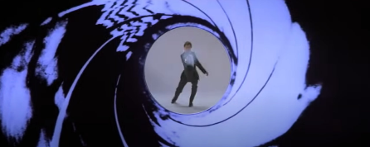  Classic appearance of James Bond  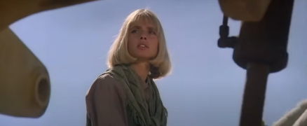  First appearance of a new Bond’s girl | “James Bond Theme” by Monty Norman, sounds of shooting
Orientation | 0:18 – 0:31 | Voiceover “Wherever he goes, adventure follows.” | 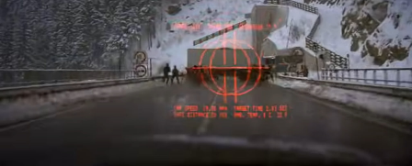  Bond and his new “adventure” | “James Bond Theme” by Monty Norman, sounds of explosion
Complication | 0:32 – 0:56 | Bond: “Two of our men are dead. Koskov’s named you.”  Pushkin: “Then I must die.”  Whitaker: “Kill him.” | 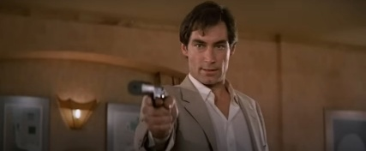  Bond with a gun  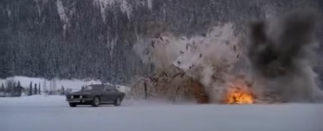 | “James Bond Theme” by Monty Norman, sound of explosion,  shooting
Evaluation | 0:57 – 1:29 | Voiceover: “He lives for danger. He lives for the moment. He lives on the edge.”  Bond: “Whoever she was, I must have scared The Living Daylights out of her.” | 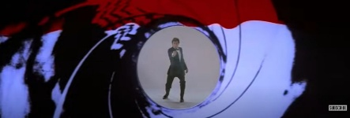  The blood effect on iconic Bond’s appearance  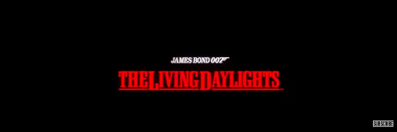  James Bond. 007. The Living Daylights | “James Bond Theme” by Monty Norman, sound of explosion, shooting

As shown in Table 3, the analysis of the trailer for The Living Daylights through the lens of Garrett’s narrative framework highlights the intricate structuring of cinematic trailers and their role in establishing character and themes within the film series. According to Garrett’s scheme, the prologue and orientation sections collectively constitute Act One of the trailers, wherein the introduction of the new James Bond, along with his new romantic interest, takes place. The iconic gun barrel sequence, a hallmark of the James Bond franchise, initiates this. This sequence, which is presented from the first-person perspective of a presumed assassin – effectively placing viewers in a position of agency – shows James Bond as he walks, turns, and ultimately shoots at the camera.
Notably, in the trailer for The Living Daylights, the initial portion of the gun barrel sequence occurs during the prologue, while a striking visual of a red blood wash — symbolizing the gunman’s bleeding — cascades down the screen during the evaluative phase, just prior to the final titles. This insight underscores the narrative and thematic significance of the gun barrel sequence, not merely as a stylistic flourish but as a fundamental component in establishing the visual and conceptual identity of the Bond films.
The complication segment of a film trailer serves as a critical juncture, often referred to as the “peak,” where the narrative tension and excitement reach a crescendo. Thomsen and Heiselberg (2020) articulate that a well-crafted film trailer typically employs a two-peak structure, featuring an initial peak occurring in the first half, preferably positioned early to capture the audience’s attention, and a subsequent peak towards the conclusion of the trailer. This structure is designed to optimize viewer engagement and sustain interest throughout the promotional piece. (Thomsen & Heiselberg 2020: 48). In The Living Daylights trailer, the transition to the first peak is facilitated using visual imagery and sound effects, particularly those invoking shooting and explosions. These elements serve to reinforce the action-packed nature of the film, prolonging the arousal experienced by viewers at this crucial moment. During this segment, the primary antagonists are introduced, enhancing the narrative stakes and heightening anticipation. The dialogue (2) within the trailer strategically employs a variety of synonyms for the term “kill,” thereby amplifying the dramatic effect and underscoring the menacing tone of the film. In the span of just six seconds, the trailer utilizes four distinct terminologies for “kill,” demonstrating a deliberate choice to enrich the emotional and thematic resonance of the narrative:

(2) Bond (00:32 – 00:34): Two of our men dead. Koskov named you.

Pushkin (00:35 – 00:36): Then I must die.

Koskov (00:36 – 00:37): Eliminate him.

Whitaker (00:38): Kill him!

From the orientation to the evaluation phase, the strategic selection of action shots engenders moments of heightened tension that benefit from tight framing, thereby accentuating conflict. The utilization of varied shot types facilitates visual storytelling by presenting fragmented glimpses that collectively suggest a broader narrative arc. The narrative arc can be categorized into four distinct stages: establisher (E) – which sets up an interaction without direct action; initial (I) – which initiates the tension within the narrative arc; peak (P) – which signifies the apex of narrative tension and the point of maximal event structure; and release (R) – which allows for the resolution of the tension (Cohn 2013: 421). While these categories follow a prescribed order, it is important to note that not all stages are requisite within a sequence. In the trailer for The Living Daylights, various dynamic shots depicting perilous situations encountered by Bond are observable, including scenes of a plane crash, the explosion of a house, shooting sequences, parachute jumps, stunt performances, and a bridge engulfed in flames.
As shown in Figure 2, the concluding line delivered by Bond in the trailer prominently features the film’s title. Following this sequence, the imagery transitions back to the initial shot characterized by the iconic gun barrel sequence, now enhanced by the visual motif of red blood overlaying the screen. The title is displayed prominently in the final shot, accompanied by the names of the actor portraying Bond, the original author of the story, and the filmmakers involved in the production of the film. This compositional choice not only serves to reinforce the film’s identity but also emphasizes the collaborative nature of its creation, linking the cinematic experience to both the character of Bond and the creative minds behind the project.

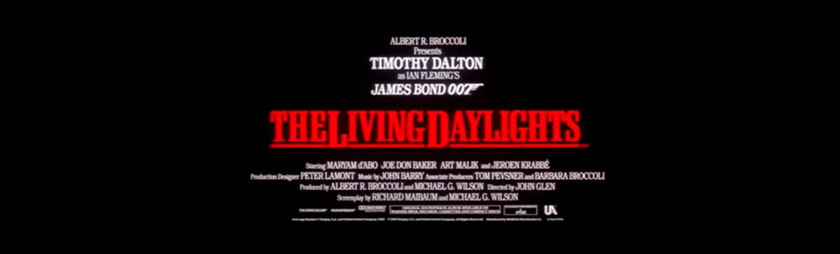
Figure 2. Screenshot from the trailer of The Living Daylights, 1987
4.3 Skyfall
The trailer for Skyfall, released in 2012 to celebrate 50 years of James Bond films, has a runtime of 2 minutes and 33 seconds, accounting for 1.61% of the film’s total duration. Unlike the previously discussed trailers, this one presents an implicit promotional context without emphasizing the actors or the filmmaking team. While Skyfall is not Daniel Craig’s debut as James Bond, the trailer notably refrains from highlighting this aspect; instead, it directly showcases the film’s main plot.
Table 4. Analysis of the film trailer for Skyfall
Stage | Time | Verbal | Visual | Audial
Prologue | 0:00 – 0:19 | Bond: “He is gone.”  M: “You both know what’s at stake here.”  M: “Take the bloody shot.” | 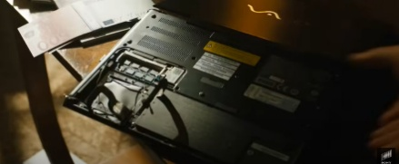  The beginning of the trailer – the missing part in the computer  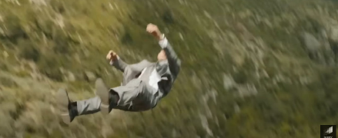  Moneypenny almost kills Bond | Dramatic music with logical pauses, sound of gunfire
Orientation | 0:20 – 0:58 | Mallory: “Three months ago you lost the drive containing the identity of every agent embedded in terrorist organizations across the globe.”  M: “Where the hell have you been?”  Bond: “Enjoying death.”  Mallory: “Why not stay dead?” | 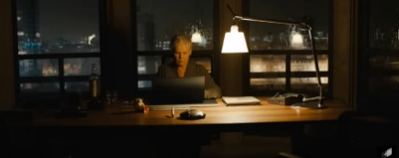  In a rainy-day M writes an obituary for Bond, knowing he’s alive  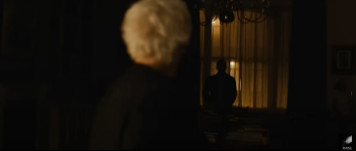  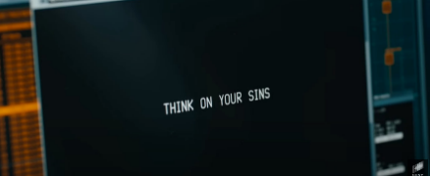  007 reporting for duty  M receives the threat from the villain  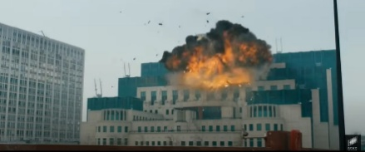  Explosion of MI6 | Dramatic music with logical pauses, which slowly comes to its peak. The sound of an explosion occurs at a moment when the music ceases, marking the peak of the trailer’s intensity.
Complication | 0:59 – 1:56 | Bond: “They went targeting her.”  Severine: “How much do you know about fear?”  Bond: “All of this.”  Silva: “Mommy was very bad.”  Bond: “Everybody needs his hobby.”  Silva: “So what’s yours?”  Bond: “Resurrection.” | 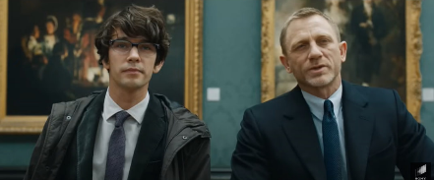  Bond meets his new Quartermaster – and he is definitely not satisfied with him  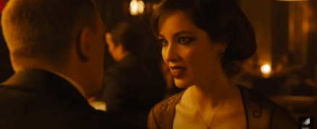  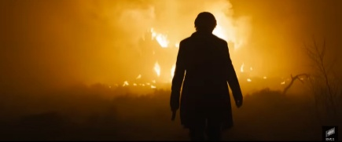  First blink on the new villain | Dramatic music, sounds of gunfire and explosions
Evaluation | 1:57 – 2:33 | - |   Iconic scene – Bond with his new girl  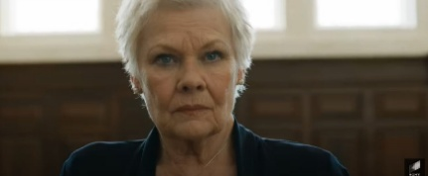  M meets an old friend | “James Bond Theme” by Monty Norman, plays during a dramatic sequence that intensifies and reaches its climax toward the end of the trailer; sounds of gunfire

As exemplified in Table 4, the prologue begins with a scene in which Bond discovers a computer with a missing component, effectively drawing the viewer directly into the movie’s central plot. According to Thomsen and Heiselberg (2020), this segment serves as the initial peak to capture the audience’s attention (Thomsen & Heiselberg 2020: 48). Compared to the film, the trailer’s prologue effectively encapsulates the entire narrative, highlighting Bond’s initial pursuit of an unidentified villain and the subsequent gunfire that leads to his apparent “death”. From the very beginning, the trailer immerses viewers in the storyline. Given that one of the primary objectives of film trailers is to generate intrigue, marketers must include a suitable amount of narrative content (Moul 2007). While consumers may seek additional information to enhance their understanding of the film’s storyline, example (3) shows that the trailer should not disclose the entirety of the film’s content (Finsterwalder et al. 2012: 593).
(3) M: You both know what’s at stake here.
The orientation portion of the trailer furthers the narrative by depicting Bond being shot by Moneypenny, while M writes his obituary. However, the trailer suggests that M is aware of Bond’s survival. The atmosphere surrounding M is sombre, accentuated by the rain in the background, which adds a dramatic flair to the scene. Bond is seen emerging from the shadows, yet M recognizes him and greets him in her distinctive manner, as presented in example (4).
(4) M: Where the hell have you been?
This section serves as a representation of Act Two (Garrett 2012) and culminates in the explosion of the MI6 building, marking a peak in the trailer’s intensity. It effectively establishes a connection to the beginning, intertwining the storyline between MI6 and the unknown villain, who makes his first move in this confrontation. The viewer is subtly led to infer that the villain has a link to MI6, highlighted by the destruction of the building. Furthermore, the villain’s personal connection to M is underscored when he sends her a picture accompanied by the ominous message, Think of your sins.
The complication section of the trailer introduces a new character, Q, who was notably absent in the first two films starring Daniel Craig, Casino Royale and Quantum of Solace. In this instalment, Q is depicted as a young man, and Bond expresses his dissatisfaction with the new assistant before even getting to know him. The trailer emphasizes Q’s return as an iconic character by showcasing the gadgets and weapons he presents to Bond during their exchange in the museum. Their dialogue (5) concludes with a handshake, signalling their readiness to collaborate in their mission to apprehend the villain.

(5) Bond: Q.
Q: Double-O-Seven.
Additionally, the complication segment introduces the villain directly, and the dialogue between Bond and Silva suggests Silva’s connections to both MI6 and M. He refers to M as “mommy”. as shown in example (6), highlighting a personal relationship and indicating that M is a significant adversary with whom Bond must confront. This interaction reinforces the characters’ narrative tension and emphasizes the betrayal and conflict within MI6.
(6) Silva: Mommy was very bad.
The final segment is characterized by its exclusive use of non-verbal elements, presenting a fast-paced sequence of frames that emphasize shootouts and confrontations between characters, Bond’s romantic interest, and M’s meeting with the film’s main antagonist. The brisk transitions between these frames generate a heightened sense of excitement and unpredictability. This stylistic choice is designed to evoke intrigue and compelling curiosity in viewers, encouraging them to engage with the full film to integrate these vibrant moments into a comprehensive narrative.
A notable feature of the Skyfall trailer is its use of dynamic music that adapts to the unfolding events. The trailer uses an adapted version of the James Bond theme song. The score intensifies during moments of high tension, while simultaneously quieting during dialogue or contemplative scenes where characters are faced with decisions. This musical arrangement blends seamlessly with the sound effects of the gunfight, creating an immersive experience. At the peak of the climax, marked by the explosion of the MI6 building, the music temporarily halts, allowing viewers to absorb the significance of the events depicted on screen. According to Leigh (1991), when the audio and video components of a message are congruent — meaning they are closely related — consumers are more likely to encode the message as a cohesive whole. This alignment enhances the overall impact of the message, facilitating better comprehension and memorization (Leigh 1991: 72). Film marketers utilize specific styles and tempos of music to convey the film’s genre or establish a particular tone. This strategic choice significantly influences consumers’ expectations regarding the content of the film, shaping their perceptions and emotional responses even before viewing (Finsterwalder et al. 2012: 590).

5 Discussion

In an analysis of three trailers of James Bond films, we found a consistent structural framework comprising four distinct stages: prologue, orientation, complication, and evaluation. The narrative nature of these trailers allows them to succinctly communicate the film’s storyline while maintaining an air of mystery, which serves to engage and intrigue potential viewers. Trailers primarily fulfill a marketing function, aiming to captivate audiences and draw them into the cinema. Previous research indicates that trailers lasting between 1 to 3 minutes are particularly effective at holding viewer attention and motivating them to watch the full feature. This duration accommodates the essential elements of the film, including its plot, principal characters, cast, and production team, thereby informing potential viewers without overwhelming them.
Movie trailers, akin to the films they represent, are multimodal texts that leverage various forms of communication. These trailers incorporate a diverse array of elements to convey their messages effectively. By engaging multiple modes, trailers create a rich sensory experience that enhances storytelling and captures the audience’s interest, ultimately aimed at encouraging them to engage with the full feature. The analysis of three James Bond film trailers — On Her Majesty’s Secret Service, The Living Daylights, and Skyfall — revealed that both verbal and non-verbal communication methods significantly enhance viewer engagement. The trailers effectively utilize musical scores, dynamic action sequences, sound effects, and vivid imagery to captivate audiences and draw their attention. This multifaceted approach not only enhances the narrative but also reinforces the emotional impact of the content, thereby increasing the likelihood of enticing viewers to watch the full film.
In movie trailers, the “peaks” play a crucial role, representing moments where the plot reaches its climax. Research indicates that the first peak typically occurs early in the trailer, aiming to capture the viewer’s attention. This initial peak may reveal key plot elements to generate intrigue and entice the audience. Conversely, the second peak takes place towards the end of the trailer, heightening tension and spurring further interest. Modern trailers often achieve this second peak through rapid changes of shots, instilling uncertainty and posing unanswered questions that compel viewers to seek out the complete film. Simultaneously, the trailer concludes on a note of ambiguity, intentionally withholding certain plot details to sustain intrigue and encourage audiences to explore the narrative in its entirety.
While verbal elements and film dialogues can enhance a trailer, they are not essential for achieving the second peak. An analysis of the Skyfall trailer demonstrated that abrupt visual transitions, coupled with dramatic music, can generate significantly more tension than relying on text alone. The use of dynamic music is particularly pivotal in shaping the viewer’s experience of a film trailer. In the action and thriller genres, trailers typically feature vigorous musical scores that contribute to a sense of momentum and narrative progression. These scores often incorporate strategic pauses and shifts in mood corresponding with changes in imagery, effectively enhancing the dramatic impact and reinforcing the emotional journey of the trailer.

6 Conclusion
The James Bond films prominently incorporate both iconic verbal and non-verbal elements, including variations of the signature musical theme, the iconic gunshot sequence, and the memorable line. These elements are strategically employed to cultivate a sense of cultural identity surrounding the franchise, reinforcing its branding while fostering an emotional connection with the audience. By leveraging these recognizable features, the films effectively engage viewers and enhance their overall experience. These elements serve to instantly signal to audiences that they are about to experience a Bond film, creating familiarity and anticipation that can draw viewers in. By incorporating these iconic elements, the trailers may evoke a sense of nostalgia and connection to the long-standing history of the franchise, making them appealing to both longstanding fans and new audiences.
While film discourse is inherently multimodal, verbal elements of communication are crucial for grasping the plot’s nuances. These elements encompass not only voice-overs featured in older trailers but also carefully selected pieces of dialogue that provide insight into the narrative without completely unveiling it. Depending on the specific nature of the film trailer, these verbal components can serve various functions, such as character description. For instance, the introduction of a new actor as James Bond can signify important changes within the franchise, reflected through the dialogue and voice-overs to inform audiences about the evolving character dynamics and storyline.
The film discourse research encompasses a wide array of topics explored by numerous scholars. Their certain aspects merit particular focus. The unique characteristics of film trailers significantly influence how studios select elements that effectively convey the essence of the film and deploy strategies that resonate with audiences. Investigating the verbal components of trailers within the spy film genre is crucial, given the specialized vocabulary that contributes to the overall atmosphere of these trailers. We identify valuable avenues for future research in examining the specific vocabulary employed in spy film discourse, as well as exploring effective techniques for crafting compelling film dialogues.

References

Cohn, Neil. 2013. Visual Narrative Structure. Cognitive Science, vol. 37, no. 3. 413–452.
DiStefano, Daniel. 2015. A Brief History of Film Trailers, or: Turns Out This Post Is Not About Peter Orner. Michigan Quarterly Review. Accessed December 10, 2024.
https://sites.lsa.umich.edu/mqr/2015/07/a-brief-history-of-film-teasers-or-turns-out-this-post-is-not-about-peter-orner/
Fekete, Diana. 2017. Naratyv kinotreilera yak performatyvna interpretatsiia produktsii kinoindustrii (Movie trailer narrative as a performative interpretation of the film industry production). Naukovyi visnyk Mizhnarodnoho humanitarnoho universytetu, vol. 31, no. 3. 188–190. [In Ukrainian].
Finsterwalder, Jörg, Kuppelwieser, Volker G., and De Villiers, Matthew. 2012. The effects of film trailers on shaping consumer expectations in the entertainment industry: A qualitative analysis. Journal of Retailing and Consumer Services, vol. 19, no. 6. 589–595.
Garrett, Stephen. 2012. The Art of First Impressions: How to Cut a Movie Trailer. Filmmaker Magazine. Accessed November 26, 2024.
https://filmmakermagazine.com/37093-first-impressions/
Hesford, Daniel. 2013. “Action… Suspense… Emotion!”: The Trailer as Cinematic Performance. Frames Cinema Journal. Accessed November 13, 2024.
https://framescinemajournal.com/article/action-suspense-emotion-the-trailer-as-cinematic-performance/
Hixson, Thomas Kim. 2006. Mission possible: Targeting trailers to movie audiences. Journal of Targeting, Measurement and Analysis for Marketing, vol. 14, no. 3. 210–224.
Kernan, Lisa. 2004. Coming Attractions: Reading American Movie Trailers. Austin: University of Texas Press.
Klinger, Barbara. 1989. Digressions at the Cinema: Reception and Mass Culture. Cinema Journal, vol. 28, no. 3. 3–19.
Kress, Gunther, and Van Leeuwen, Theo. 2001. Multimodal Discourse: The Modes and Media of Contemporary Communication. London: Arnold.
Leigh, James H. 1991. Information Processing Differences among Broadcast Media: Review and Suggestions for Research. Journal of Advertising, vol. 20, no. 2. 71–75.
Maier, Carmen Daniela. 2009. Visual evaluation in film trailers. Visual Communication, vol. 8, no. 2. 159–180.
Maier, Carmen Daniela. 2011. Structure and function in the generic staging of film trailers: A multimodal analysis. In Piazza, R., Bednarek, M., and Rossi, F. (eds.). Pragmatics & Beyond New Series. 141–158. Amsterdam: John Benjamins Publishing Company.
Moul, Charles C. 2007. Measuring Word of Mouth’s Impact on Theatrical Movie Admissions. Journal of Economics & Management Strategy, vol. 16, no. 4. 859–892.
Shcherbak, Olena. 2022. Kinodyskurs yak dvorivneva systema skladnykiv: funktsiinyi pohliad (Film discourse as a two-level system of components: a functional view). Pomiędzy. Polonistyczno-Ukrainoznawcze Studia Naukowe, vol. 6, no. 3. 175–181. [In Ukrainian].
Thomsen, Morten, and Heiselberg, Lene. 2020. Arousing the audience: The two-peak structure of drama film trailers. Journal of Scandinavian Cinema, vol. 10, no. 1. 45–65.
Xing, Qidan. 2022. Multimodal Discourse Analysis on a Cartoon Film Trailer Up. Journal of Linguistics and Communication Studies, vol. 1, no. 1. 17–26.

Audiovisual sources
Hunt, Peter R. 1969. On Her Majesty’s Secret Service. Eon Productions. YouTube. Accessed November 25, 2024. https://www.youtube.com/watch?v=dOLq5Rg9N-c
Glen, John. 1987. The Living Daylights. Eon Productions. YouTube. Accessed December 3, 2024.
https://www.youtube.com/watch?v=IXAVKJTIM1E
Mendes, Sam. 2012. Skyfall. Eon Productions. YouTube. Accessed December 18, 2024.
https://www.youtube.com/watch?v=6kw1UVovByw

Mariia Rudenko
Department of Germanic Philology
Sumy State University
Ukraine
e-mail: Ma.Rudenko@ms.sumdu.edu.ua

In SKASE Journal of Literary and Cultural Studies [online]. 2025, vol. 7, no. 2 [cit. 2025-12- 30]. Available on web page http://www.skase.sk/Volumes/JLCS15/01.pdf. ISSN 2644-5506

